
Develop and implement operational
policies
D1.HGE.CL7.14 D1.HGA.CL6.13 D2.TGA.CL6.10
Trainer Guide

Develop and implement operational policies

D1.HGE.CL7.14 D1.HGA.CL6.13 D2.TGA.CL6.10

Trainer Guide





Project Base
William Angliss Institute of TAFE
555 La Trobe Street
Melbourne 3000 Victoria
Telephone: | (03) 9606 2111
Facsimile: | (03) 9670 1330
Acknowledgements
Project Director: | Wayne Crosbie
Project Manager | Jim Irwin
Chief Writer: | Alan Hickman
Subject Writer: | Alan Hickman
Editor: | Jim Irwin
DTP/Production: | Daniel Chee, Mai Vu, Cindy Curran

The Association of Southeast Asian Nations (ASEAN) was established on 8 August 1967. The Member States of the Association are Brunei Darussalam, Cambodia, Indonesia, Lao PDR, Malaysia, Myanmar, Philippines, Singapore, Thailand and Viet Nam.
The ASEAN Secretariat is based in Jakarta, Indonesia.
General Information on ASEAN appears online at the ASEAN Website: www.asean.org.
All text is produced by William Angliss Institute of TAFE for the ASEAN Project on “Toolbox Development for Tourism Labour Divisions for Travel Agencies and Tour Operations”.
This publication is supported by the Australian Government’s aid program through the ASEAN- Australia Development Cooperation Program Phase II (AADCP II).
Copyright: Association of Southeast Asian Nations (ASEAN) 2015. All rights reserved.
Disclaimer
Every effort has been made to ensure that this publication is free from errors or omissions. However, you should conduct your own enquiries and seek professional advice before relying on any fact, statement or matter contained in this book. The ASEAN Secretariat and William Angliss Institute of TAFE are not responsible for any injury, loss or damage as a result of material included or omitted from this course. Information in this module is current at the time of publication. Time of publication is indicated in the date stamp at the bottom of each page.
Some images appearing in this resource have been purchased from stock photography suppliers Shutterstock and iStockphoto and other third party copyright owners and as such are non-transferable and non-exclusive. Clip arts, font images and illustrations used are from the Microsoft Office Clip Art and Media Library. Some images have been provided by and are the property of William Angliss Institute.
Additional images have been sourced from Flickr and SXC and are used under Creative Commons licence: http://creativecommons.org/licenses/by/2.0/deed.en
File name: TG Develop and implement operational policies_291015



Table of contents
Competency Based Training (CBT) and assessment – An introduction for trainers 1
Competency standard 11
Notes and PowerPoint slides 19
Recommended training equipment 181
Instructions for Trainers for using PowerPoint – Presenter View 183
Appendix – ASEAN acronyms 185

© ASEAN 2015
Trainer Guide Develop and implement operational policies

© ASEAN 2015
Trainer Guide
Develop and implement operational policies

Competency Based Training (CBT) and assessment – An introduction for trainers
Competency
Competency refers to the ability to perform particular tasks and duties to the standard of performance expected in the workplace.
Competency requires the application of specified knowledge, skills and attitudes relevant to effective participation, consistently over time and in the workplace environment.
The essential skills and knowledge are either identified separately or combined.
Knowledge identifies what a person needs to know to perform the work in an informed and effective manner.
Skills describe the application of knowledge to situations where understanding is converted into a workplace outcome.
Attitude describes the founding reasons behind the need for certain knowledge or why skills are performed in a specified manner.
Competency covers all aspects of workplace performance and involves:
- Performing individual tasks
- Managing a range of different tasks
- Responding to contingencies or breakdowns
- Dealing with the responsibilities of the workplace
- Working with others.

Unit of competency

Like with any training qualification or program, a range of subject topics are identified that focus on the ability in a certain work area, responsibility or function.
Each manual focuses on a specific unit of competency that applies in the hospitality workplace.
In this manual a unit of competency is identified as a ‘unit’.
Each unit of competency identifies a discrete workplace requirement and includes:
- Knowledge and skills that underpin competency
- Language, literacy and numeracy
- Occupational safety and health requirements.
Each unit of competency must be adhered to in training and assessment to ensure consistency of outcomes.

Element of competency
An element of competency describes the essential outcomes within a unit of competency. The elements of competency are the basic building blocks of the unit of competency.
They describe in terms of outcomes the significant functions and tasks that make up the competency.
In this manual elements of competency are identified as an ‘element’.

Performance criteria

Performance criteria indicate the standard of performance that is required to demonstrate achievement within an element of competency. The standards reflect identified industry skill needs.
Performance criteria will be made up of certain specified skills, knowledge and attitudes.

Learning

For the purpose of this manual learning incorporates two key activities:
- Training
- Assessment.
Both of these activities will be discussed in detail in this introduction.
Today training and assessment can be delivered in a variety of ways. It may be provided to participants:
- On-the-job – in the workplace
- Off-the-job – at an educational institution or dedicated training environment
- As a combination of these two options.
No longer is it necessary for learners to be absent from the workplace for long periods of time in order to obtain recognised and accredited qualifications.

Learning approaches

This manual will identify two avenues to facilitate learning: Competency Based Training (CBT)
This is the strategy of developing a participant’s competency.
Educational institutions utilise a range of training strategies to ensure that participants are able to gain the knowledge and skills required for successful:
- Completion of the training program or qualification
- Implementation in the workplace.
The strategies selected should be chosen based on suitability and the learning styles of participants.

Competency Based Assessment (CBA)

This is the strategy of assessing competency of a participant.
Educational institutions utilise a range of assessment strategies to ensure that participants are assessed in a manner that demonstrates validity, fairness, reliability, flexibility and fairness of assessment processes.

Flexibility in learning

It is important to note that flexibility in training and assessment strategies is required to meet the needs of participants who may have learning difficulties. The strategies used will vary, taking into account the needs of individual participants with learning difficulties.
However they will be applied in a manner which does not discriminate against the participant or the participant body as a whole.
Catering for participant diversity
Participants have diverse backgrounds, needs and interests. When planning training and assessment activities to cater for individual differences, trainers and assessors should:
- Consider individuals’ experiences, learning styles and interests
- Develop questions and activities that are aimed at different levels of ability
- Modify the expectations for some participants
- Provide opportunities for a variety of forms of participation, such as individual, pair and small group activities
- Assess participants based on individual progress and outcomes.
The diversity among participants also provides a good reason for building up a learning community in which participants support each other’s learning.
Participant centred learning
This involves taking into account structuring training and assessment that:
- Builds on strengths – Training environments need to demonstrate the many positive features of local participants (such as the attribution of academic success to effort, and the social nature of achievement motivation) and of their trainers (such as a strong emphasis on subject disciplines and moral responsibility). These strengths and uniqueness of local participants and trainers should be acknowledged and treasured
- Acknowledges prior knowledge and experience – The learning activities should be planned with participants’ prior knowledge and experience in mind
- Understands learning objectives – Each learning activity should have clear learning objectives and participants should be informed of them at the outset. Trainers should also be clear about the purpose of assignments and explain their significance to participants
- Teaches for understanding – The pedagogies chosen should aim at enabling participants to act and think flexibly with what they know
- Teaches for independent learning – Generic skills and reflection should be nurtured through learning activities in appropriate contexts of the curriculum. Participants should be encouraged to take responsibility for their own learning

- Enhances motivation – Learning is most effective when participants are motivated. Various strategies should be used to arouse the interest of participants
- Makes effective use of resources – A variety of teaching resources can be employed as tools for learning
- Maximises engagement – In conducting learning activities, it is important for the minds of participants to be actively engaged
- Aligns assessment with learning and teaching – Feedback and assessment should be an integral part of learning and teaching
- Caters for learner diversity – Trainers should be aware that participants have different characteristics and strengths and try to nurture these rather than impose a standard set of expectations.
Active learning
The goal of nurturing independent learning in participants does not imply that they always have to work in isolation or solely in a classroom. On the contrary, the construction of knowledge in tourism and hospitality studies can often best be carried out in collaboration with others in the field. Sharing experiences, insights and views on issues of common concern, and working together to collect information through conducting investigative studies in the field (active learning) can contribute a lot to their eventual success.
Active learning has an important part to play in fostering a sense of community in the class. First, to operate successfully, a learning community requires an ethos of acceptance and a sense of trust among participants, and between them and their trainers. Trainers can help to foster acceptance and trust through encouragement and personal example, and by allowing participants to take risks as they explore and articulate their views, however immature these may appear to be. Participants also come to realise that their classmates (and their trainers) are partners in learning and solving.
Trainers can also encourage cooperative learning by designing appropriate group learning tasks, which include, for example, collecting background information, conducting small-scale surveys, or producing media presentations on certain issues and themes.
Participants need to be reminded that, while they should work towards successful completion of the field tasks, developing positive peer relationships in the process is an important objective of all group work.

Competency Based Training (CBT)

Principle of Competency Based Training
Competency based training is aimed at developing the knowledge, skills and attitudes of participants, through a variety of training tools.

Training strategies
The aims of this curriculum are to enable participants to:
- Undertake a variety of subject courses that are relevant to industry in the current environment
- Learn current industry skills, information and trends relevant to industry
- Learn through a range of practical and theoretical approaches
- Be able to identify, explore and solve issues in a productive manner

- Be able to become confident, equipped and flexible managers of the future
- Be ‘job ready’ and a valuable employee in the industry upon graduation of any qualification level.
To ensure participants are able to gain the knowledge and skills required to meet competency in each unit of competency in the qualification, a range of training delivery modes are used.

Types of training
In choosing learning and teaching strategies, trainers should take into account the practical, complex and multi-disciplinary nature of the subject area, as well as their participant’s prior knowledge, learning styles and abilities.
Training outcomes can be attained by utilising one or more delivery methods:
Lecture/tutorial
This is a common method of training involving transfer of information from the trainer to the participants. It is an effective approach to introduce new concepts or information to the learners and also to build upon the existing knowledge. The listener is expected to reflect on the subject and seek clarifications on the doubts.
Demonstration
Demonstration is a very effective training method that involves a trainer showing a participant how to perform a task or activity. Through a visual demonstration, trainers may also explain reasoning behind certain actions or provide supplementary information to help facilitate understanding.
Group discussions
Brainstorming in which all the members in a group express their ideas, views and opinions on a given topic. It is a free flow and exchange of knowledge among the participants and the trainer. The discussion is carried out by the group on the basis of their own experience, perceptions and values. This will facilitate acquiring new knowledge. When everybody is expected to participate in the group discussion, even the introverted persons will also get stimulated and try to articulate their feelings.
The ideas that emerge in the discussions should be noted down and presentations are to be made by the groups. Sometimes consensus needs to be arrived at on a given topic.
Group discussions are to be held under the moderation of a leader guided by the trainer. Group discussion technique triggers thinking process, encourages interactions and enhances communication skills.
Role play
This is a common and very effective method of bringing into the classroom real life situations, which may not otherwise be possible. Participants are made to enact a particular role so as to give a real feel of the roles they may be called upon to play. This enables participants to understand the behaviour of others as well as their own emotions and feelings. The instructor must brief the role players on what is expected of them. The role player may either be given a ready-made script, which they can memorise and enact, or they may be required to develop their own scripts around a given situation. This technique is extremely useful in understanding creative selling techniques and human relations. It can be entertaining and energising and it helps the reserved and less literate to express their feelings.

Simulation games
When trainees need to become aware of something that they have not been conscious of, simulations can be a useful mechanism. Simulation games are a method based on "here and now" experience shared by all the participants. The games focus on the participation of the trainees and their willingness to share their ideas with others. A "near real life" situation is created providing an opportunity to which they apply themselves by adopting certain behaviour. They then experience the impact of their behaviour on the situation. It is carried out to generate responses and reactions based on the real feelings of the participants, which are subsequently analysed by the trainer.
While use of simulation games can result in very effective learning, it needs considerable trainer competence to analyse the situations.
Individual /group exercises
Exercises are often introduced to find out how much the participant has assimilated. This method involves imparting instructions to participants on a particular subject through use of written exercises. In the group exercises, the entire class is divided into small groups, and members are asked to collaborate to arrive at a consensus or solution to a problem.
Case study
This is a training method that enables the trainer and the participant to experience a real life situation. It may be on account of events in the past or situations in the present, in which there may be one or more problems to be solved and decisions to be taken. The basic objective of a case study is to help participants diagnose, analyse and/or solve a particular problem and to make them internalise the critical inputs delivered in the training. Questions are generally given at the end of the case study to direct the participants and to stimulate their thinking towards possible solutions. Studies may be presented in written or verbal form.
Field visit
This involves a carefully planned visit or tour to a place of learning or interest. The idea is to give first-hand knowledge by personal observation of field situations, and to relate theory with practice. The emphasis is on observing, exploring, asking questions and understanding. The trainer should remember to brief the participants about what they should observe and about the customs and norms that need to be respected.
Group presentation
The participants are asked to work in groups and produce the results and findings of their group work to the members of another sub-group. By this method participants get a good picture of each other's views and perceptions on the topic and they are able to compare them with their own point of view. The pooling and sharing of findings enriches the discussion and learning process.
Practice sessions
This method is of paramount importance for skills training. Participants are provided with an opportunity to practice in a controlled situation what they have learnt. It could be real life or through a make-believe situation.

Games
This is a group process and includes those methods that involve usually fun-based activity, aimed at conveying feelings and experiences, which are everyday in nature, and applying them within the game being played. A game has set rules and regulations, and may or may not include a competitive element. After the game is played, it is essential that the participants be debriefed and their lessons and experiences consolidated by the trainer.
Research
Trainers may require learners to undertake research activities, including online research, to gather information or further understanding about a specific subject area.

Competency Based Assessment (CBA)

Principle of Competency Based Assessment
Competency based assessment is aimed at compiling a list of evidence that shows that a person is competent in a particular unit of competency.
Competencies are gained through a multitude of ways including:
- Training and development programs
- Formal education
- Life experience
- Apprenticeships
- On-the-job experience
- Self-help programs.
All of these together contribute to job competence in a person. Ultimately, assessors and participants work together, through the ‘collection of evidence’ in determining overall competence.
This evidence can be collected:
- Using different formats
- Using different people
- Collected over a period of time.
The assessor, who is ideally someone with considerable experience in the area being assessed, reviews the evidence and verifies the person as being competent or not.

Flexibility in assessment
Whilst allocated assessment tools have been identified for this subject, all attempts are made to determine competency and suitable alternate assessment tools may be used, according to the requirements of the participant.
The assessment needs to be equitable for all participants, taking into account their cultural and linguistic needs.

Competency must be proven regardless of:
- Language
- Delivery Method
- Assessment Method.

Assessment objectives
The assessment tools used for subjects are designed to determine competency against the ‘elements of competency’ and their associated ‘performance criteria’.
The assessment tools are used to identify sufficient:
- Knowledge, including underpinning knowledge
- Skills
- Attitudes
Assessment tools are activities that trainees are required to undertake to prove participant competency in this subject.
All assessments must be completed satisfactorily for participants to obtain competence in this subject. There are no exceptions to this requirement, however, it is possible that in some cases several assessment items may be combined and assessed together.

Types of assessment
Allocated Assessment Tools
There are a number of assessment tools that are used to determine competency in this subject:
- Work projects
- Written questions
- Oral questions
- Third Party Report
- Observation Checklist.
Instructions on how assessors should conduct these assessment methods are explained in the Assessment Manuals.
Alternative assessment tools
Whilst this subject has identified assessment tools, as indicated above, this does not restrict the assessor from using different assessment methods to measure the competency of a participant.
Evidence is simply proof that the assessor gathers to show participants can actually do what they are required to do.
Whilst there is a distinct requirement for participants to demonstrate competency, there are many and diverse sources of evidence available to the assessor.
Ongoing performance at work, as verified by a supervisor or physical evidence, can count towards assessment. Additionally, the assessor can talk to customers or work colleagues to gather evidence about performance.

A range of assessment methods to assess competency include:
- Practical demonstrations
- Practical demonstrations in simulated work conditions
- Problem solving
- Portfolios of evidence
- Critical incident reports
- Journals
- Oral presentations
- Interviews
- Videos
- Visuals: slides, audio tapes
- Case studies
- Log books
- Projects
- Role plays
- Group projects
- Group discussions
- Examinations.

Recognition of Prior Learning
Recognition of Prior Learning is the process that gives current industry professionals who do not have a formal qualification, the opportunity to benchmark their extensive skills and experience against the standards set out in each unit of competency/subject.
Also known as a Skills Recognition Audit (SRA), this process is a learning and assessment pathway which encompasses:
- Recognition of Current Competencies (RCC)
- Skills auditing
- Gap analysis and training
- Credit transfer.

Assessing competency
As mentioned, assessment is the process of identifying a participant’s current knowledge, skills and attitudes sets against all elements of competency within a unit of competency. Traditionally in education, grades or marks were given to participants, dependent on how many questions the participant successfully answered in an assessment tool.
Competency based assessment does not award grades, but simply identifies if the participant has the knowledge, skills and attitudes to undertake the required task to the specified standard.

10
© ASEAN 2015
Trainer Guide
Therefore, when assessing competency, an assessor has two possible results that can be awarded:
- Pass Competent (PC)
- Not Yet Competent (NYC).
Pass Competent (PC)
If the participant is able to successfully answer or demonstrate what is required, to the expected standards of the performance criteria, they will be deemed as ‘Pass Competent’ (PC).
The assessor will award a ‘Pass Competent’ (PC) if they feel the participant has the necessary knowledge, skills and attitudes in all assessment tasks for a unit.
Not Yet Competent’ (NYC)
If the participant is unable to answer or demonstrate competency to the desired standard, they will be deemed to be ‘Not Yet Competent’ (NYC).
This does not mean the participant will need to complete all the assessment tasks again. The focus will be on the specific assessment tasks that were not performed to the expected standards.
The participant may be required to:
- Undertake further training or instruction
- Undertake the assessment task again until they are deemed to be ‘Pass Competent’.

Competency standard

UNIT TITLE: DEVELOP AND IMPLEMENT OPERATIONAL POLICIES |  | NOMINAL HOURS: 60
UNIT NUMBER: D1.HGE.CL7.14 D1.HGA.CL6.13 D2.TGA.CL6.10
UNIT DESCRIPTOR: This unit deals with the skills and knowledge required to develop and implement operational policies in a range of settings within the hotel and travel industries.
ELEMENTS AND PERFORMANCE CRITERIA | UNIT VARIABLE AND ASSESSMENT GUIDE
Element 1. Develop operational policies  - Develop operational polices and strategies based on monitoring of workplace needs and identification of opportunities for improvement and innovation  - Develop scope and objectives of the required initiative based on enterprise goals, staff and customer feedback  - Identify and analyse internal and external factors that may impact on the policy  - Consult appropriate stakeholders during the development of the policy  - Develop appropriate and financially-sound resource strategies  - Develop administrative framework and systems capable of supporting the planned initiative | Unit Variables  The Unit Variables provide advice to interpret the scope and context of this unit of competence, allowing for differences between enterprises and workplaces. It relates to the unit as a whole and facilitates holistic assessment.  This unit applies to developing and implementing operational policies within the labour divisions of the hotel and travel industries and may include:  - Front Office  - Housekeeping  - Food and Beverage Service  - Food Production  - Travel Agencies  - Tour Operation  The operational policies may relate to:  - The environment  - Products and services

- Identify and communicate clearly all priorities, responsibilities and timelines  - Develop evaluation systems in consultation with appropriate colleagues  Element 2. Administer and monitor operational policy  - Implement and evaluate identified actions in accordance with agreed priorities  - Monitor performance indicators  - Provide progress and other reports in accordance with enterprise requirements  - Make assessment of the need for additional resource requirements and take appropriate action in accordance with enterprise policy  Element 3. Conduct ongoing evaluation  - Review the operational policy to assess effectiveness in the workplace  - Monitor performance  - Identify problems and make adjustments accordingly  - Incorporate the results of evaluation into ongoing planning and operational management | - Training  - Workplace relations  - Finance  - Asset management.  Strategies may include:  - Client development  - Geographic expansion  - Organisational growth  - Service growth  - Debt reduction  - Income development.  Objectives may include:  - Sales figures  - Revenues  - Delivery times  - Service standards  - Client numbers  - Sales figures and targets  - Booking levels  - Customer or staff feedback  - Productivity gains.

Analyse internal and external factors may relate to:
  - Capabilities and resources:
    - Human resources
    - Financial resources
    - Equipment capacity
    - Staff skill levels
    - Hours of operation
    - Communication capabilities
    - Location/position
  - Trends and developments in the marketplace:
    - Economic
    - Ecological/environmental
    - Government activities
    - Social and cultural
    - Demographic
    - Technology
    - Industrial
  - Comparative market information:
    - Best practice information
    - Benchmarking
    - Competitor information
  - Legal and ethical constraints:
    - Legislation
    - Regulation
    - Codes of practice

- Cultural expectations and influences
- Social responsibilities, e.g. Protection of children, environmental issues.
Stakeholders may include:
- Customers
- Employees
- Government agencies
- Owners
- Suppliers
- Strategic alliance partners.
Evaluate may include
- Key performance indicators
- Gap analysis
- Customer feedback
- Compliance reports
- Employee feedback.
Performance indicators may include:
- Sales
- Return on investment
- Customer service
- Debt servicing costs.

Review the operational policy may relate to:
- Quarterly reviews
- Business plan cycle
- Major events triggering a review, e.g. change in market-place.
Assessment Guide
The following skills and knowledge must be assessed as part of this unit:
- Understanding of the key planning concepts and techniques including the structure of operational polices and steps in the planning process
- Knowledge of current internal and external environments which impact on planning within the enterprise or industry sector
- Understanding of research skills sufficient to source and analyse a broad range of information on varying issues and from multiple sources
- Knowledge of legal issues that impact on enterprise operations as appropriate to the industry sector.
Linkages To Other Units
- Develop and implement business plans
- Plan and establish systems and procedures
- Prepare business documents
- Maintain financial standards and records
- Manage legal requirements for business compliance
- Manage physical assets and infrastructure
- Lead and manage people.

Critical Aspects of Assessment
Evidence of the following is essential:
- Demonstrated ability to undertake detailed, thorough and appropriate analysis of both internal and external business environments to provide a sound basis for policy planning
- Demonstrated ability to develop and implement integrated operational policies within a travel and hotel industry context
- Demonstrated ability to perform across a range of situations that demonstrates knowledge, understanding and skill in implementing the principles and practices of developing and implementing operational policies
- Demonstrated ability to collect and analyse financial performance information
- Demonstrated ability to plan and forecast future trends
- Demonstrated ability to schedule activities to meet milestones
- Demonstrated ability to research data and trends.
Context of Assessment
This unit may be assessed on or off the job:
- Assessment should include practical demonstration of the ability to develop and implement operational policies in the workplace or through a simulation activity, supported by a range of methods to assess underpinning knowledge
- Assessment must relate to the individual’s work area, job role and area of responsibility
- Assessment must include project or work activities that allow the candidate to respond to multiple and varying workplace issues relevant to work area, job role and area of responsibility that allow the candidate to demonstrate knowledge and awareness of developing and implementing operational policies.

Resource Implications
Training and assessment to include access to a real or simulated commercial workplace environment in which operational policies can be implemented; and access to workplace standards, procedures, policies, guidelines, tools and equipment.
Assessment Methods
The following methods may be used to assess competency for this unit:
- Case studies
- Observation of practical candidate performance
- Oral and written questions
- Portfolio evidence
- Problem solving
- Role plays
- Third party reports completed by a supervisor
- Project and assignment work.
Key Competencies in this Unit
Level 1 = competence to undertake tasks effectively Level 2 = competence to manage tasks
Level 3 = competence to use concepts for evaluating
 | Key Competencies | Level | Examples
 | Collecting, organising and analysing information | 3 | Identify and analyse competitive activity
 | Communicating ideas and information | 3 | Express complex strategies in a clear and concise format

18
© ASEAN 2015
Trainer Guide

 | Planning and organising activities | 3 | Coordinate stakeholder involvement in the planning process
 | Working with others and in teams | 3 | Devise strategies to ensure team commitment to business strategies
 | Using mathematical ideas and techniques | 2 | Create financial projections and forecasts
 | Solving problems | 3 | Adjust strategies to respond to severe and sudden budgetary constraints
 | Using technology | 2 | Identify and analyse the optimum use of technology to achieve business objectives

Notes and PowerPoint slides

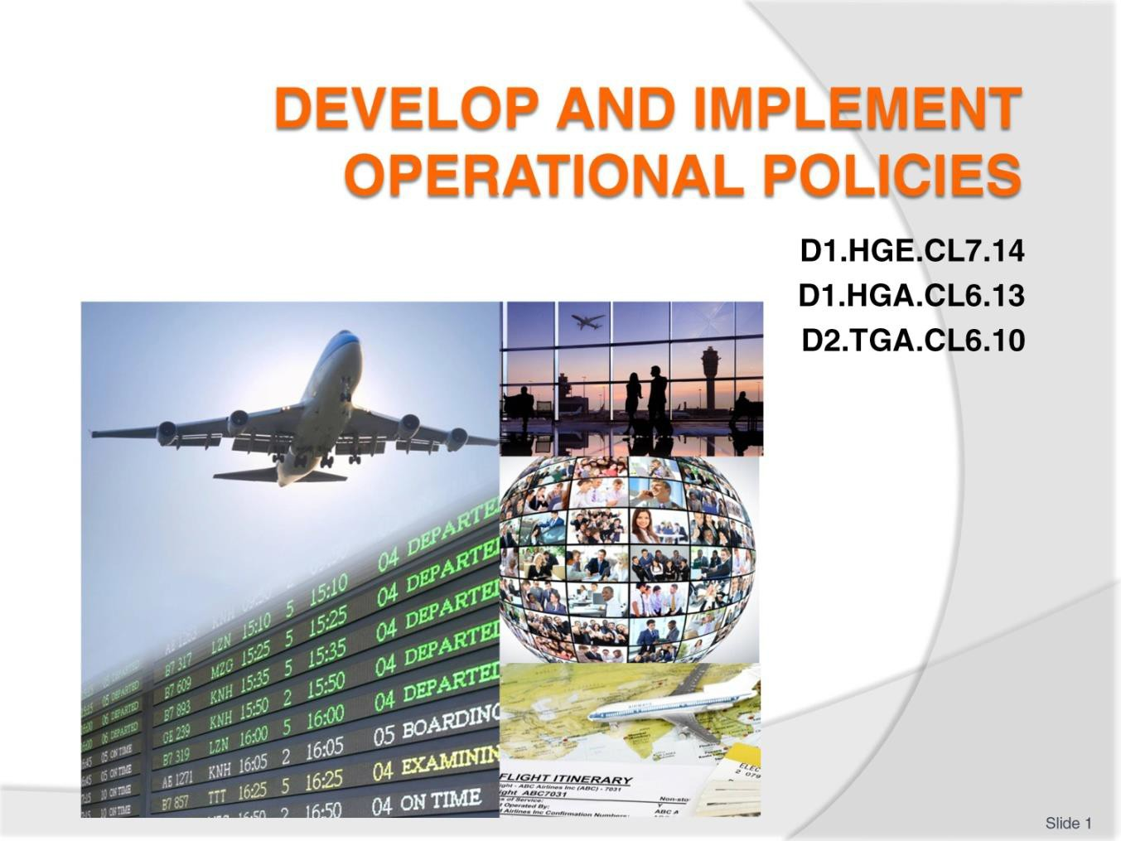
Slide
Slide No
Trainer Notes
1.
Trainer welcomes students to class.

Slide
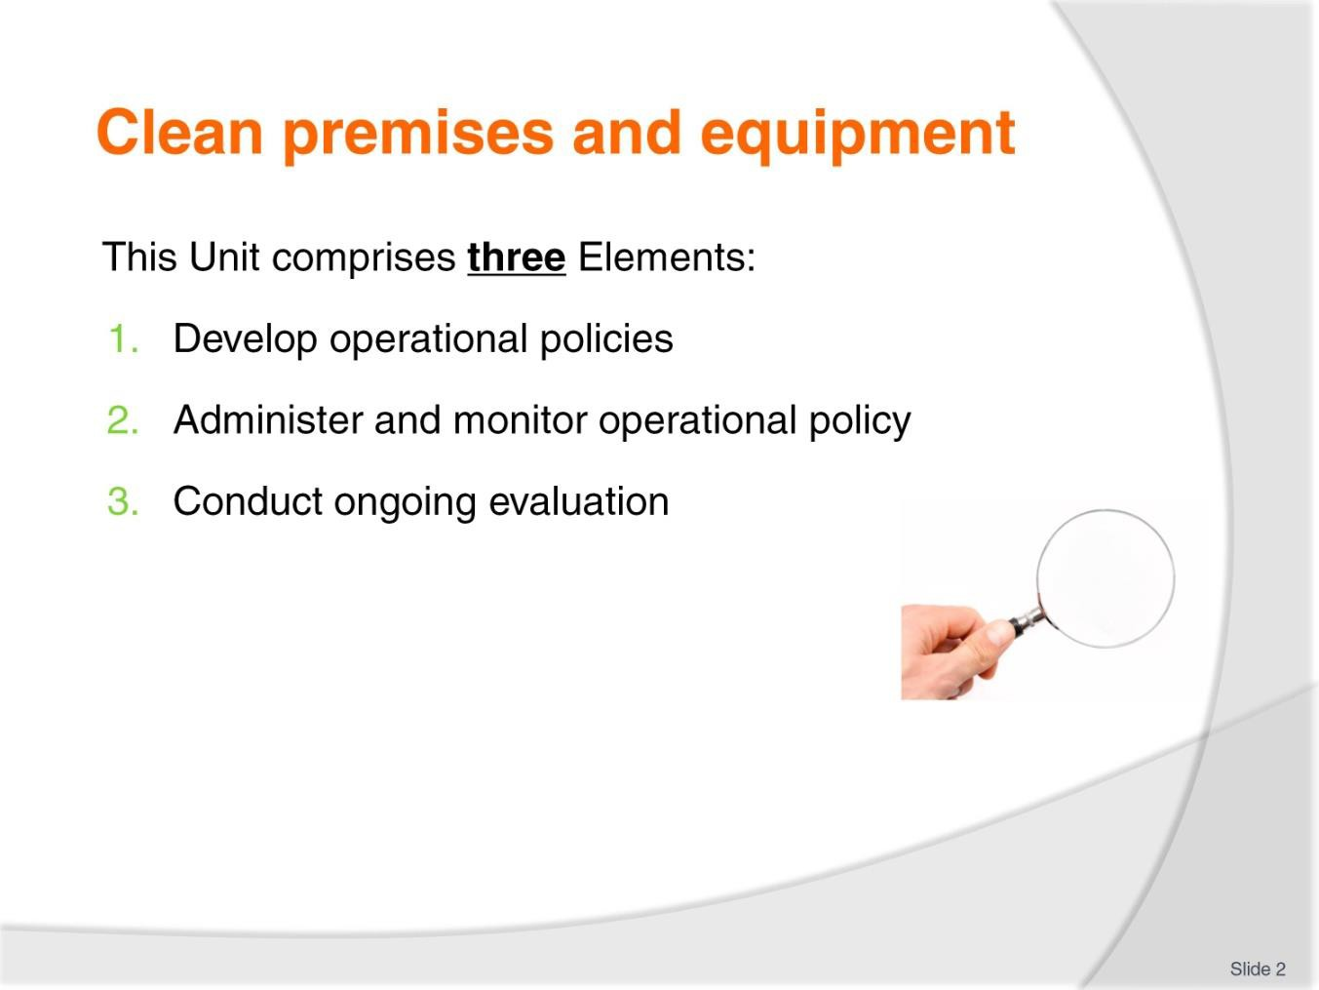
Slide No | Trainer Notes
2. | Trainer advises trainees this Unit comprises three Elements, as listed on the slide explaining:  - Each Element comprises a number of Performance Criteria which will be identified throughout the class and explained in detail  - Trainees can obtain more detail from their Trainee Manual  - At times the course presents advice and information about various protocols but where their workplace requirements differ to what is presented, the workplace practices and standards, as well as policies and procedures must be observed.

Slide
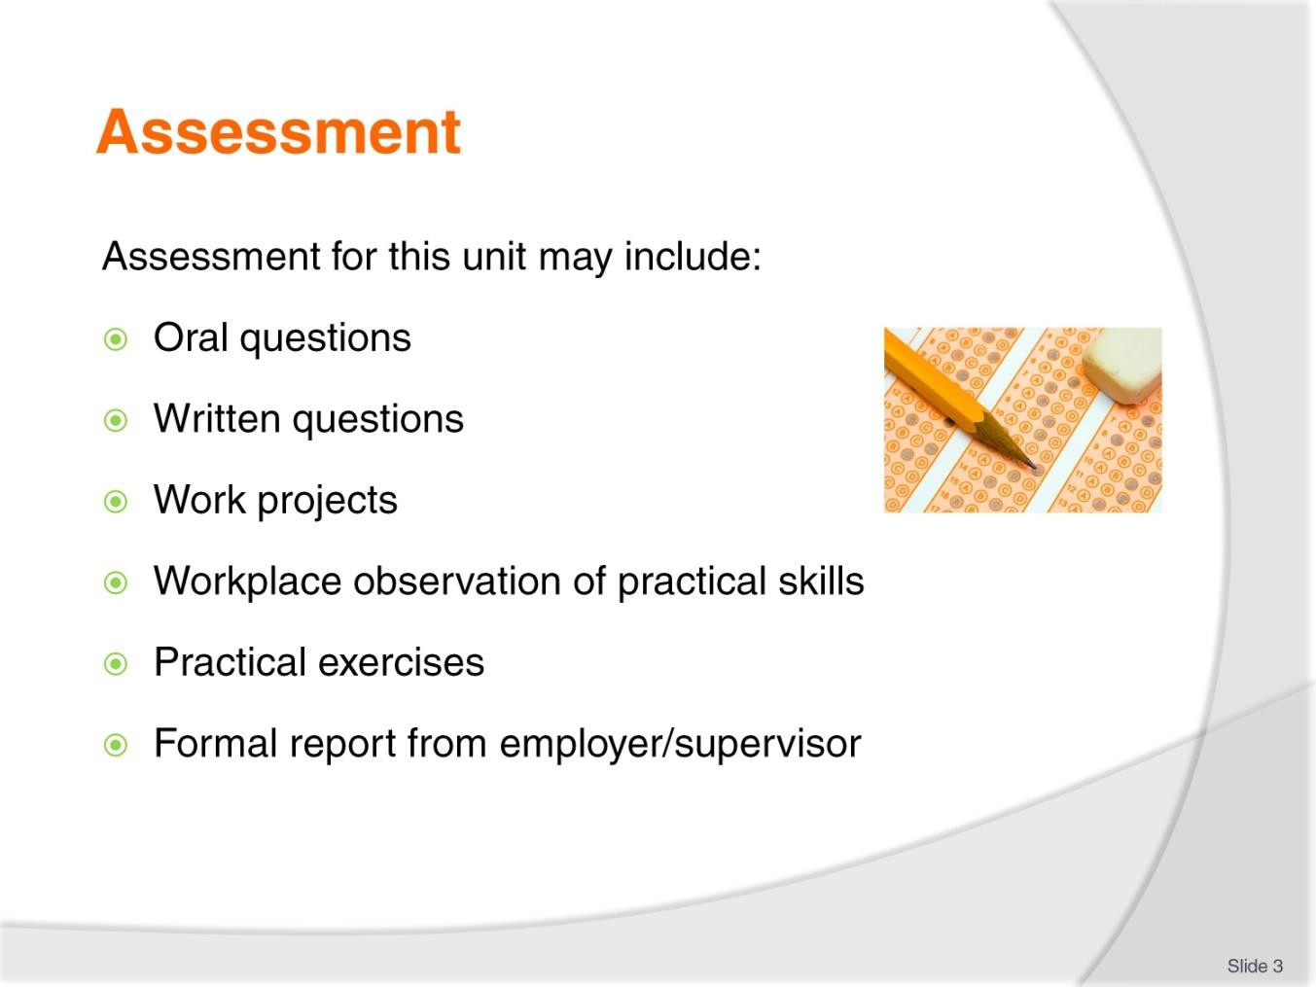
Slide No | Trainer Notes
3. | Trainer advises trainees that assessment for this Unit may take several forms, all of which are aimed at verifying they have achieved competency for the Unit as required.  Trainer indicates to trainees the methods of assessment that will be applied to them for this Unit.

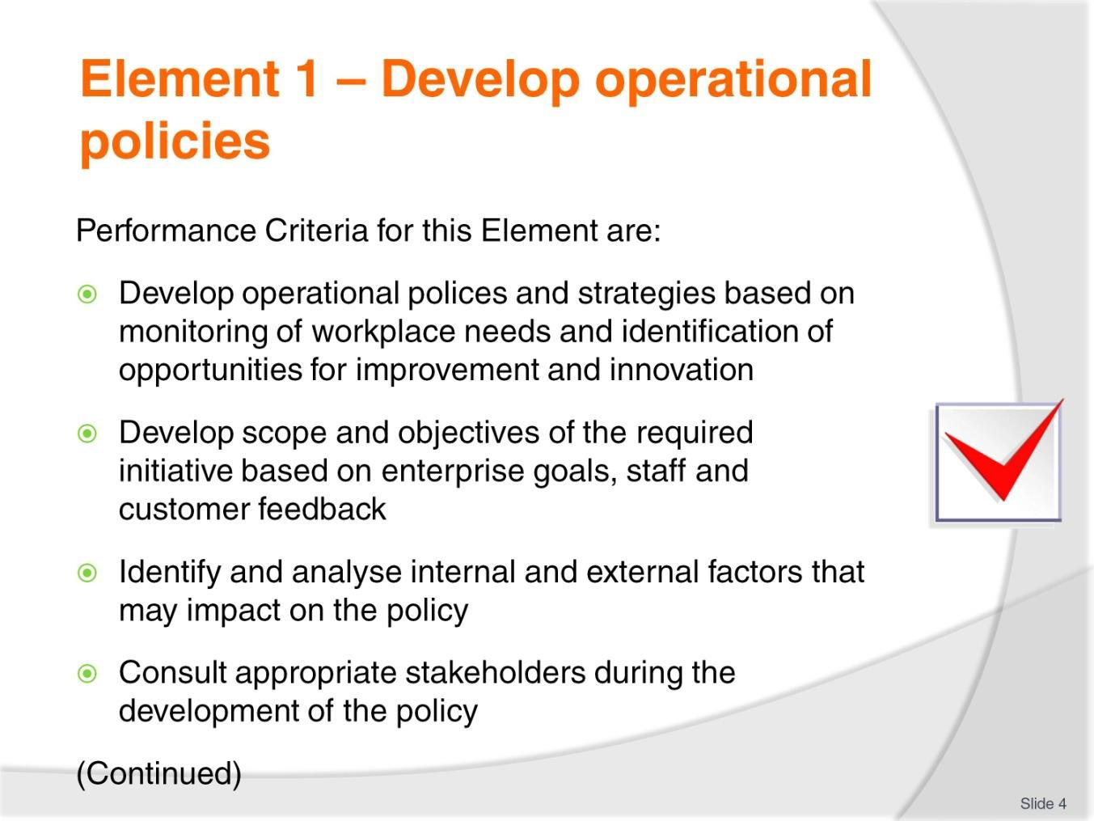
Slide
Slide No
Trainer Notes
4.
Trainer identifies for trainees the Performance Criteria for this Element, as listed on the slide.

Slide
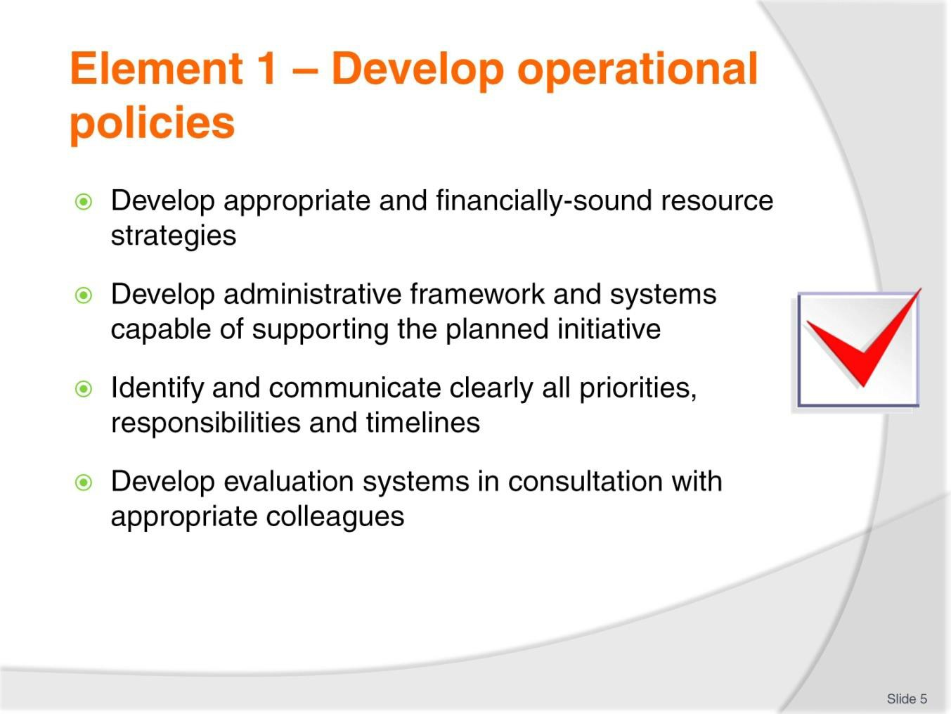
Slide No | Trainer Notes
5. | Trainer identifies for trainees the Performance Criteria for this Element, as listed on the slide.  Class Activity – General Discussion  Trainer leads a general class discussion by asking questions such as:  - What are operational policies?  - Why do businesses have them?  - How are they developed?  - Who might be involved in developing them?  - What factors are considered when developing them?

Slide
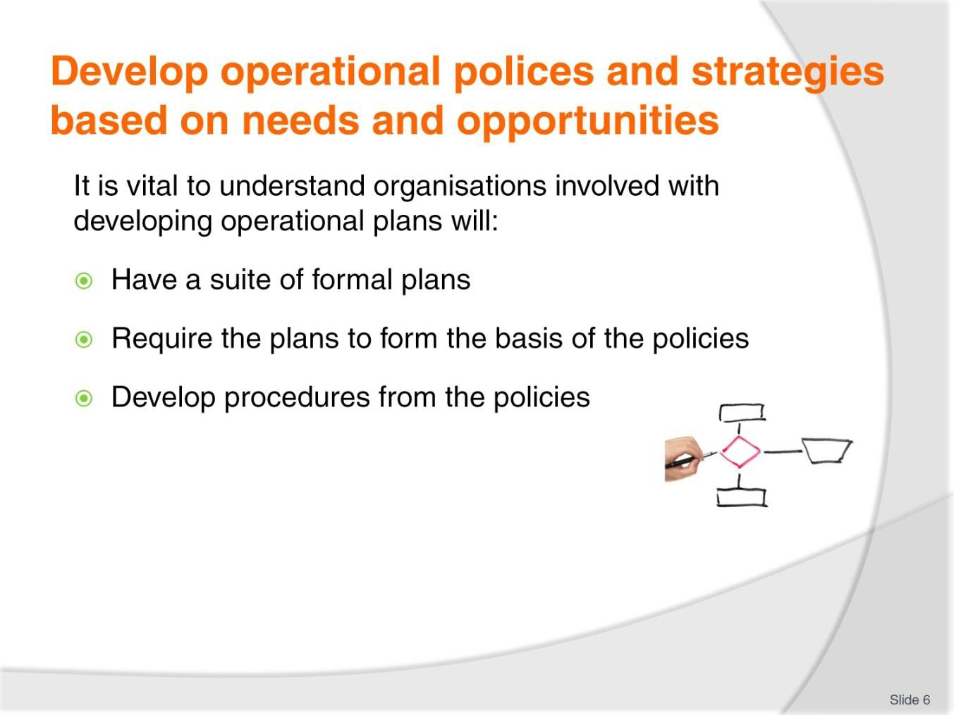
Slide No | Trainer Notes
6. | Trainer advises an organisation involved in development/implementation of operational polices will typically be one where:  - The organisation has a formal set of plans – which may include:  - A business plan; Strategic plans; Tactical plans; Operational plans; Contingency plans  - The policies of the organisation need to:  - Reflect the plans which have been developed for the business  - Flow directly from the plans  - Support attainment of the goals and objectives identified in the plans  - The procedures of the organisation are:  - Driven by the statements made in relevant policies  - In accordance with policies  - Directly linked to the public statements the organisation makes about itself (in terms of its Mission Statement, Vision Statement and Core Values statement).  Classroom Activity (1) – Handouts  Trainer distributes and discusses sample plans as identified on the slide.

Classroom Activity (2) – Internet research
Trainer supervises internet research on relevant websites for items identified above, such as:
- http://study.com/academy/lesson/types-of-planning-strategic-tactical-operational- contingency-planning.html
- https://blog.udemy.com/planning-in-management/
- https://www.boundless.com/management/textbooks/boundless-management- textbook/control-8/types-of-control-62/strategic-tactical-and-operational-control-313- 3960/

Slide
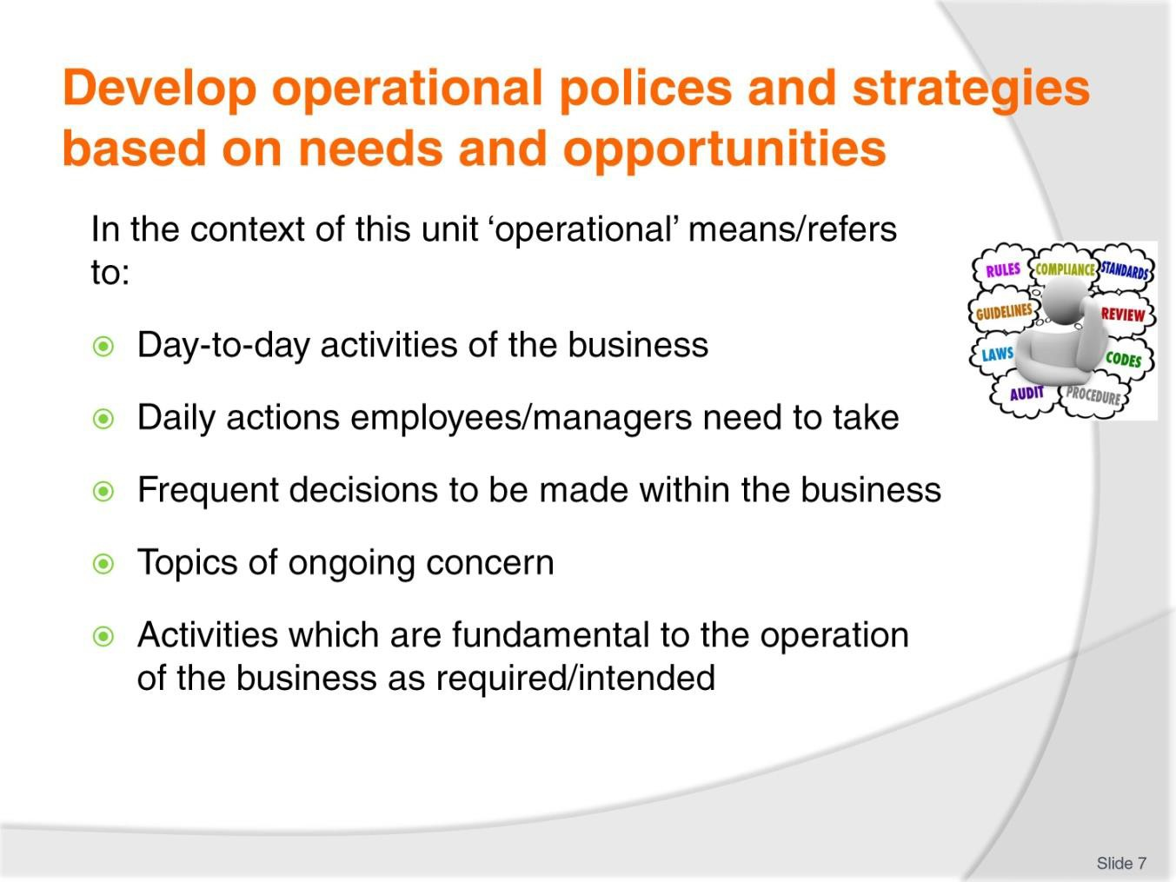
Slide No | Trainer Notes
7. | Trainer emphasises it is necessary to understand the word ‘operational’ in this context means/refers to:  - Day-to-day activities of the business  - Daily actions employees/managers need to take  - Frequent decisions within the business which need to be made  - Topics which are of ongoing concern to the organisation  - Activities which are fundamental to the processes necessary for the business to function (operate) as required/intended.

Slide
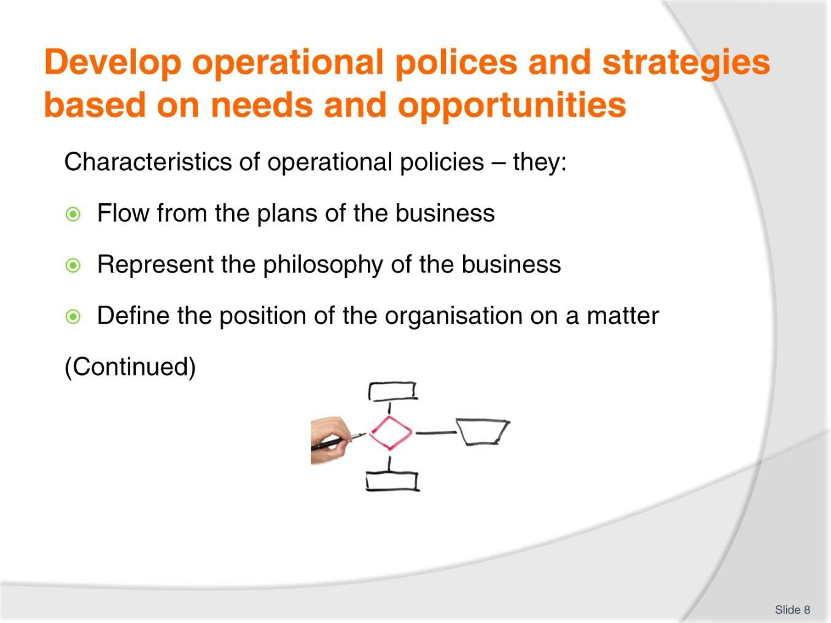
Slide No | Trainer Notes
8. | Trainer provides examples of characteristics of operational policies:  - Flow from the plans of the business  - Represent the thinking/philosophy of the business  - Define the position of the organisation on a matter by giving insight into its stance and orientation on issues which are covered by the policy.

Slide
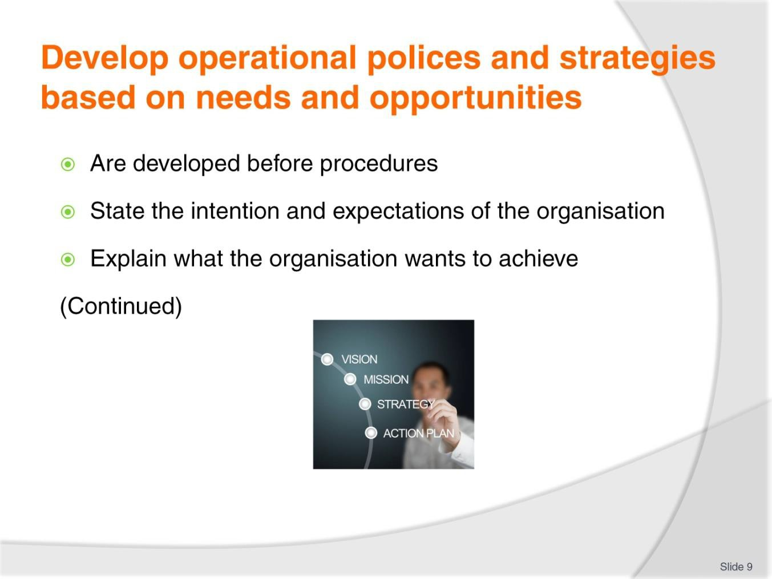
Slide No | Trainer Notes
9. | Trainer provides examples of characteristics of operational policies:  - Are developed before procedures  - State the intention and expectations of the organisation and staff in relation to the subject that is the title of the policy  - Explain what the organisation wants to achieve.

Slide
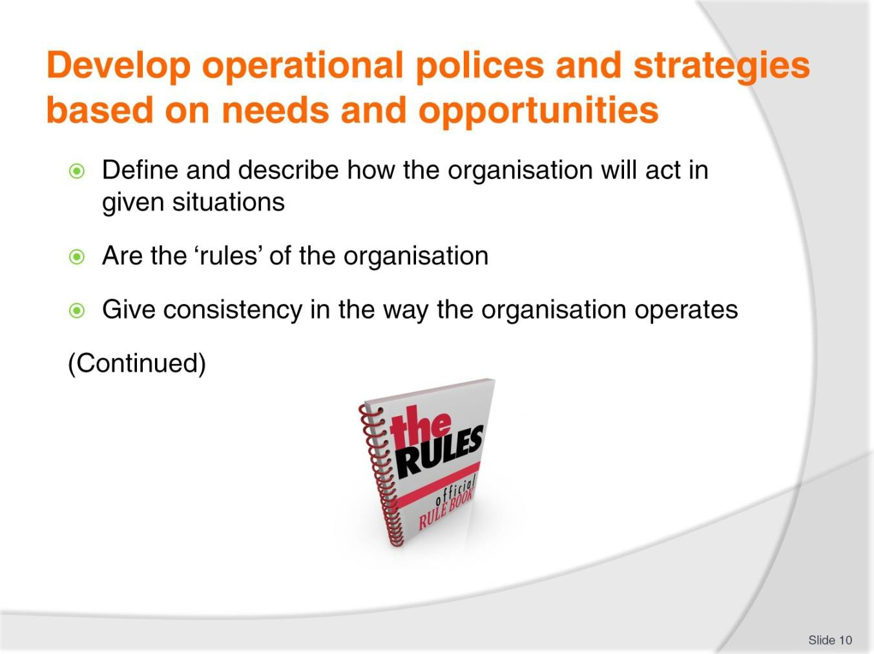
Slide No | Trainer Notes
10. | Trainer provides examples of characteristics of operational policies:  - Define and describe how the organisation (and, by extension, its employees) will act in given situations, if/when they arise  - Are the ‘rules’ the organisation seeks to operate by  - Give consistency in the way the organisation operates.

Slide
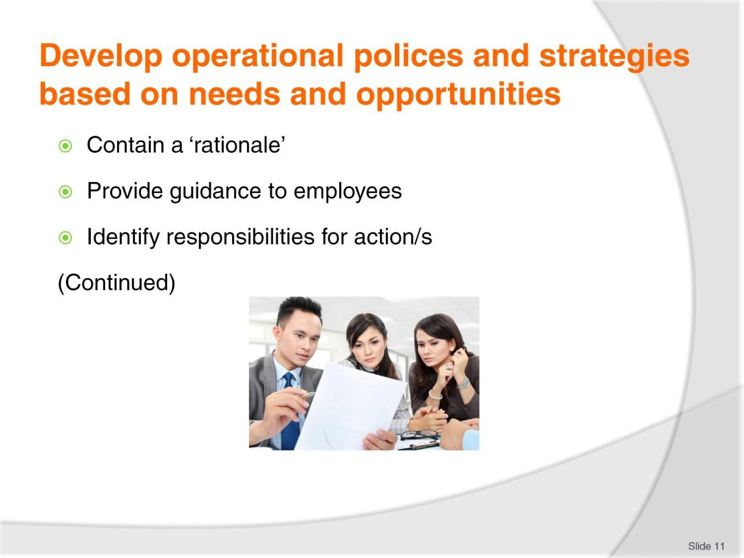
Slide No | Trainer Notes
11. | Trainer provides examples of characteristics of operational policies:  - Contain a statement explaining the reason the policy has been prepared  - Provide guidance to employees about what the organisation wants – and how workers should act to help achieve that outcome  - Identify responsibilities for taking action to achieve the desired outcomes.

Slide
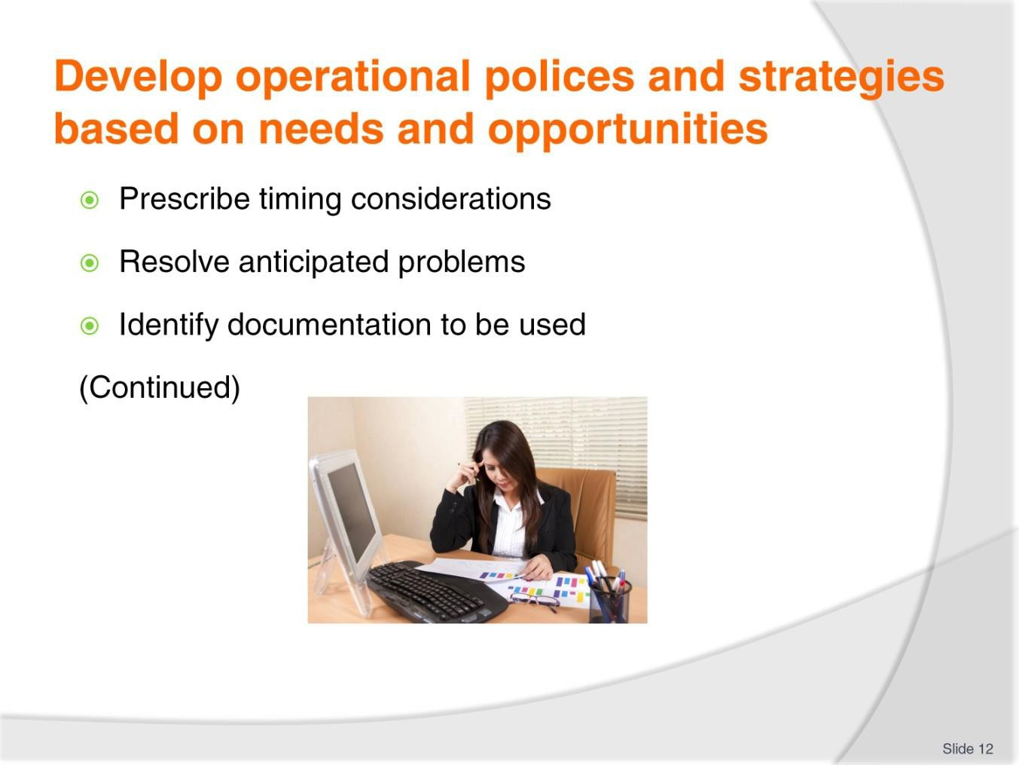
Slide No | Trainer Notes
12. | Trainer provides examples of characteristics of operational policies:  - Prescribe timing considerations relevant to the issue  - Resolve anticipated problems in relation to the policy topic  - Identify documentation to be used or completed in relation to the topic, if/where necessary.

Slide
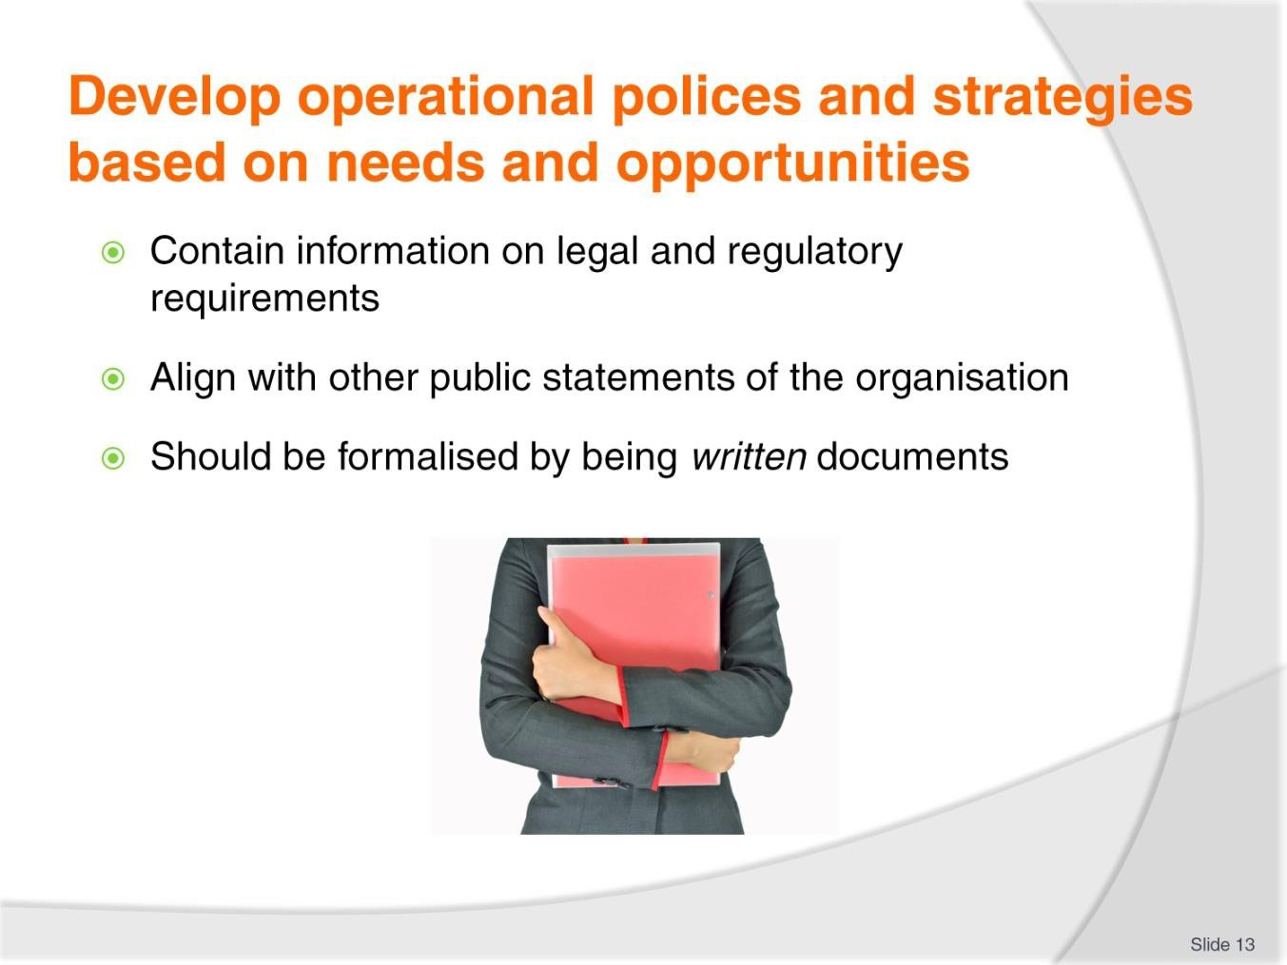
Slide No | Trainer Notes
13. | Trainer provides examples of characteristics of operational policies:  - Contain information on legal and regulatory requirements the organisation must meet, if applicable  - Align with other public statements the organisation makes about itself  - Should be formalised by being written documents – rather than simply existing in the minds of management in order that:  - There is no confusion about what they say  - They can be readily shared among the workforce.

Slide
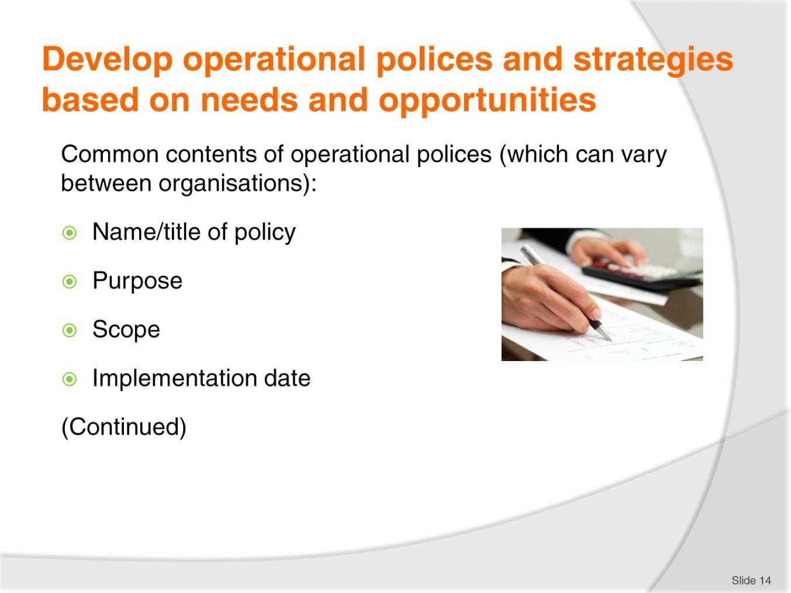
Slide No | Trainer Notes
14. | Trainer provides indication of contents of operational policies:  - Name/title of the policy  - Purpose of the policy – explaining why the policy has been developed  - Scope of the policy – identifying who the policy applies to/who is bound by it  - Date the policy applies – the date the policy becomes/became effective.  Classroom Activity – Handouts  Trainer distributes and discusses sample operational policies.

Slide
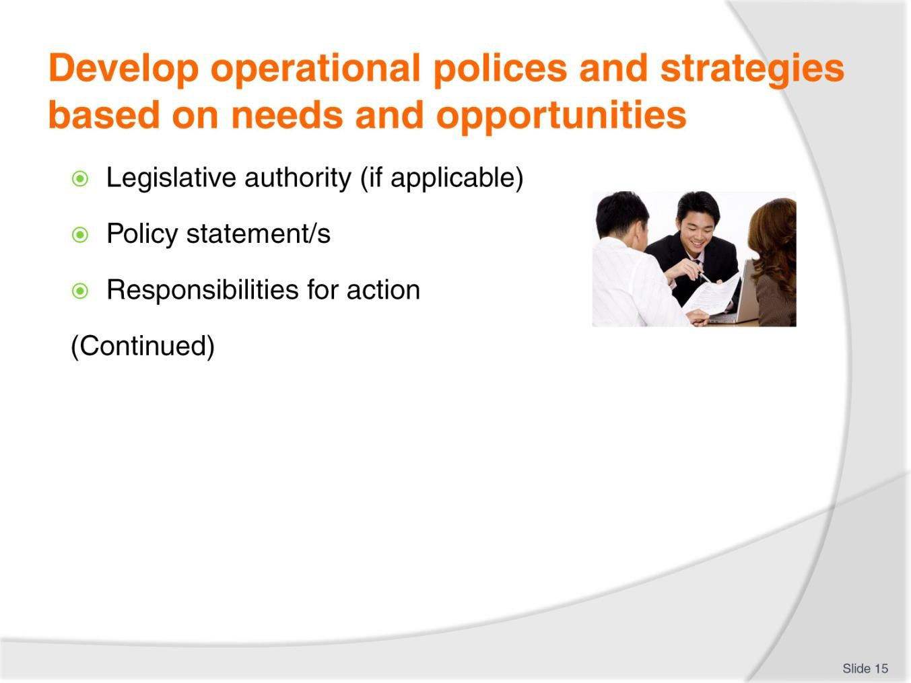
Slide No | Trainer Notes
15. | Trainer provides indication of contents of operational policies:  - Legislative authority – specifying statutes which govern implementation of the policy (if applicable – many operational are subject to legislation, and many are not)  - Policy statement/s – statement/s indicating:  - How this policy fits with others and with the overall operation of the business  - Relevant commitments by management to specifics of the policy  - Description/s of processes inherent in implementing the policy  - Responsibilities for action – giving names/titles of those with specific responsibility under the policy in areas such as, for example:  - Compliance  - Monitoring  - Review  - Record management  - Reporting.

Slide
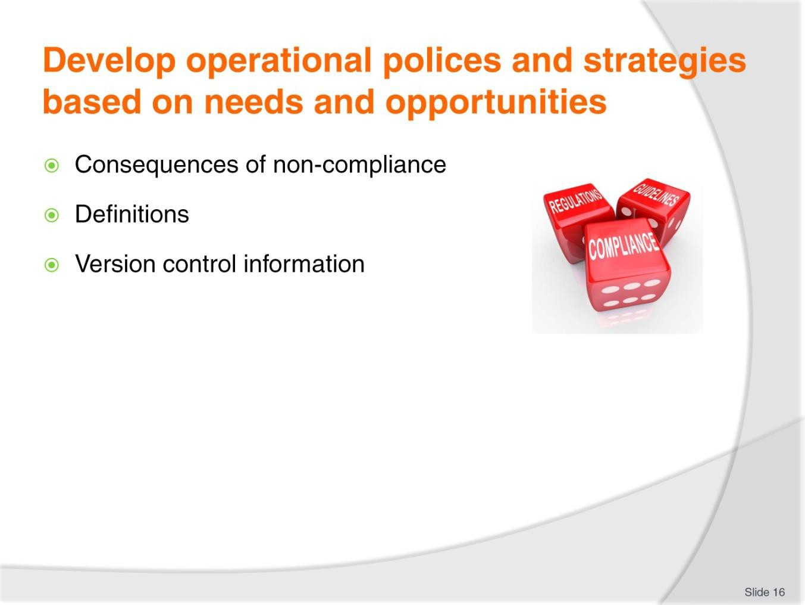
Slide No | Trainer Notes
16. | Trainer provides indication of contents of operational policies:  - Consequences of non-compliance  - Definitions – in relation to policy-specific terms  - Version control information.  Classroom Activity – Internet research  Trainer supervises internet research on relevant websites for items identified above, such as:  - http://www.industrialrelations.nsw.gov.au/oirwww/Employment_info/Managing_empl oyees/Workplace_policies_and_procedures.page - Workplace policies and procedures  - http://www.industrialrelations.nsw.gov.au/biz_res/oirwww/pdfs/workplace_pp.pdf - Workplace policies and procedures.

Slide
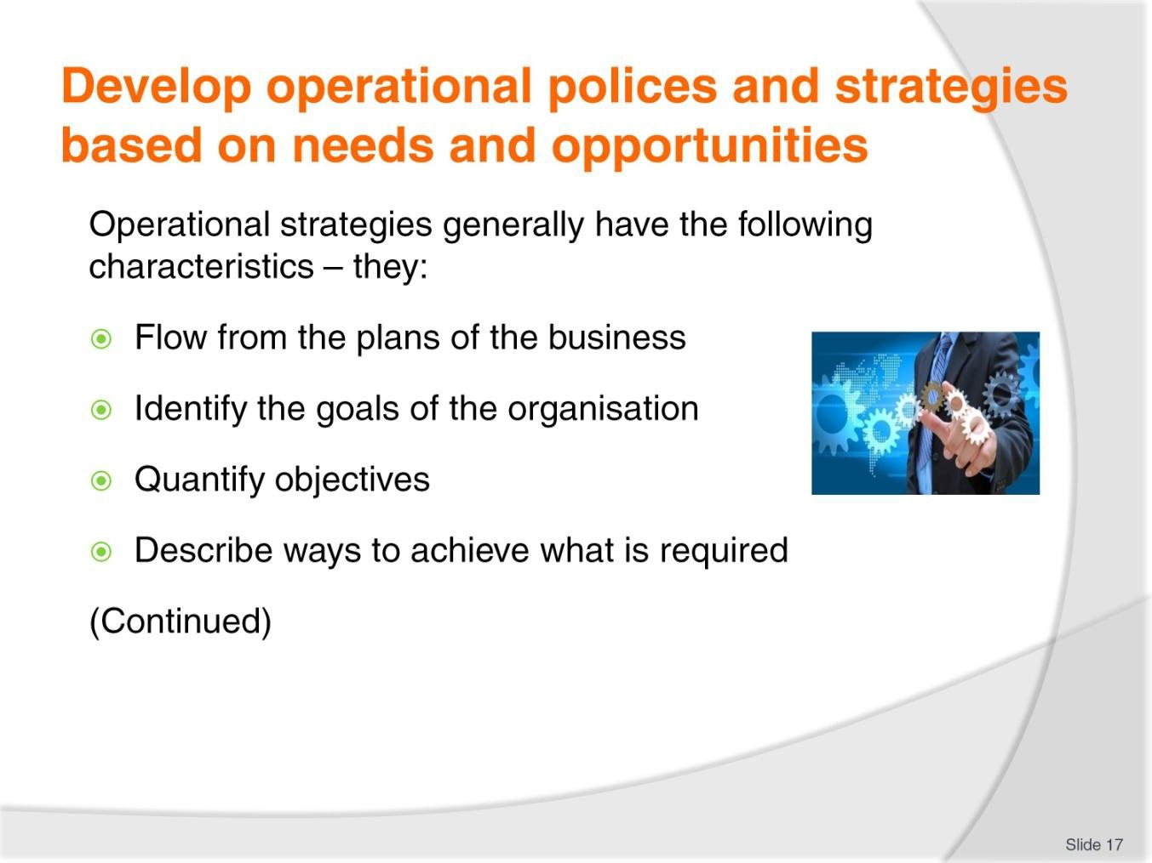
Slide No | Trainer Notes
17. | Trainer states strategies (generally) have the following characteristics – they:  - Flow from the plans of the business  - Identify the goals the organisation has set for itself  - Quantify the objectives to be achieved  - Describe ways to achieve what is required.

Slide
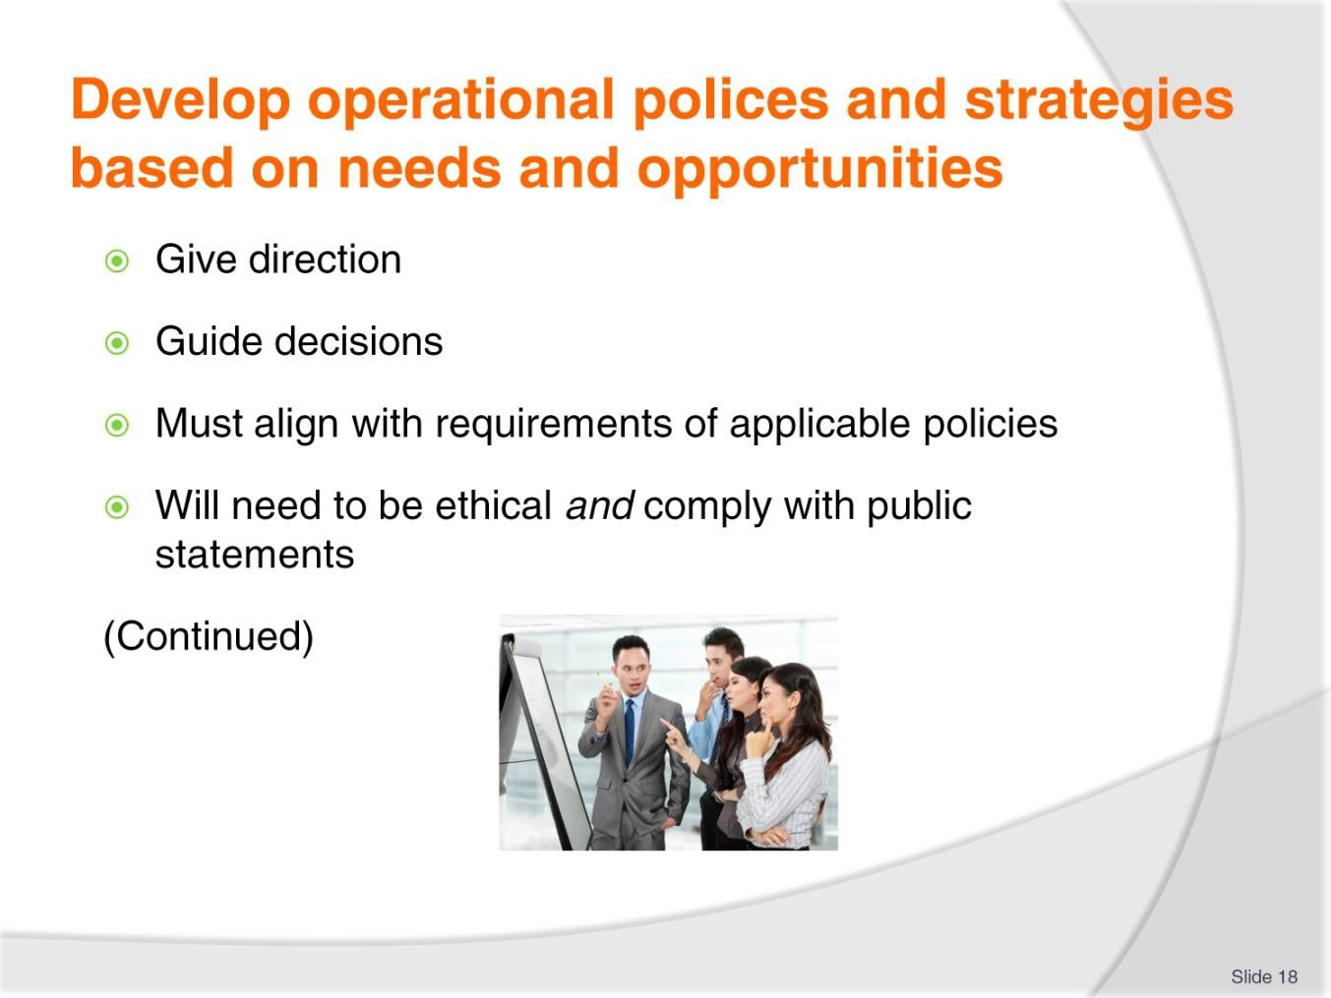
Slide No | Trainer Notes
18. | Trainer states strategies (generally) have the following characteristics – they:  - Give direction to the course the organisation is to take  - Guide decisions managers/supervisors need to make about the operation of the business  - Must align with requirements of applicable policies  - Will need to be ethical and comply with public statements the organisation makes about itself.

Slide
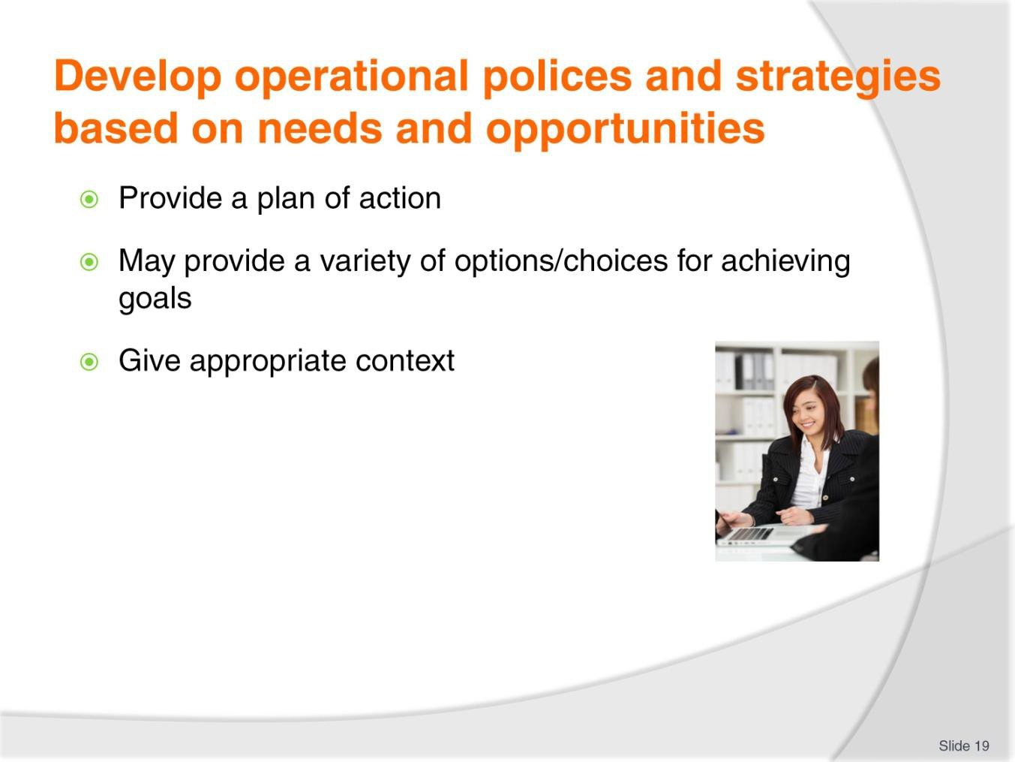
Slide No | Trainer Notes
19. | Trainer states strategies (generally) have the following characteristics – they:  - Provide a plan of action about what needs to be done  - May indicate different ways/a range of options to achieve the one goal, objective or target  - Give a context for organisational procedures in relation to achieving pertinent objectives – meaning an SOP may be acceptable in one context, but unacceptable in another.  Classroom Activity – Internet research  Trainer supervises internet research on relevant websites for items identified above, such as:  - http://www.scribd.com/doc/64899080/Difference-Between-Policy-and- Strategy#scribd – Difference between policy and strategy  - http://www.executive.org/bibliography/policy.pdf - What is policy? Strategic and operational policies and good governance  - http://nraombakc.blogspot.com.au/2011/12/content-and-process-of-operations.html  - The content and process of operations strategy.

Slide
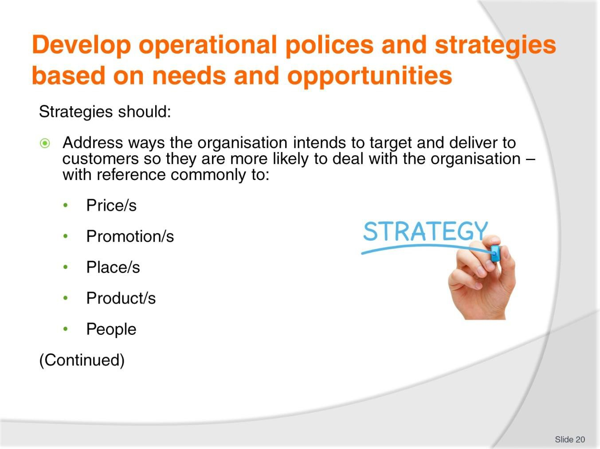
Slide No | Trainer Notes
20. | Trainer observes there are no formal or mandatory requirements for the content of operational strategies but it is commonly held they should:  - Address ways in which the organisation intends to target the customer and deliver the product or service it has to offer so the customer is more likely to deal with the organisation.  This refers to the marketing- based concept whereby ‘The Customer’ is at the centre of all organisational thinking and actions and the business seeks to adjust how it applies its available resources to service ‘The Customer’.  The available resources being ‘The 5Ps of Marketing’:  - Prices it charges  - Promotions it undertakes  - Places it sells from  - Products it offers  - People it uses.

Slide
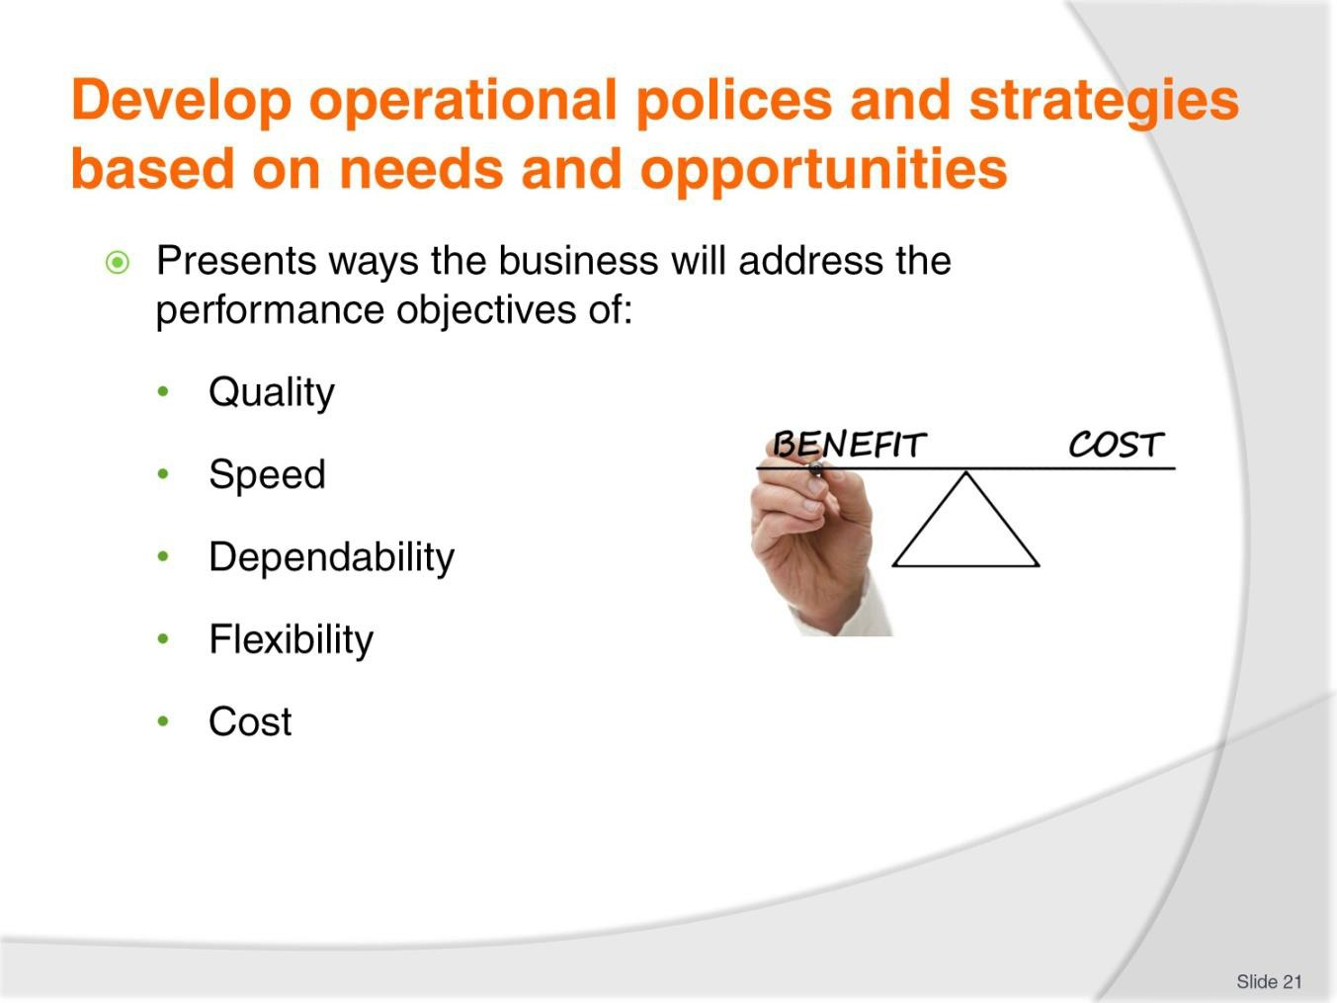
Slide No | Trainer Notes
21. | Trainer continues with common content of operational strategies.  Present ways in which the business proposes, as appropriate to its individual need at this point in time, to address the five performance objectives (identified by Slack and Lewis in Operations Strategy [3rd edition], 2011, p. 16 ) of:  - Quality – specifying  - Quality criteria and standards expected  - How the organisation will (for example), as necessary/required :  - Improve its quality  - Maintain its quality  - Build quality into the production process  - Speed – identifying:  - Acceptable or target times for service delivery  - Action to be taken to attain these targets  - Dependability – detailing:  - The criteria which determine reliability of product/service from the customer’s perspective  - How the organisation intends ensuring promises made about products and services are kept/honoured

- Flexibility – explaining:
  - Ways in which the business will be prepared/able to customise the provision of products and services to suit individual need
  - New or different variations in products and services so there is a better match with identified customer demand
- Cost – detailing possible areas such as:
  - Productivity targets for individuals, departments and/or the business
  - Margins required from different products/services or departments/divisions.

Slide
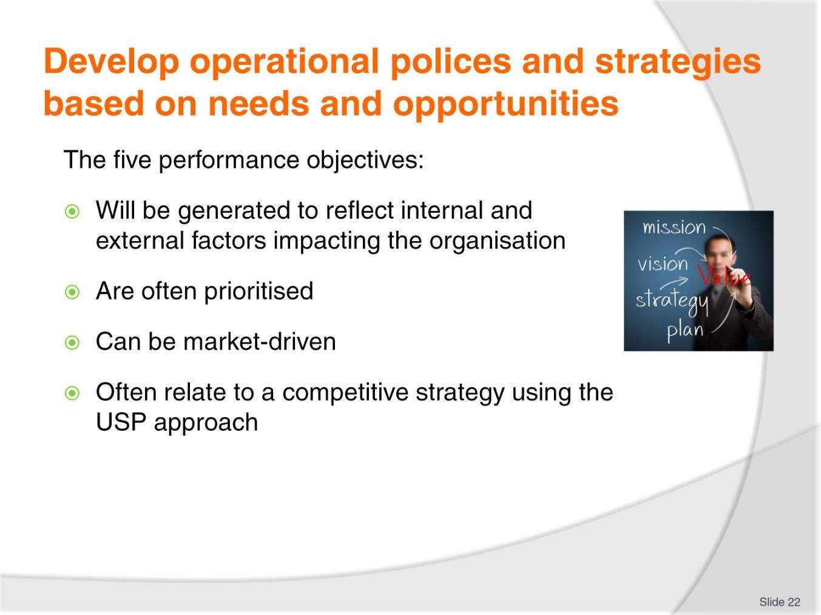
Slide No | Trainer Notes
22. | Trainer notes in relation to these five performance objectives – they:  - Will be generated to accommodate external factors (demand or preferences of customers) and internal factors (what it is the organisation seeks to achieve)  - Are often weighted or prioritised – in that one (or two, or three) of the five may have greater importance/relevance than the other(s)  - May be driven by the market (customer demand) or by the organisation in terms of the resources it has available to it  - Can relate to a competitive strategy where the organisation focuses on a factor where it has a unique advantage (a USP).  Classroom Activity – Internet research  Trainer supervises internet research on relevant websites for items identified above, such as:  - http://www.som.cranfield.ac.uk/som/dinamic- content/media/knowledgeinterchange/themedareas/innovation/key%20concepts/Bo b_Lillis/index.htm - The process and content of operations strategy  - http://www.business.gov.au/business-topics/business-planning/marketing/Pages/5- ps-of-marketing.aspx - The 5Ps of marketing.

Slide
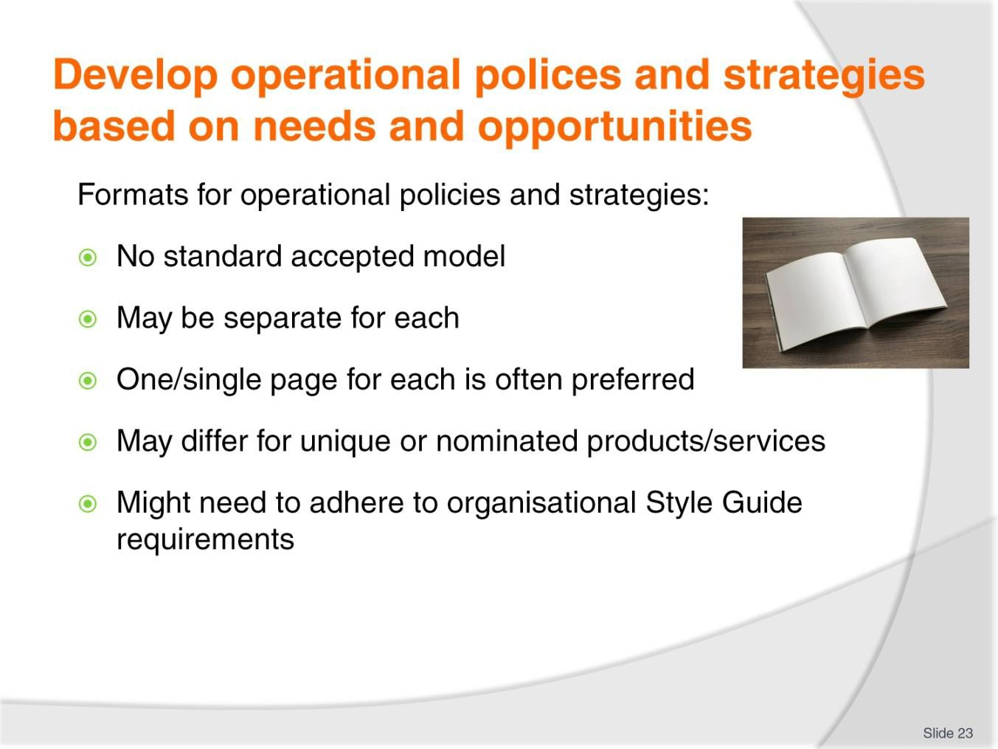
Slide No | Trainer Notes
23. | Trainer indicates there is no universally accepted format for the way in which operational policies and strategies are presented and organisations may:  - Produce a simple single page document for each policy  - Produce a simple single page document for each strategy  - Some believe this is all that is necessary providing it covers all relevant requirements. In practice, people are more likely to read (and remember and follow/adhere to) a briefer policy than a longer and more complex one  - Produce a unique document for a specific/important product or service  - Use a Style Guide – with approved templates, examples and production guidelines to assist with preparing operational policies and strategies (and procedures).

Slide
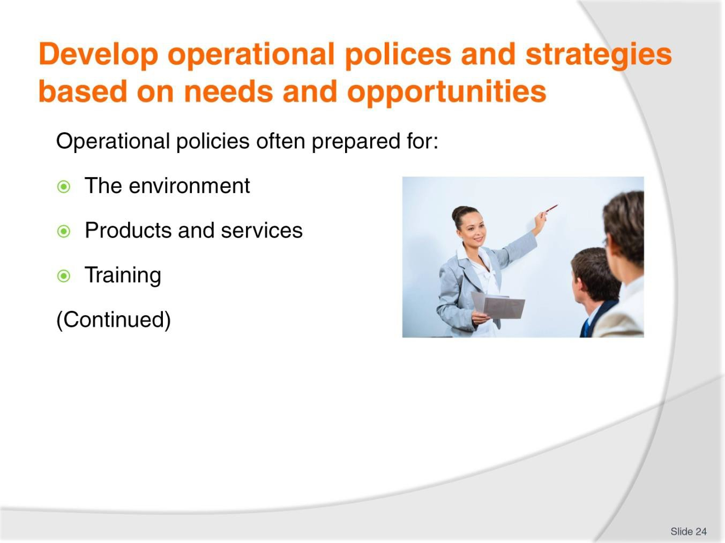
Slide No | Trainer Notes
24. | Trainer gives examples of topics which often have operational policies prepared for them:  - The environment – which may target:  - Committing to the concept of ‘sustainability’  - Reducing general/total waste  - Introducing recycling of waste  - Lowering power/utilities use  - Products and services – which may target:  - Generating new SOPs for production of items  - Revising protocols for delivery of nominated services  - Introducing new products and/or services  - Setting criteria and standards for targeted products and services  - Re-positioning/re-branding existing products and/or services in the marketplace  - Eliminating products and/or services which have reached the end of the their life cycle  - Training – which may target:  - Determining training needs for all or selected workers or departments

- Conducting non-accredited internal training on the basis of the results from TNAs
- Using external providers to deliver identified accredited training courses
- Ensuring all staff in nominated departments achieve a minimum standard of relevant formal qualifications.

Slide
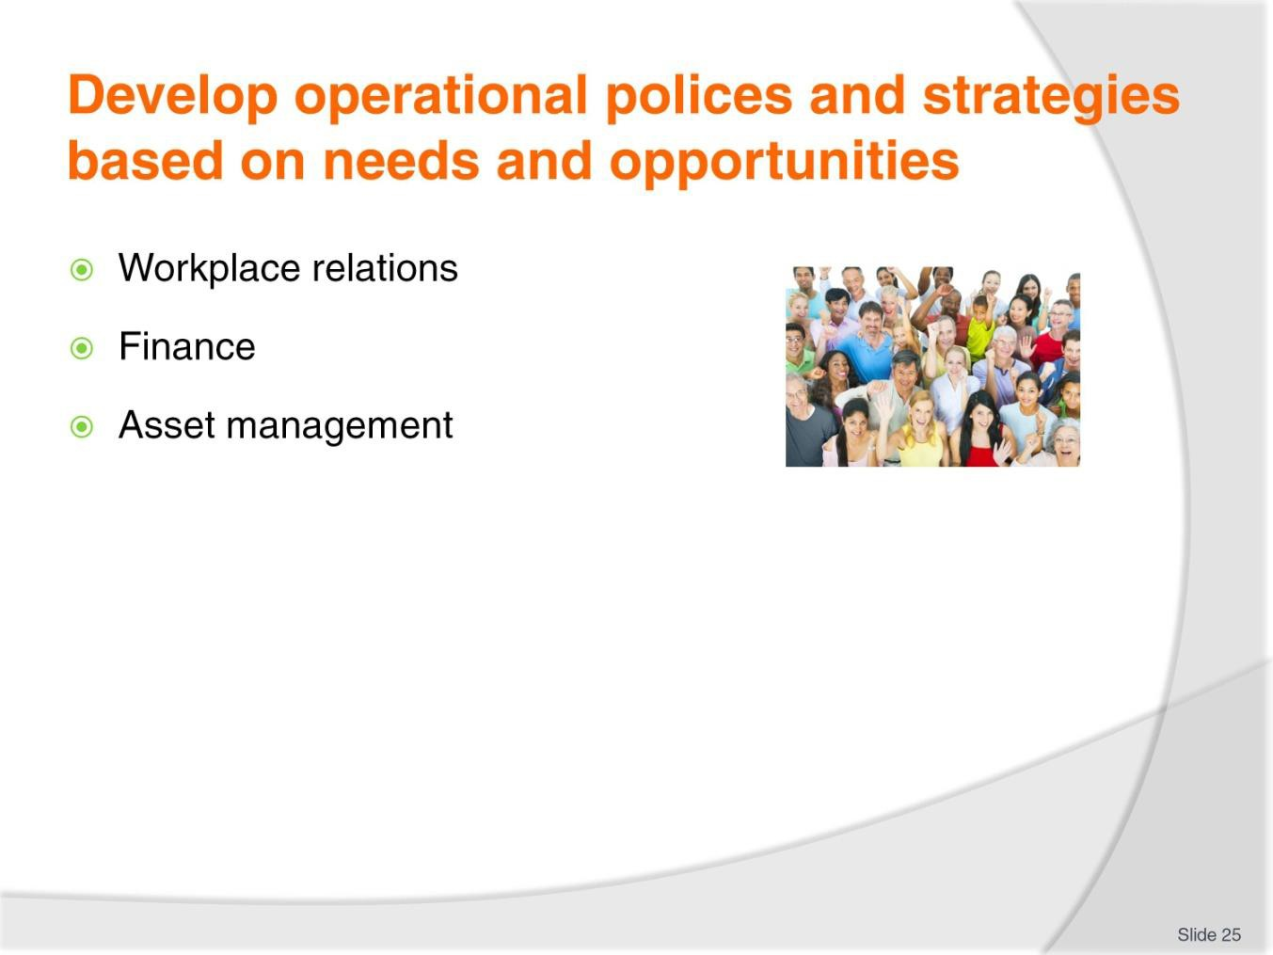
Slide No | Trainer Notes
25. | Trainer presents possible topics for operational policies:  - Workplace relations – which may target:  - Describing minimum qualifications for workers for nominated positions  - Ensuring equity and diversity in staff recruitment and selection  - Guaranteeing professional development for the workforce  - Providing counselling and support for employees  - Requiring respect for others  - Finance – which may target:  - Authorising use of funds and resources  - Operating bank accounts and investments  - Paying creditors  - Borrowing  - Collecting debts  - Purchasing  - Asset management – which may target:  - Classifying assets

- Specifying authority to purchase or acquire assets
- Recording of assets
- Using the Assets Register
- Identifying asset management responsibilities
- Stocktaking
- Maintaining and securing assets.

Slide
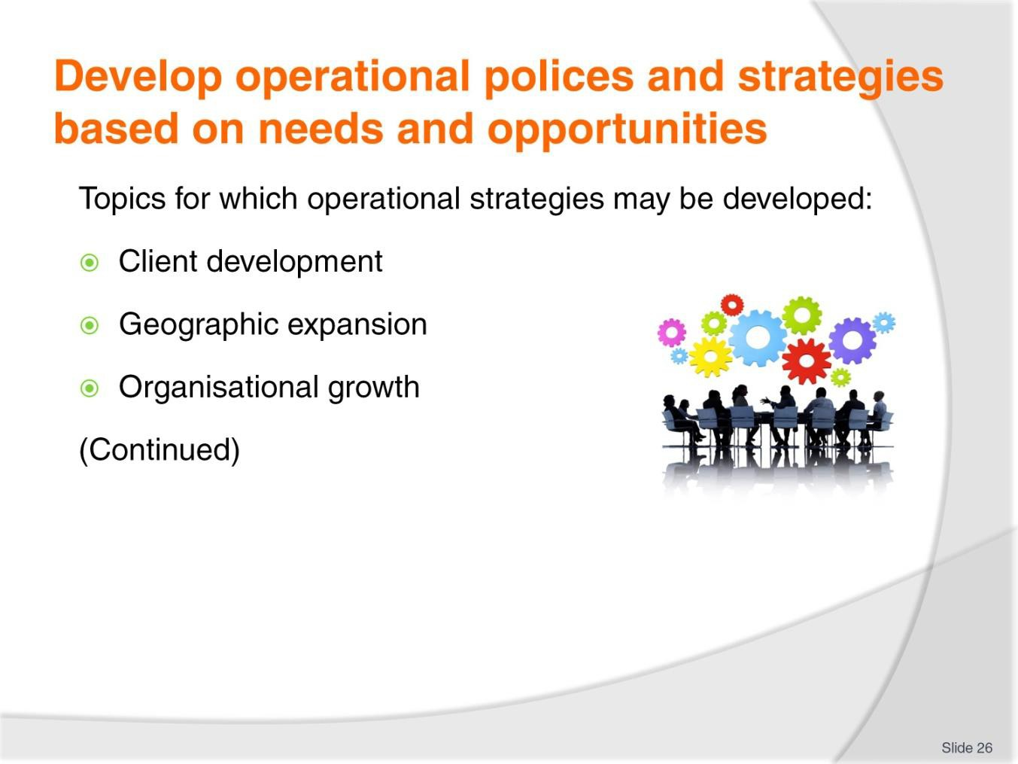
Slide No | Trainer Notes
26. | Trainer gives examples of topics which operational strategies may be developed for:  - Client development – which may target:  - Increasing the number of actual users/customers/people who buy from the business  - Adding names to a ‘Prospects List’  - Growing the list of contacts on the CMS database  - Developing a new target market  - Transferring existing customers into new products and/or services  - Geographic expansion – which may target:  - Entering new markets in identified countries  - Going global via online activities  - Starting up offices or agencies in new towns and/or countries  - Partnering with an existing company in identified ‘other countries’ or locations  - Organisational growth – which may target:  - Building new building or refurbishing existing buildings  - Increasing staff numbers  - Adding new departments to the organisational structure

- Becoming a public/registered company
- Generating additional revenue/sales
- Introducing new products and services to the product mix
- Acquiring other/nominated businesses
- Entering new markets.
Classroom Activity – Internet research
Trainer supervises internet research on relevant websites for items identified above, such as:
- http://policies.uws.edu.au/view.current.php?id=00086 – Asset management policy
- http://www.business.vic.gov.au/money-profit-and-accounting/financial-processes- and-procedures/accounting-and-financial-policies-and-procedures - Accounting and financial policies and procedures
- https://mifosforge.jira.com/wiki/display/docs/Operational+Policy+Samples+for+Fina ncial+Institutions – Operational policy samples for financial institutions.

Slide
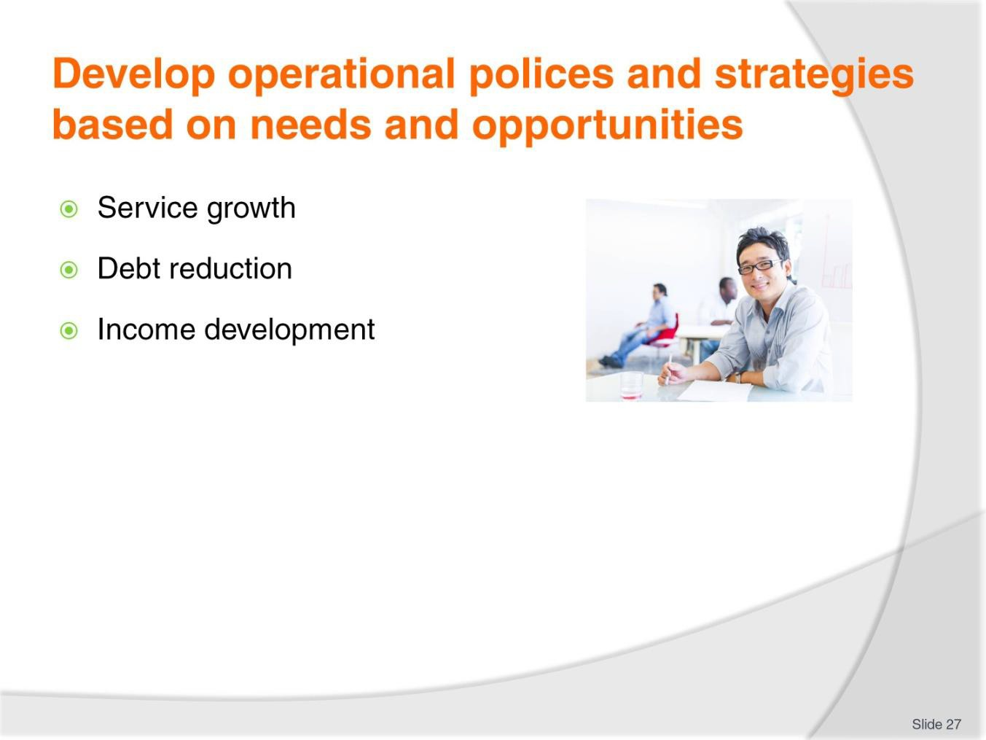
Slide No | Trainer Notes
27. | Trainer gives examples of topics which operational strategies may be developed for:  - Service growth – which may target:  - Lifting service standards/criteria  - Introducing new services  - Improving service delivery  - Adding extra services to existing services/products  - Debt reduction – which may target:  - Decreasing overall debt  - Obtaining lower interest rates for monies owed  - Paying off nominated loans  - Negotiating better deals for selected debts with nominated creditors  - Income development – which may target:  - Increasing sales by volume/quantity of products/services sold  - Increasing sales using a nominated monetary unit  - Increasing profit by lowering costs  - Lowering costs by negotiating better deals with suppliers  - Lowering costs by identifying less expensive but suitable alternative raw materials.

Classroom Activity – Internet research
Trainer supervises internet research on relevant websites for items identified above, such as:
- http://www.templatezone.com/download-free-ebook/office-policy-manual-reference- guide.pdf - How to write a policy manual
- http://smallbusiness.chron.com/operations-strategy-examples-24650.html - Operations strategy examples
- http://www.referenceforbusiness.com/management/Ob-Or/Operations-Strategy.html
-Operations strategy.

Slide
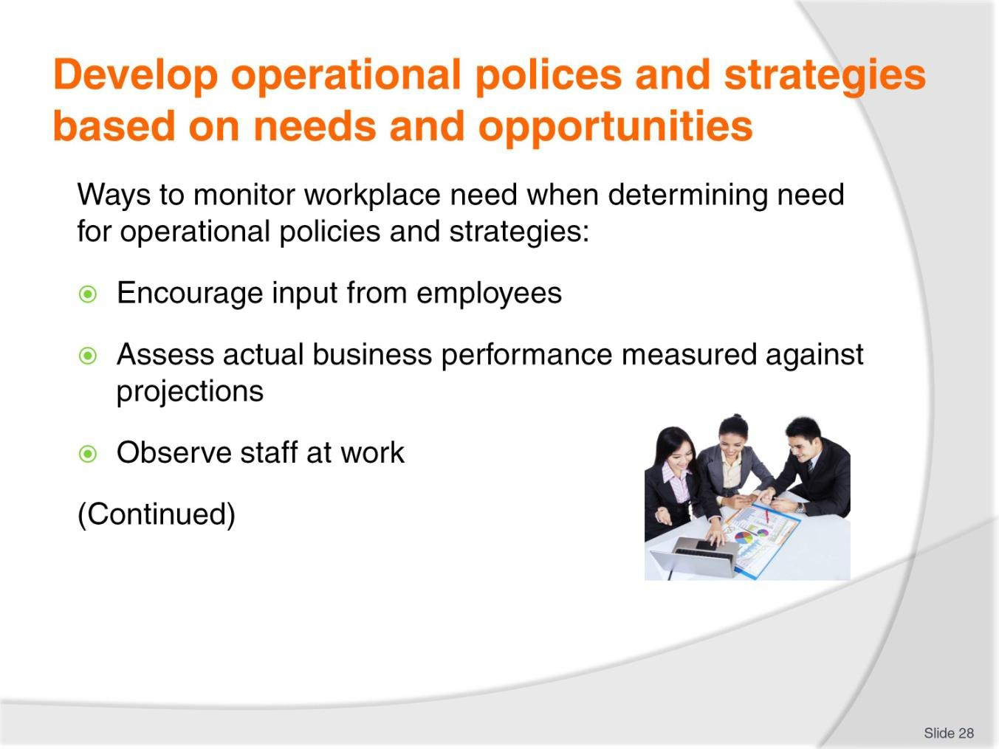
Slide No | Trainer Notes
28. | Trainer presents ways to monitor workplace need when determining need for operational policies and strategies:  - Encourage staff to identify areas for attention through a selection of communication and feedback mechanisms – such as Suggestion Boxes, staff meetings, ‘open door’ policy by management towards staff suggestions  - Assess actual business performance (KPIs) against projected outcomes – to determine areas that require attention  - Observe worker practice – comparing the competency being displayed and seeking operational issues impacting (as appropriate) service provision or product production.

Slide
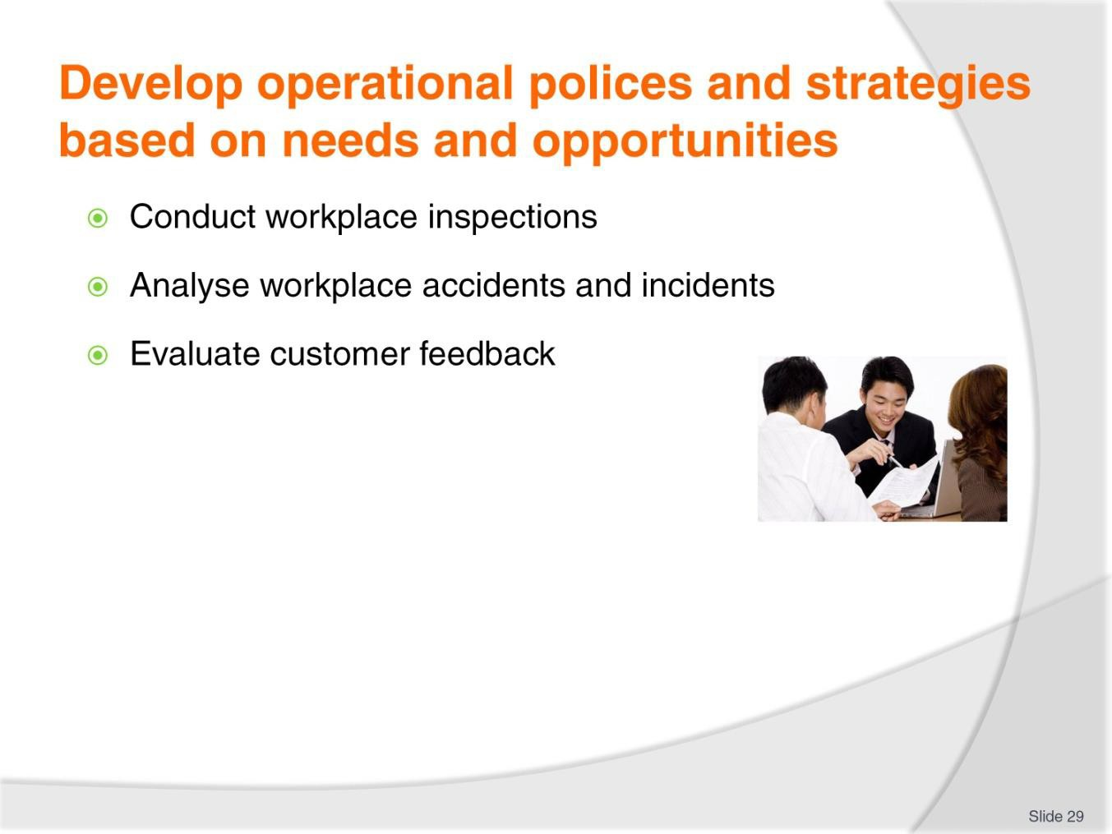
Slide No | Trainer Notes
29. | Trainer presents ways to monitor workplace need when determining need for operational policies and strategies:  - Conduct workplace inspections – to determine the level of compliance with externally imposed legislated requirements as these apply to (for example) safety, environmental management, employment regulations and similar  - Analyse workplace accidents and incidents – to identify if the causes indicate a need for action  - Evaluate feedback received from customers – regarding complaints about service/products, suggestions for improvements and positive comments.

Slide
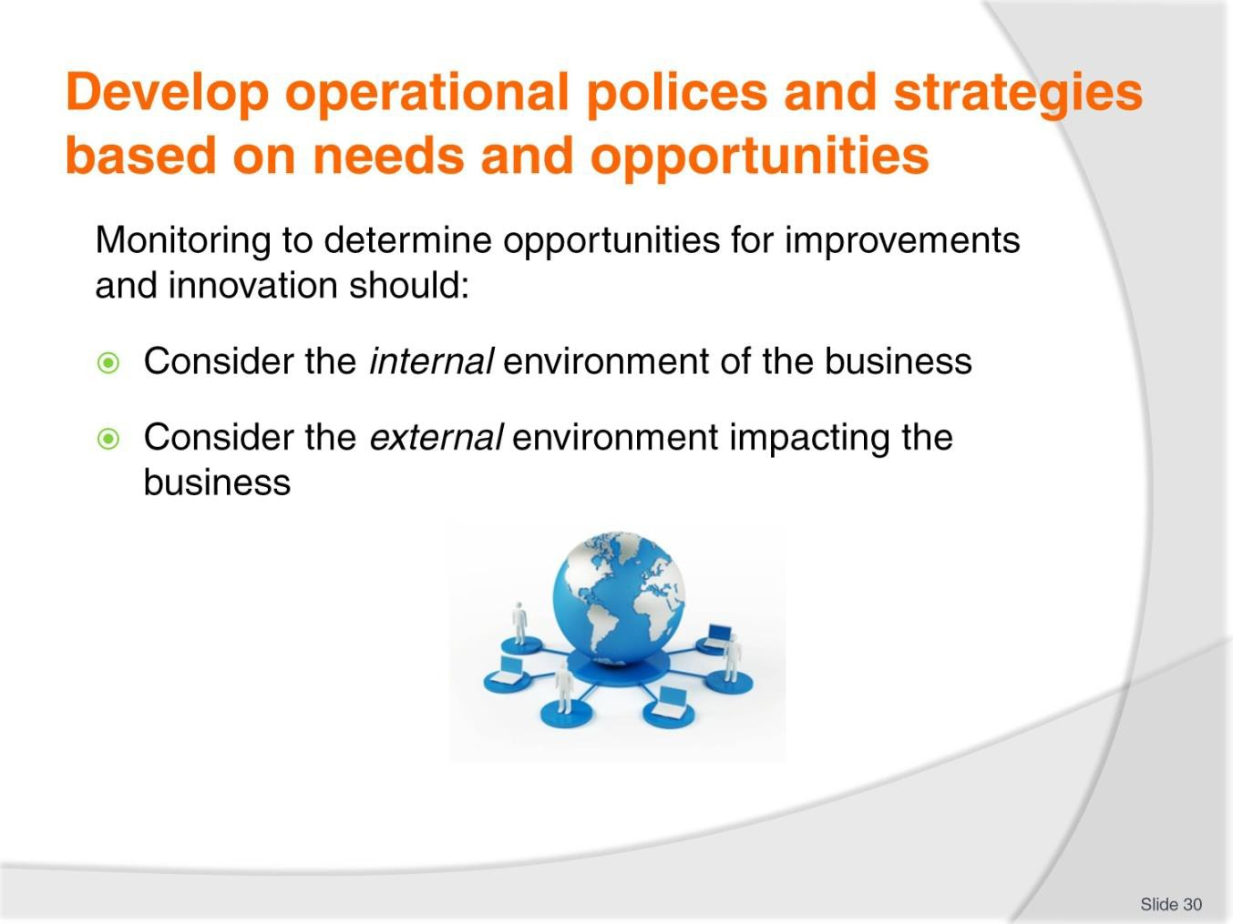
Slide No | Trainer Notes
30. | Trainer identifies monitoring to determine opportunities for improvements and innovation should:  - Consider the internal environment – of the organisation, by looking inwards towards what is happening within the business in terms of (for example):  - New, different and/or updated skills held by staff  - New, different and/or updated equipment and/or production processes  - New, different and/or updated financial resources  - New, different and/or updated knowledge  - Changes which may have been made to organisational plans  - Alterations to business targets. goals and objectives  - Identified actual (or potential) issues related to accidents, injury, error, near misses, complaints, compliments, faults, defects and failure to attain projected targets.  - Consider the external environment – of the business environment in which the organisation operates in terms of (for example):  - New markets – emerging as new products are invented/developed and/or as ‘old’ products finish their life cycle  - Shifts in customer needs, wants and preferences – as these alter over time given the dynamic nature of public demand

- Action being taken by competitors – such as new products being introduced into the market or promotional activities to attract business
- Changes to legislation – which cause mandatory alterations to products/services and/or the way the organisation is forced to conduct its operations
- New technologies – which introduce an opportunity to provide a service or produce a product in a novel, more efficient, less expensive or better way.

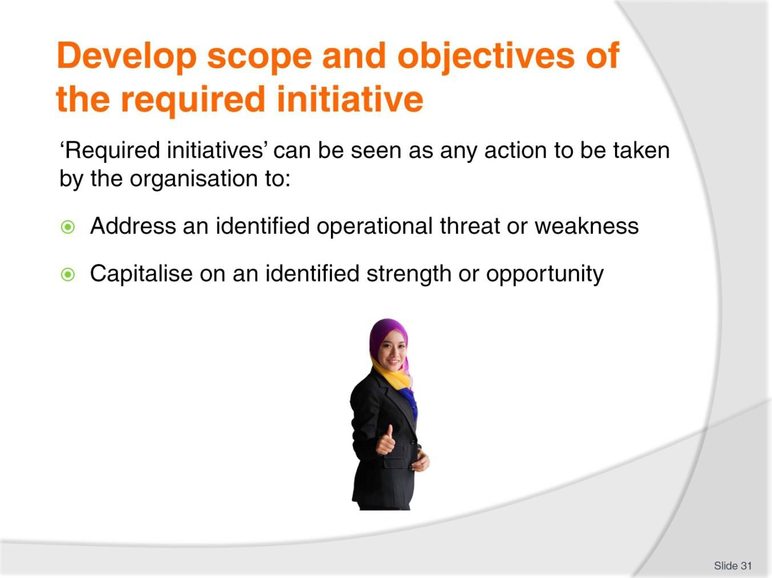
Slide
Slide No
Trainer Notes
31.
Trainer explains in this context ‘required initiatives’ can be seen as any action to be taken by the organisation to:
- Address an identified operational threat or weakness
- Capitalise on an identified strength or opportunity.

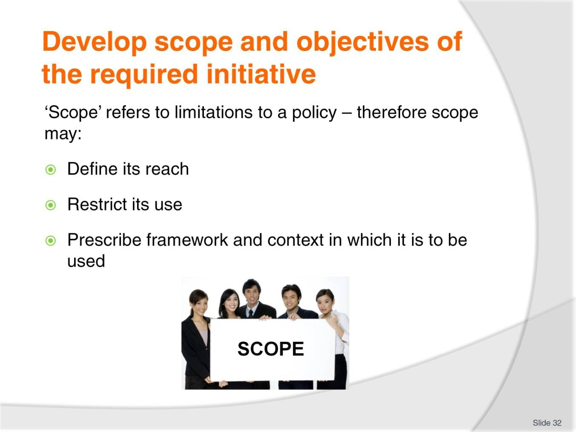
Slide
Slide No
Trainer Notes
32.
Trainer states ‘Scope’ refers to the limitations which apply to a policy. The scope of a policy therefore:
- Defines its reach
- Restricts its use
- Prescribes the framework and context in which it is to be applied.

Slide
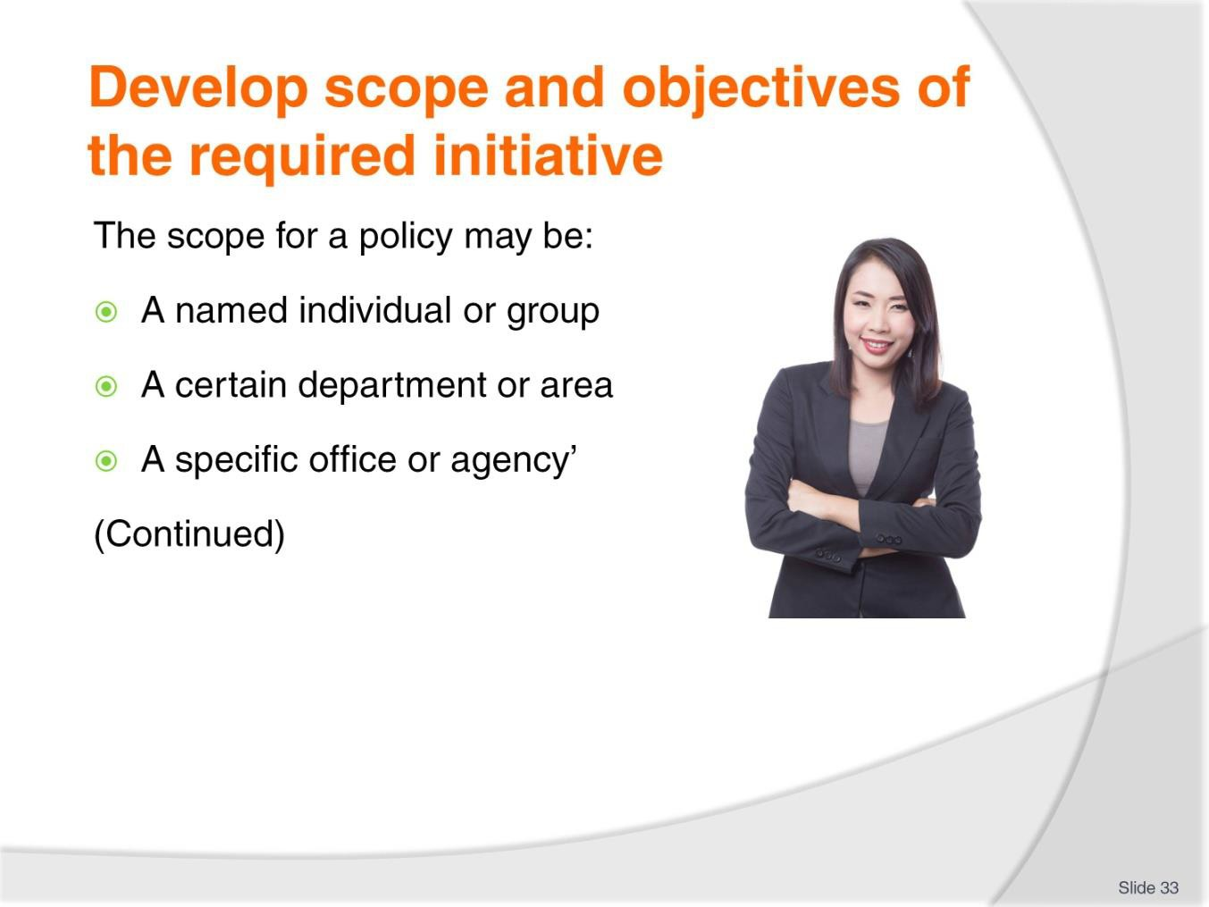
Slide No | Trainer Notes
33. | Trainer notes in practice the scope for a policy may be:  - A named individual or nominated group of individuals – instead of all employees, persons or customers  - A certain department or area of an organisation – instead of all workplace divisions  - A specific office or agency of the organisation – instead of all physical locations.

Slide
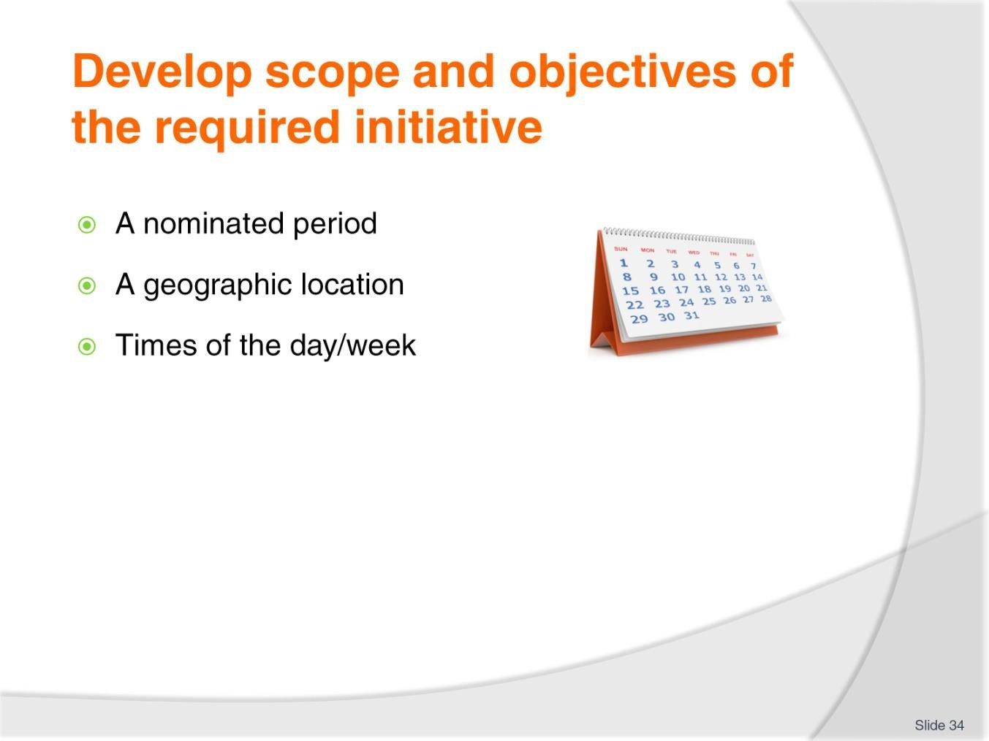
Slide No | Trainer Notes
34. | Trainer notes in practice the scope for a policy may be:  - A stated time of the year – which may be described by dates or in some other industry-appropriate or industry-relevant manner  - A geographic location – such as a given country, region or destination  - Time-related – detailing times of the day when the policy applies, and times when it does not.

Slide
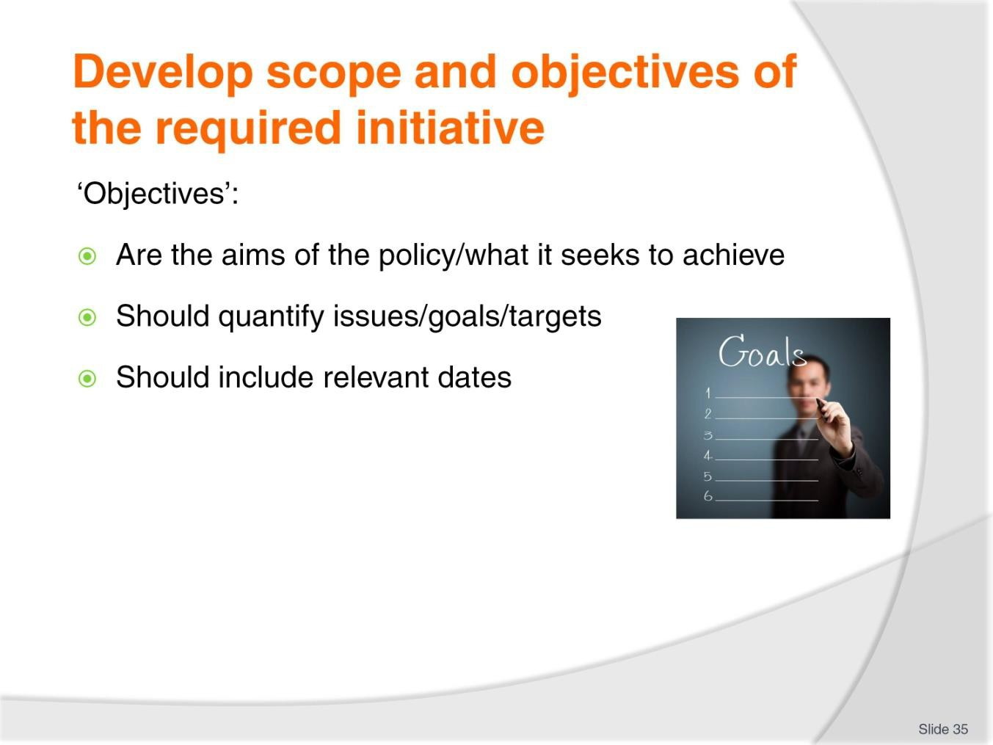
Slide No | Trainer Notes
35. | Trainer observes ‘Objectives’ for a policy refer to the aims of the policy. The objectives should:  - Quantify issues which are central to the policy – and which are to be evaluated in terms of:  - Milestones/KPIs – as the policy is implemented  - Final analysis of performance  - Set dates – when the policy:  - Starts  - Assesses milestones/KPIs  - Finishes  - Is reviewed.

Slide
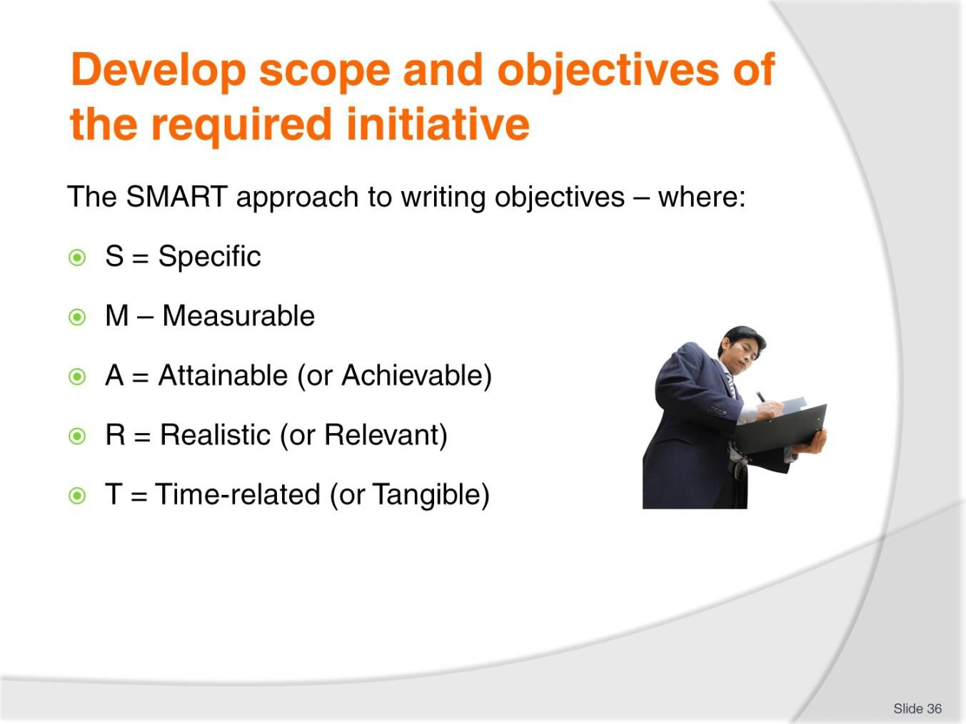
Slide No | Trainer Notes
36. | Trainer indicates one approach to writing objectives (and goals) is to follow/apply the SMART acronym, where:  - S = Specific: the objectives must be clearly spelled out/described so there is no confusion  - M = Measurable: there must be some metric/way of measuring/quantifying progress towards/attainment of the objective  - A = Attainable (or Achievable): the target set must be something that can be done  - R -= Realistic (or Relevant): the topic that is the focus of the policy must be something to which the organisation is committed and is genuinely committed to  - T = Time-related (or Tangible): there must be a finite timeframe attached.  Classroom Activity – Small group exercise  Trainer divides class into small groups and asks them to prepare several objectives using the SMART approach.  Trainer and class to provide constructive critiques of objectives written.

Slide
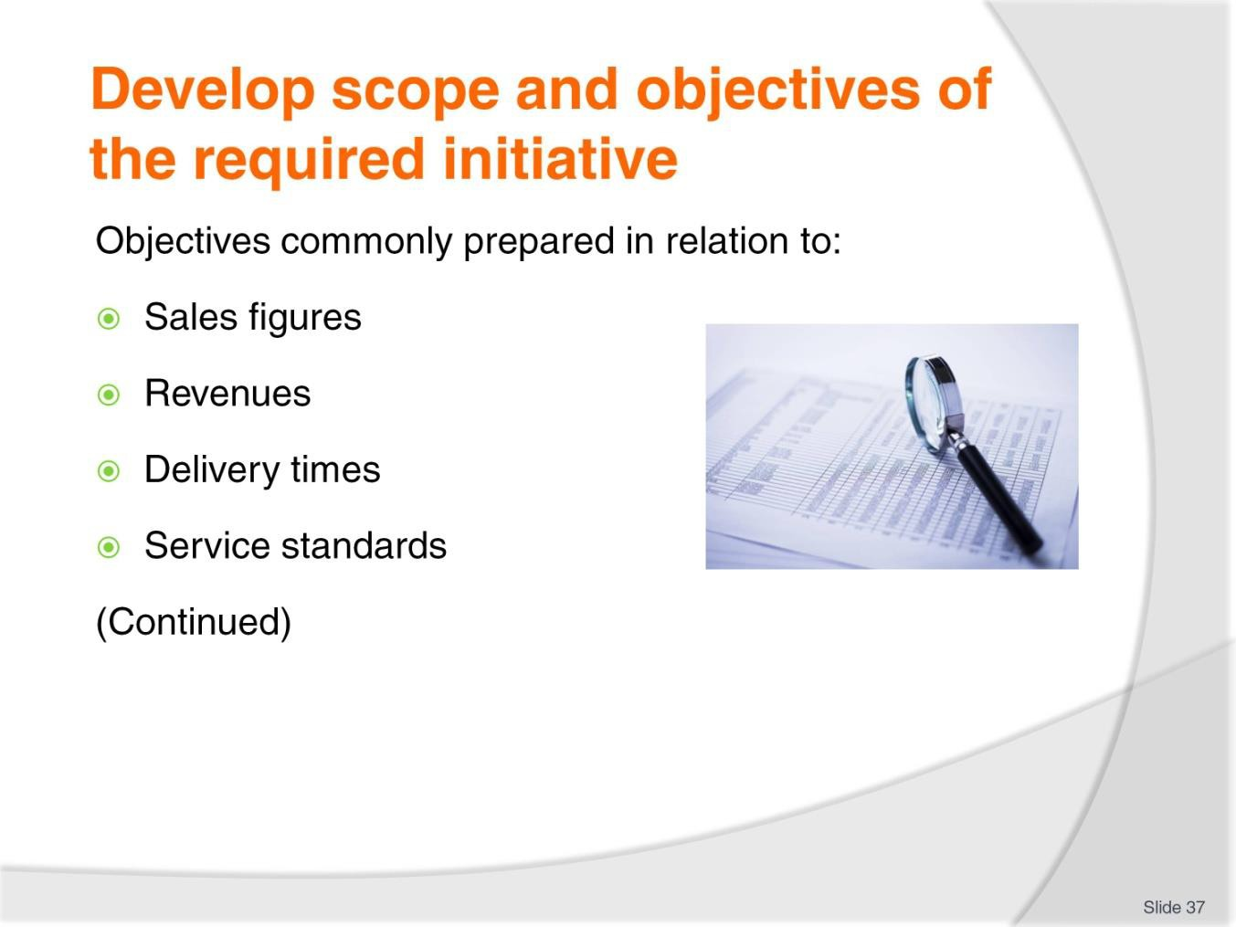
Slide No | Trainer Notes
37. | Trainer indicates organisations commonly prepare objectives for policies addressing:  - Sales figures – in terms of units sold  - Revenues – in terms of money earned/generated  - Delivery times – which may refer to speed of delivery and the percentage of ‘on time’ deliveries  - Service standards – with reference to established criteria (as set by the organisation, or with reference to an industry benchmark or accepted industry standard) for each individual aspect of service delivery.  Classroom Activity – Class exercise  Trainer asks class to generate sample policy objectives for topics listed on the slide.

Slide
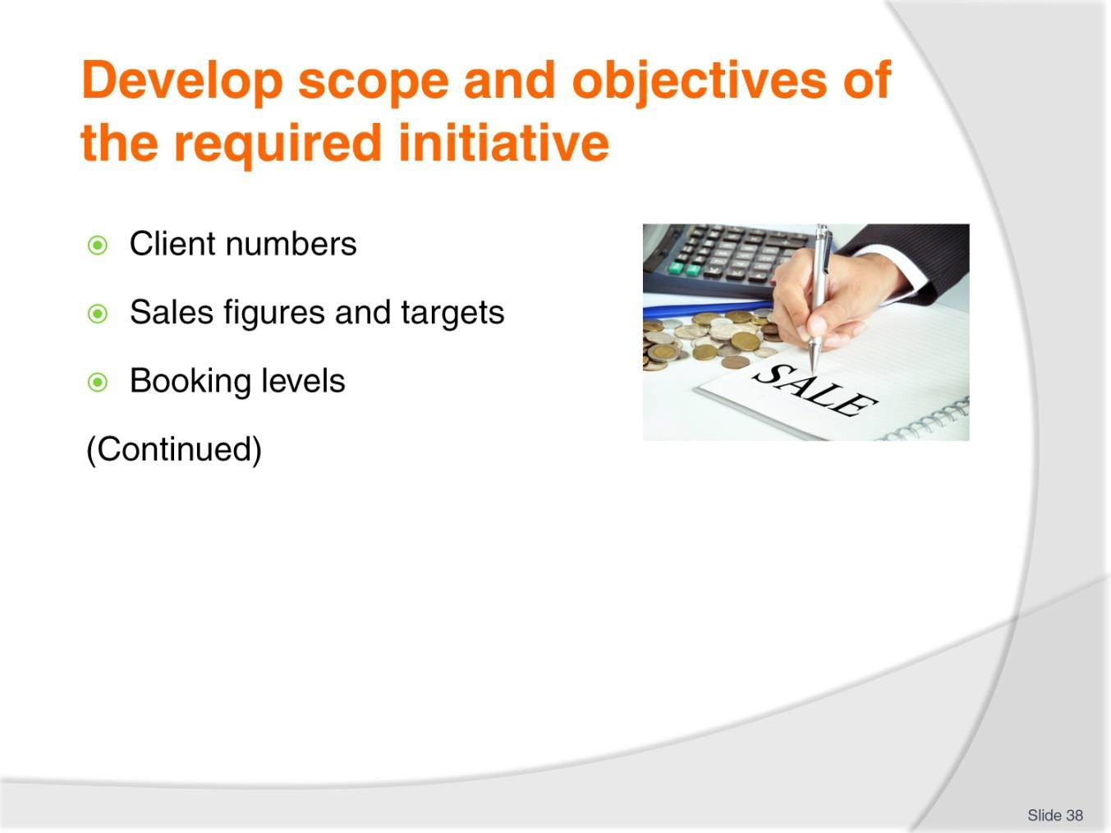
Slide No | Trainer Notes
38. | Trainer indicates organisations commonly prepare objectives for policies addressing:  - Client numbers – which may be classified in terms of (for example):  - New customers  - Repeat customers  - Converted customers – that is, customers who transition from ‘enquiries’ into ‘sales’ or who move from ‘prospects’ to ‘purchasers’  - Sales figures and targets – which can be specified by:  - Product or service type  - Name of individual staff member  - Department or other physical location  - Target market type, as defined by the business  - Booking levels – which can be stated with reference to:  - Physical numbers  - Specific products, services and/or target markets  - Conversions  - Percentage accompanied by advance/holding deposit  - Refunds and withdrawals

Classroom Activity (1) – Class exercise
Trainer asks class to generate sample policy objectives for topics listed on the slide.
Classroom Activity (2) – Internet research
Trainer supervises internet research on relevant websites for items identified above, such as:
- http://www.leoisaac.com/policy/top131.htm - Policy goals and objectives
- http://www.fao.org/wairdocs/ilri/x5499e/x5499e04.htm - Examples of objectives for a company.

Slide
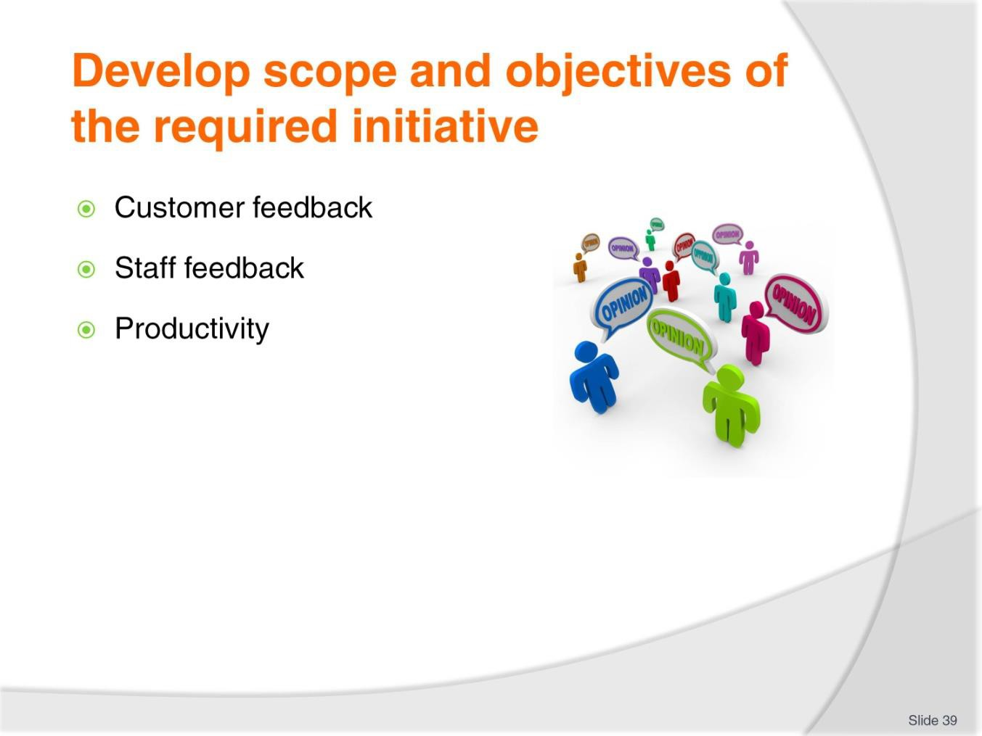
Slide No | Trainer Notes
39. | Trainer indicates organisations commonly prepare objectives for policies addressing:  - Customer feedback – which may be:  - Separated into ‘Compliments’ and ‘Criticisms’  - Rated on a ‘Customer Satisfaction’ score/index  - Staff feedback – which is often classified:  - By number  - With reference to topic/focus of the feedback (management; operational issues; remunerations; working conditions)  - Productivity – measuring (in a useful way to the organisation) the relationship between inputs to the production process and the resulting outputs.  Classroom Activity (1) – Class exercise  Trainer asks class to generate sample policy objectives for topics listed on the slide.  Classroom Activity (2) – Internet research  Trainer supervises internet research on relevant websites for items identified above, such as:  - http://www.businessdictionary.com/definition/objective.html - Objectives defined  - http://topachievement.com/smart.html - Creating SMART goals.

Slide
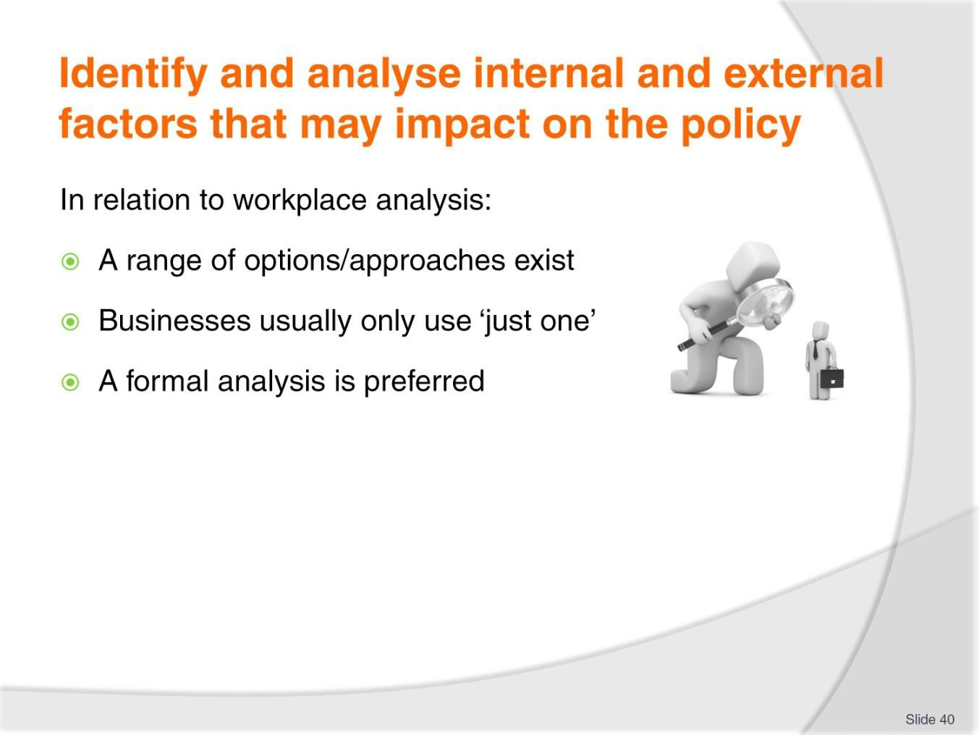
Slide No | Trainer Notes
40. | Trainer explains a range of options is available to identify and analyse the internal and external factors that impact policy initiatives but that commonly a business will only use one option to determine their situation.  A formal analysis is the preferred/recommended course of action as this will:  - Demonstrate personal professionalism towards the proposal and (may) discharge due diligence requirements  - Be the most likely strategy for identifying and gaining a proper/full appreciation of all relevant factors.

Slide
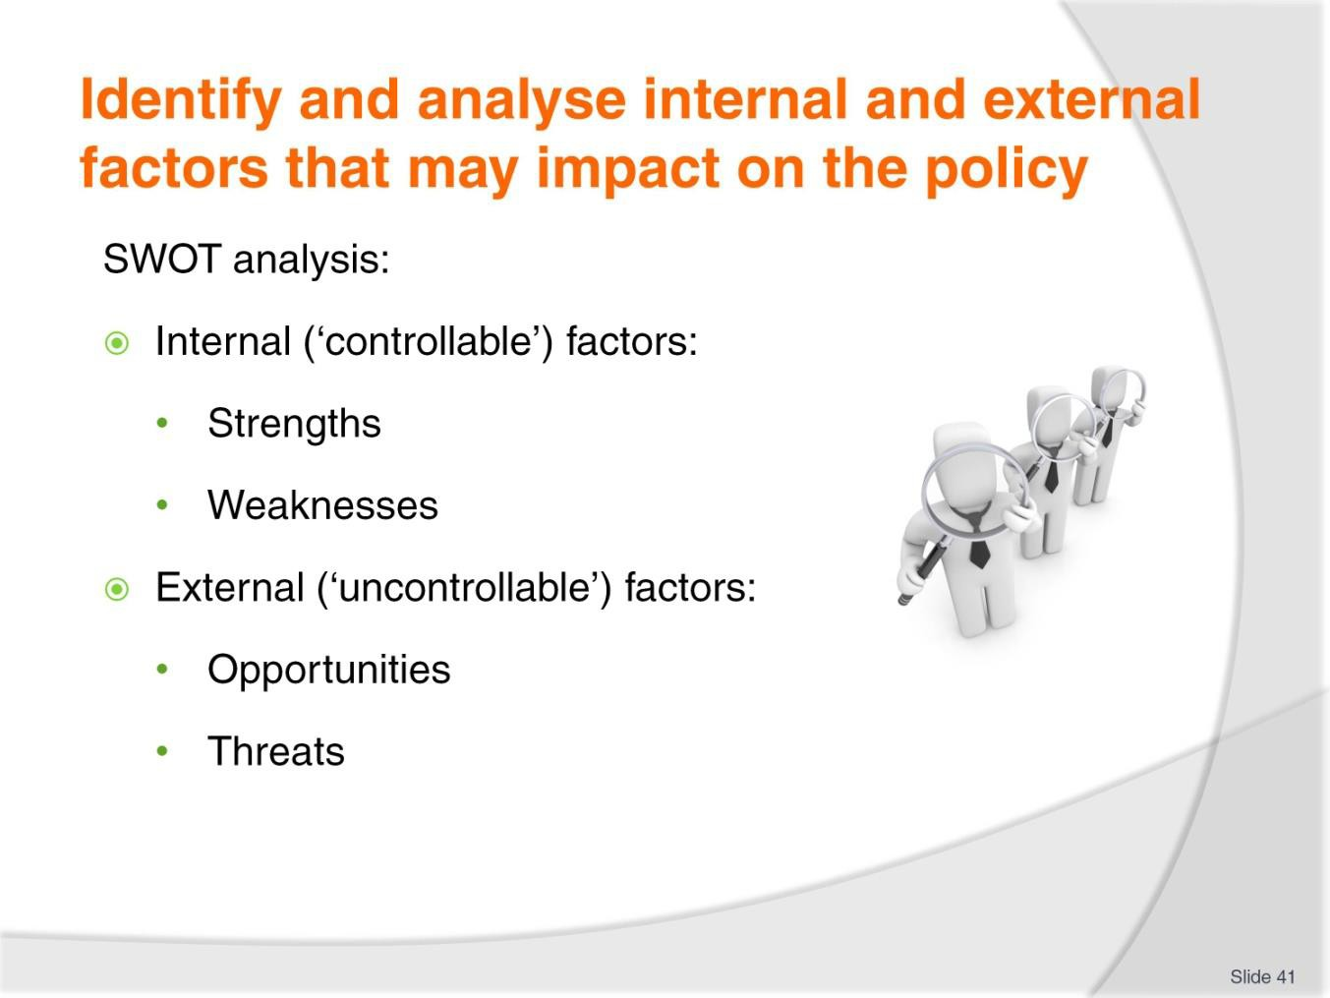
Slide No | Trainer Notes
41. | Trainer explains SWOT analysis approach:  - A SWOT analysis is a well-known and respected strategic planning tool  - It is the process of gathering together information/data on both the internal and external environments of the organisation to determine the strengths, weaknesses, opportunities that are present as well as the threats relating to the situation being considered – in this case, the development of a specific policy  - A SWOT analysis is a fundamental pre-requisite for any research to help determine the situation being considered.  Internal factors  - The internal factors in a SWOT analysis are the factors present within the organisation.  - They are the ‘Strengths’ and ‘Weaknesses’ of the entity  - What is classified as a Strength for one business may well be a Weakness for another. For example:  - One business may have loads of cash to fund whatever is the focus of the policy, while another could be cash-poor  - One organisation may have a detailed knowledge of the topic which is the focus for the policy while another operator knows little/nothing in this regard

- These factors are sometimes referred to as ‘controllable’ as organisations have the power to impact them – they can (for example) take action to raise more money or obtain additional resources and work to gain more experience regarding the issue/policy topic being considered.
External factors
- External factors are those which exist outside the business. They are divided into:
  - Opportunities – which are factors which can be exploited or taken advantage of in relation to the development of a policy or an initiative
  - Threats – which represent things which might prejudice, jeopardise or otherwise negatively influence the development of a policy or an initiative.
- External factors are regarded as being ‘uncontrollable’ in that the business/entity undertaking the analysis is unable to (significantly) impact the relevant factors.
Classroom Activity – Internet research
Trainer supervises internet research on relevant websites for items identified above, such as:
- http://www.mindtools.com/pages/article/newTMC_05.htm - SWOT analysis
- https://www.business.qld.gov.au/business/starting/market-customer-research/swot- analysis/example-swot-analysis - Example SWOT analysis
- http://smallbusiness.chron.com/swot-analysis-diversity-training-1850.html - SWOT analysis on diversity training.

Slide
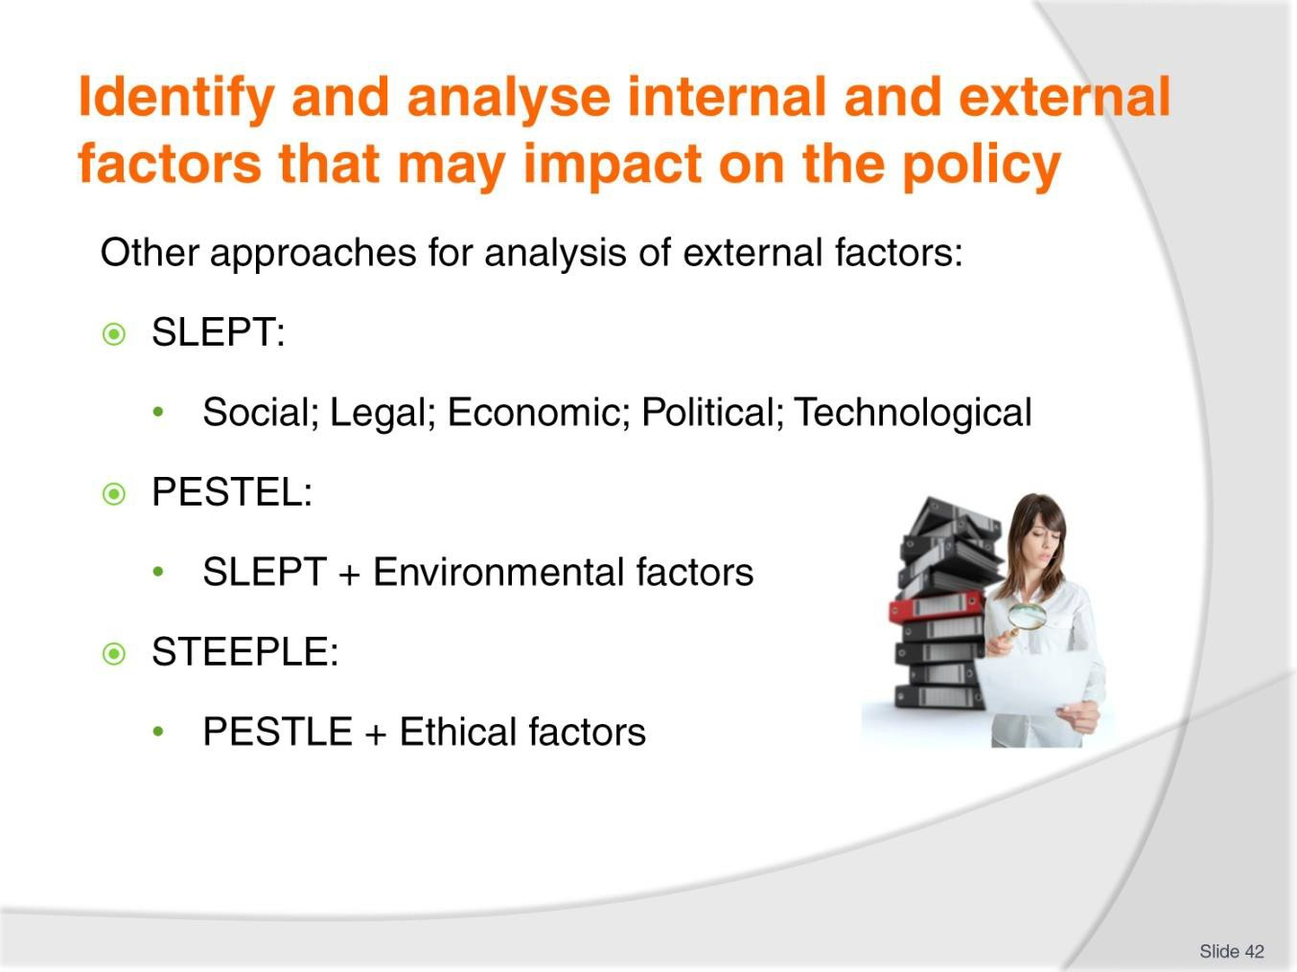
Slide No | Trainer Notes
42. | Trainer presents other approaches/options for looking at external factors:  - SLEPT analysis involves consideration of:  - Social factors  - Legal factors  - Economic factors  - Political factors  - Technological factors  - PESTEL analysis is the same as SLEPT but with the addition of ‘Environmental’ factors  - STEEPLE analysis adds consideration of Ethics.  Classroom Activity – Internet research  Trainer supervises internet research on relevant websites for items identified above, such as:  - http://pestleanalysis.com/ - PESTLE analysis  - http://www.slideshare.net/lconner/steeple - STEEPLE analysis.

Slide
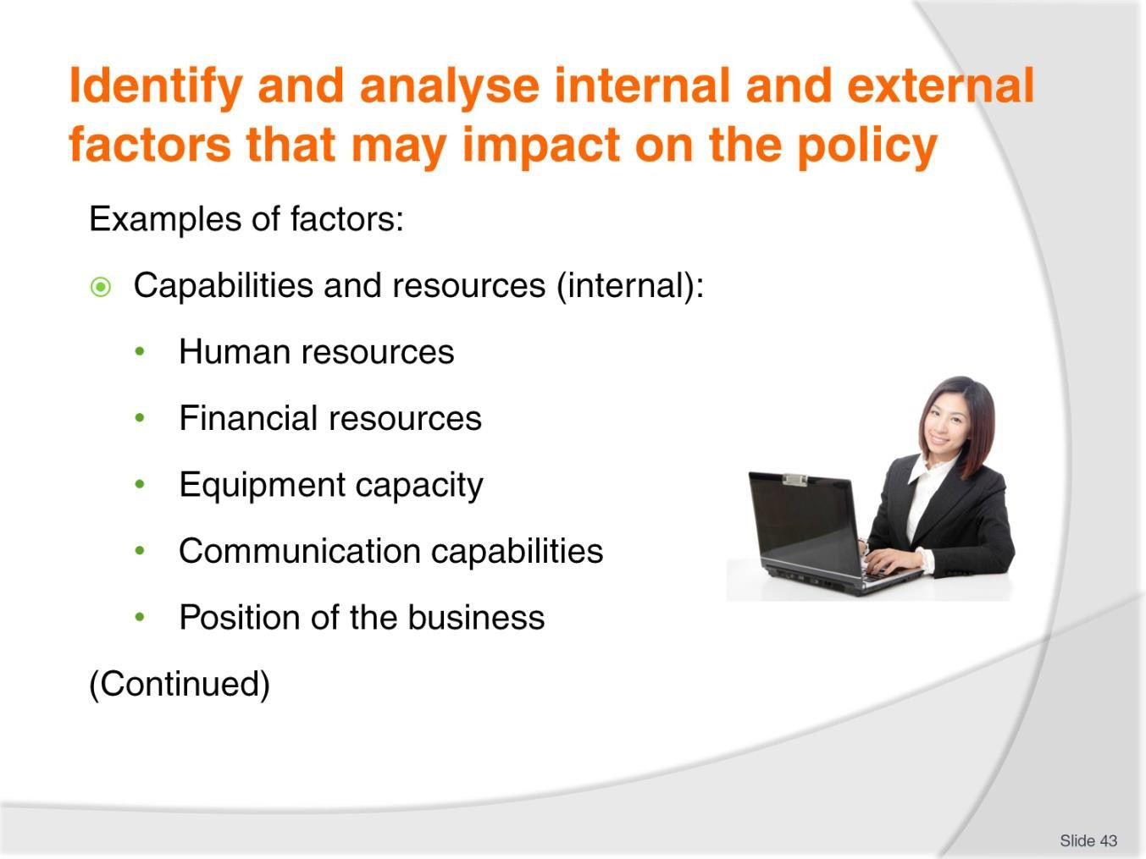
Slide No | Trainer Notes
43. | Trainer discusses examples of factors  Capabilities and resources  The capabilities of the organisation to deliver services and produce products, and the resources it has to support these activities are all internal factors. Specific factors may be:  - Human resources – this relates to issues such as:  - Number of staff available within the business  - Pool of potential employees the organisation is able to recruit from  - Experience and expertise of employees/staff skill and knowledge levels  - Payment being sought by workers  - Degree of fit between staff profiles and profiles of target markets  - Financial resources – which relates to:  - Amount of cash reserved held by the company  - Amount of loans the business is able to access  - Contributions which can be sourced from ‘other sources’ such as government agencies, joint venture partners, or industry organisations  - Interest rates and costs of borrowing/money

- Equipment capacity – with reference to:
  - Production capacity of current plant and machinery
  - Safety status of items
  - Potential to modify equipment to meet changing/changed market needs and/or projected new inventory requirements for the business
- Communication capabilities of the organisation – in terms of being able to:
  - Solicit feedback from customers
  - Generate contributions from other stakeholders
  - Notify target markets of initiatives and innovations
- Position of the organisation – which relates to:
  - Physical/geographic location of the business in terms of offices, outlets, agencies
  - The hours of operation of the business
  - Different ways customers can interact with/buy from the organisation – including online options for providing information, responding to queries and making sales and accepting payments.

Slide
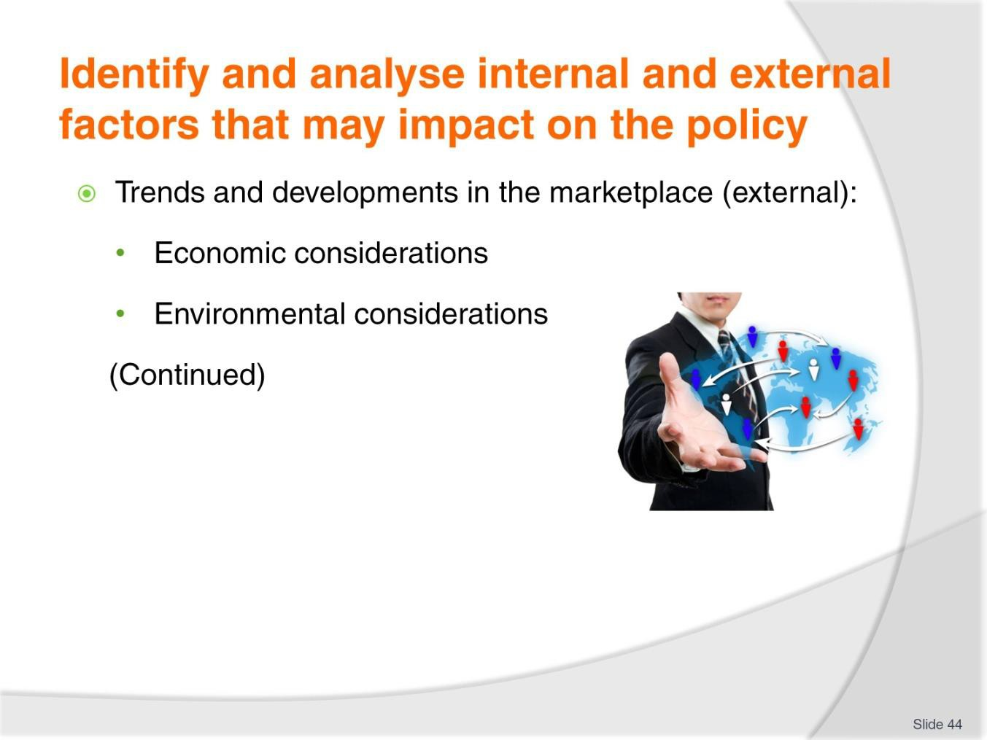
Slide No | Trainer Notes
44. | Trainer discusses examples of factors.  Trends and developments in the marketplace  These are all external factors.  Economic considerations  Analysis of the economic considerations in which the business operates may address matters such as:  - The local economic environment as well as the economic state of other countries from which the business draws its customers  - Inflation  - Interest rates  - Exchange rates  - Levels of employment and unemployment  - Availability of local skilled/competent staff  - Amount of discretionary income customers have  - Community thoughts on the state and/or future of the economy.

Environmental considerations
Analysis of environmental considerations/factors could include:
- Sustainability issues
- Use of power and water
- Rubbish disposal
- Pollution – traffic, noise, air, water
- The impact of the venue on local communities.
- Ecological/environmental.

Slide
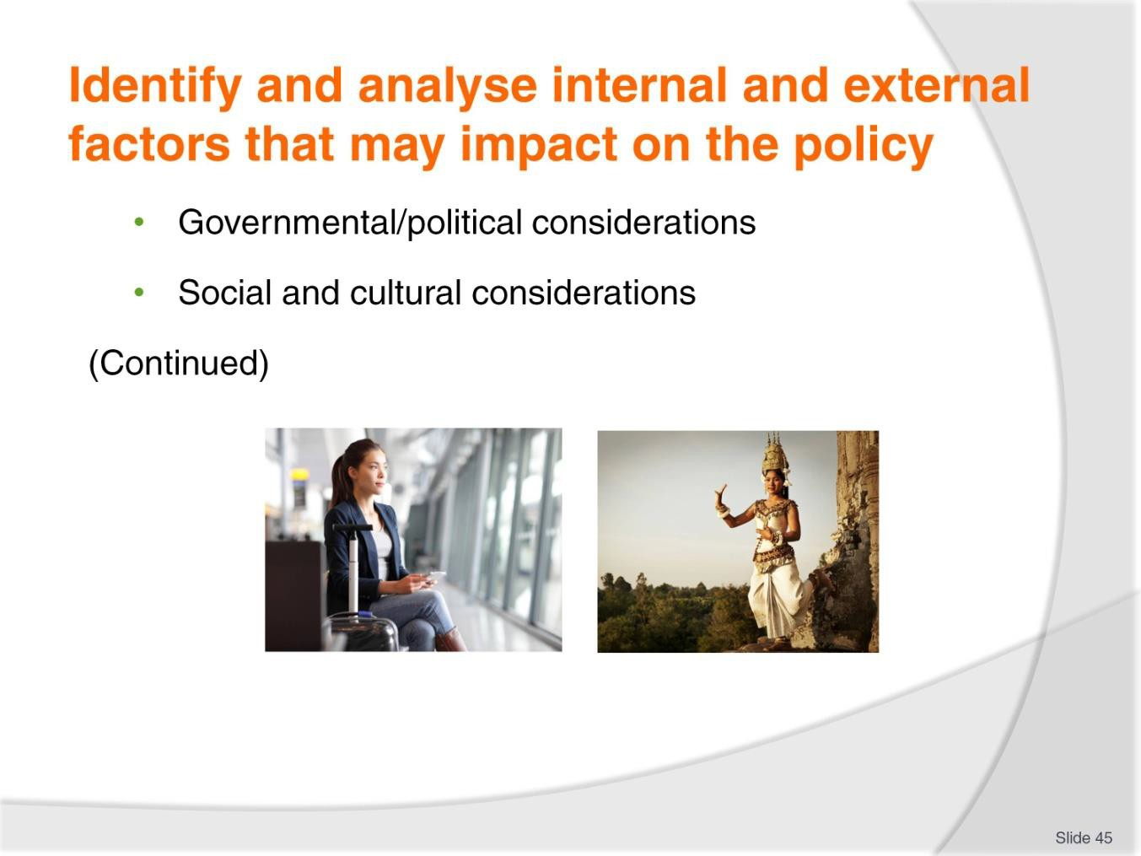
Slide No | Trainer Notes
45. | Trainer discusses examples of factors  Governmental/political considerations  Analysis of governmental/political factors may consider:  - The political stability of the country  - Is a change of government imminent and if so what implications can be expected?  - Feelings in relation to international trade/dealings  - Political relationships between home country and other countries  - The support available from government (agencies and bodies) for industry and/or initiatives.  Social and cultural considerations  Analysis of social and cultural factors could include:  - What image does the industry have in the eyes of society? Is it a positive image? Is it tarnished for some reason and if so how/why?  - Projected responses of local and other communities if the business pursues various options – such as entering into a relationship with a certain organisation, entering into a new market, erecting a new building  - The status of the business in the eyes of the community/public as a ‘corporate citizen’  - Mobility of people and their ability to travel to and from the venue/organisation.

Slide
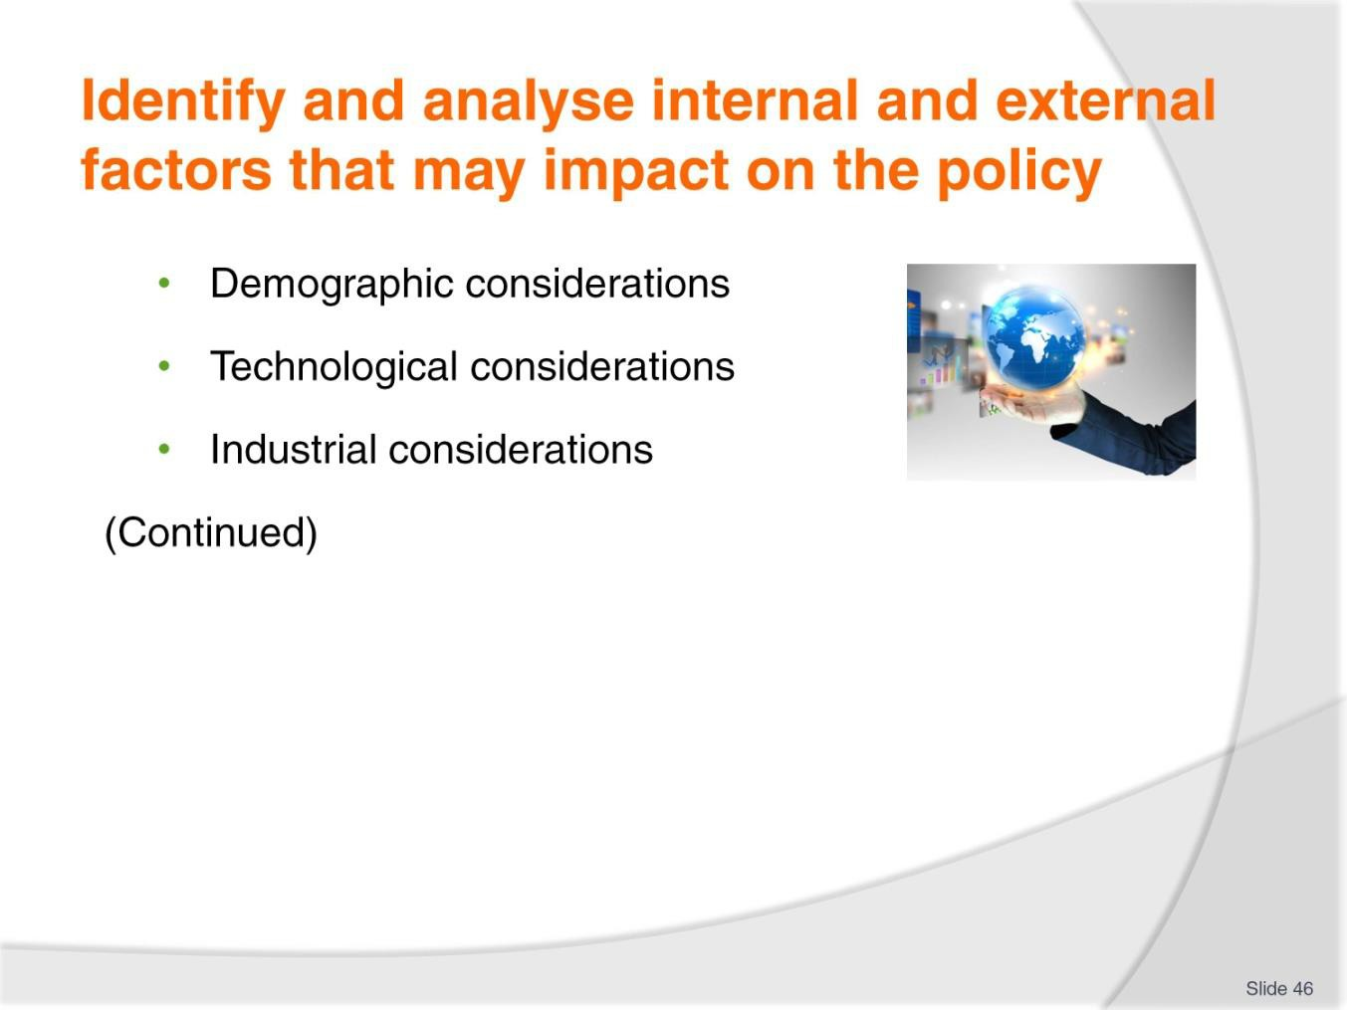
Slide No | Trainer Notes
46. | Trainer discusses examples of factors  Demographic considerations  Analysis of demographic factors could include:  - Are customers getting older or younger?  - What is the ratio of males to females? Is this changing?  - Are there increasing or decreasing domestic and/or international customers?  - Which countries are customers coming from?  - Are customers increasingly (or decreasingly) single, married, married with children?  Technological considerations  Analysis of technological considerations could include:  - Does the current technology being used by the business remain effective and efficient?  - Is there new technology in the marketplace which can/should be used to:  - Improve business performance/save time and/or money?  - Provide better/different facilities for customers and perhaps give the organisation a USP or meet identified customer demand/meet competition?  - Does legislation require use of nominated technology? When?

- What is the cost of new/required technology and what are supply/purchase options?
- Dangers or problems inherent in adopting new technology and/or integrating it into existing systems and/or processes.
Industrial considerations
Analysis of industrial considerations could include:
- Level of unionisation of workforce
- Conditions of employment for workers
- Triggers for industrial unrest.

Slide
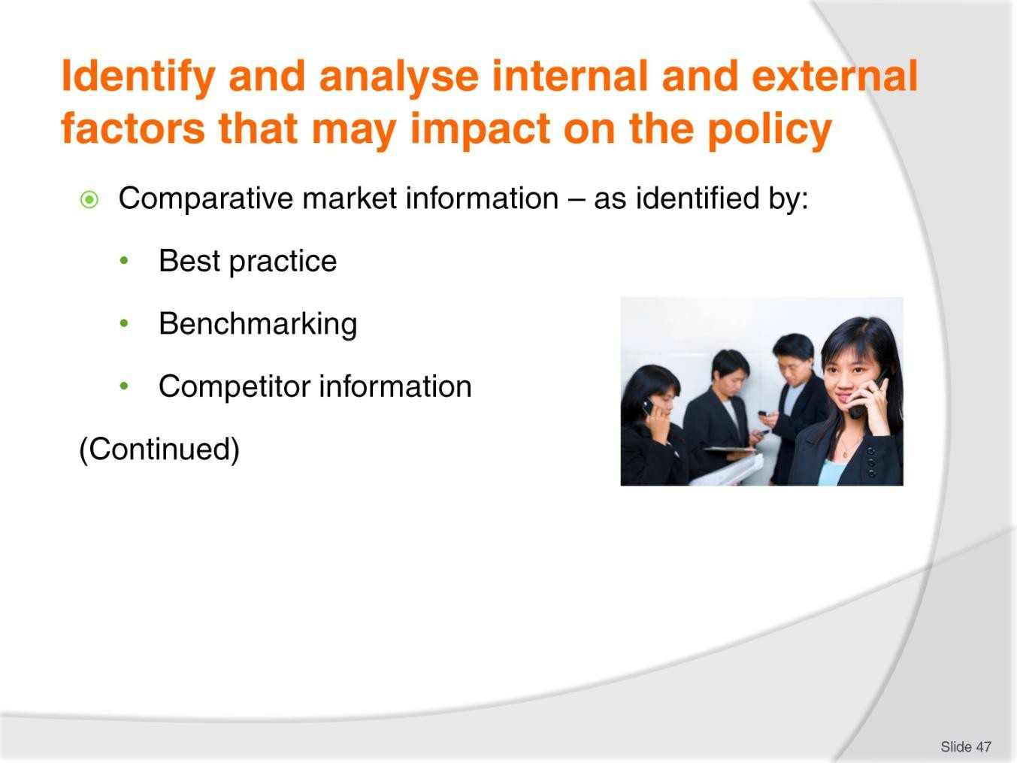
Slide No | Trainer Notes
47. | Trainer discusses examples of factors  Comparative market information  These factors relate to the issues and applicable details as they relate to:  - Best practice information – for:  - The industry or industry sector  - Services delivered  - The extent to which the organisation wants to align with nominated ‘Best practice’ protocols  - Benchmarking – with reference to:  - Identifying the other industries or businesses with which comparisons will be made  - Describing the metrics which will be used for comparison purposes  - Determining how relevant data will be collected and compared  - Competitor information – with reference to:  - Prices being charged by them  - Their trading hours and locations  - Special deals being offered

- Quality and characteristics of their products and services
- Promotions they are undertaking
- The staff they are using to deliver services/produce products
- Their market share
- Impact they are having on the business.
Classroom Activity – Internet research
Trainer supervises internet research on relevant websites for items identified above, such as:
- http://study.com/academy/lesson/what-is-benchmarking-definition-types-process- examples.html - What is benchmarking?
- http://www.tutor2u.net/business/strategy/benchmarking.htm - Benchmarking
- http://en.wikipedia.org/wiki/Best_practice - Best practice.

Slide
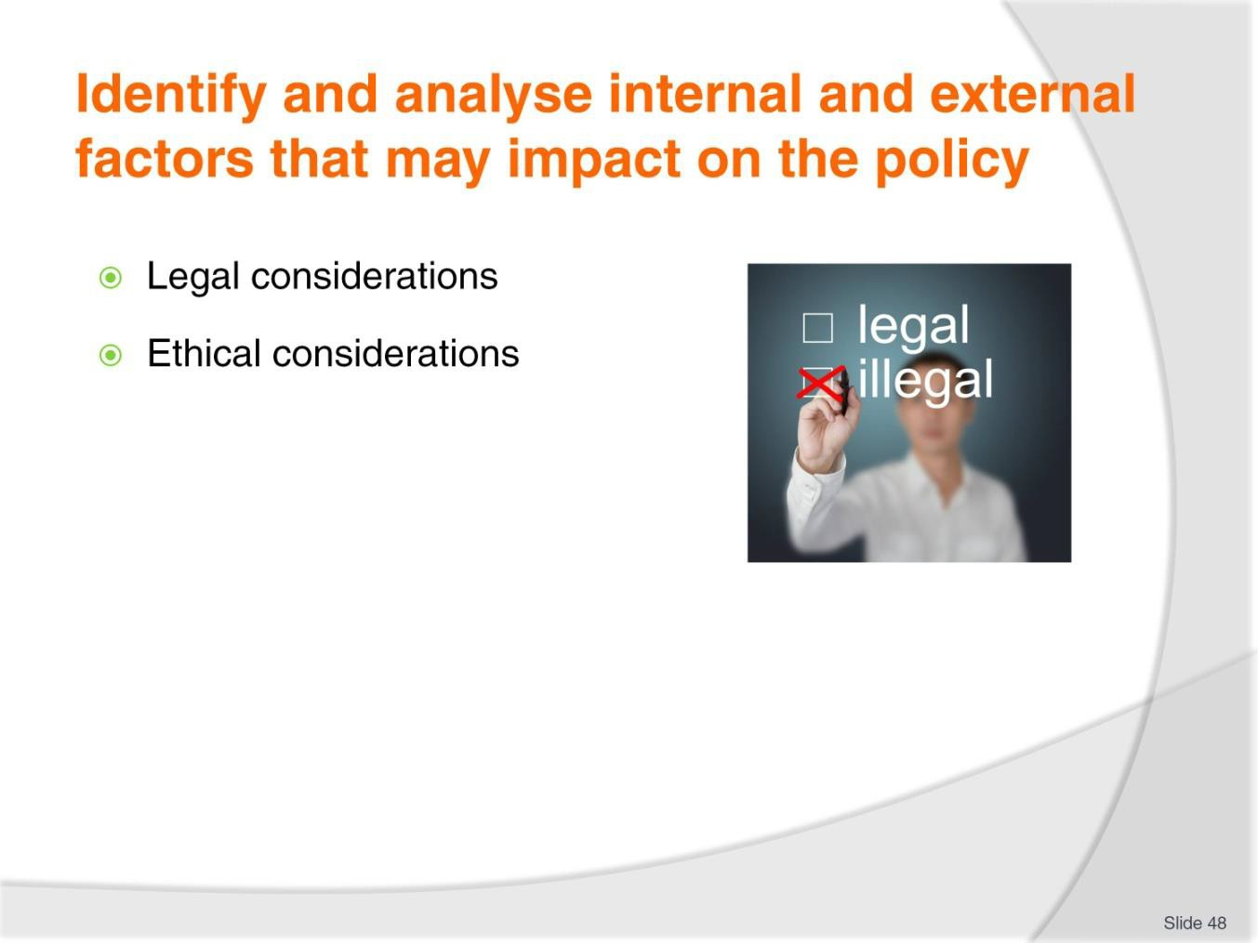
Slide No | Trainer Notes
48. | Trainer discusses examples of factors  Legal considerations  Legal considerations will relate to:  - Complying with relevant legislation  - Ensuring adherence with contractual obligations  - Adhering to mandatory Codes of Practice/Conduct  - Liaising with authorities to seek advice and direction on what is legally permissible  - Discharging ‘duty of care’ and ‘due diligence’ obligations  - Involving external legal practitioners to evaluate and advise on operations and initiatives  - Ensuring customers are suitably advised about changes to products and services, and terms and conditions of trade.  Ethical considerations  Ethical considerations will relate to:  - Ensuring fairness and equity  - Maintaining safety and security  - Child protection

- Retaining transparency and accountability
- Guaranteeing sustainability
- Addressing environmental issues
- Preserving community
- Testing and proving the safety of initiatives prior to release
- Promoting the local country, buying locally and supporting local employment.

Slide
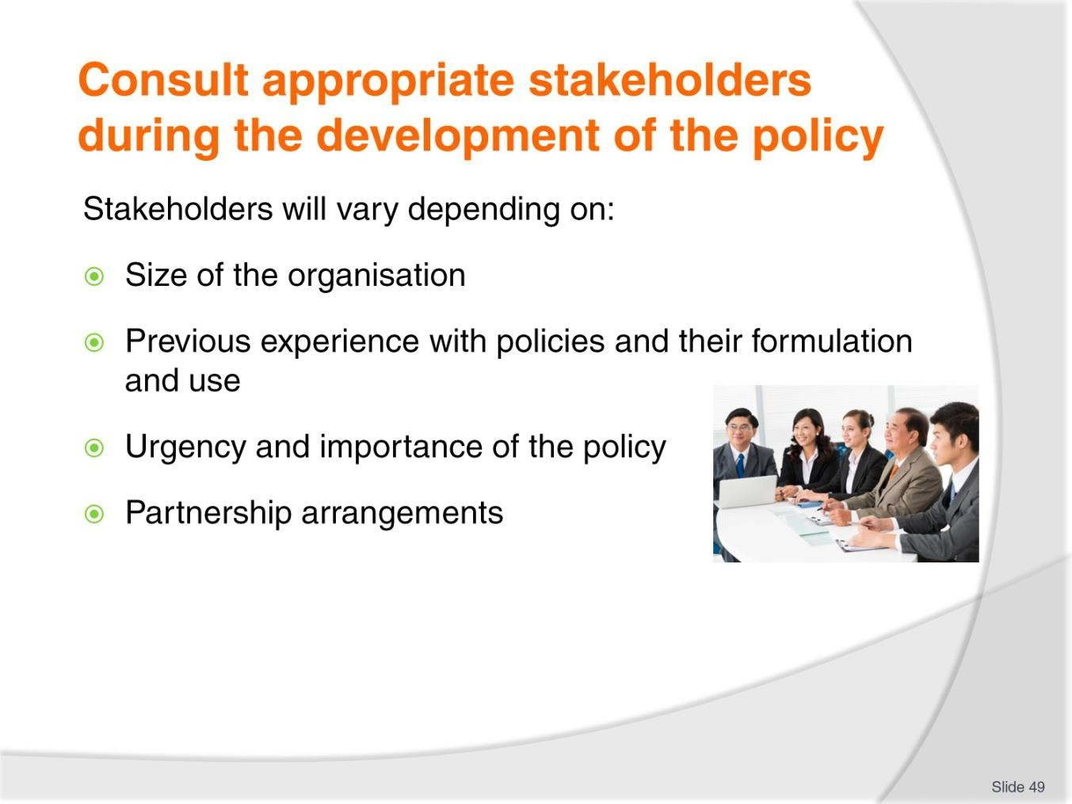
Slide No | Trainer Notes
49. | Trainer indicates stakeholders in the development of operational policies will vary depending on:  - Company size and structure  - Previous experience/engagement with the development of formal organisational documentation such as plans, policies, strategies and procedures  - Urgency attached to the need to produce a particular policy  - The importance of the policy being considered  - Partnership arrangements and working agreements which exist between the organisation and other businesses.

Slide
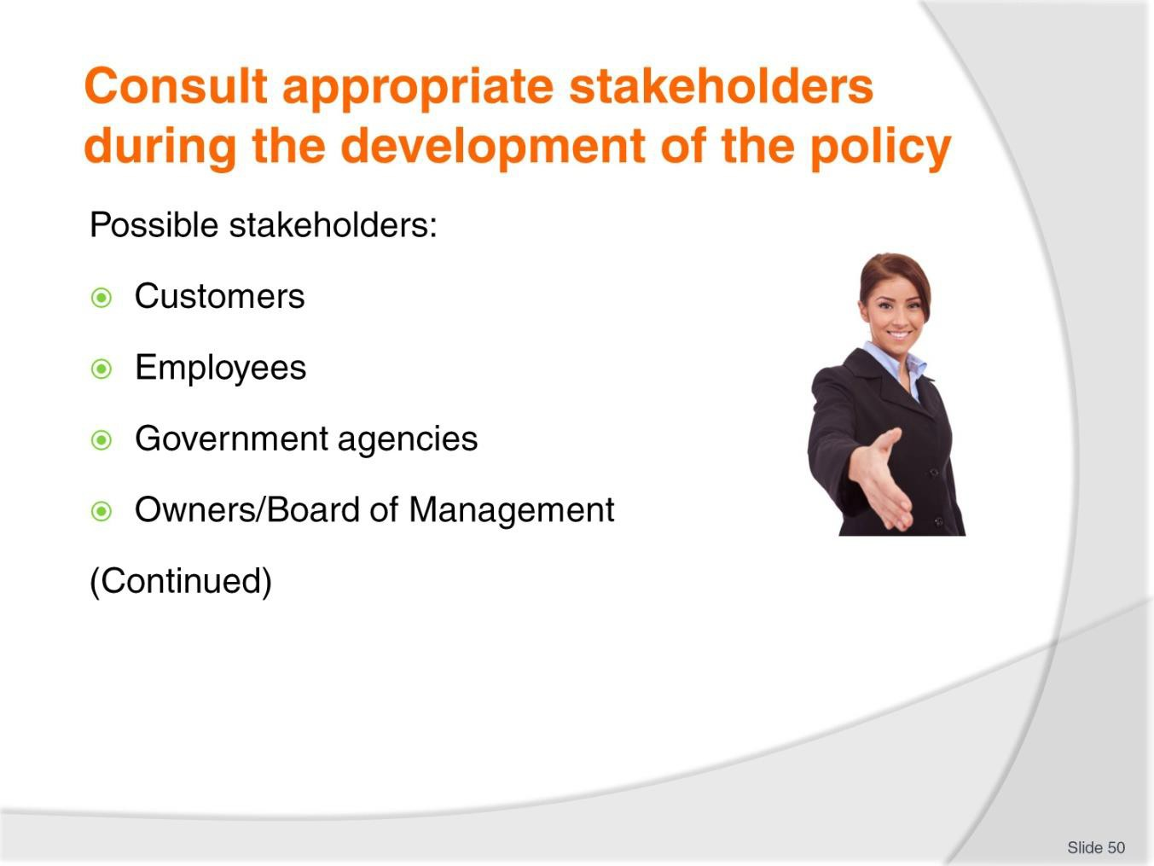
Slide No | Trainer Notes
50. | Trainer identifies potential stakeholders:  - Customers – standard practice is to establish a ‘representative sample’ of the profile of the organisation’s customers  - Employees – from all departments/areas to which the individual policy applies or relates  - Government agencies – who may:  - Request involvement  - Have a mandated interest  - Be able to make valuable contributions  - Owners – and/or The Board of Management within the organisation.

Slide
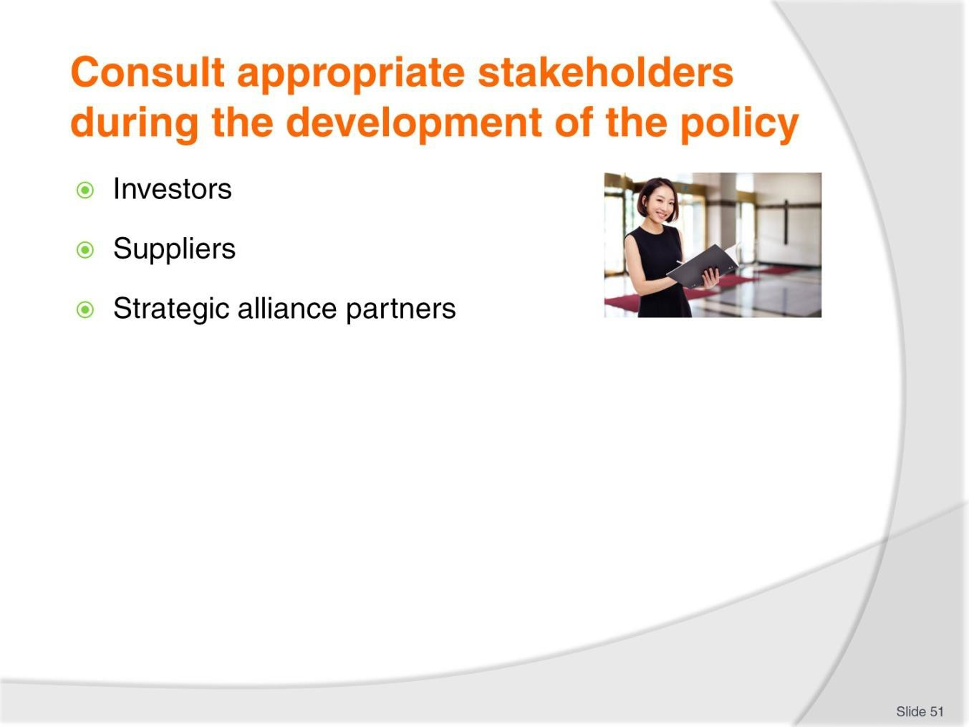
Slide No | Trainer Notes
51. | Trainer identifies potential stakeholders:  - Investors – and shareholders  - Suppliers – who:  - May be impacted by policy decisions  - Are critical to pivotal policy decisions  - Strategic alliance partners – who:  - Are involved in operations flowing from policy decisions  - Will want to have their interests reflected in policies which are developed  - Need to be kept advised in order to maintain a cohesive, working and mutually beneficial business partnership.  Classroom Activity – Guest Speaker  Trainer arranges for suitable owner/operator or manager to attend and:  - Discuss their protocols for developing operational policies  - Provide examples of policies  - Identify stakeholders in the policy development process  - Explain implementation, monitoring and evaluation of policies.

Slide
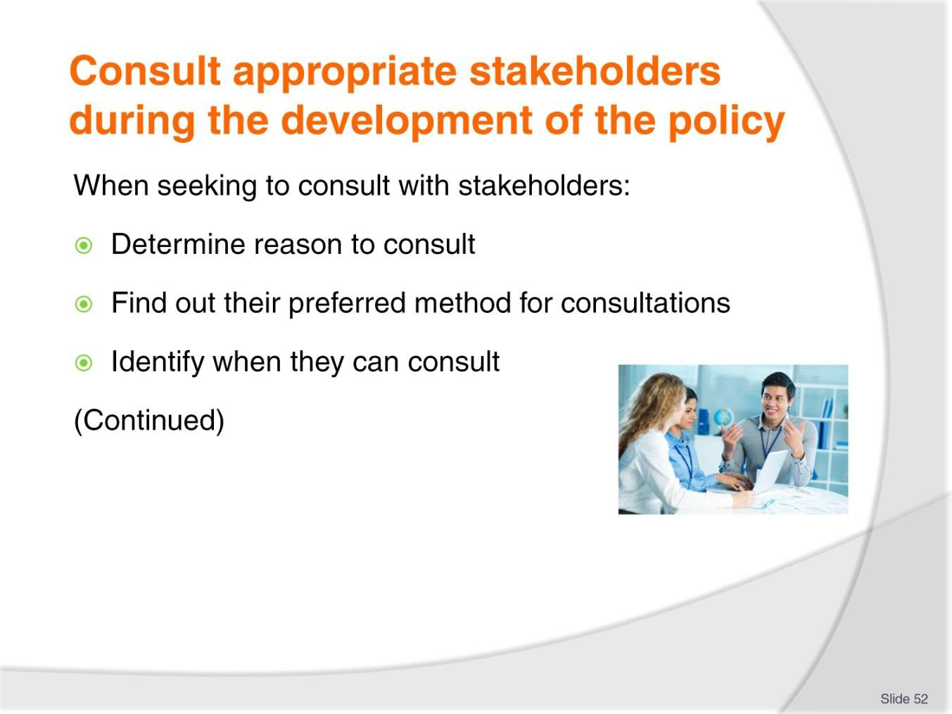
Slide No | Trainer Notes
52. | Trainer provides advice in relation to seeking to consult with stakeholders:  - Determine/define the reason for the consultation  - Determine their preferred method of consultations  - Identify the times/days they have available for consultation/to attained meetings.

Slide
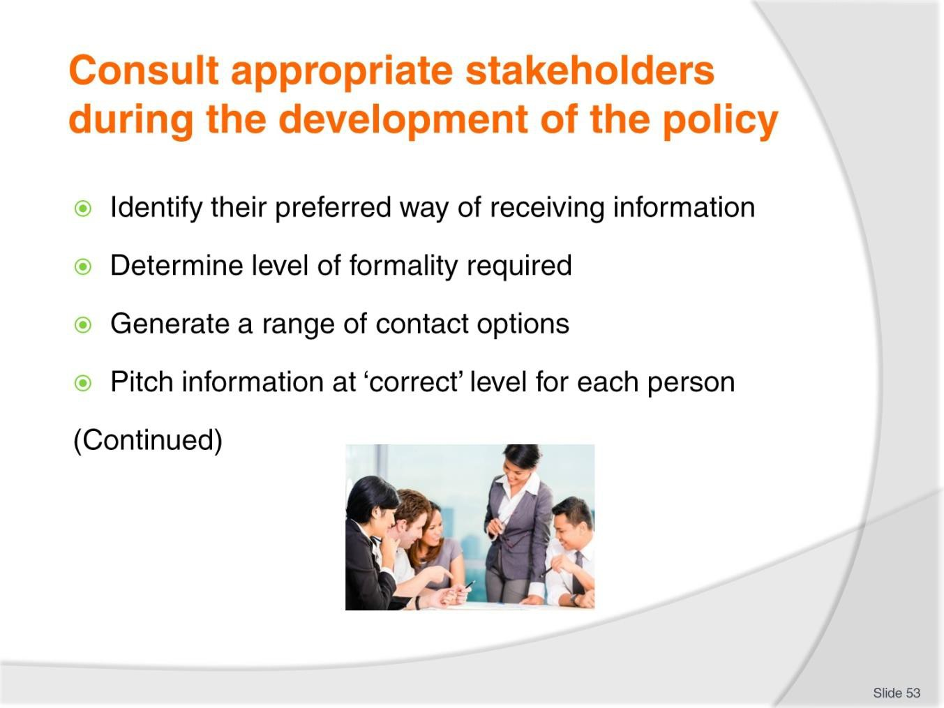
Slide No | Trainer Notes
53. | Trainer provides advice in relation to seeking to consult with stakeholders:  - Work out how they prefer their information to be provided to them  - Determine the level of formality/informality of the consultations preferred or required  - Generate a range of ways in which stakeholders can contribute  - Pitch information at the known level/s of stakeholders.

Slide
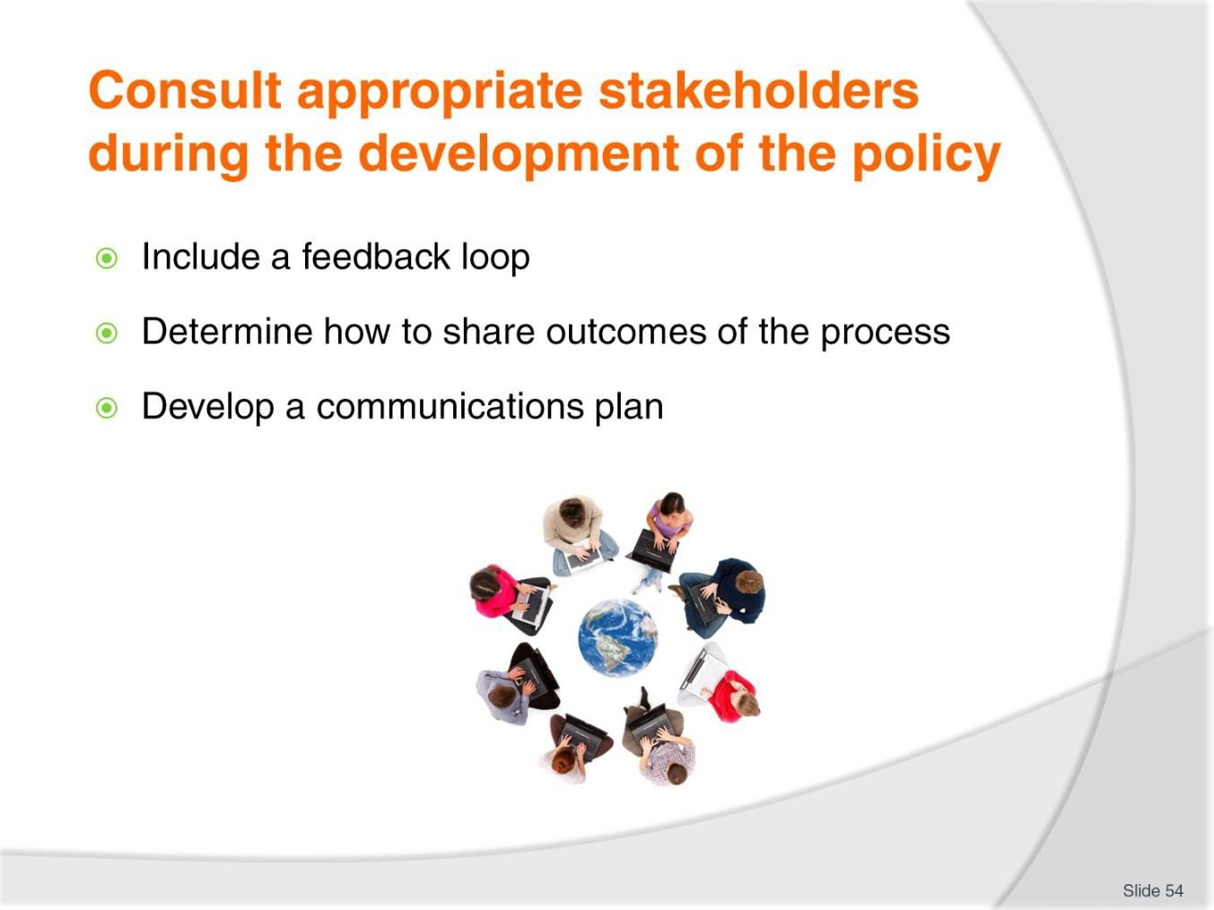
Slide No | Trainer Notes
54. | Trainer provides advice in relation to seeking to consult with stakeholders:  - Include a feedback loop/facility for all communications which occur as part of the consultation process  - Determine how the outcomes from the consultation process can be effectively shared among others  - Develop a communications plan to support the overall process.

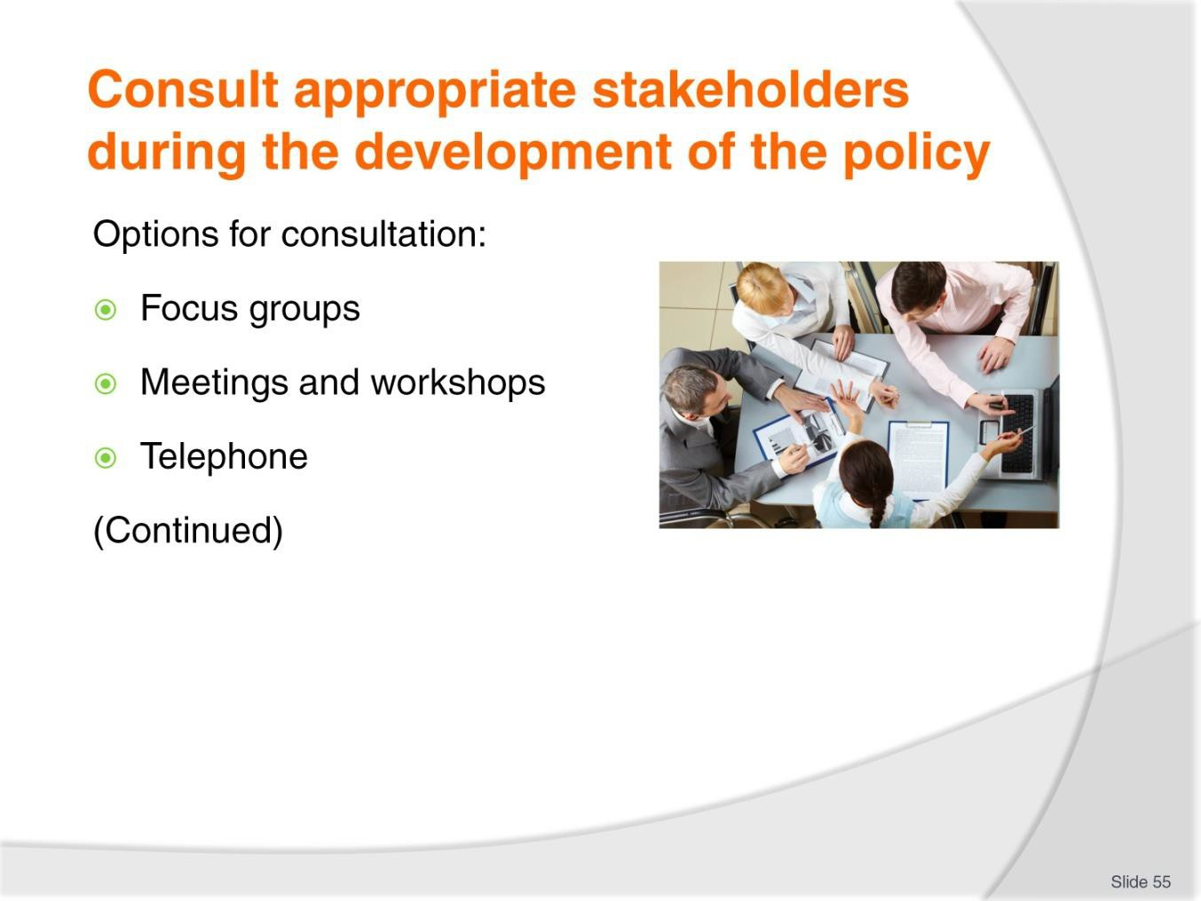
Slide
Slide No
Trainer Notes
55.
Trainer offers strategies for consultations may include:
- Use of focus groups – for customers
- Face-to-face meetings and workshops – with individuals and/or groups, featuring:
  - Presentations
  - Discussions
  - Decision making
- Telephone contact.

Slide
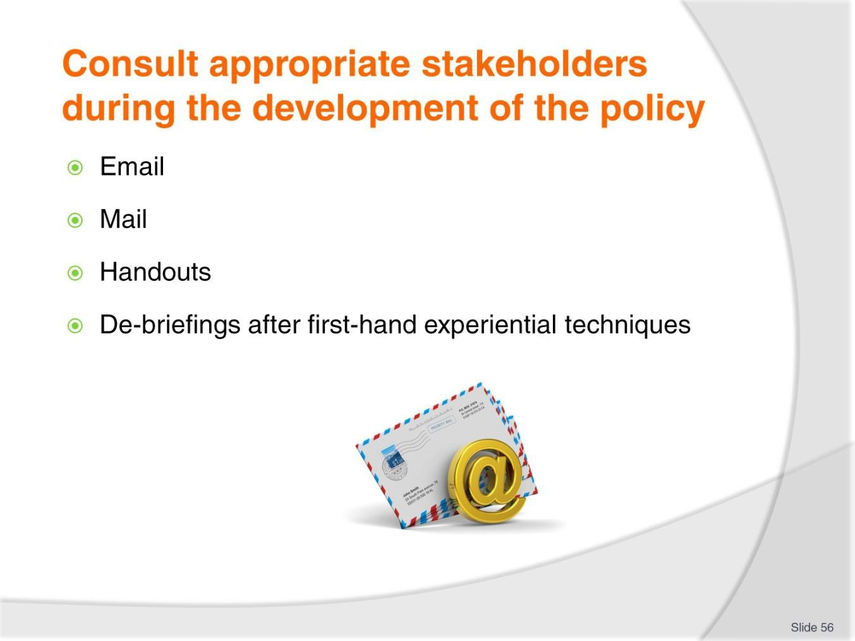
Slide No | Trainer Notes
56. | Trainer offers strategies for consultations may include:  - Email communications  - Posting information on designated websites  - Provision of hard copy materials  - De-briefing sessions following use of first-hand experiential techniques – such as:  - Receiving proposed services  - Tasting planned food and beverages products  - Visiting proposed destinations and venues.

Slide
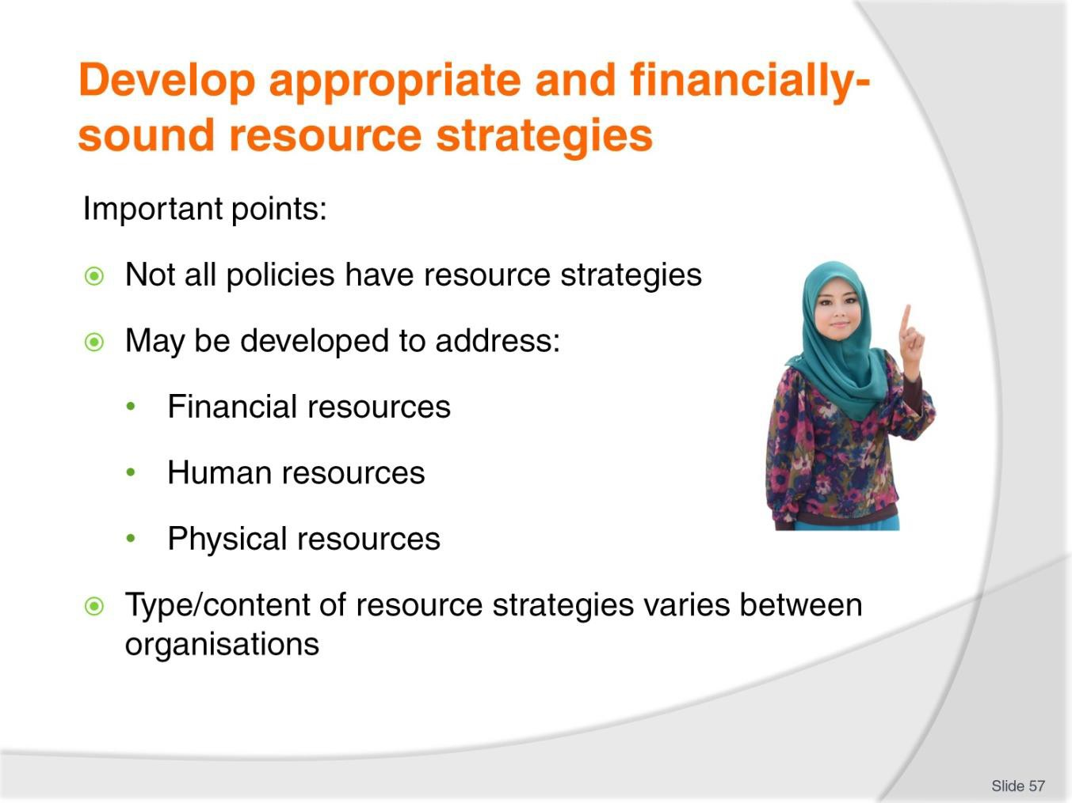
Slide No | Trainer Notes
57. | Trainer provides context stating in relation to resource strategies it is necessary understand:  - Some policies and initiatives will not have resource strategies developed for them – smaller organisations and small projects often do not need or use resource strategies for every single policy/initiative  - Where resource strategies are used, they are likely to be developed for each classification of resources to be used:  - Financial resources  - Human resources  - Physical resources – which may include intellectual property or knowledge relating to the operation of the business such as statistics, information, recipes, SOPs and operational protocols  - Exactly what constitutes a resource strategy is likely to vary between organisations  – these is not a standard template for these strategies and it is possible/probable:  - Not all strategies will identify the source of resources  - Some may only address use of resources  - Others will cover both the above aspects.

Slide
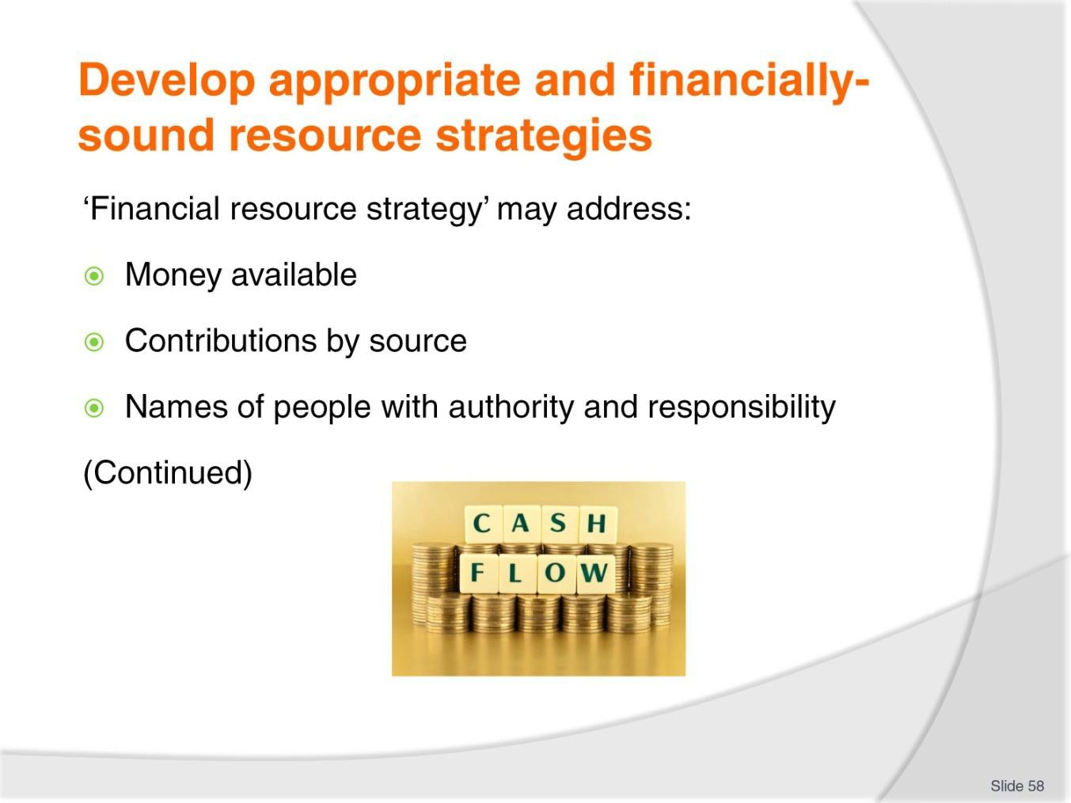
Slide No | Trainer Notes
58. | Trainer discusses resource strategies  Financial resource strategy  It is to be expected the financial resource strategy for an initiative might address:  - The total amount of money available for the project  - Contributions made by individual sources (consolidated funds, contributions by individual departments or offices/agencies, borrowings/loans, shareholders, government grants and similar  - Names of people – with:  - Authority to access/spend the identified funds  - Responsibility for monitoring and reporting.

Slide
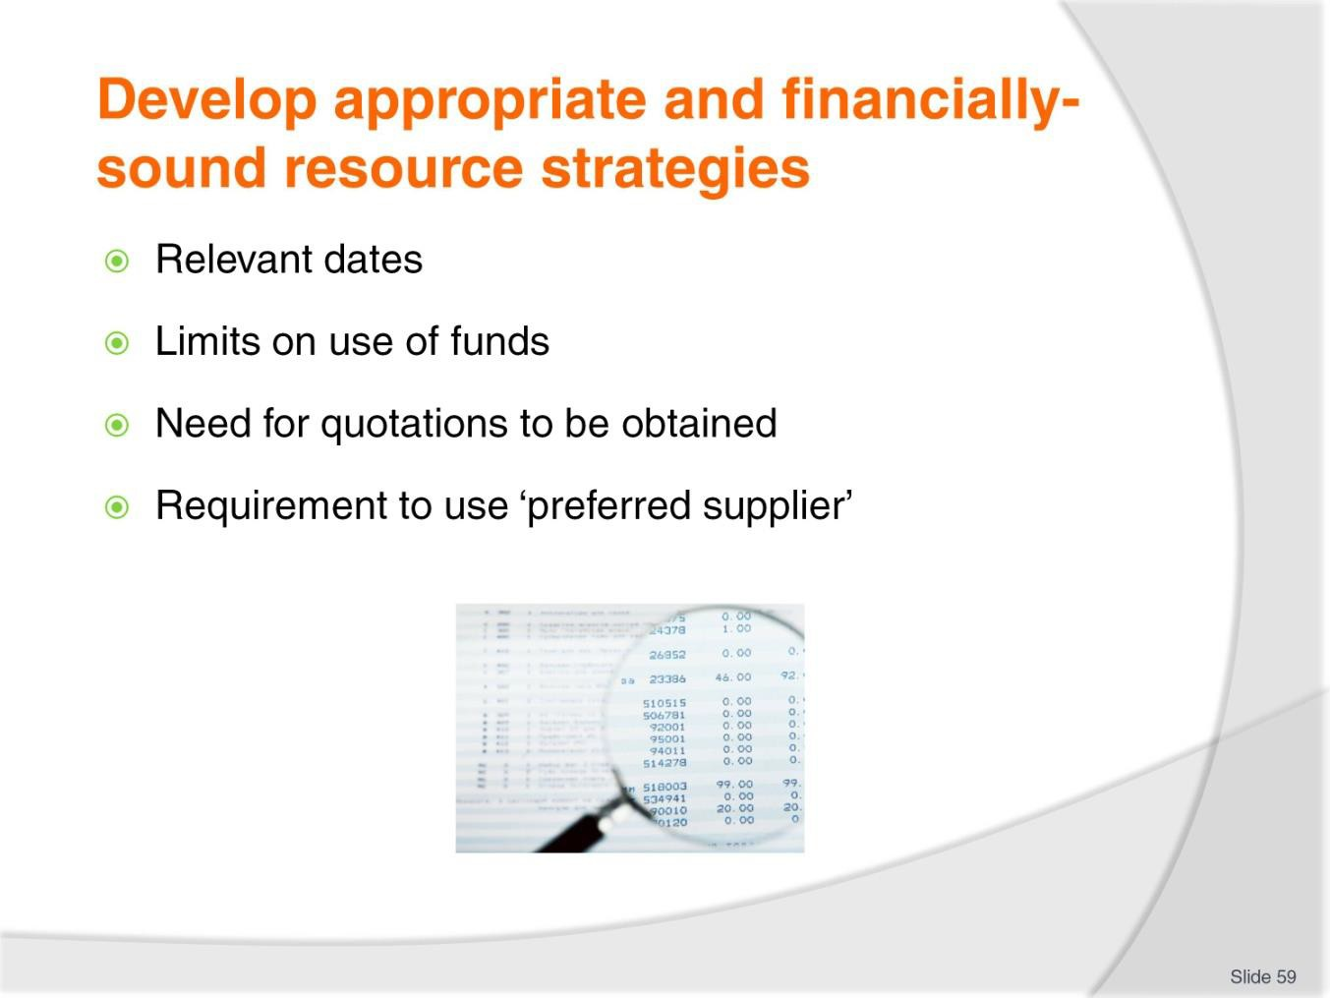
Slide No | Trainer Notes
59. | Trainer continues discussing financial resource strategies:  - Times which apply to use of the money – for example:  - Dates when funds become available  - Dates by which funds must be spent  - Limits regarding what money can be spent on  - Need for quotations to be obtained – for expenses over a given amount  - Requirement for money to be spent with ‘preferred suppliers/providers’ where possible.

Slide
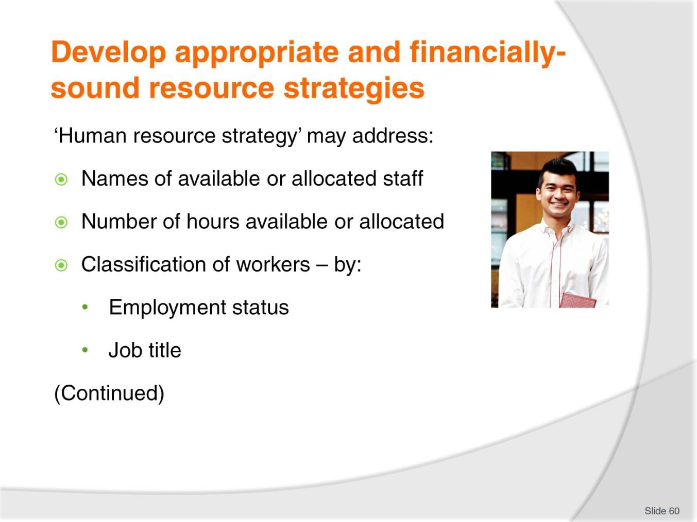
Slide No | Trainer Notes
60. | Trainer discusses resource strategies.  Human resource strategy  It is to be expected the HR strategy for an initiative might address:  - Names of staff to be involved – or who have been allocated to the initiative  - Number of hours for each staff member – or each department/division  - Classification of employees – by:  - Employment status  - Job title/position.

Slide
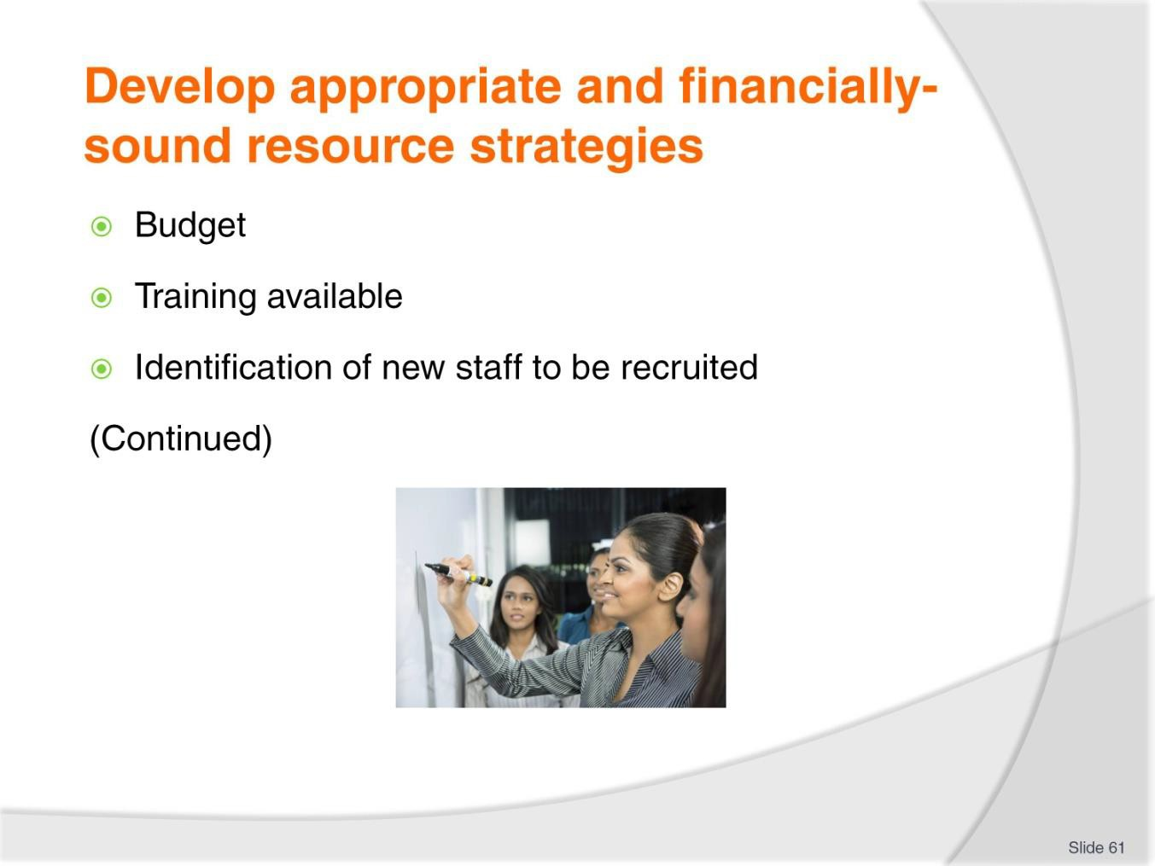
Slide No | Trainer Notes
61. | Trainer continues discussing human resource strategies:  - A budget for staffing – which may be based on:  - Hours  - A monetary figure  - A department/office contribution  - Definition and treatment of relevant on costs  - Training available for nominated employees – in relation to the initiative  - Identification of new staff to be recruited.

Slide
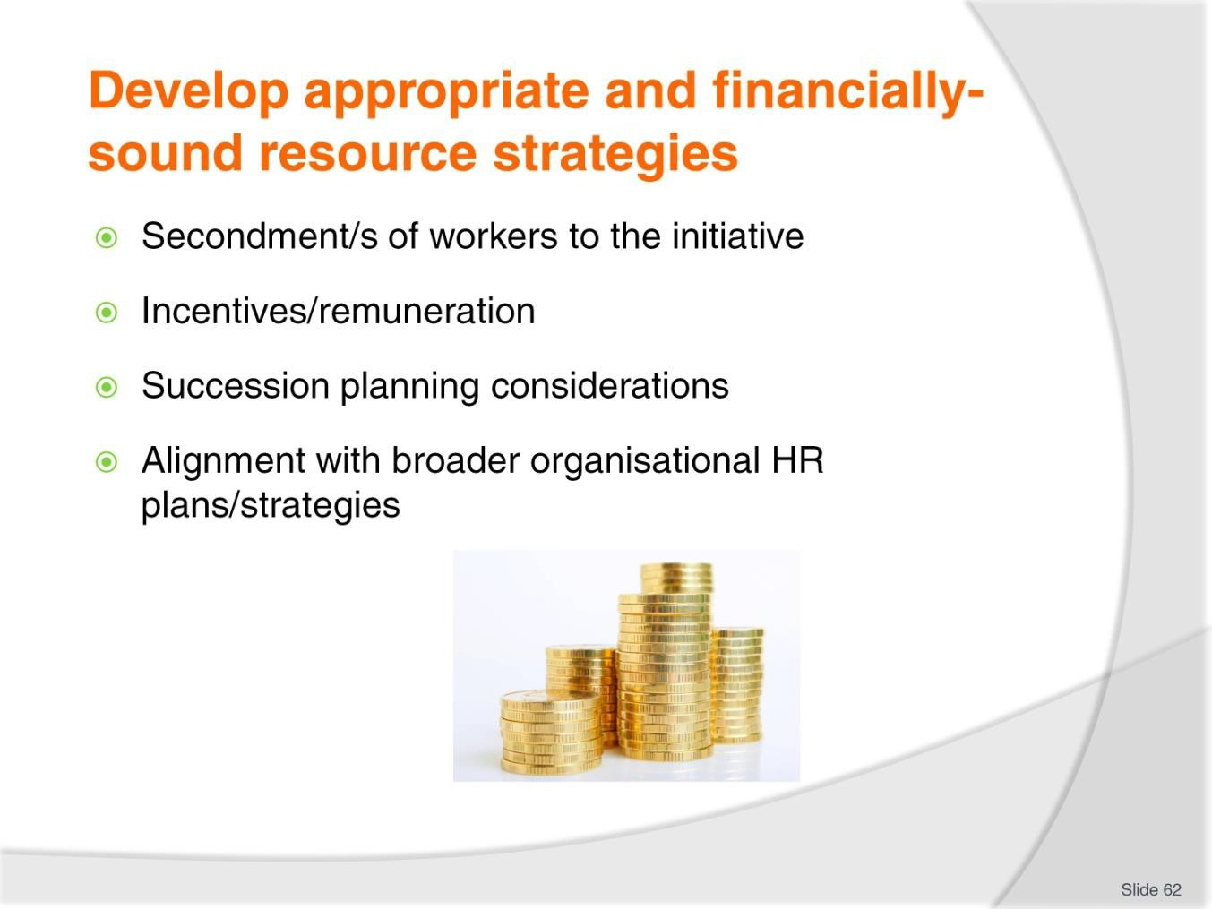
Slide No | Trainer Notes
62. | Trainer continues discussing human resource strategies:  - Secondment of employees to the project  - Incentives/remuneration adjustments to be paid to those working on the initiative – where/if applicable (such as ‘higher duties’ payments)  - Considerations in relation to internal succession planning for the organisation  - Alignment of HR actions and decisions with umbrella HR plans.

Slide
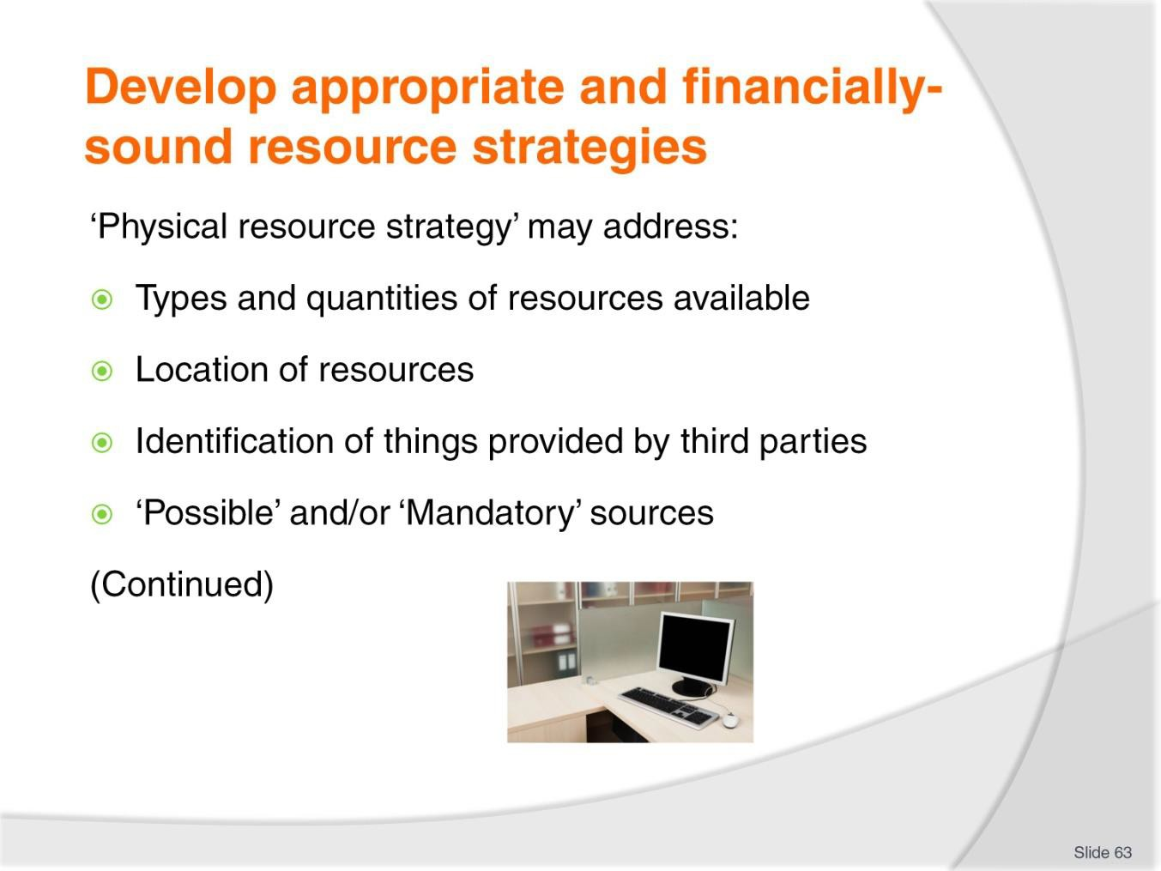
Slide No | Trainer Notes
63. | Trainer discusses resource strategies  Physical resource strategy  It is to be expected the physical resource strategy for an initiative might address:  - Types and quantities of resources available  - Location of resources  - Identification of resources which have been contributed by partners/external sources  - Where resources which need to be obtained can or must be sourced.

Slide
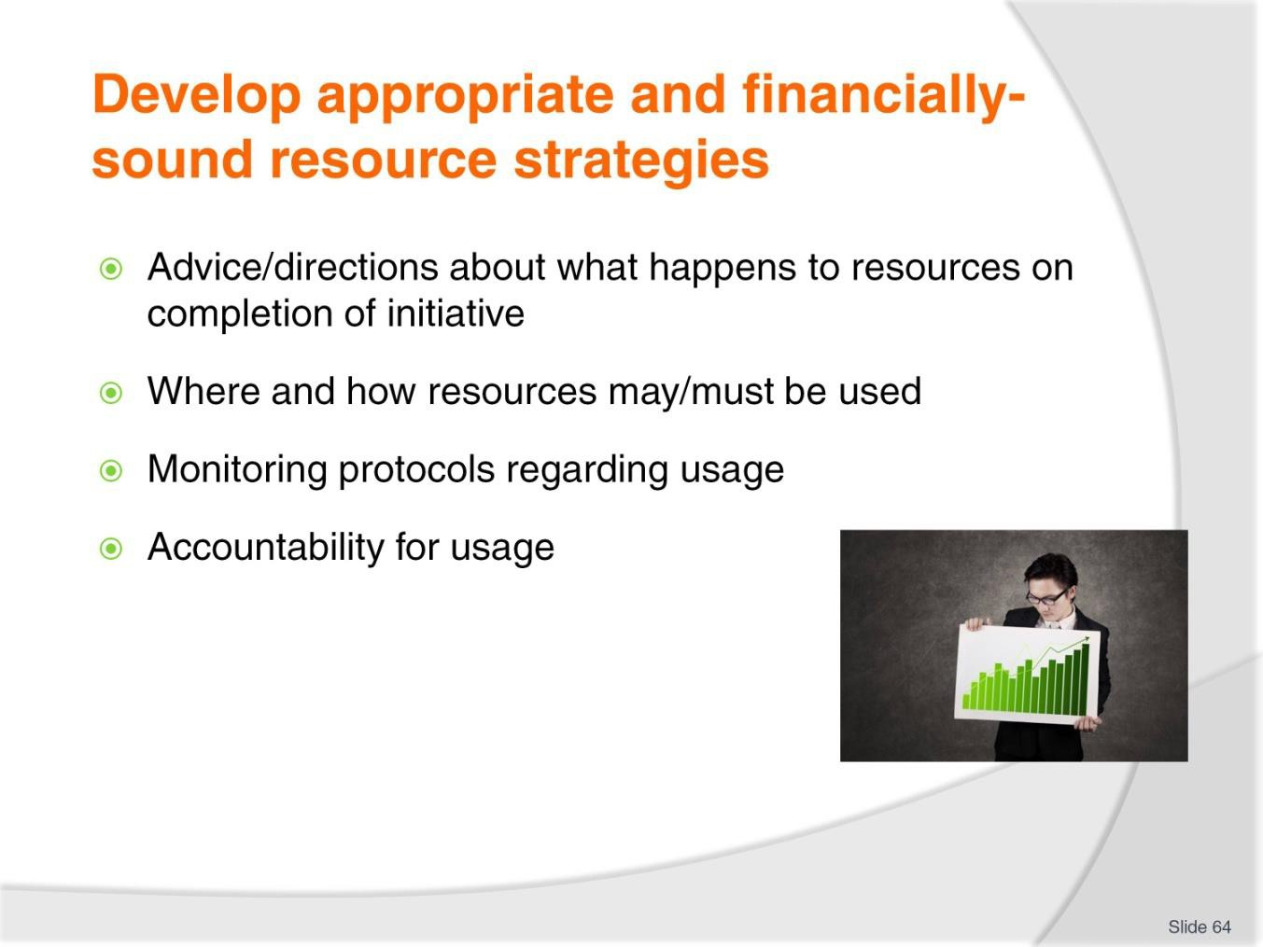
Slide No | Trainer Notes
64. | Trainer continues discussing physical resource strategies:  - Specification of what is to happen with physical resources when the initiative is complete – for example, disposed of/thrown out, sold, given to charity, returned to XYZ  - Where and how certain resources may/must be used  - Monitoring of resource usage  - Accountability for usage.

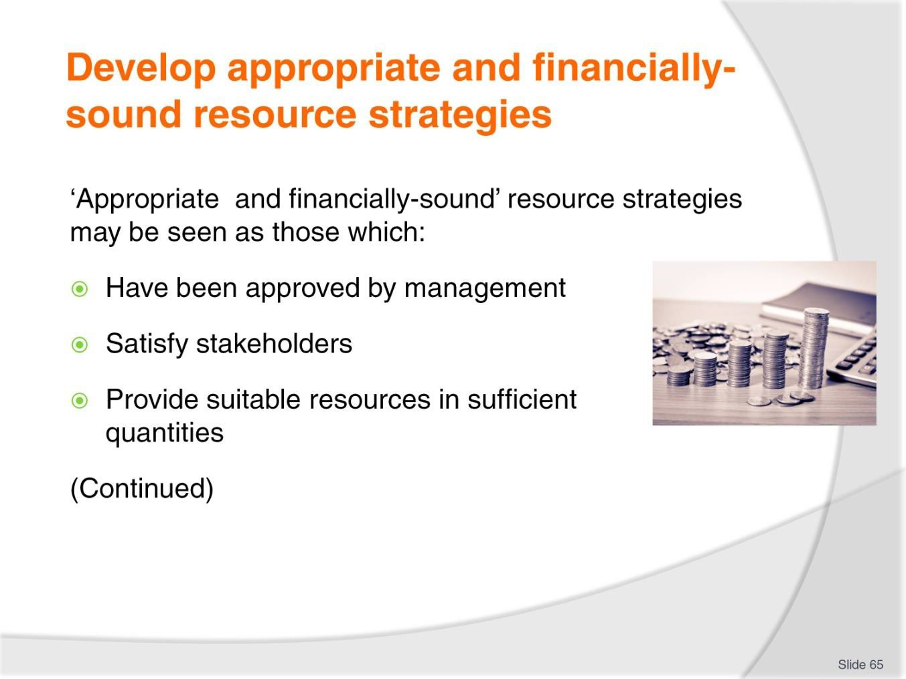
Slide
Slide No
Trainer Notes
65.
Trainer explains ‘appropriate and financially-sound’ resource strategies may be seen as those which:
- Have been approved by management
- Satisfy requirements of key stakeholders
- Provide suitable resources in sufficient quantities.

Slide
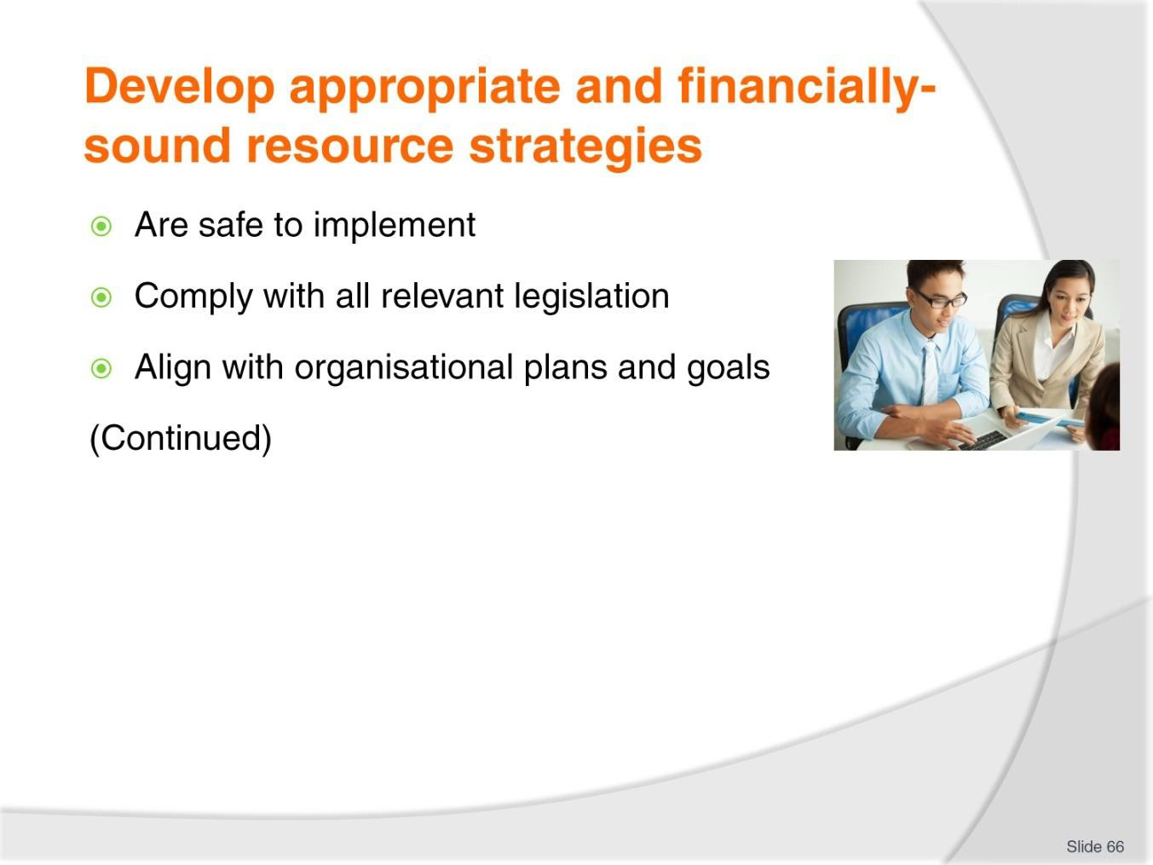
Slide No | Trainer Notes
66. | Trainer continues explaining ‘appropriate and financially-sound’ resource strategies may be seen as those which:  - Are safe to use/implement  - Comply with all legislated obligations  - Align with company goals, objectives, higher-level plans and public statements.

Slide
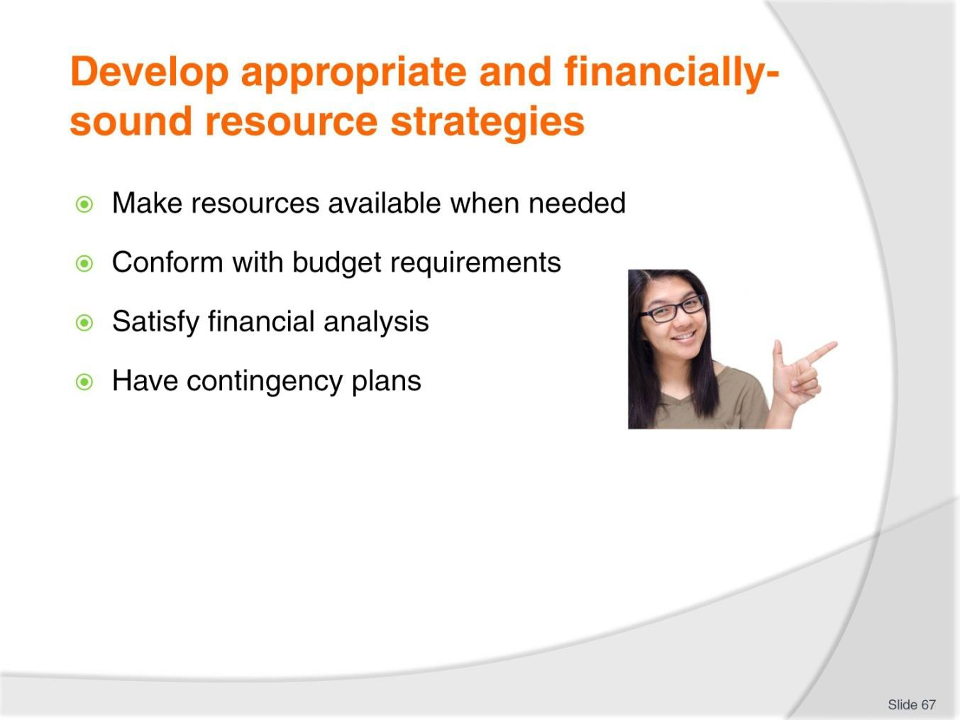
Slide No | Trainer Notes
67. | Trainer continues explaining ‘appropriate and financially-sound’ resource strategies may be seen as those which:  - Make resources available when needed  - Conform with budgetary limitations  - Have been subjected to required analysis – which may include:  - Cost-Benefit analysis  - ROI  - Have contingency plans developed for them.  Classroom Activity – Internet research  Trainer supervises internet research on relevant websites for items identified above, such as:  - http://www.mindtools.com/pages/article/newTED_08.htm - Cost-Benefit analysis  - http://management.about.com/cs/money/a/CostBenefit.htm - Cost Benefit analysis  - https://www.business-case-analysis.com/return-on-investment.html - ROI explained.

Slide
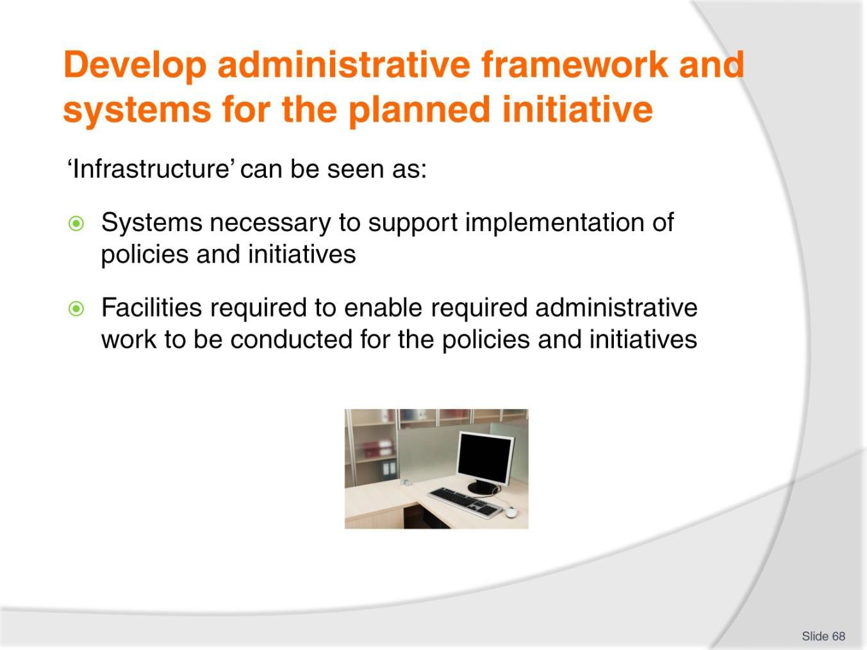
Slide No | Trainer Notes
68. | Trainer defines ‘infrastructure’ noting in this context it can be seen as:  - Systems necessary to support implementation of policies and initiatives  - Facilities required to enable required administrative work to be conducted for the policies and initiatives.

Slide
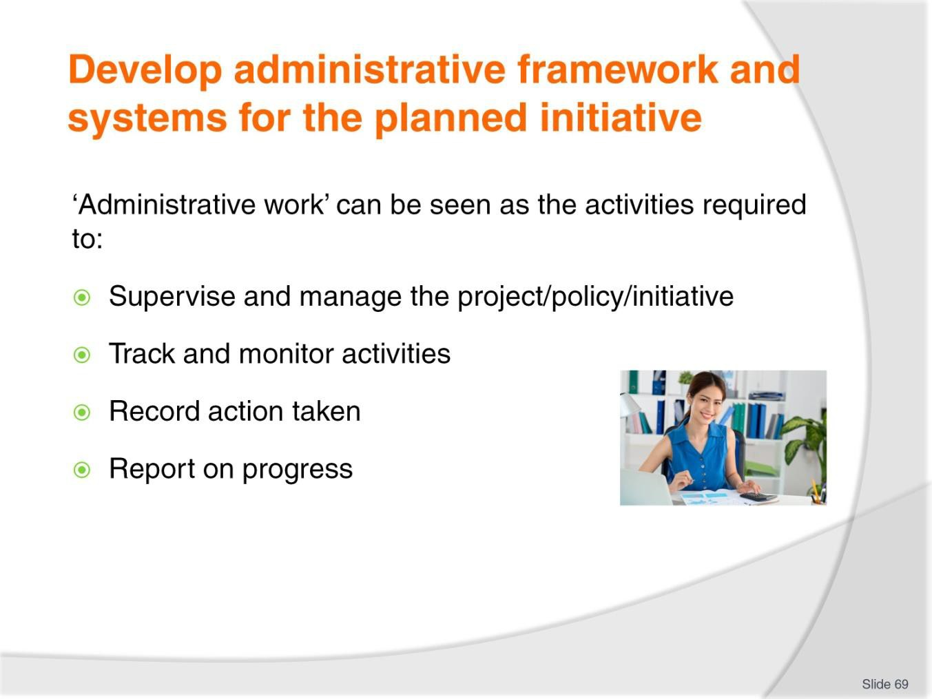
Slide No | Trainer Notes
69. | Trainer explains ‘Administrative work’ can be seen as the activities required to:  - Supervise and manage the project – to enable suitable implementation of policy and conduct of the initiative  - Track and monitor activities – so there is oversight of all nominated aspects and progress is examined to identify variations from projections/expectations at the earliest opportunity so corrective action can be taken  - Record action taken – so an accurate and up-to-date database of information is established and maintained for the project  - Report on progress – using factual data to form the basis of information sharing to relevant stakeholders.

Slide
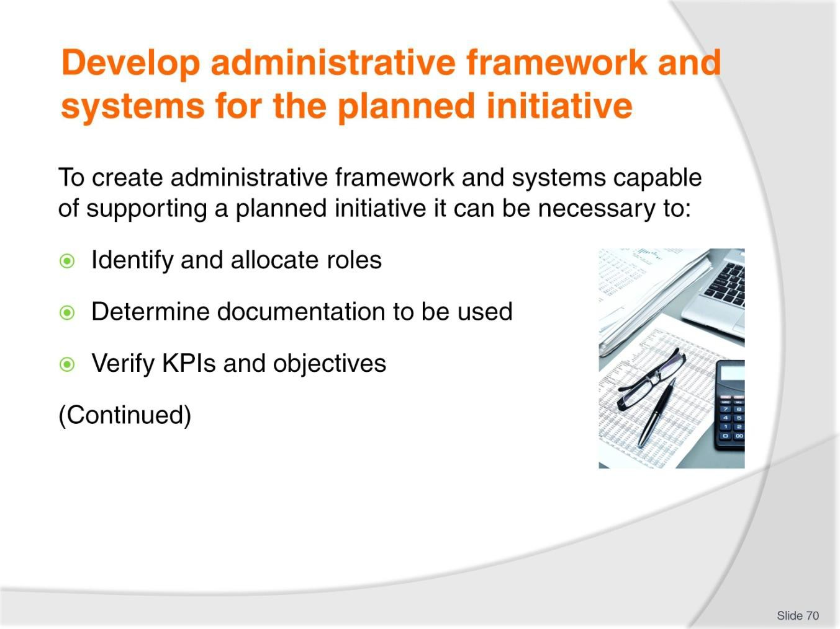
Slide No | Trainer Notes
70. | Trainer highlights in order to create an effective administrative framework and systems capable of supporting a planned initiative it can be necessary to:  - Identify and allocate roles for the initiative – so there is clarity regarding responsibilities for action required  - Determine documentation to be used – which may mean:  - Developing new forms  - Deciding on the use of existing internal paperwork  - Verify KPIs and planned objectives have been addressed – to ensure all aspects of the policy/initiative can be covered by administrative duties.

Slide
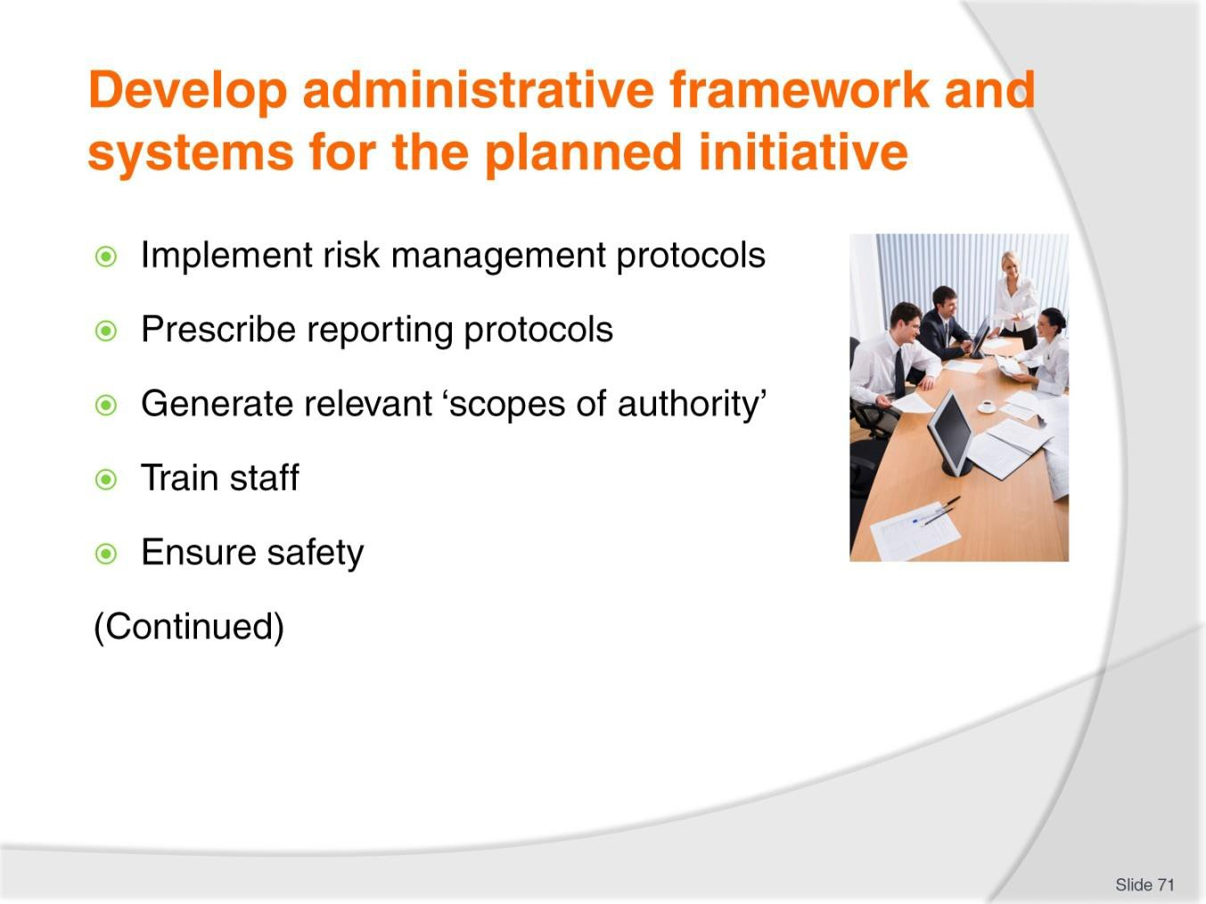
Slide No | Trainer Notes
71. | Trainer continues explaining to create an effective administrative framework and systems capable of supporting a planned initiative it can be necessary to:  - Implement relevant risk management – as appropriate to issues where this action is deemed necessary  - Prescribe reporting protocols – with reference to:  - Timing of reports  - Nature of the reporting mechanism/s  - Generate scopes of authority for policy-specific issues  - Train staff – in required practices as they apply to the initiative  - Ensure safety provisions – for all aspects of the project.

Slide
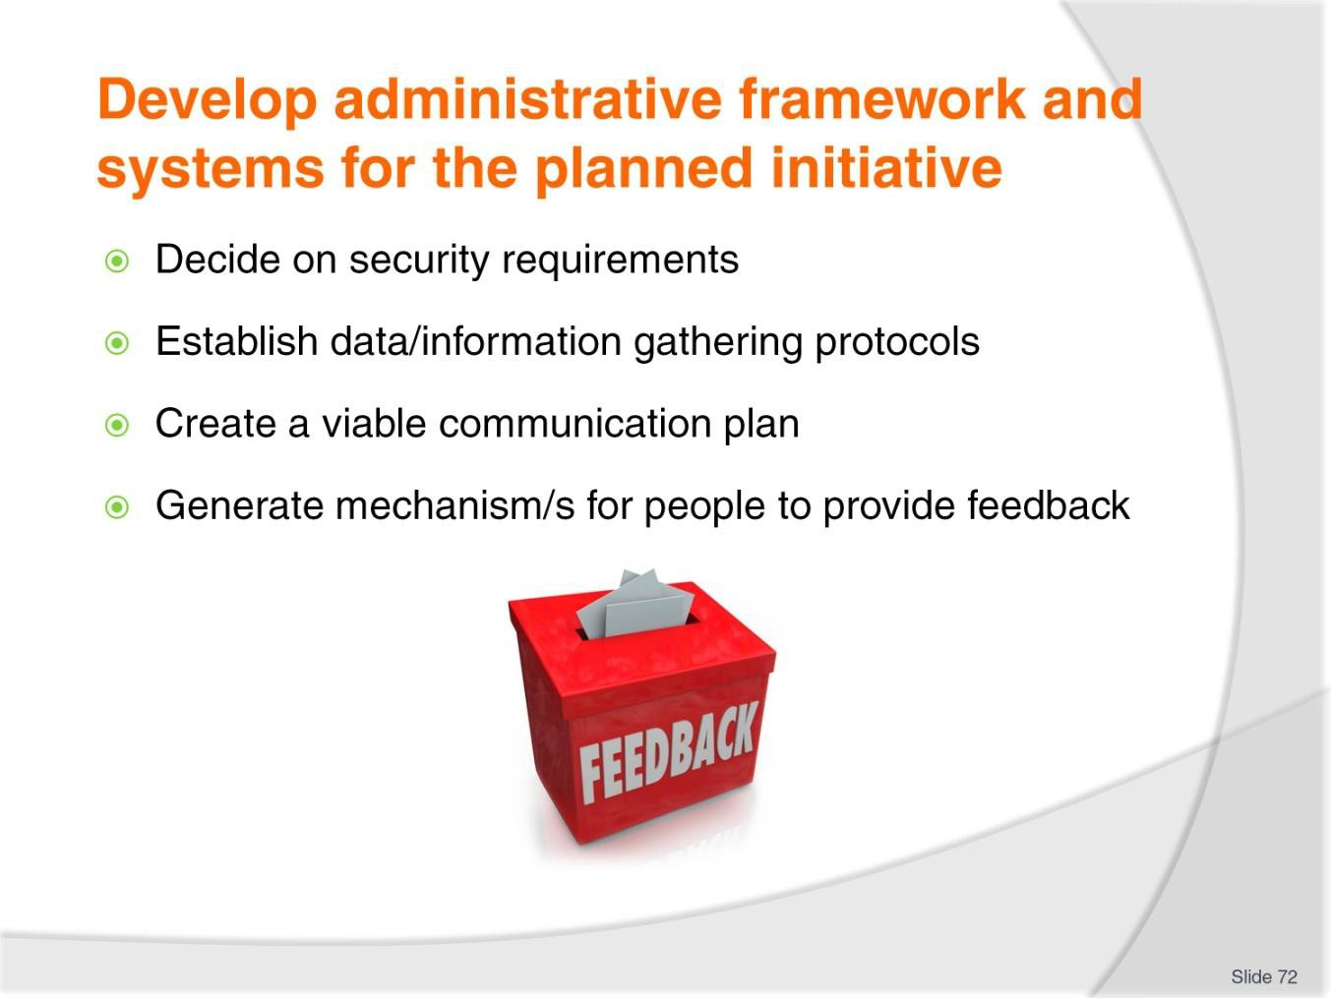
Slide No | Trainer Notes
72. | Trainer continues explaining to create an effective administrative framework and systems capable of supporting a planned initiative it can be necessary to:  - Decide on security protocols – to safeguard information captured/generated by administration  - Set up suitable data/information gathering options and procedures – to ensure all identified materials are captured and recorded  - Establish a viable communication plan – to exchange information between stakeholders  - Create a system for users and customers to provide feedback – if they:  - Identify a problem or issue  - Have a suggestion/recommendation to make.

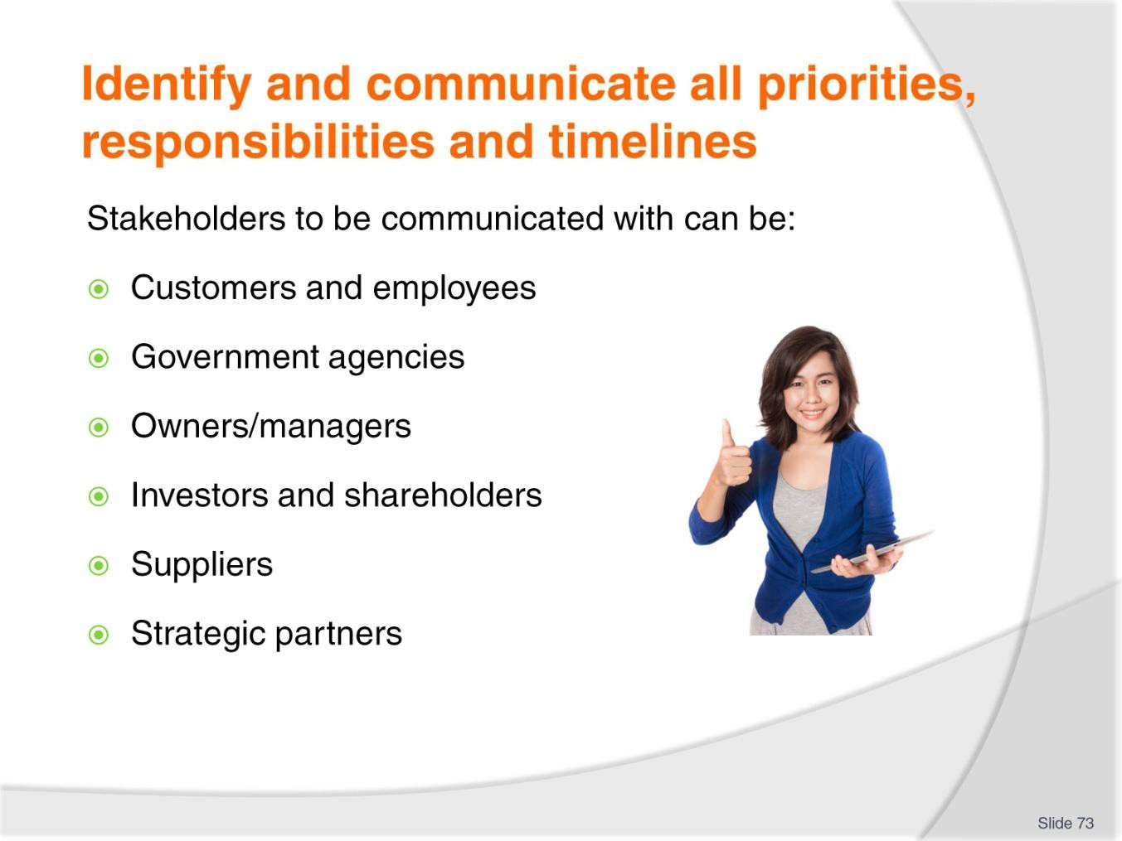
Slide
Slide No
Trainer Notes
73.
Trainer reminds of possible stakeholders:
- Customers
- Employees
- Government agencies
- Owners and/or The Board of Management within the organisation
- Investors and shareholders
- Suppliers
- Strategic alliance partners.

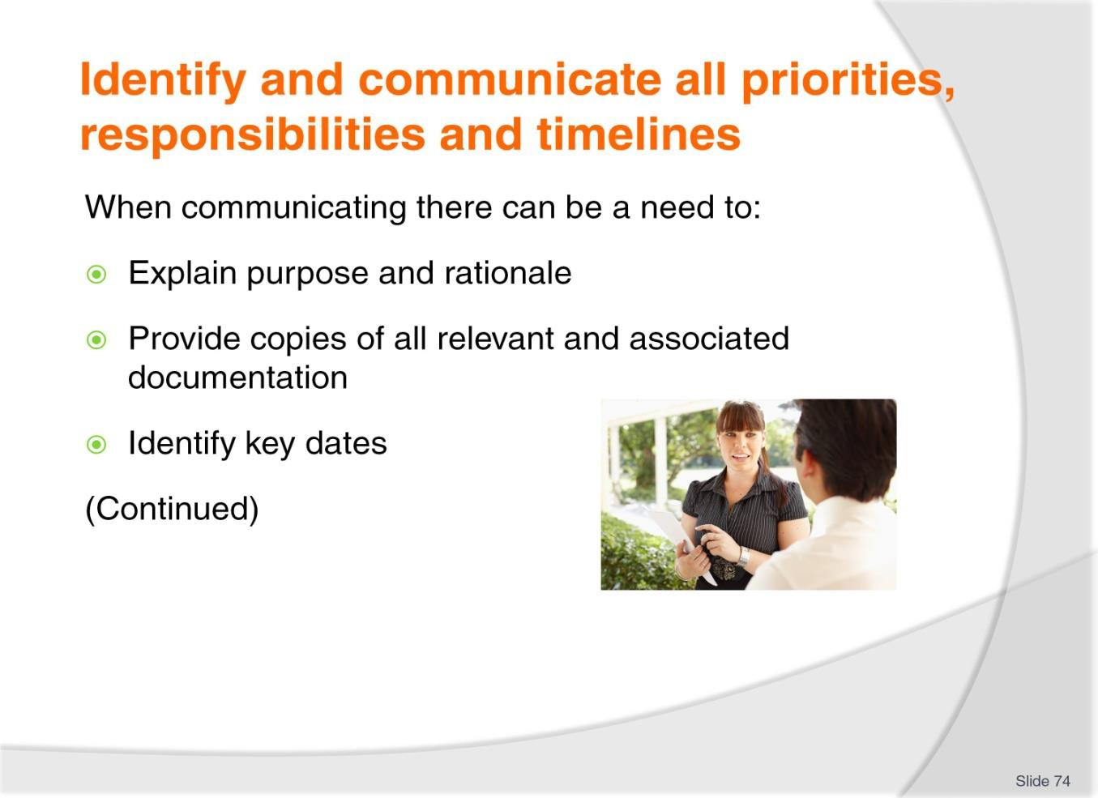
Slide
Slide No | Trainer Notes
74. | Trainer indicates when communicating with stakeholders there is a need to:  - Present the purpose of the operational initiative and also explain why it will be beneficial/has been introduced  - Give staff everything relevant to the initiative and the applicable to their area of work – which might include:  - Copies of plans from which policies flowed  - Copies of standards which apply to the initiative  - Copies of all relevant policies  - Copies of procedures which are based on the policies  - Identify dates relevant to the policy – which will commonly relate to:  - Implementation and introducing the initiative  - Transitional periods  - Dates for evaluation of KPIs  - Review dates  - Monitoring activities  - Reporting  - Completion  - Final analysis.

Slide
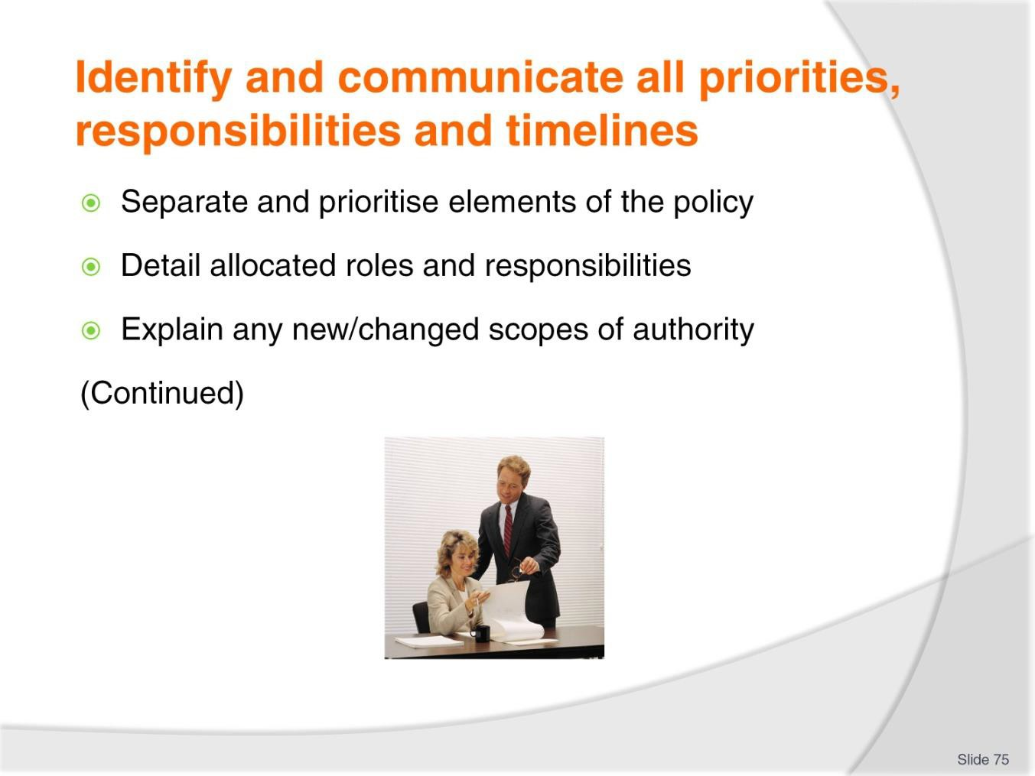
Slide No | Trainer Notes
75. | Trainer indicates when communicating with stakeholders there is a need to:  - Separate and prioritise elements of the policy (where applicable) – so stakeholders understand the relative importance for each of the components  - Detail the allocated roles and responsibilities – which attach to individuals under the policy  - Explain any new/changed scopes of authority – which attach to roles and responsibilities created under the policy.

Slide
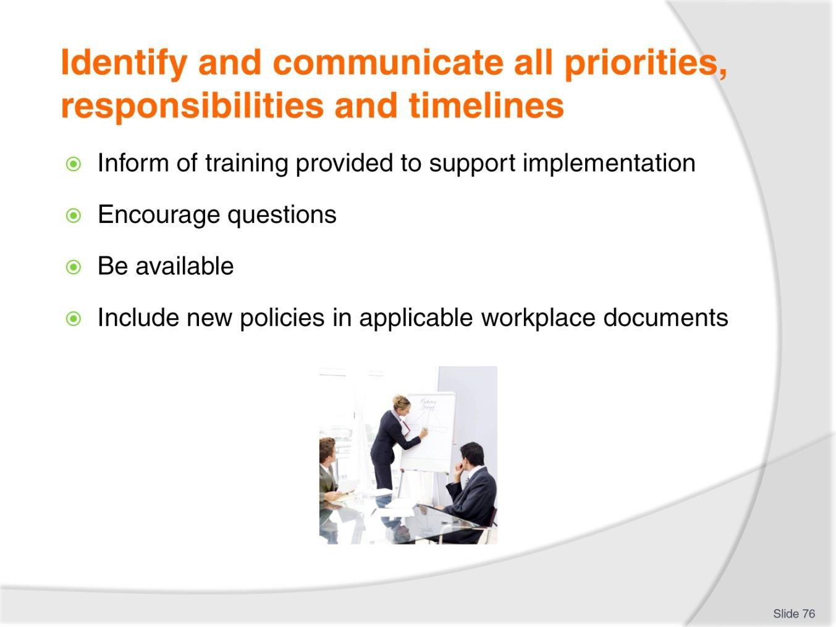
Slide No | Trainer Notes
76. | Trainer indicates when communicating with stakeholders there is a need to:  - Inform of training provided to support implementation of the policy/project  - Encourage questions about the operational policy  - Be available – for later discussions if individuals have concerns/need more detail  - Include new policies in applicable workplace documents – such as operational manuals, induction programs and in-house training.

Slide
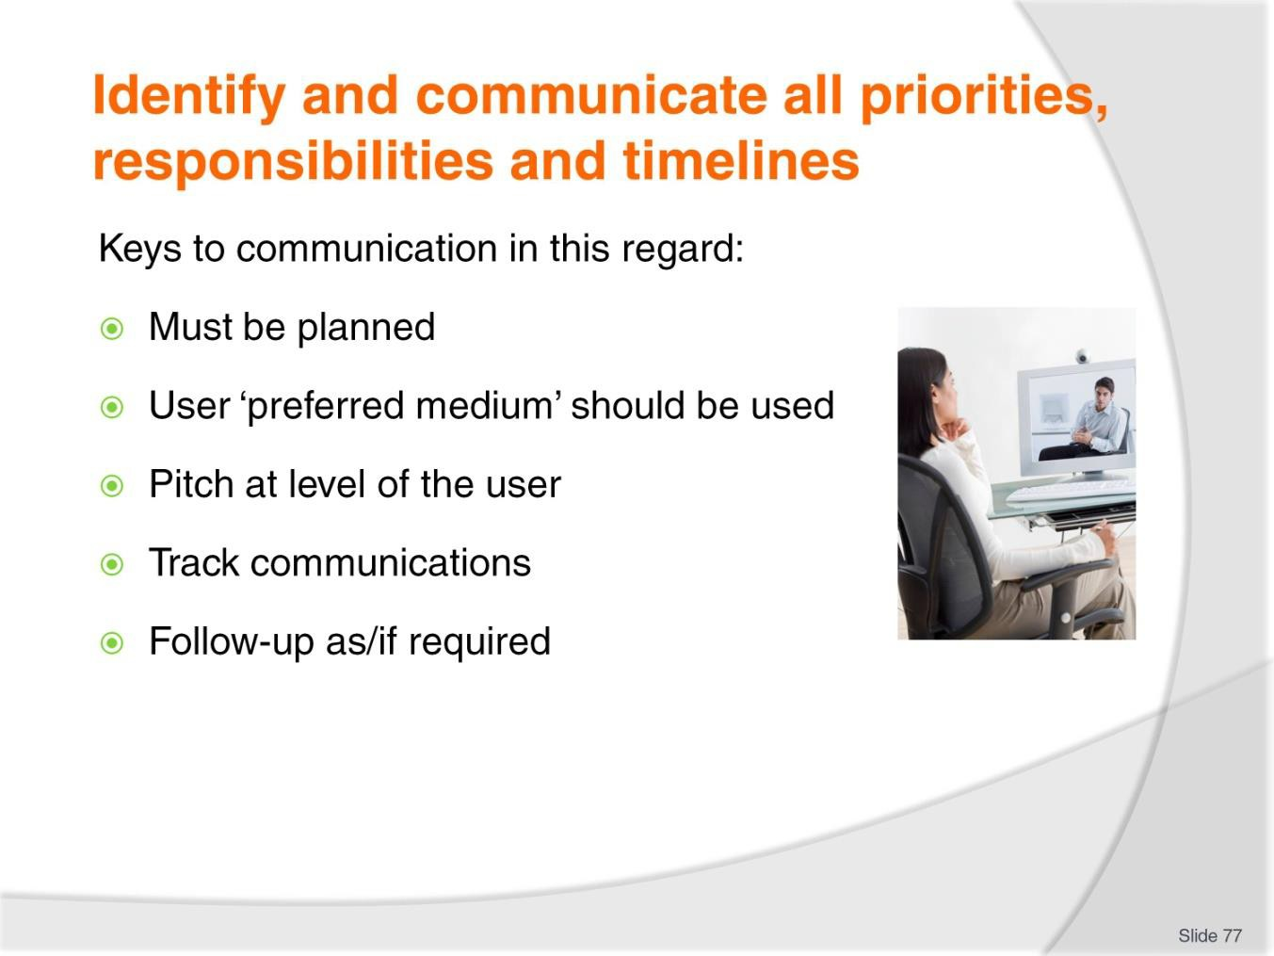
Slide No | Trainer Notes
77. | Trainer discusses guidelines for communication noting the communication of new (or revised) operational policies (or strategies or initiatives) may occur in various ways.  Keys  Keys to communicating are:  - The communication must be planned – effective communication never ‘just happens’  - The communication method/medium preferred by the stakeholder should be used – to demonstrate respect for their stated preferences  - Communications should be pitched at the level of the recipient – to optimise likelihood of people reading and understanding what is being provided  - A track must be kept of those who are contacted – so a record of the communication is maintained and/or available  - Follow-up must occur – in situations where:  - There is difficulty contacting a person  - Questions/issues are raised  - More information/explanation is requested.

Slide
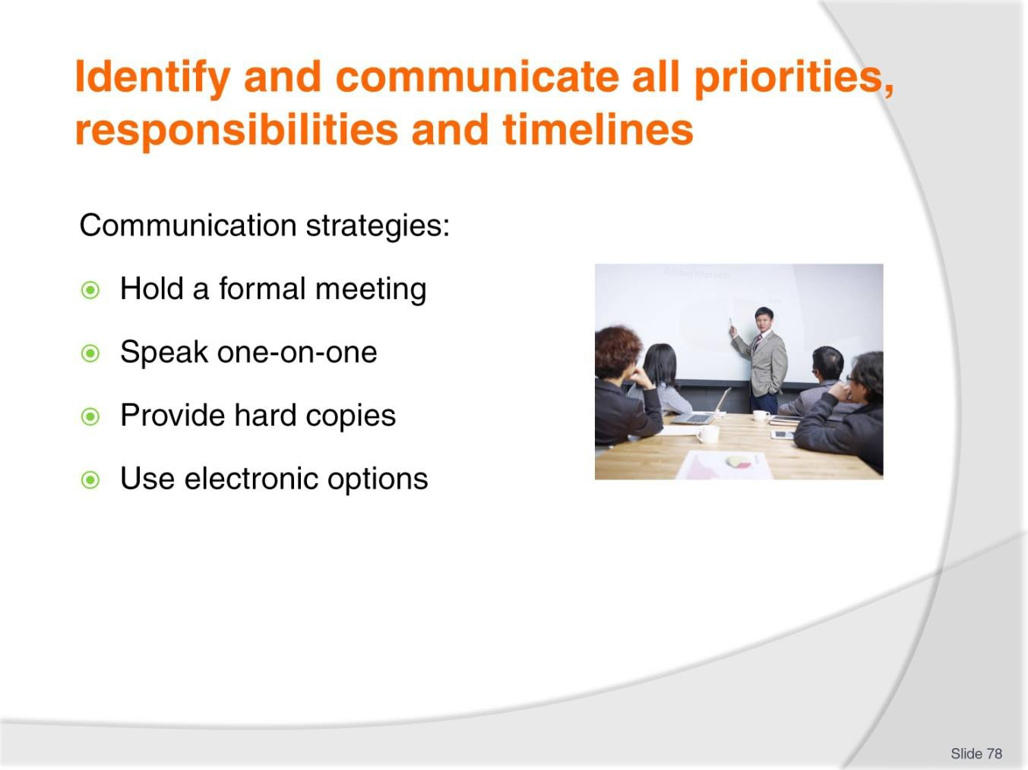
Slide No | Trainer Notes
78. | Trainer presents strategies for communication in this regard:  - Hold a formal meeting (or series of meetings) to inform stakeholders of the operational initiative – this could/should feature:  - Verbal explanation  - PowerPoint presentation  - Hard copy handouts  - A Q&A session  - Speak to key stakeholders on a one-on-one basis – to personalise the delivery and allow a more individualised approach.  - This may include face-to-face discussions with external and internal people, as appropriate to the nature of the policy/initiative  - Provide hard copy documents – without more formal contact, which may mean:  - Mailing documents to recipients  - Hand-delivering documents  - Posting documents on restricted access intranet sites  - Use electronic options – where these have been indicated as a preferred communication option.  - Include attachments of documents as necessary.

Slide
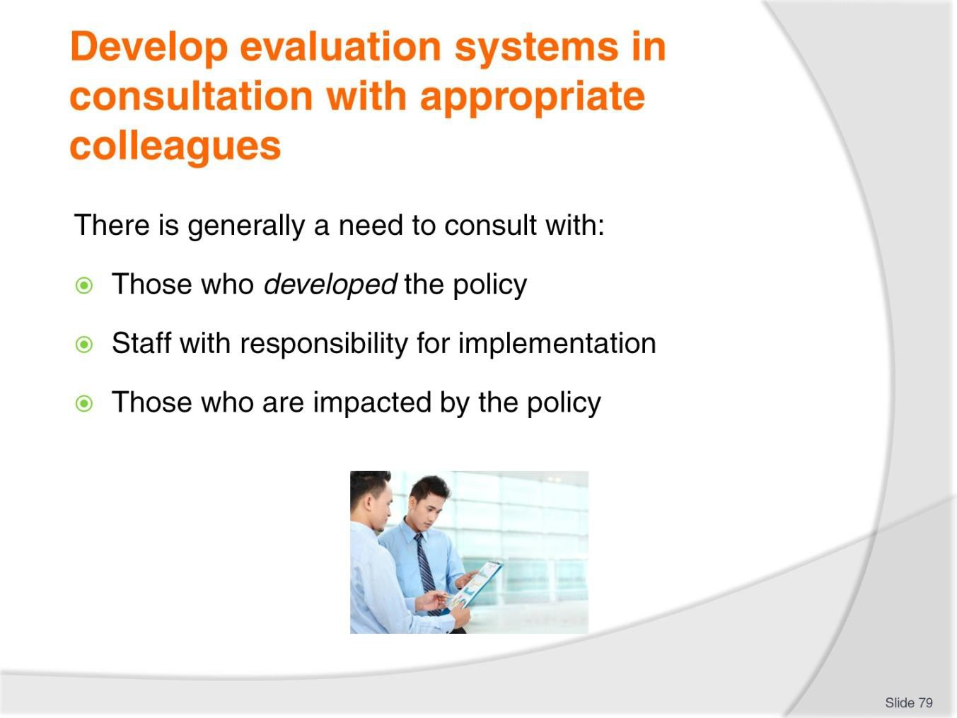
Slide No | Trainer Notes
79. | Trainer states the procedures to be used when evaluating a policy should be developed in consultation with ‘appropriate colleagues’. These should/could be:  - Those who were involved in developing the policy  - Staff with responsibility for applying/implementing the policy  - Those who were impacted by the operation of the policy.  Note: some organisations will separate the functions of development of policy from the evaluation of policy believing this approach helps avoid people with vested interests covering up (or ‘fudging’) unsatisfactory/unacceptable outcomes.

Slide
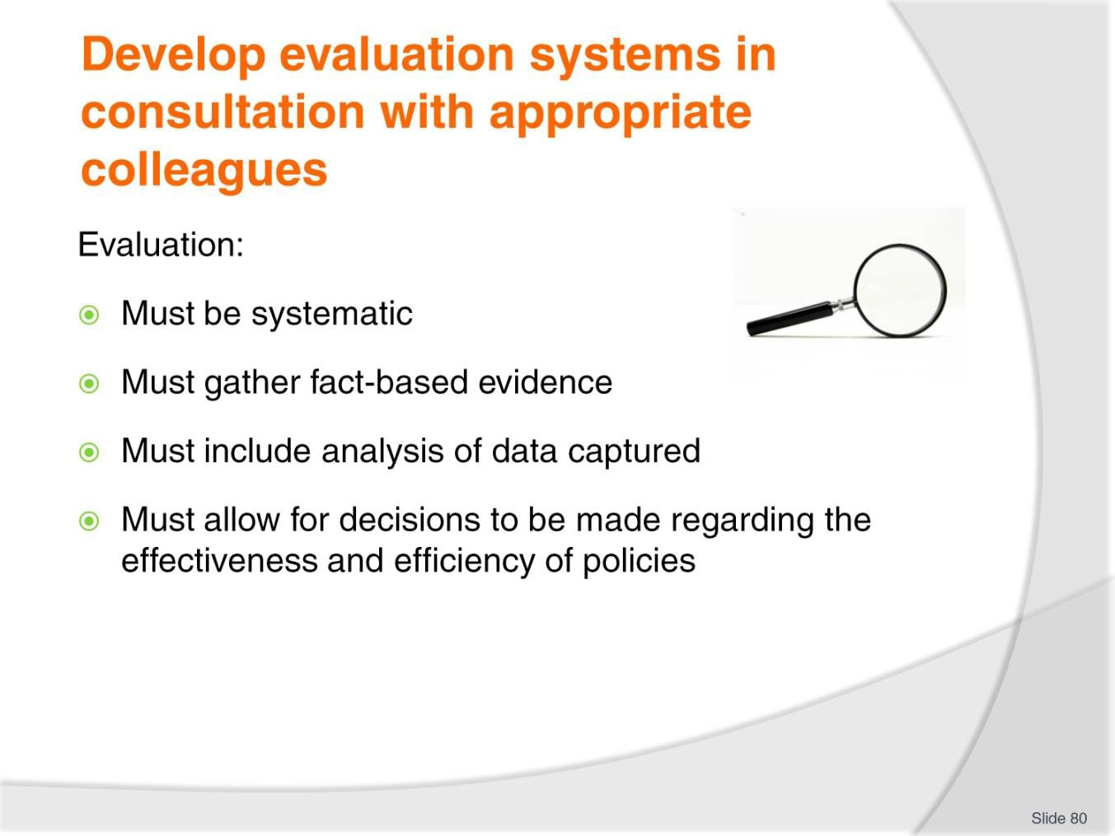
Slide No | Trainer Notes
80. | Trainer defines ‘evaluation’:  Evaluation defined  ‘Evaluation’ in this context may be seen as a systematic gathering and analysis of information (data, opinions, fact, statistics) to allow evidence-based judgements to be made about the extent to which a policy has been effective, appropriate and/or efficient when compared to its original objective/s.

Slide
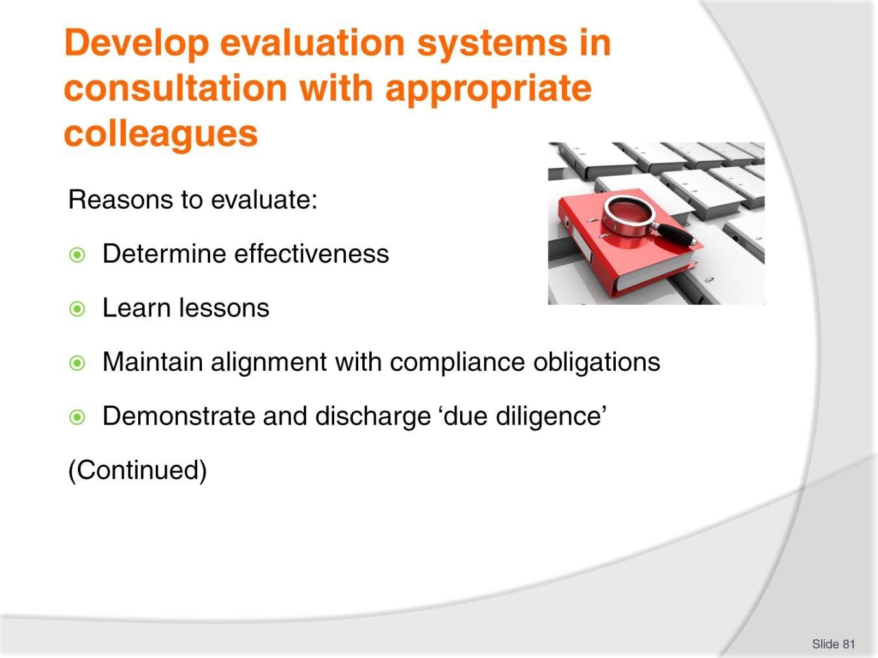
Slide No | Trainer Notes
81. | Trainer observed it is important to evaluate operational polices in order to:  - Determine their effectiveness  - Learn lessons which may be able to be transferred to other policies and/or other areas  - Maintain alignment with compliance obligations  - Demonstrate and discharge ‘due diligence’.

Slide
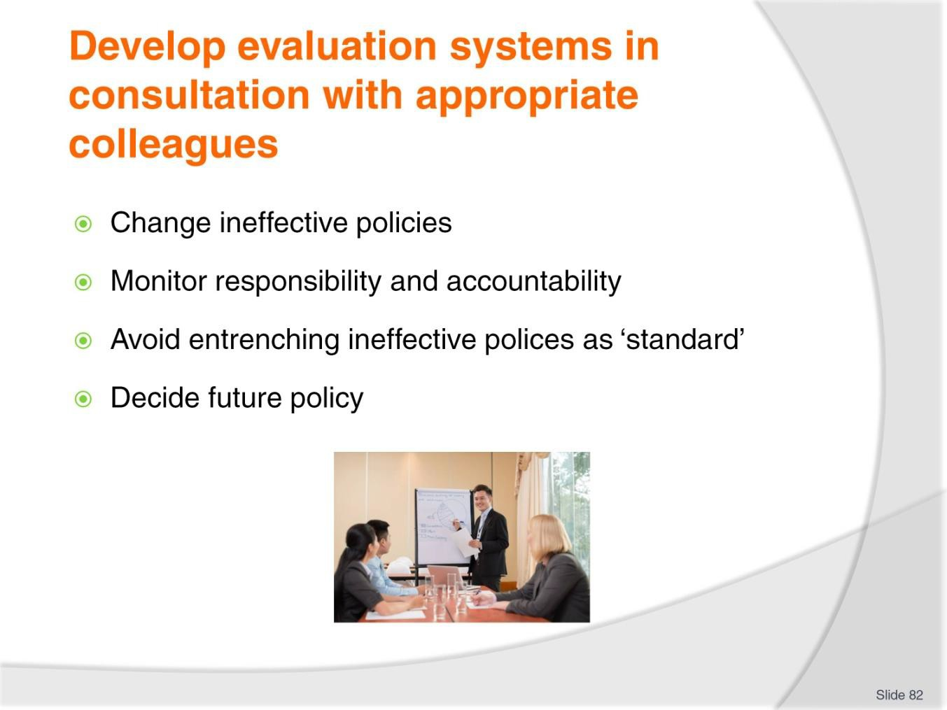
Slide No | Trainer Notes
82. | Trainer explains reasons to evaluate:  - Change ineffective policies so they become more effective  - Monitor responsibility and accountability issues relevant to the focus of the policy  - Avoid a situation where ineffective policies become entrenched as standard  - Decide the future for the policy – with options being:  - Leave the policy ‘as is’  - Amend one or more aspects of the policy  - Delete the policy from operational use.

Slide
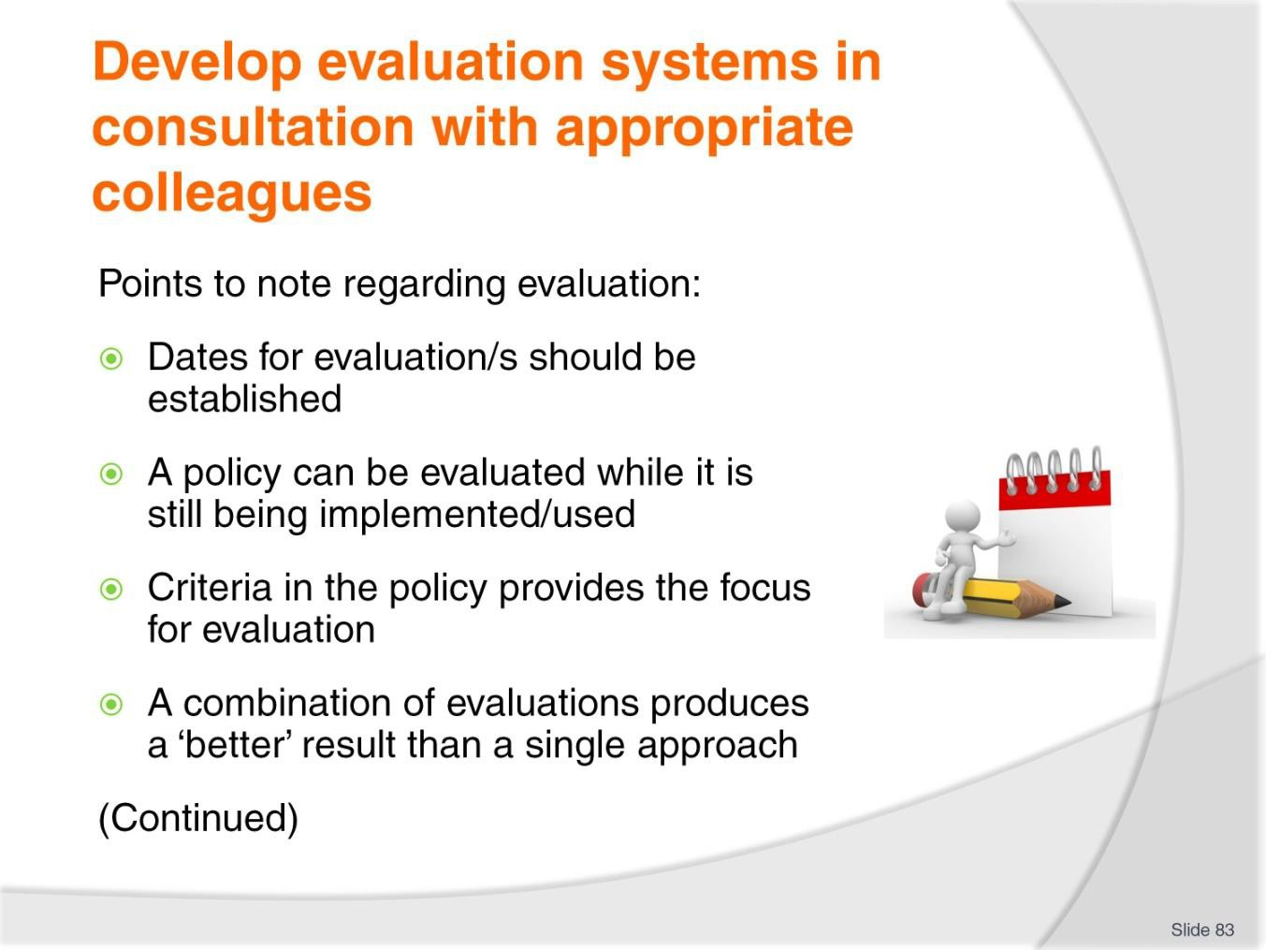
Slide No | Trainer Notes
83. | Trainer presents points to note regarding evaluation:  - Dates for evaluation/s should be established as part of the policy development process – to a schedule is set and the evaluation aspect is not forgotten/overlooked  - A policy can be evaluated while it is still being implemented/used – the evaluation does not have to wait until the policy has been retired  - The development phase should include establishing the criteria which will be used for the evaluation – these are commonly stated in/inherent within:  - Objectives for the policy/initiative  - KPIs  − The more tightly written these two elements are, the easier it will be to conduct the evaluation as the standards for the evaluation will be more certain/obvious  - A combination of evaluation approaches achieves optimum results – as opposed to relying only on one method of evaluation: see following section.

Slide
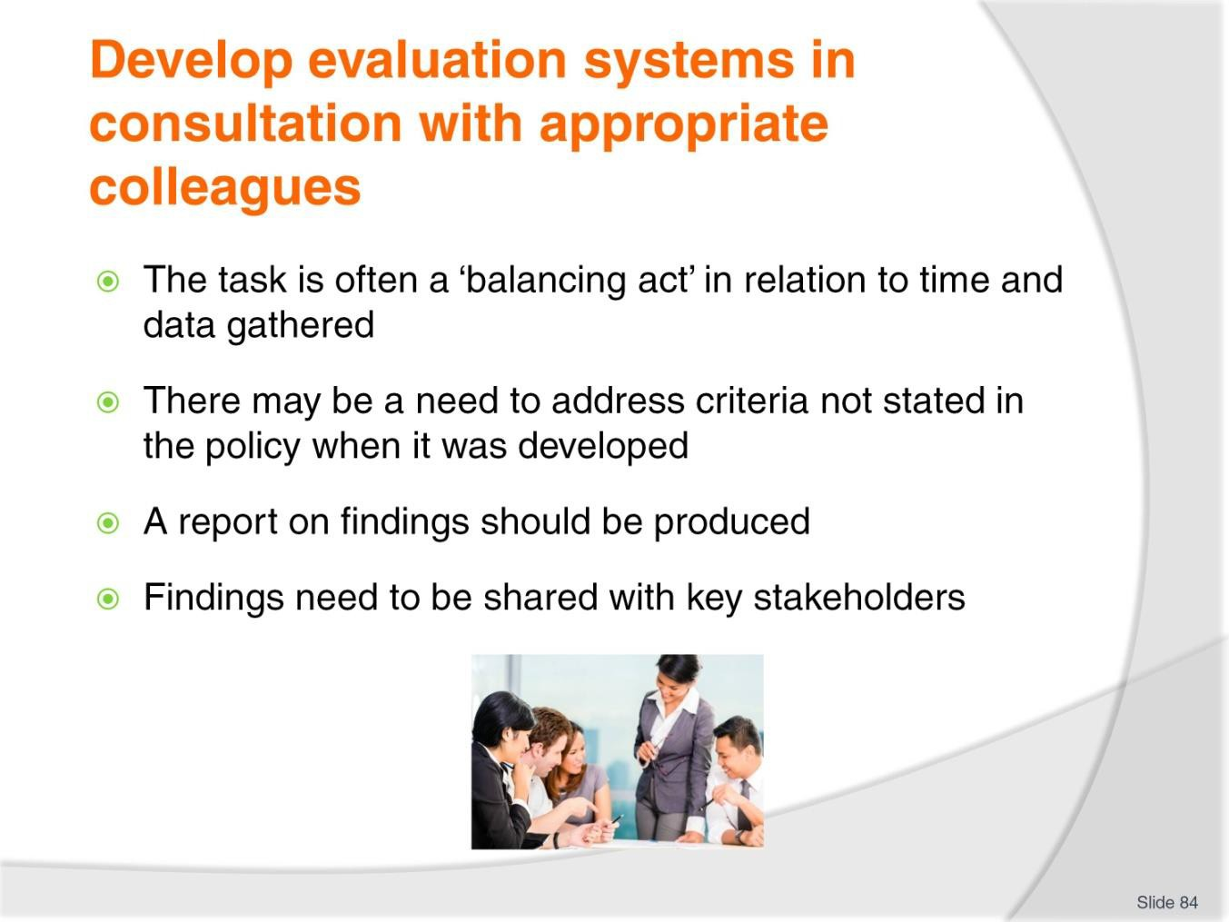
Slide No | Trainer Notes
84. | Trainer presents points to note regarding evaluation:  - The evaluation process for policies is often a balancing act – in that:  - There is often little time or funds available for the evaluation process  - Subjective evidence is easy to acquire but may introduce unacceptable bias in the outcomes deduced  - Objective data based on scientific/mathematical precepts can be (too) costly and time consuming to produce given the importance of the policy  - Times change – an operational policy may have been professionally and expertly developed six months ago but be inappropriate to the internal and external conditions which apply now.  - This highlights not all criteria which should be used to determine the effectiveness of a policy may have been included when the policy was written  - A report on the evaluation should be produced – with appropriate recommendations based on the available data/information  - Results/findings should be shared – in order that:  - There is transparency regarding occurrences  - The organisation supports a learning culture characterised by continuous improvement.

Slide
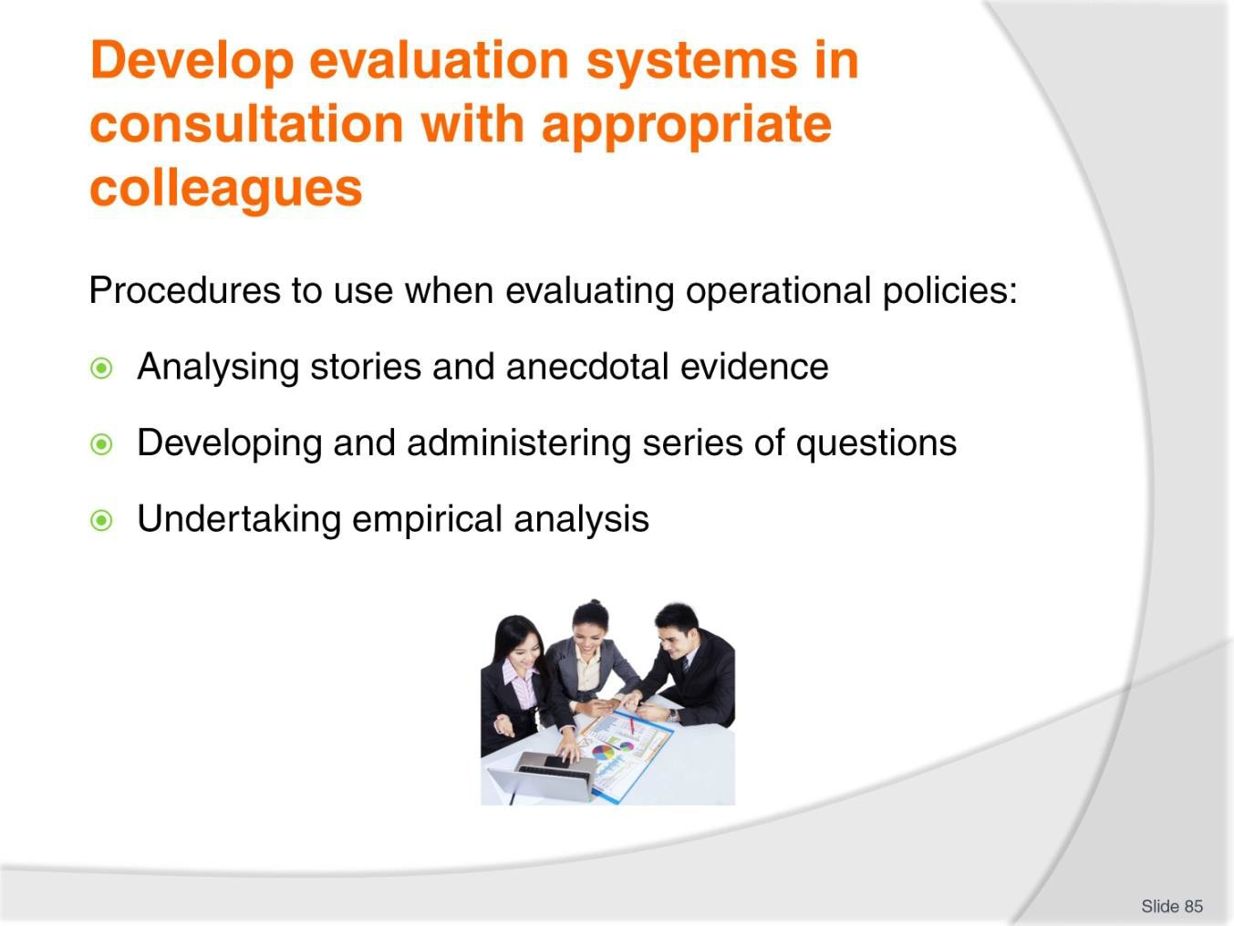
Slide No | Trainer Notes
85. | Trainer explains procedures which may be used to evaluate operational policies can include:  - Analysing stories and anecdotal evidence regarding a range of issues such as:  - Impact of the policy  - Ease/difficulty in implementing aspects of it/all of it  - Feedback received  - Developing and administering series of questions or a questionnaire – to elicit information on the factors deemed by the stakeholders to be important to the evaluation process  - Undertaking empirical analysis – which may feature:  - Comparisons of quantifiable projected and actual data – as set out in the KPIs and objectives for the policy/initiative  - Statistical manipulation – where certain data is manipulated to produce results deemed relevant for the purpose of the activity.

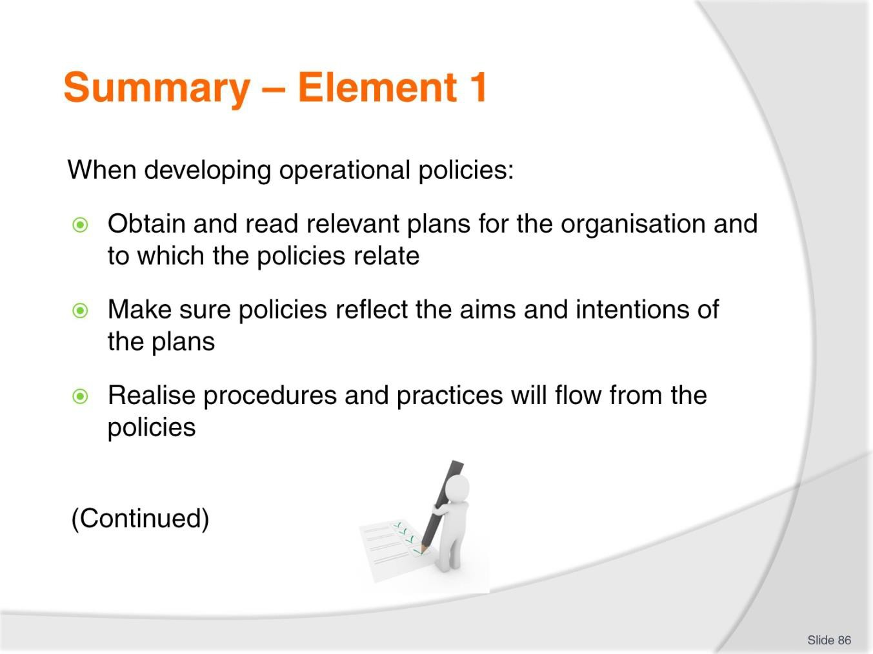
Slide
Slide No
Trainer Notes
86.
Trainer provides a recap of the Element asking questions to check trainee understanding and responding to questions from trainees, as required.

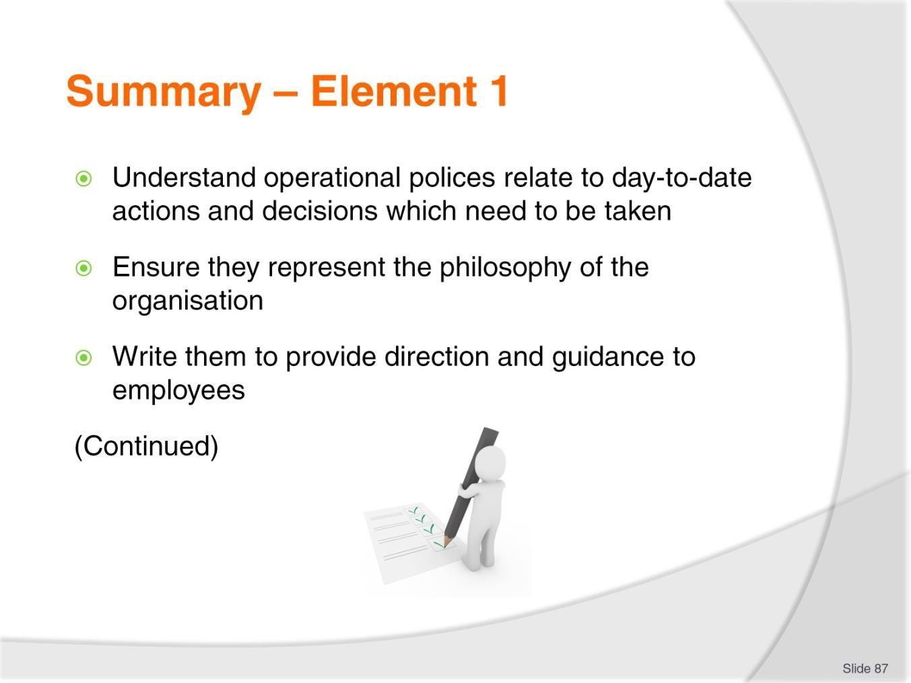
Slide
Slide No
Trainer Notes
87.
Trainer provides a recap of the Element asking questions to check trainee understanding and responding to questions from trainees, as required.

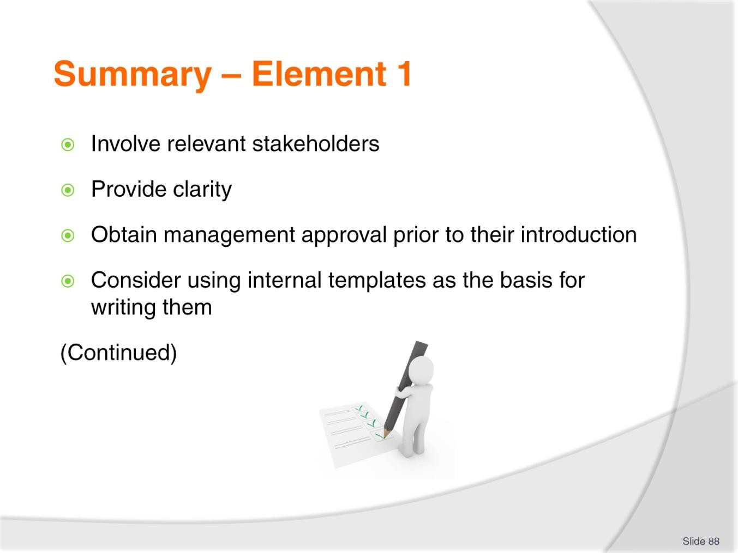
Slide
Slide No
Trainer Notes
88.
Trainer provides a recap of the Element asking questions to check trainee understanding and responding to questions from trainees, as required.

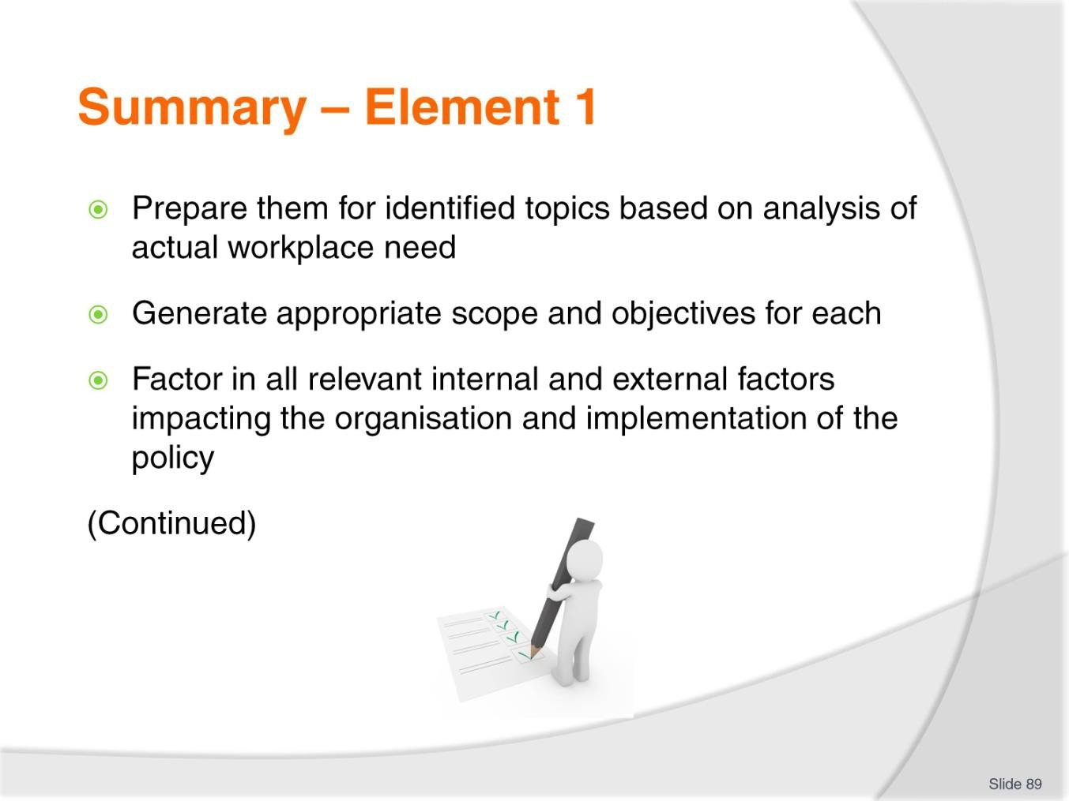
Slide
Slide No
Trainer Notes
89.
Trainer provides a recap of the Element asking questions to check trainee understanding and responding to questions from trainees, as required.

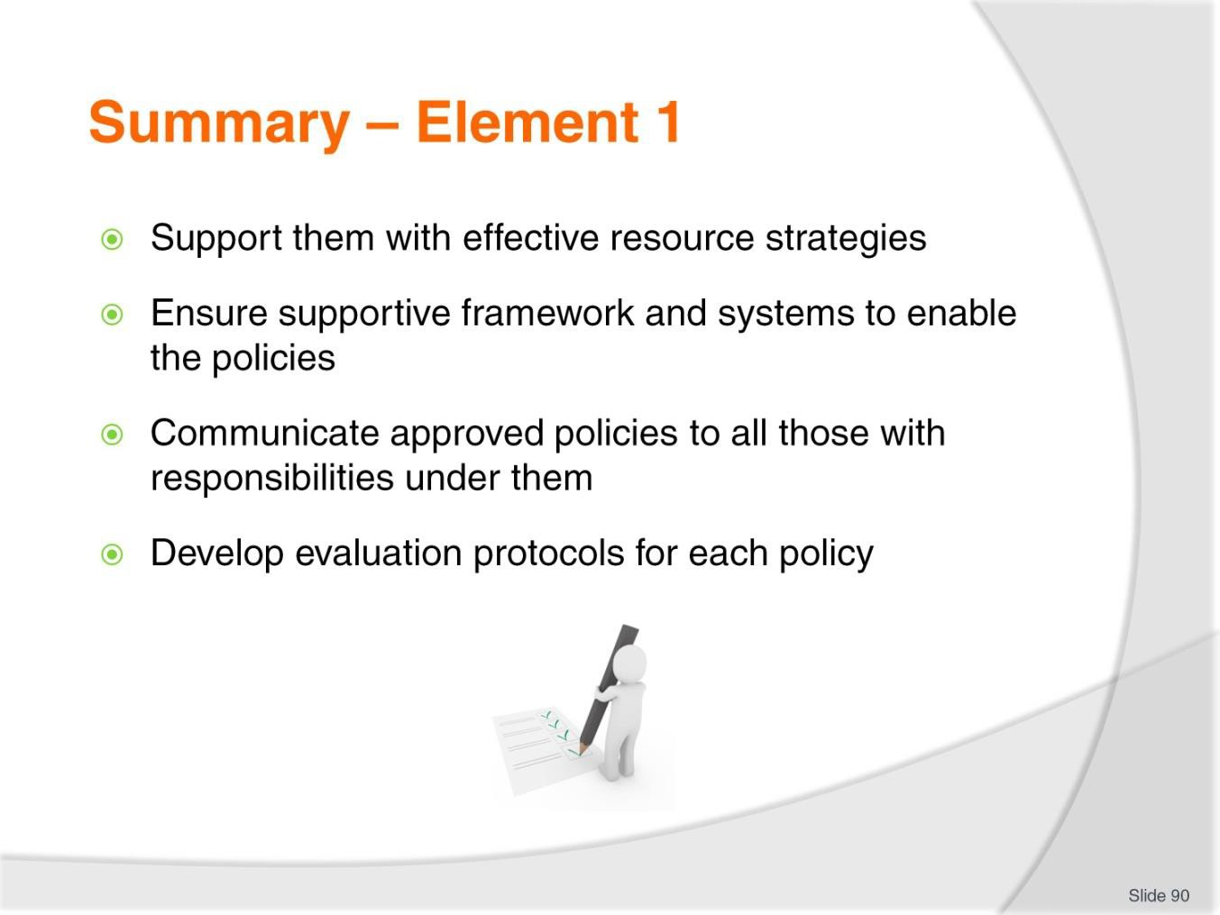
Slide
Slide No
Trainer Notes
90.
Trainer provides a recap of the Element asking questions to check trainee understanding and responding to questions from trainees, as required.

Slide
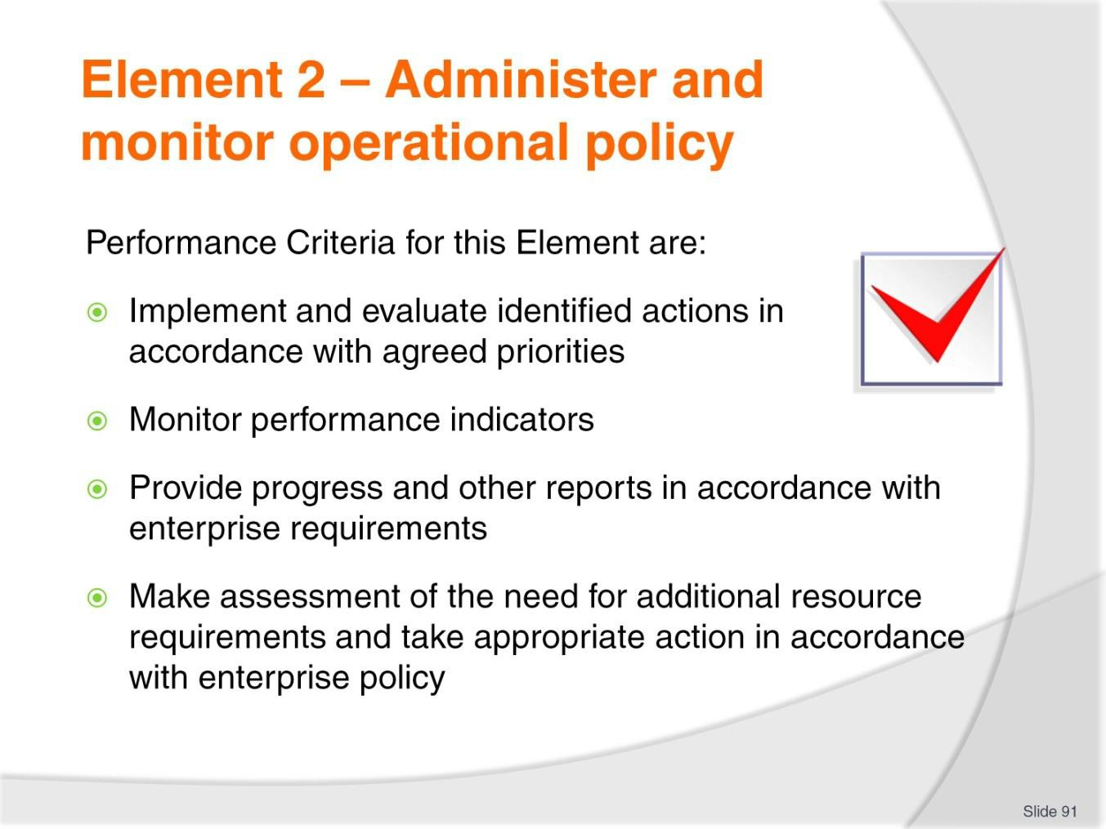
Slide No | Trainer Notes
91. | Trainer identifies for trainees the Performance Criteria for this Element, as listed on the slide.  Class Activity – General Discussion  Trainer leads a general class discussion by asking questions such as:  - What administration activities are inherent in implementation of workplace operational policies?  - How might implementation of workplace operational policies be monitored?  - Why is there a need to monitor implementation?

Slide
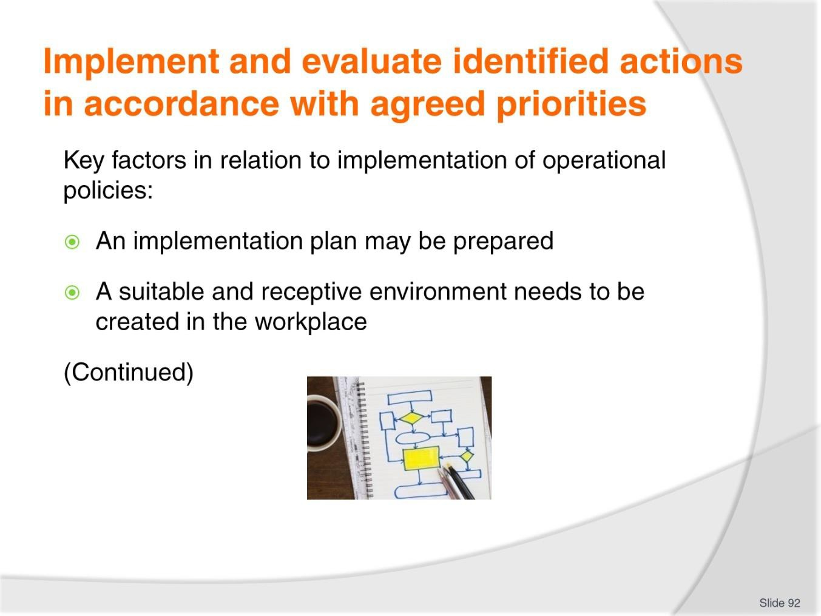
Slide No | Trainer Notes
92. | Trainer presents key factors in relation to implementation of operational policies are:  - An implementation plan may be prepared – for the introduction/implementation of a policy.  - This is SOP for the introduction/implementation of many workplace initiatives but not so common where polices are concerned unless they are major policies with significant expected impact across a very wide range of people and/or issues  - A suitable and receptive environment needs to be created in the workplace – where:  - Those impacted are well disposed to the initiative  - People are made aware of an inclusive orientation to the introduction so they understand their opinions and feedback are sought and will be listened to  - Effective procedures and protocols have been established where necessary to enable effective implementation of the policy  - Everyone knows possible risks/problems have been identified and preparations taken to manage those situations  - Management (not workers) is seen as accountable – but they are reliant on support and cooperation from others.

Classroom Activity – Guest Speaker
Trainer arranges for suitable owner-operator or senior manager to attend and:
- Discuss implementation of operational policies in the workplace
- Talk about monitoring of operational policies
- Explain reporting protocols
- Explain how resource requirements and allocations for policies are assessed and responded to
- Provide sample documentation and policies
- Illustrate how findings of monitoring has impacted and influenced future plans and policies.

Slide
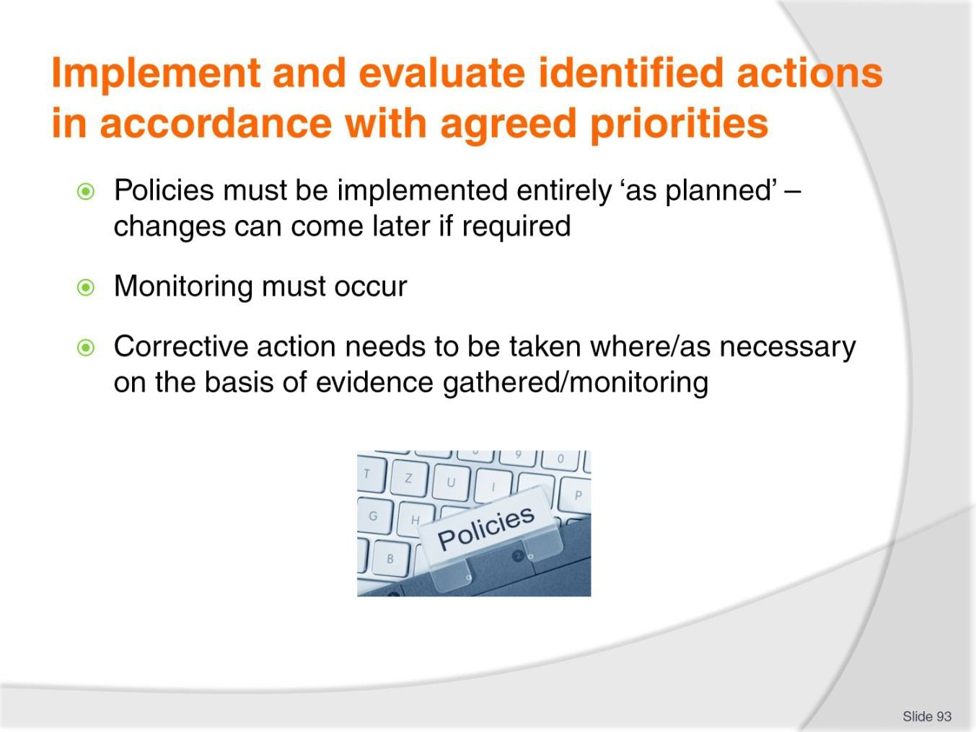
Slide No | Trainer Notes
93. | Trainer presents key factors in relation to implementation of operational policies are:  - The policies must be initially implemented totally as planned – and as stated in the policy document.  - If policies do not succeed ‘as planned’ it is important to know the fault lies with the policy and the way it was developed or written, and not in the way it was put into practice  - Initial implementation must be monitored – to determine if immediate changes need to be made to the plans for implementation/the policy itself based on;  - Issues arising/emerging  - Obvious unintended and/or unforeseen consequences  - Corrective action needs to be taken when obvious need to do so is identified – as opposed to waiting for scheduled reviews and analysis which may be listed for weeks or months into the future: see following slides.

Slide
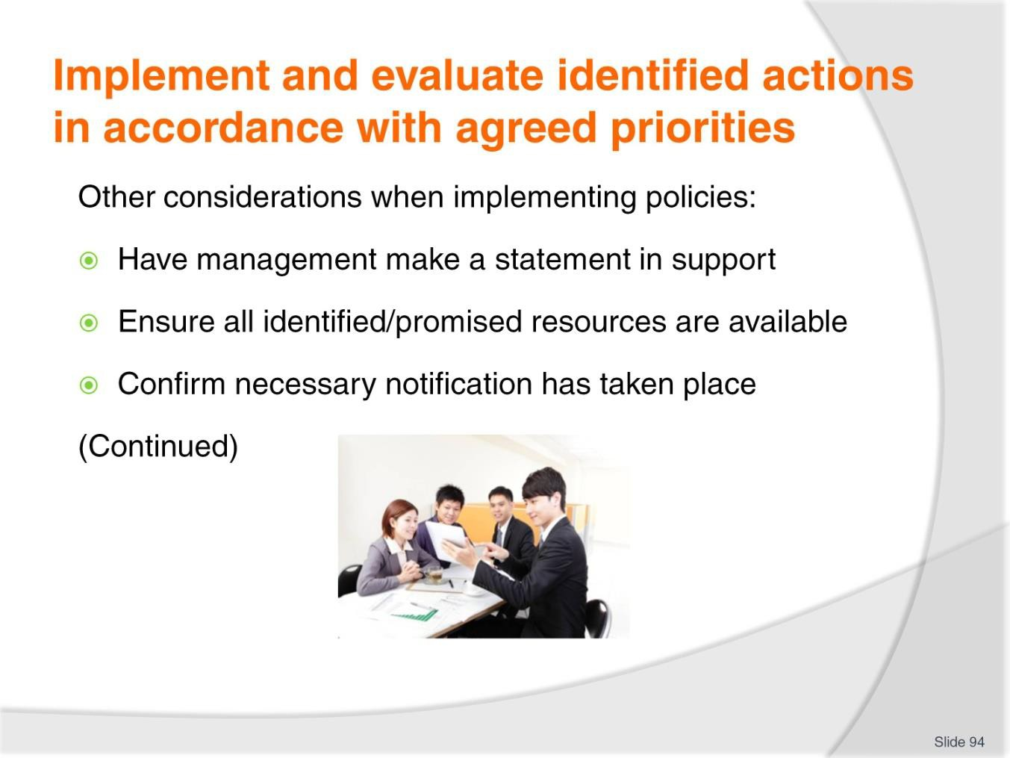
Slide No | Trainer Notes
94. | Trainer offers when implementing a new (or revised) operational workplace policy it is important to:  - Have senior management make a public statement – which:  - Recognises and shows support for the policy  - Encourages compliance with its requirements  - Extols the virtues and benefits of the initiative  - Ensure all resources (financial, physical, human and knowledge/information-based) are available – in accordance with:  - Research  - Plan  - Promises made  - Check all those impacted by the policy have been informed – which may take the form of:  - A formal briefing  - Verbal explanation  - Handouts of documentation  - Training, practice and role plays.

Slide
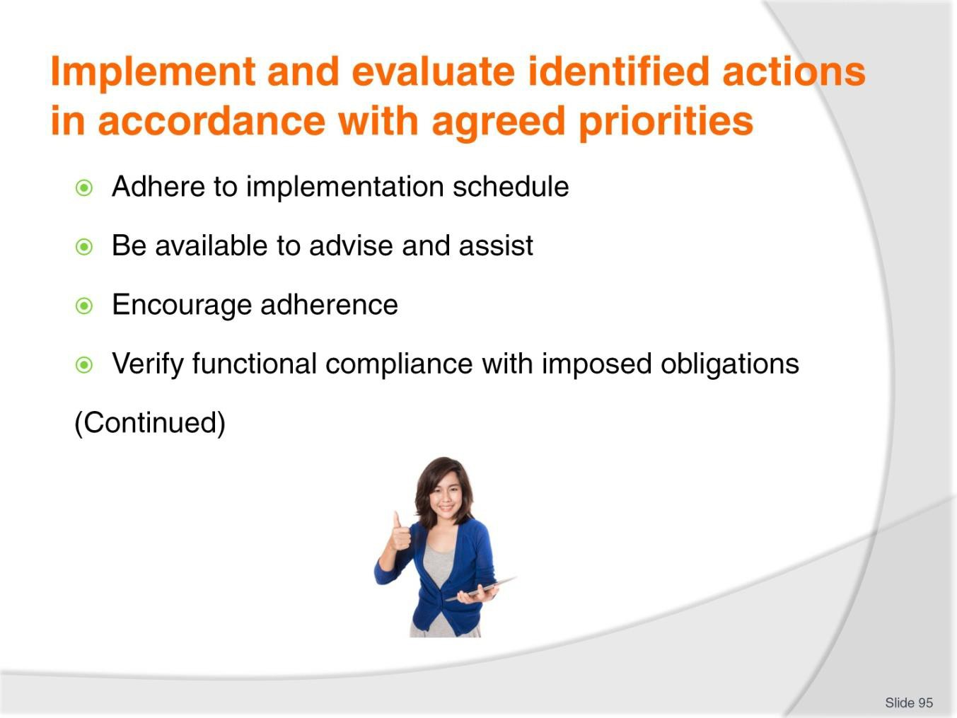
Slide No | Trainer Notes
95. | Trainer offers when implementing a new (or revised) operational workplace policy it is important to:  - Adhere to the promised/projected schedule for implementation – as this may apply to:  - Implementation/start dates  - Transitional periods/phases  - Milestones for reviews  - Be available to provide necessary and assistance – to those impacted by the initiative so they can:  - Obtain more detail as/when required  - Seel clarification or guidance on ambiguous matters/issues  - Show support for those with operational responsibility  - Encourage adherence to the requirements of the policy – through a range of actions such as:  - Congratulating and thanking those who comply  - Demonstrating personal compliance with what is required  - Motivating individuals as needed  - Never ignoring instances of non-compliance

- Verify the policy is functionally compliant with all necessary related obligations – as these may occur in terms of:
  - Occupational safety and health
  - Legal liability as specific to the individual policy
  - Promises/statements made in regard to product and/or service delivery.

Slide
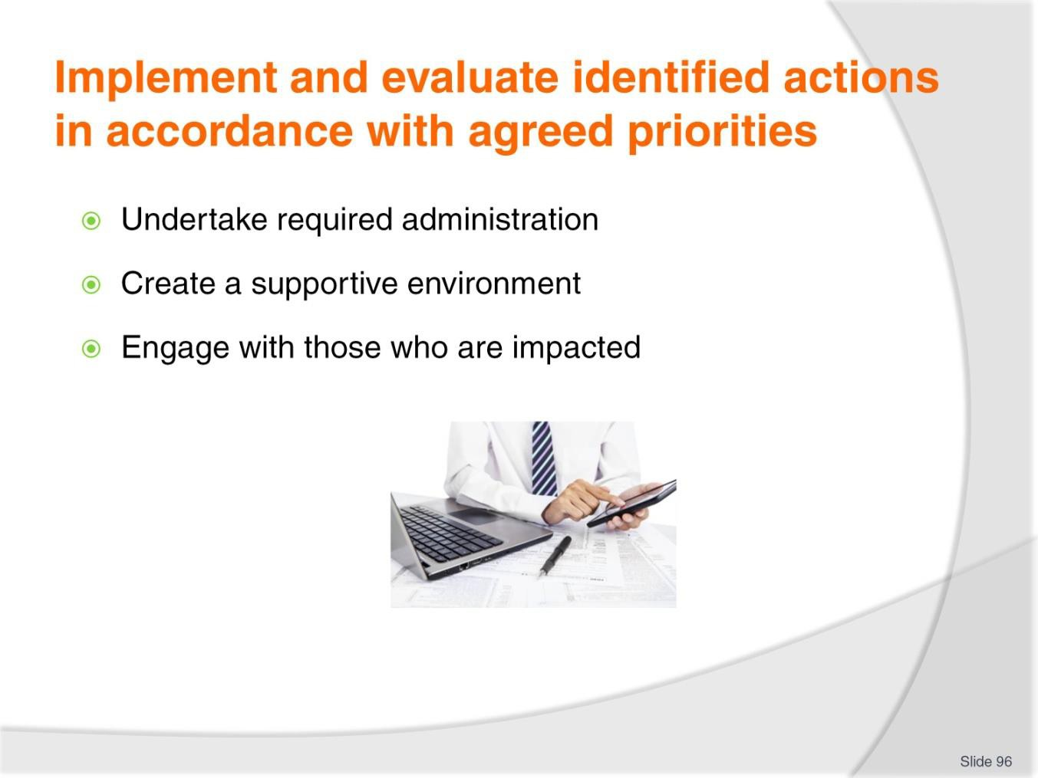
Slide No | Trainer Notes
96. | Trainer offers when implementing a new (or revised) operational workplace policy it is important to:  - Ensure required administrative activities are being undertaken in relation to the initiative – as these may apply with reference to:  - Scheduled/required monitoring activities  - Recording of action taken, money spent and feedback received  - Reporting  - Action is taken to create a workplace environment supportive of the change – which may require attention being paid to:  - Handling disruptions caused to normal operation/SOPs  - Reassuring those initially (adversely) impacted by the initiative  - Showing appropriate leadership and remaining positive/being enthusiastic about the implementation  - Highlighting positive outcomes of the new/revised policy  - Engage with those who are to be impacted – which (in addition to other relevant topics already identified) may mean:  - Setting personal objectives for individuals  - Setting sub-targets of larger goals  - Managing how individuals interact with requirements of the policy including dealing with common obstacles through conflict management, negotiation and explanation.

Slide
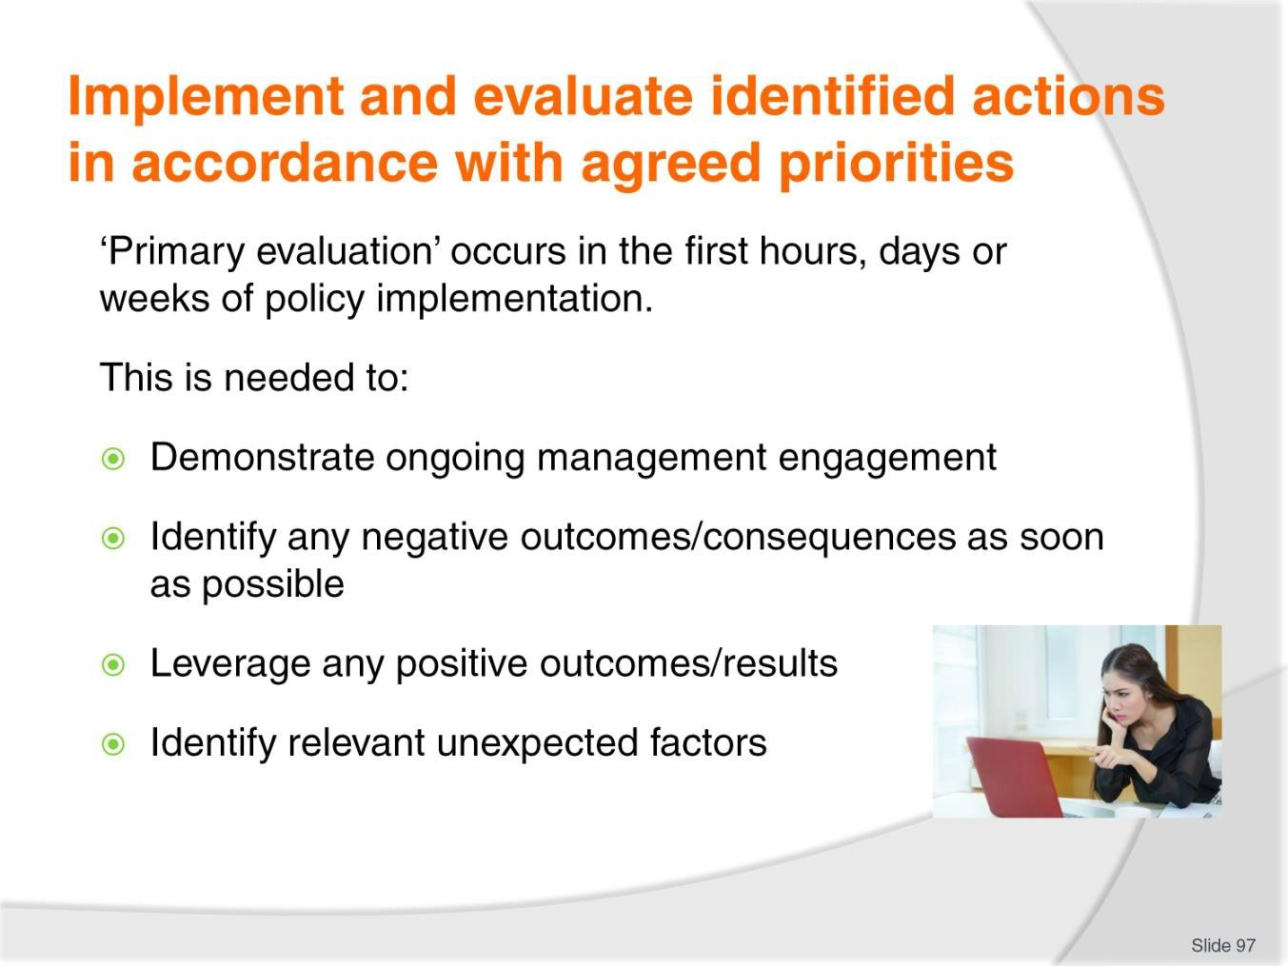
Slide No | Trainer Notes
97. | Trainer discusses ‘primary evaluation’.  Context and rationale  ‘Primary evaluation’ in this context refers to management activities undertaken to monitor the very first stages (hours, days, weeks) of a new policy.  This standard procedure applies/should be in place to:  - Demonstrate ongoing management engagement with and investment in the policy initiative – as opposed to allowing others to believe management has no further interest in the initiative  - Ensure obvious and immediate negative outcomes from the introduction of the policy are identified as quickly as possible – so appropriate remedial/corrective action can be taken.  - Essentially this is done to stop bad situations getting worse  - Leverage any obvious and immediate positive results which emerge – so they can be applied/transferred to other areas  - Allow unexpected factors which are influencing or nuancing the implementation to be identified at the earliest opportunity – so that an appropriate response can be developed.

Slide
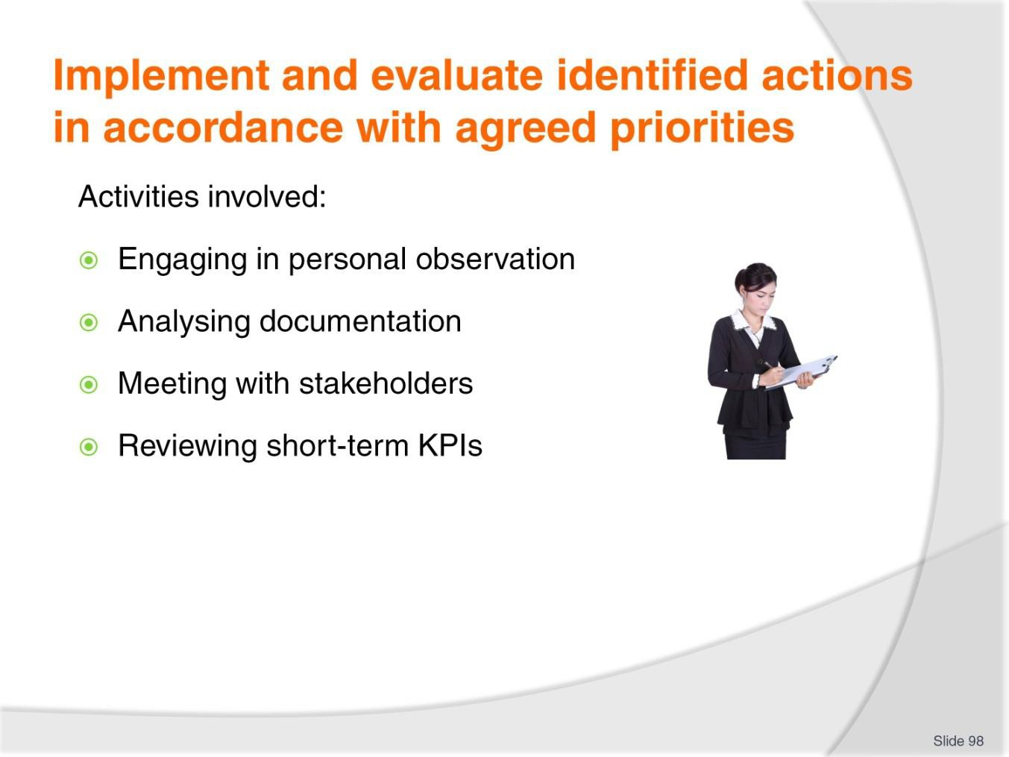
Slide No | Trainer Notes
98. | Trainer notes a combination of the following should be used when undertaking primary evaluation monitoring activities:  - Engaging in personal observation – of practice and procedures in the workplace:  - Judging reality against perceptions of what was expected  - Looking at the impact of the policy on service delivery and the people impacted/involved  - Putting the initiative into perspective by setting it against other relevant or competing factors  - Analysing documentation – which could include:  - Evaluating mandatory reports/forms which are completed as part of the policy/initiative  - Looking at results/outcomes represented in the documentation  - Reading compliance reports  - Meeting with stakeholders – which could involve:  - Conducting end of shift/day de-briefings with employees  - Soliciting and analysing customer feedback  - Encouraging and interpreting employee feedback  - Holding formal meetings

- Reviewing short-term KPIs – which needs to address:
  - Evaluating extent to which they are being met/attained
  - Determining if on the basis of hindsight the KPIs were realistic
  - Undertaking formal gap analyses.
Classroom Activity – Internet research
Trainer supervises internet research on relevant websites for items identified above, such as:
- http://2020projectmanagement.com/2013/05/how-gap-analysis-adds-value-to-your- business/ - How gap analysis adds value to your business
- http://en.wikipedia.org/wiki/Gap_analysis - Gap analysis.

Slide
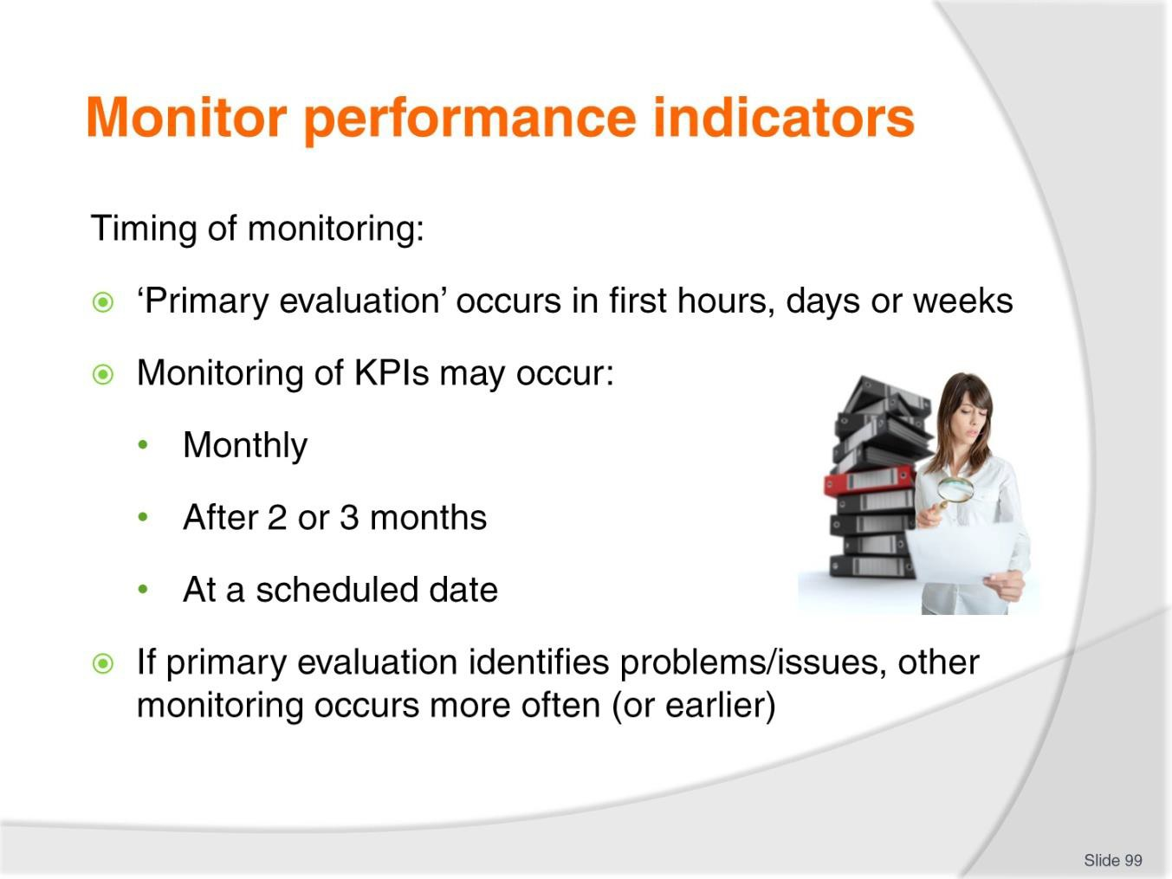
Slide No | Trainer Notes
99. | Trainer discusses timing identifying:  - The ‘primary evaluation’ described earlier occurs in the first hours, days or weeks of the implementation of an operational policy  - The monitoring of performance indicators (or key performance indicators [KPIs]} may occur:  - In terms of a single month  - After several (two or three) months  - At a date identified in the plan for the operational policy  - Note: it is SOP where significant variations are identified in the ‘primary evaluation’ the tendency is for the more formal monitoring activities to be moved forward.

Slide
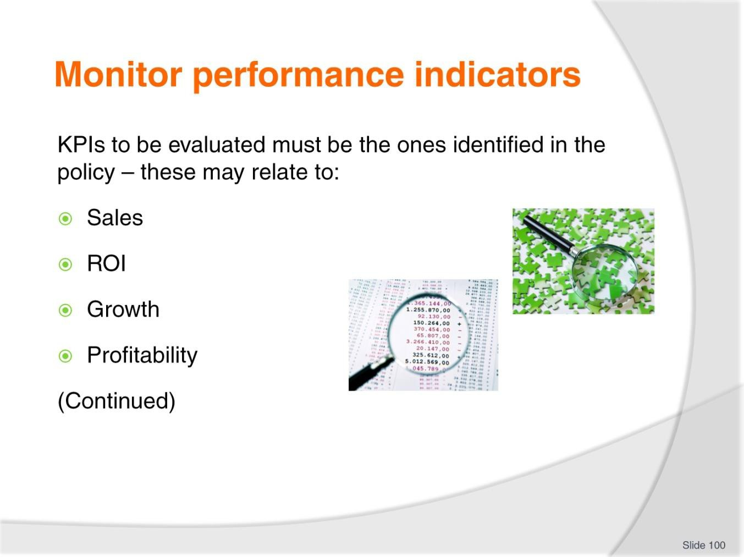
Slide No | Trainer Notes
100. | Trainer explains the KPIs which need to be evaluated must be the KPIs identified and as stated in the original policy.  It is possible KPIs can relate or apply to the following although the way they might apply will very much depend on the context and content of the individual policy as it is written:  - Sales figures  - ROI  - Growth  - Profitability.

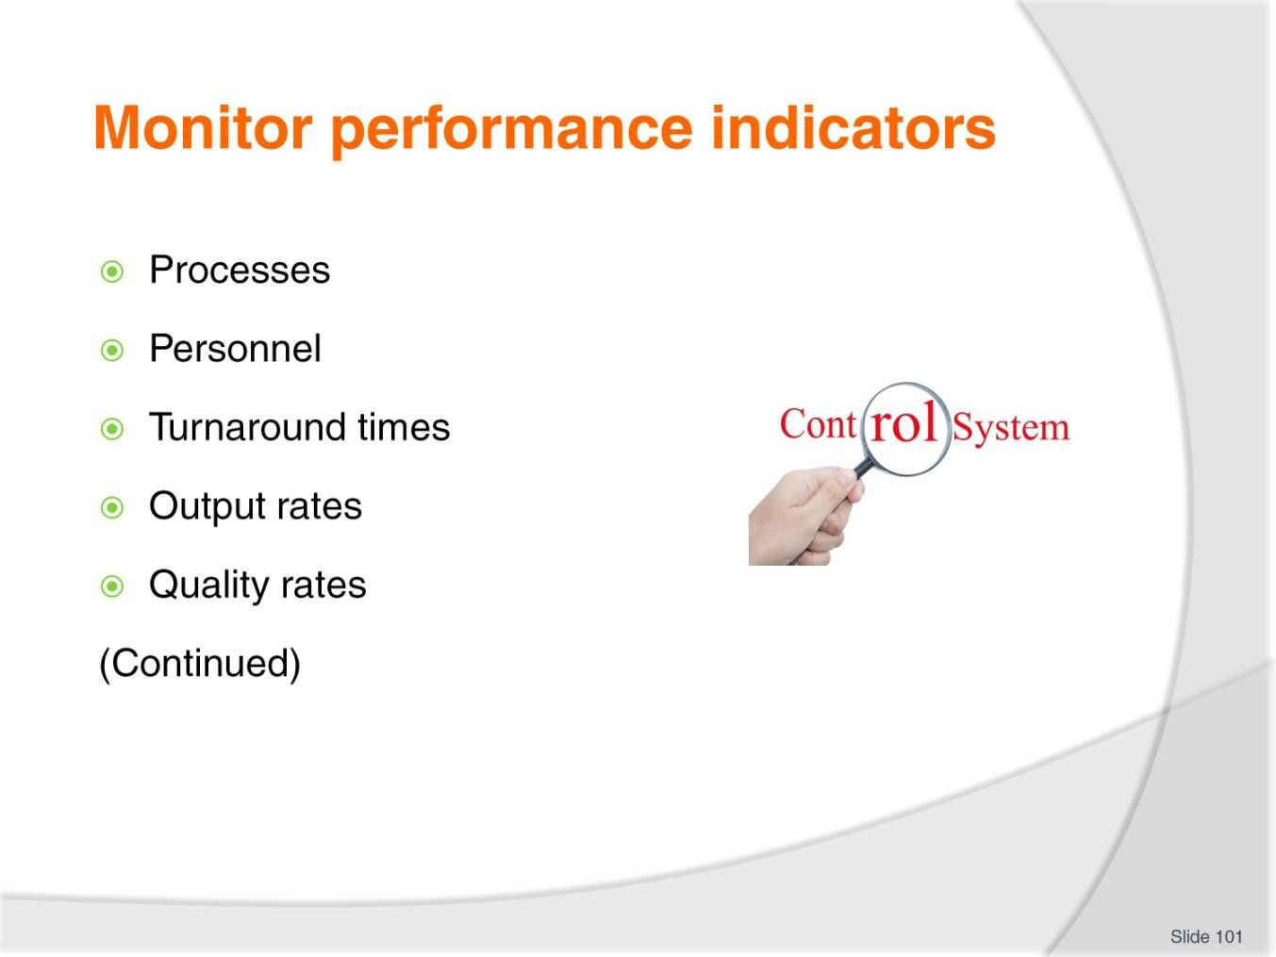
Slide
Slide No
Trainer Notes
101.
Trainer continues giving examples of possible KPIs which may be monitored:
- Processes
- Personnel
- Turnaround times
- Output rates
- Quality rates.

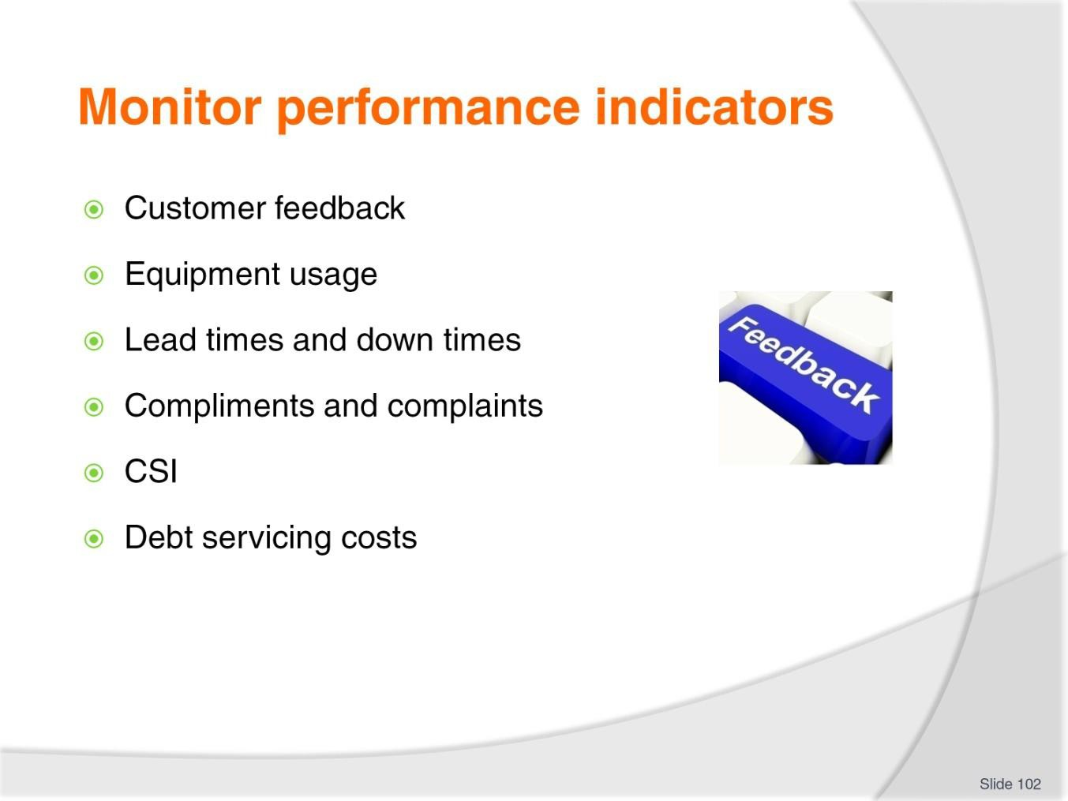
Slide
Slide No
Trainer Notes
102.
Trainer continues giving examples of possible KPIs which may be monitored:
- Customer feedback
- Equipment usage rates
- Lead times and down times
- Compliments-complaints ratio
- CSI
- Debt servicing costs.

Slide
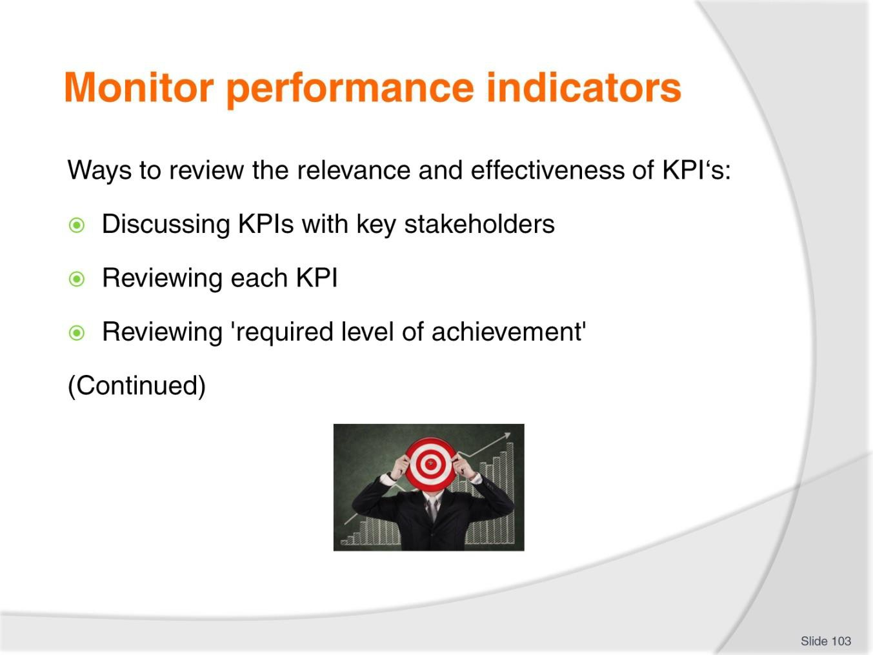
Slide No | Trainer Notes
103. | Trainer identifies there are a number of ways to review the relevance and effectiveness of KPI's including but not limited to:  - Discussing KPIs with key stakeholders  - Reviewing each KPI to ensure it is still accurate  - Reviewing 'required level of achievement' for each KPI.

Slide
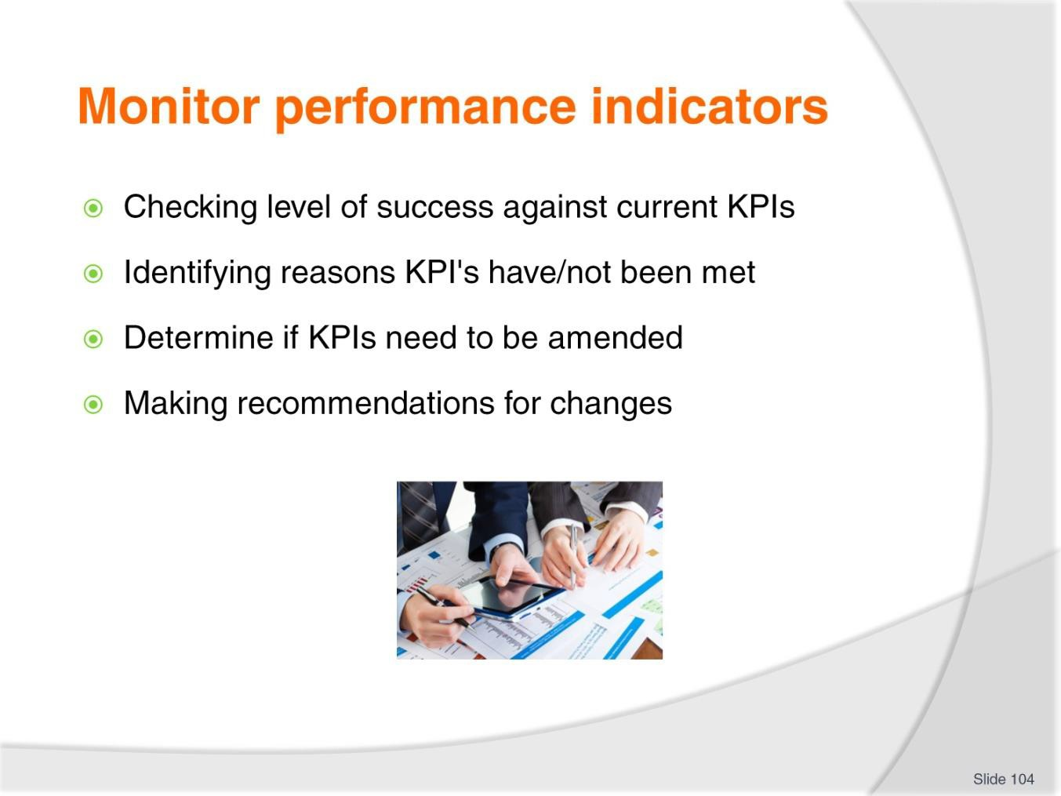
Slide No | Trainer Notes
104. | Trainer presents ways to monitor/review KPIs:  - Checking level of success against current KPIs  - Identifying reasons why KPI's have or have not been met  - Determine if KPIs need to be amended  - Making recommendations for changes where amendments are required.  Classroom Activity – Internet research  Trainer supervises internet research on relevant websites for items identified above, such as:  - http://www.admin.ox.ac.uk/media/global/wwwadminoxacuk/localsites/estatesservice s/documents/capitalprojectsforms/KPI_Process_Guidance_Note.pdf - The KPI evaluation process  - http://www.learnmanagement2.com/Key%20Performance%20Indicators.htm – KPIs.

Slide
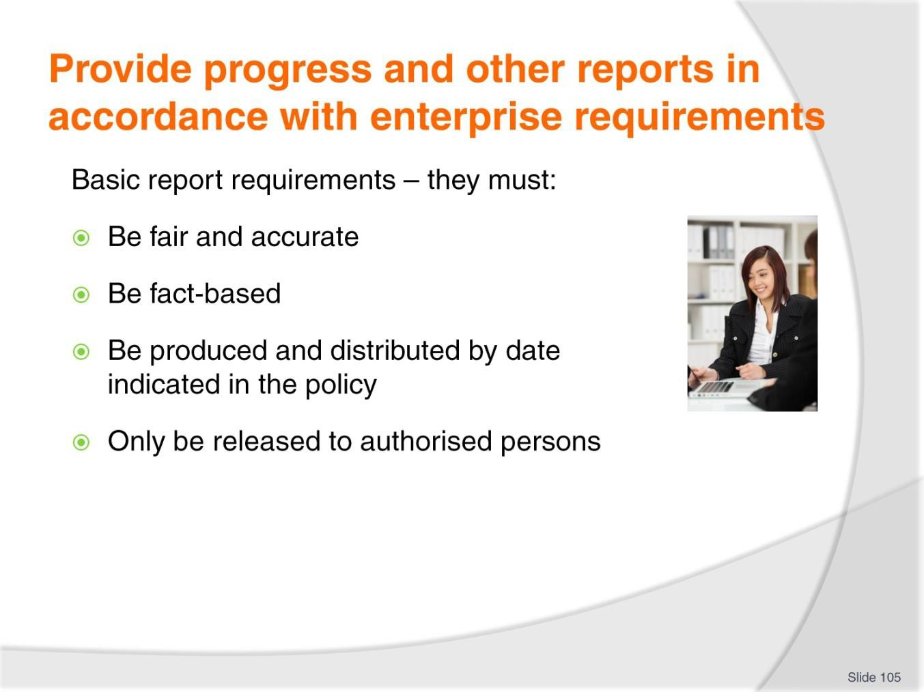
Slide No | Trainer Notes
105. | Trainer highlights basic requirements for reports on the implementation of operational policies are they must:  - Be fair and accurate – they must be truthful, telling the ‘bad’ as well as the ‘good’  - Be based on facts – as opposed to being based on supposition, opinion and ‘hope’  - Not be personal in nature – that is, they should not aim to be vindictive about a person/group of people  - Be produced and circulated by the date identified in the plan for implementation – each time the need for a report is mentioned. There can also be a need for:  - An Initial/Introductory report  - Interim report/s  - Final report  - Only be released for discussion to those who have been approved to receive them  – usually this means only those designated on an authorised Distribution List, as these reports are often regarded as being Commercial in Confidence.  Classroom Activity – Handout  Trainer distributes and discusses use of Distribution List.

Slide
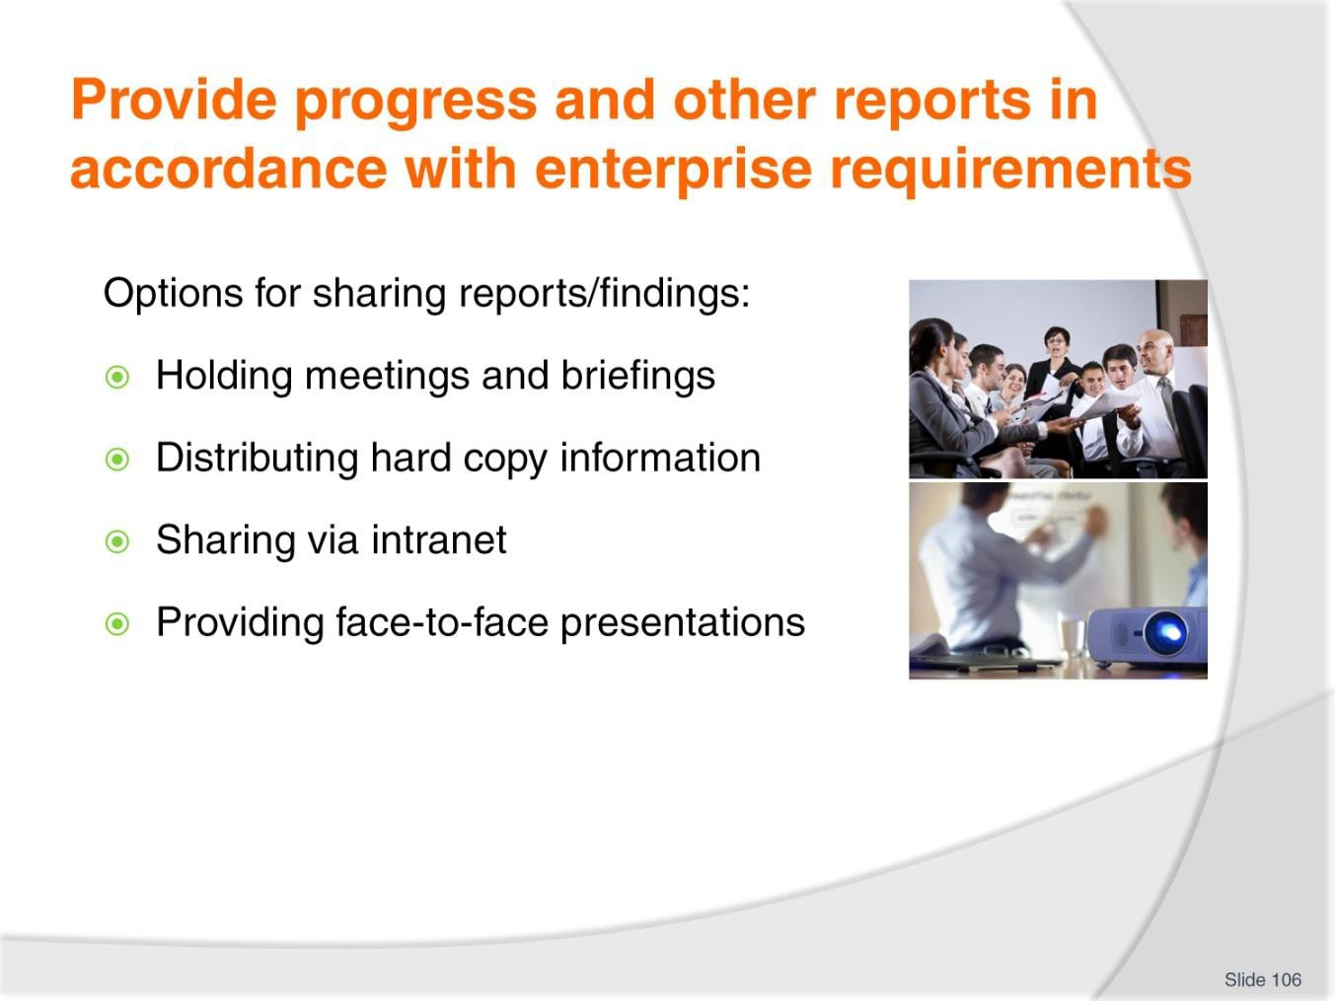
Slide No | Trainer Notes
106. | Trainer notes every enterprise is likely to have its own protocols for the sharing of information/the distribution of internal reports and SOP is to adhere to whatever practice is in common usage within the organisation.  Those who receive the reports should be asked to keep the contents of the reports private.  Common options for sharing these reports include:  - Holding team meetings and disseminating information at staff briefings – to share information within operational teams/workers  - Distributing hard copy information – to identified stakeholders  - Sharing information via the intranet – using ‘Password protected’ protocols to limit access only to nominated persons  - Providing formal face-to-face group presentations with stakeholders – supplemented by hard copy handouts, explanations and Q&A sessions.

Slide
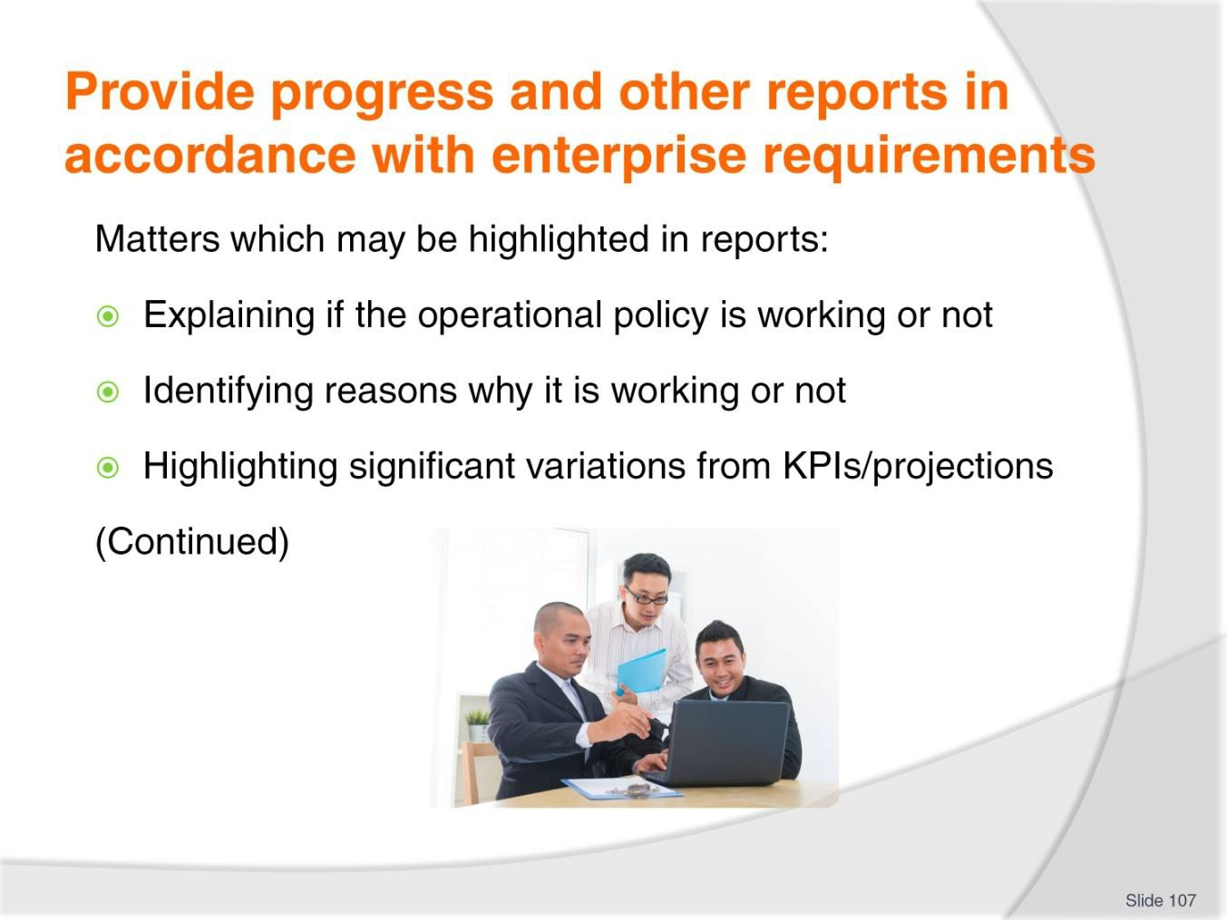
Slide No | Trainer Notes
107. | Trainer explains matters which may be highlighted in these reports are potentially numerous but special attention should be paid to:  - Explaining if the operational policy is working or not – and quantifying the outcome (if possible)  - Identifying the reasons why it is working or not working – drawing direct links between ‘cause and effect’  - Highlighting significant variations from KPIs/projections – and coverage of the factors associated with those variances changes.

Slide
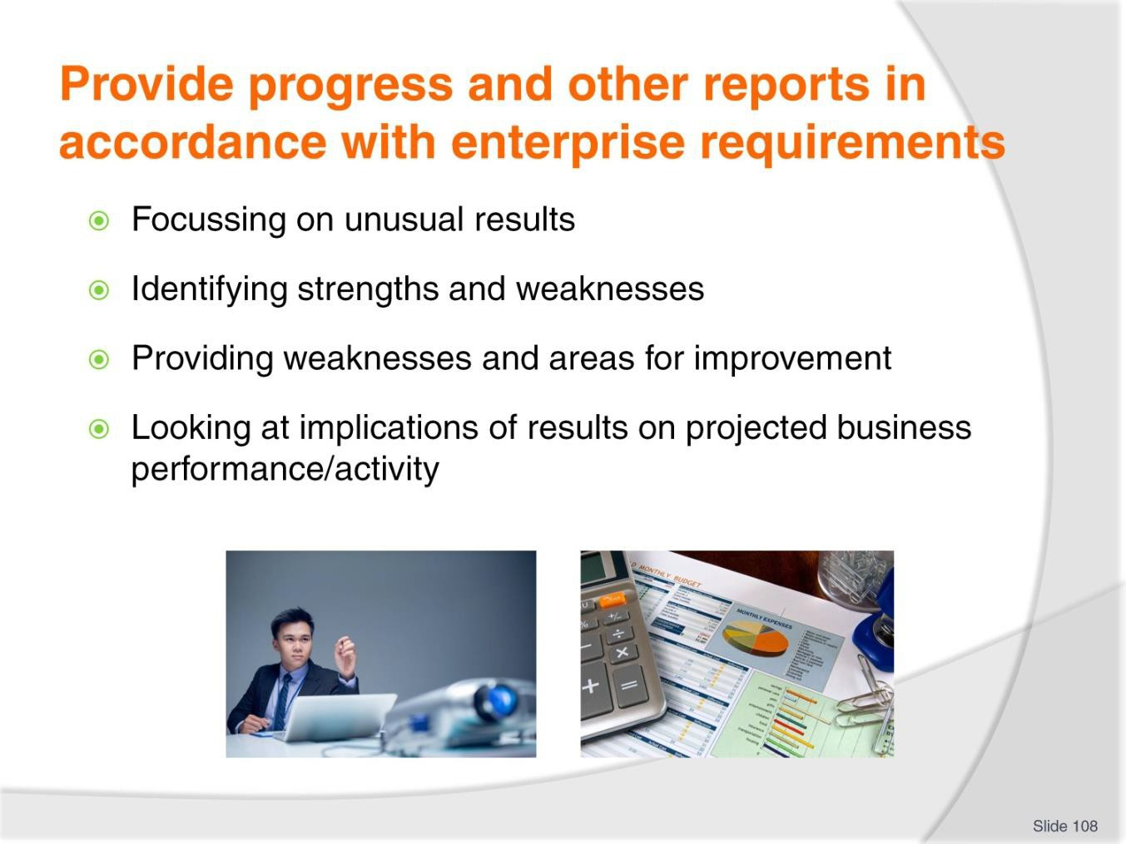
Slide No | Trainer Notes
108. | Trainer identifies issues to potential address in reports:  - Unusual results – and determination of their causes  - Strengths and opportunities – which have emerged from the initiative  - Weaknesses and potential areas for improvement – as indicated by the evidence captured  - Impact/implications of the results and conclusions – on projected future performance of the organisation.  Classroom Activity – Excursion  Trainer arranges for students to visit a workplace and:  - Talk to management about developing implementing, monitoring and evaluating/reviewing operational policies  - Talk to workers regarding their role in relation to developing and implementing  - Obtain sample documentation  - Attend a meeting where operational policies are discussed or developed or reviewed  - Observe administrative support and systems/framework used to enable implementation and monitoring of operational policies.

Slide
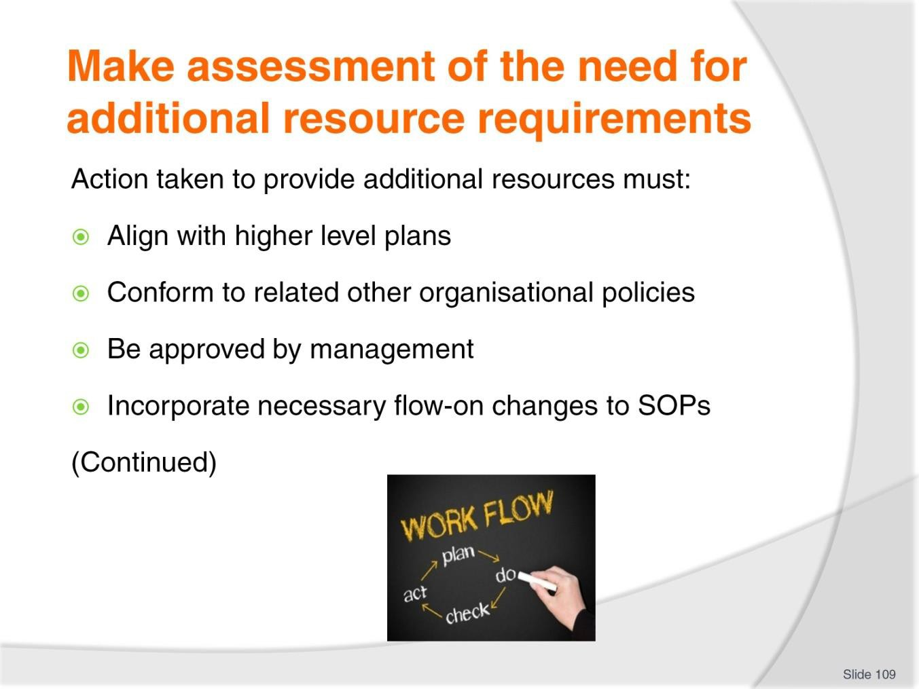
Slide No | Trainer Notes
109. | Trainer states where important information about a policy/initiative has been revealed as a result of the monitoring undertaken there is commonly a need to revise and adjust the initiative in response.  When responding it is vital action taken:  - Aligns with higher level plans  - Conforms to all other/related enterprise policies  - Is approved by management prior to implementation  - Results in necessary changes to all SOPs which are directly related to the changes made to the policy.

Slide
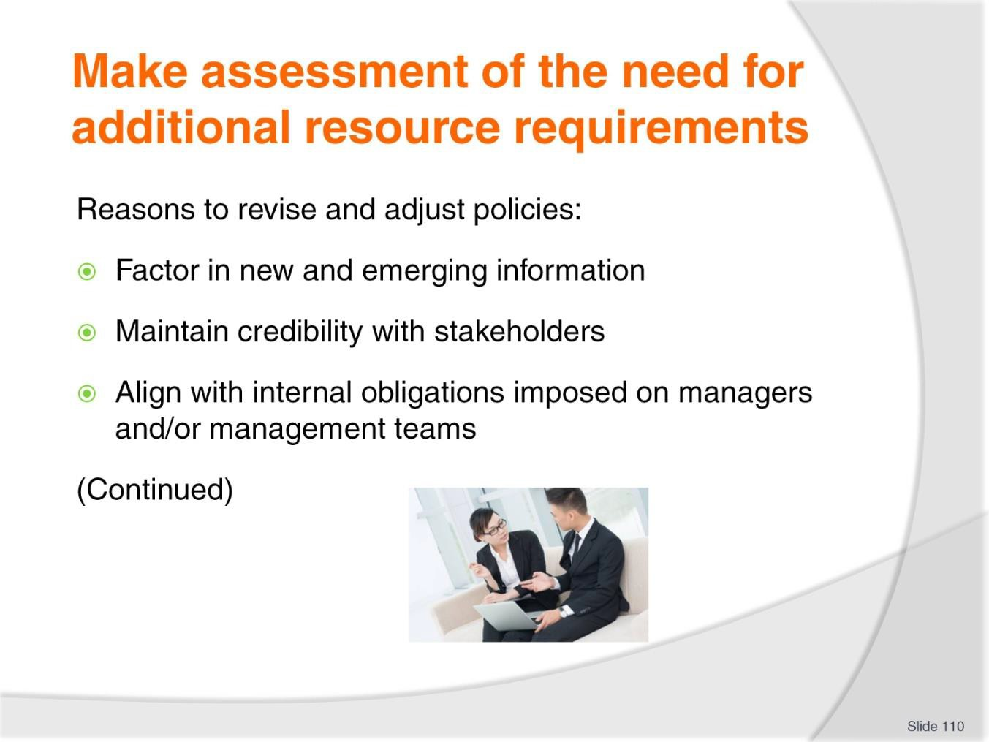
Slide No | Trainer Notes
110. | Trainer explains it is important to revise and adjust policies to:  - Factor in new and emerging information – which would simply not have been available when the original policy was written  - Maintain credibility with stakeholders – who will expect the organisation to be taking some action in response to implementation of a new or revised policy  - Align with internal obligations imposed on managers and/or management teams – most managers or management teams will be under a formal responsibility to take action as/where necessary to revise and adjust policies on the basis of evidence derives as a result of monitoring activities.

Slide
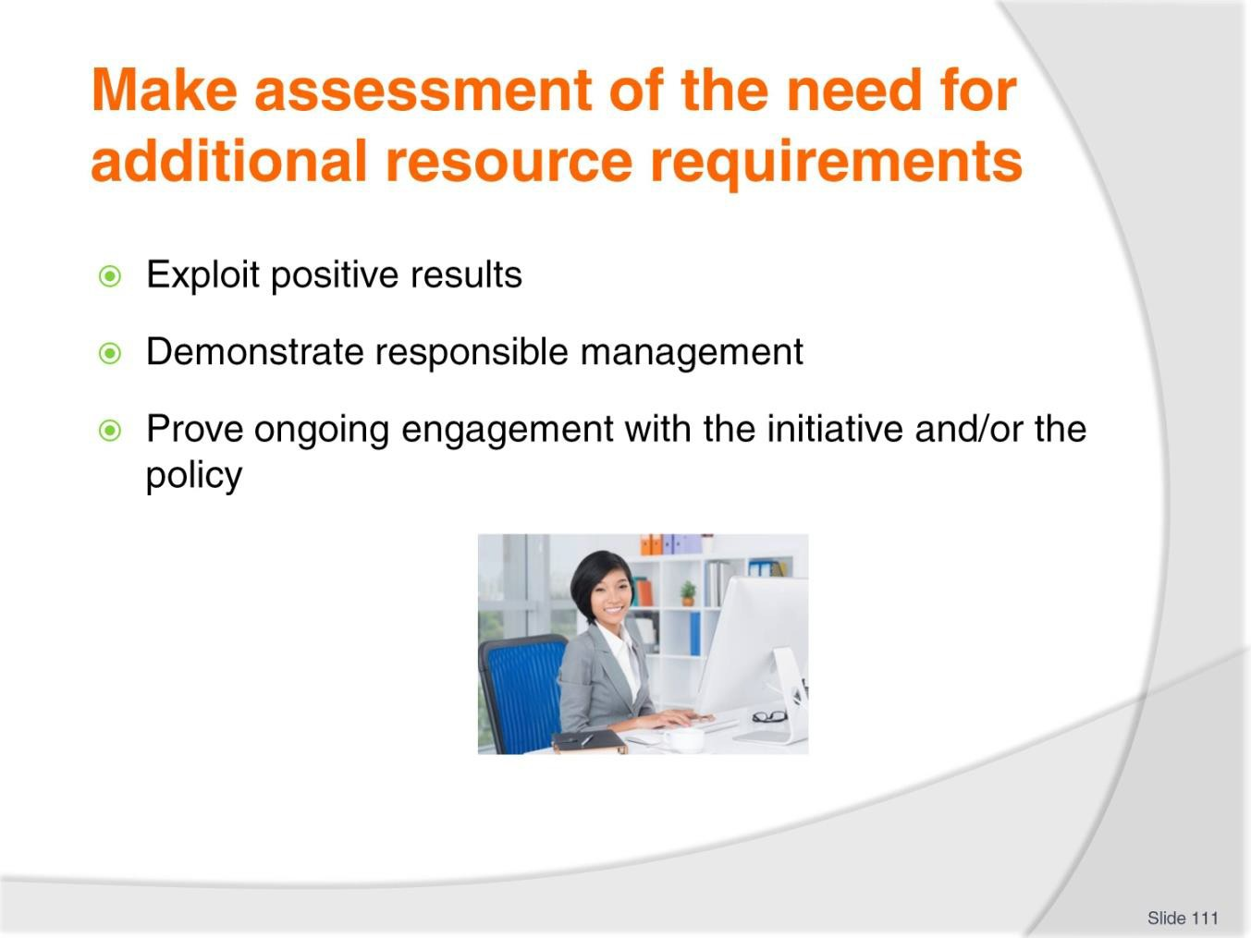
Slide No | Trainer Notes
111. | Trainer explains it is important to revise and adjust policies to:  - Exploit positive results – and minimise adverse impacts  - Demonstrate responsible management – and discharge requirements relating to due diligence (if these requirements have not been specifically stipulated/spelled out by the organisation  - Prove ongoing engagement with the initiative and/or the policy – in a practical/hands-on way.

Slide
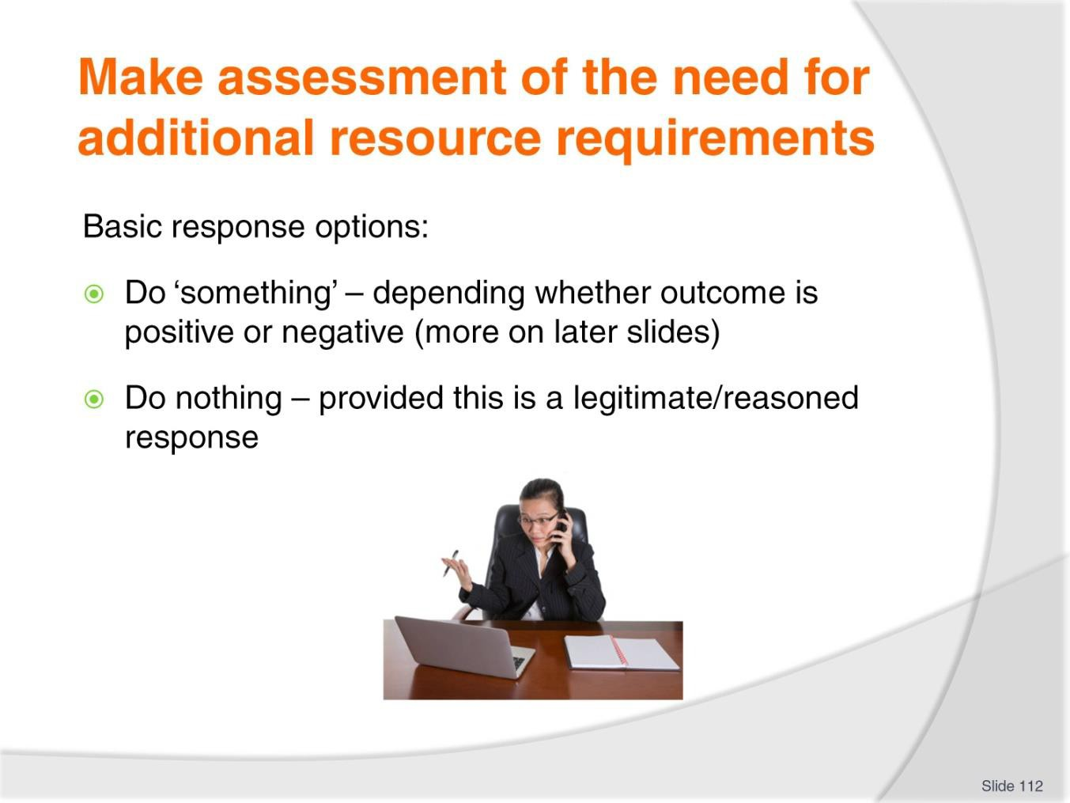
Slide No | Trainer Notes
112. | Trainer suggests basic options for possible action in response to monitoring evidence/data are:  - Do something – see later slides ‘Responding to positive outcomes’ and ‘Responding to negative outcomes’  - Do nothing – doing nothing is a valid in response in some cases but it must be a considered and rational decision to do so and not just a default position because people cannot be bothered taking action.

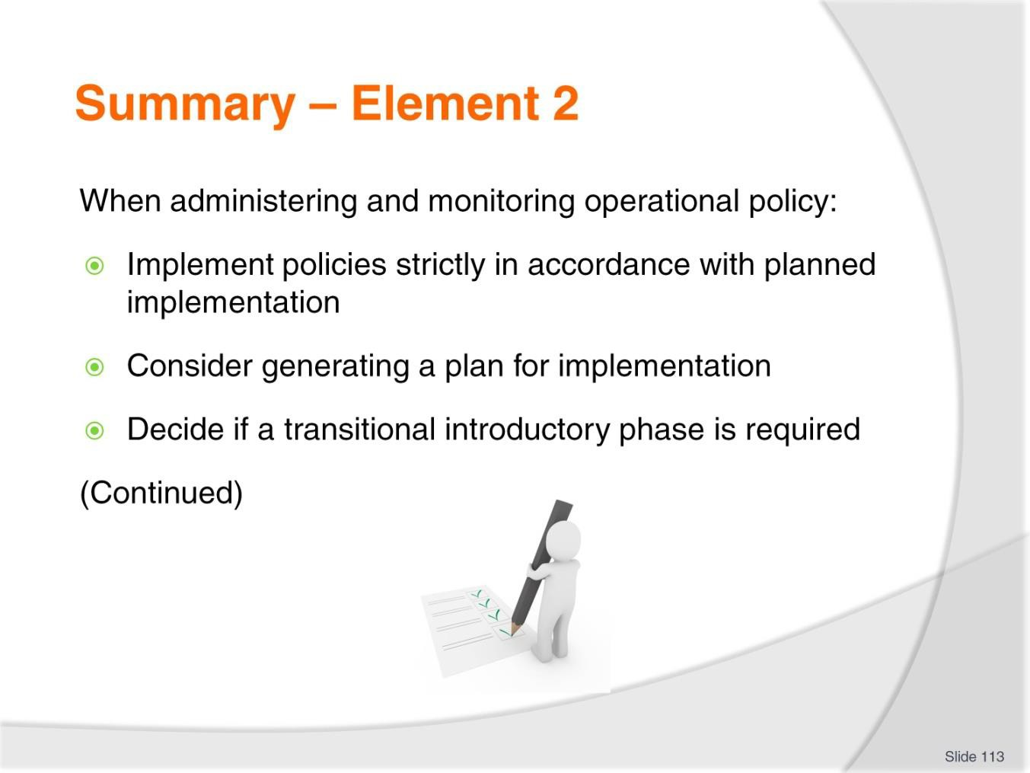
Slide
Slide No
Trainer Notes
113.
Trainer provides a recap of the Element asking questions to check trainee understanding and responding to questions from trainees, as required.

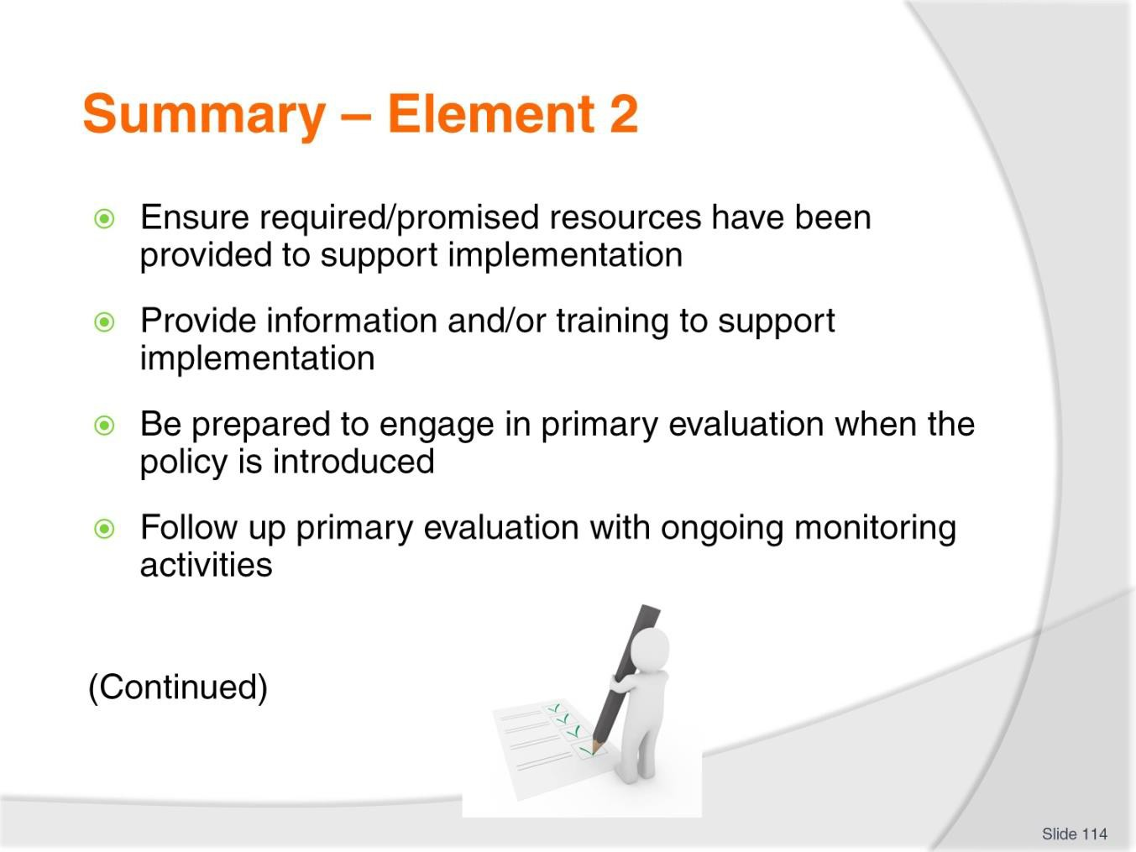
Slide
Slide No
Trainer Notes
114.
Trainer provides a recap of the Element asking questions to check trainee understanding and responding to questions from trainees, as required.

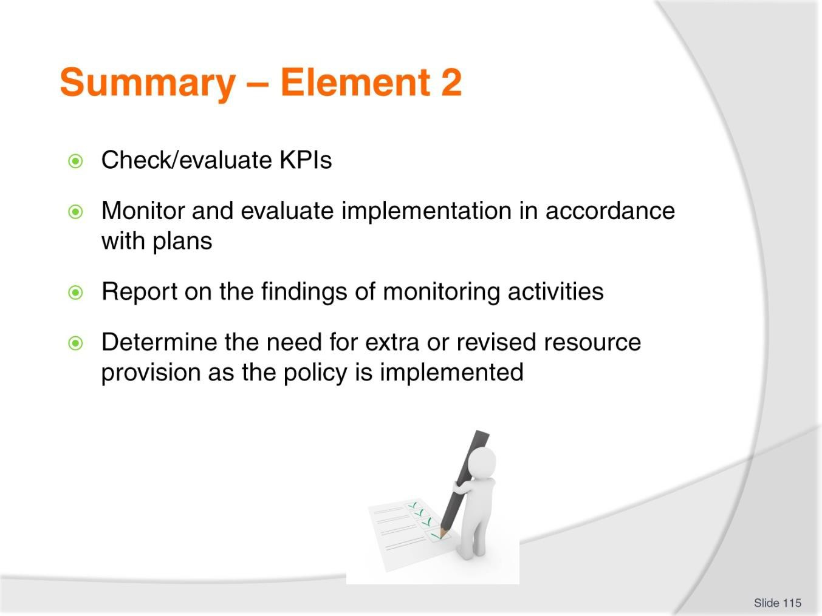
Slide
Slide No
Trainer Notes
115.
Trainer provides a recap of the Element asking questions to check trainee understanding and responding to questions from trainees, as required.

Slide
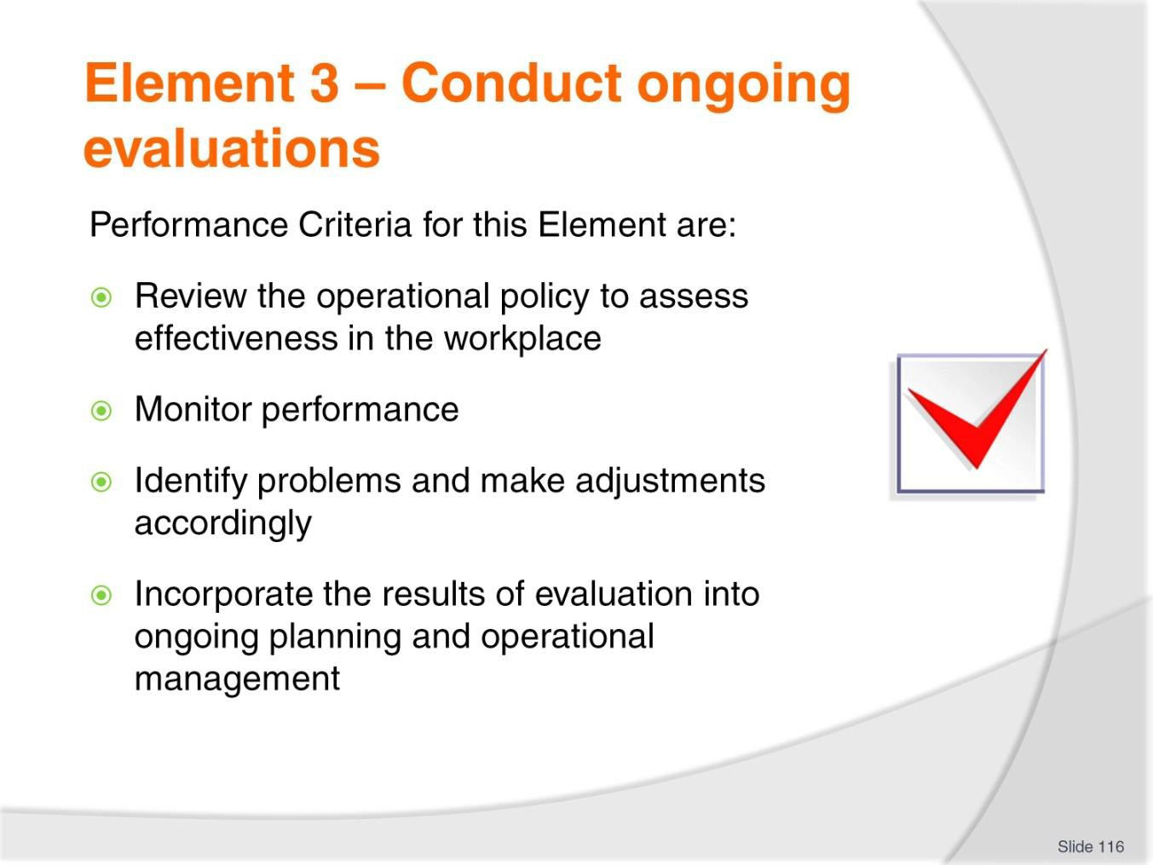
Slide No | Trainer Notes
116. | Trainer identifies for trainees the Performance Criteria for this Element, as listed on the slide.  Class Activity – General Discussion  Trainer leads a general class discussion by asking questions such as:  - What is an ‘evaluation’?  - Why are they conducted?  - How are they done?  - Why are they undertaken?

Slide
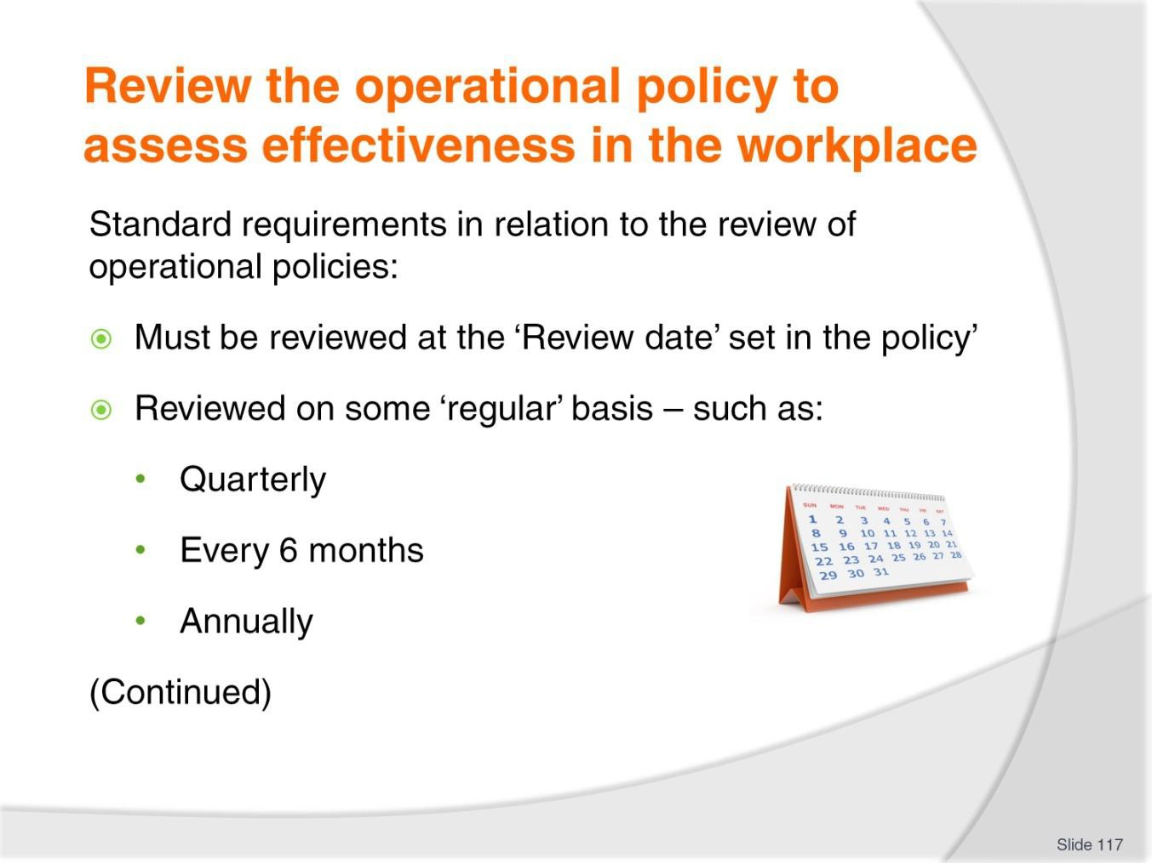
Slide No | Trainer Notes
117. | Trainer indicates it must be a standard requirement all policies are:  - Reviewed at the date contained in the policy and set as the official review date – incorporation of this review date must be a mandatory part of the development of every policy  - Reviewed on some regular basis, regardless – such as:  - Quarterly  - Every six months  - Annually  - In synchronisation with the business plan cycle for the organisation.

Slide
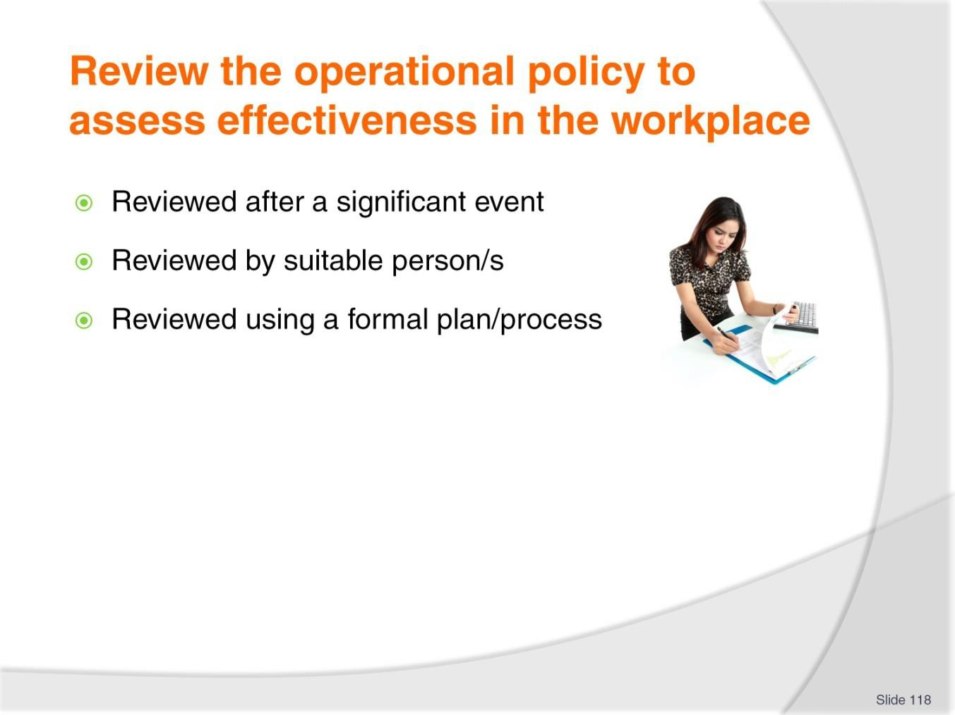
Slide No | Trainer Notes
118. | Trainer gives standard requirements when reviewing operational policies:  - Reviewed when there has been an event deemed to be ‘significant’ in nature – this may be:  - An incident or accident (or near miss)  - A serious complaint or other nominated occurrence  - Legal action  - A major change in marketplace  - Reviewed by suitable persons – generally:  - Those involved in the development of the policy  - Those impacted by the policy  - Reviewed and revised according to a pre-determined process/plan – this is a written plan detailing and/or providing guidelines or requirements in relation to:  - The aspects of the policy to be evaluated and/or given special attention  - When evaluations will take place  - How the evaluation will be conducted  - Who will be involved in conducting evaluations  - Documents, data and/or organisations which need to be investigated/researched as part of the review process.

Slide
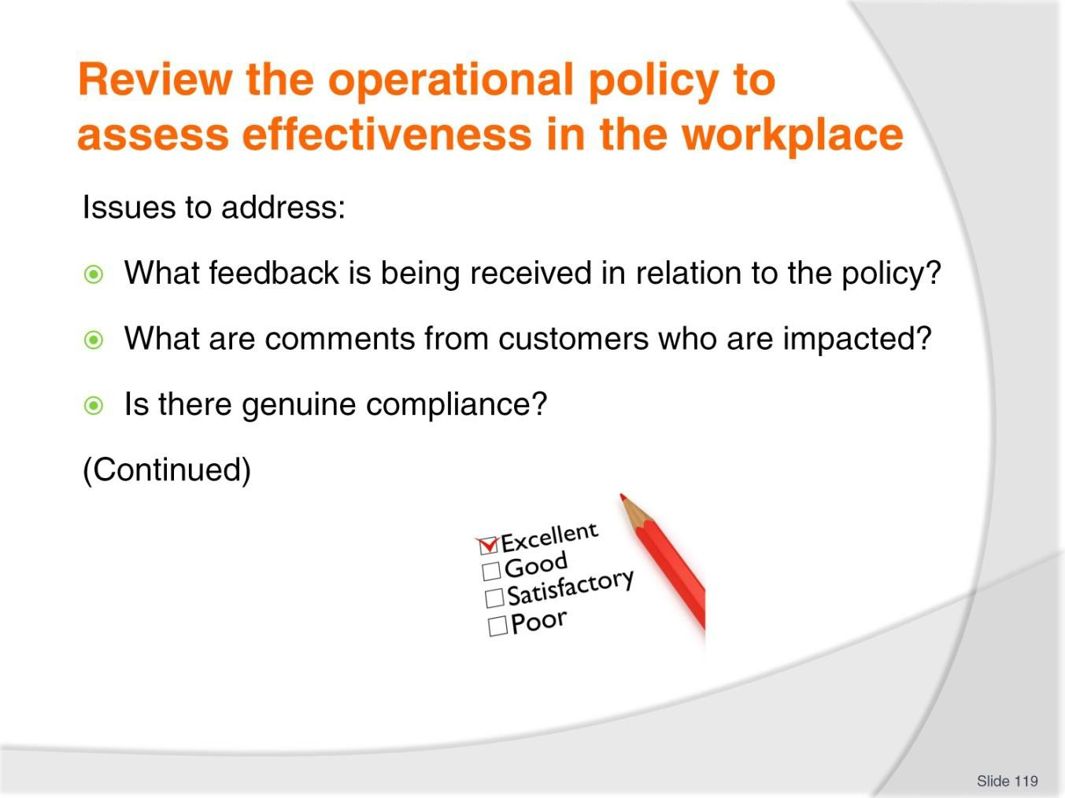
Slide No | Trainer Notes
119. | Trainer presents issues to address:  - What is the feedback from staff and other users in relation to the policies – for example:  - Are they aware of the policy? Do they understand what it means and what they are expected to do in order to comply?  - What do they think of the policy? Do they think the policy is good or bad/effective of ineffective? Why?  - How do they impact/guide workplace activity?  - Can they suggest improvements? What? Where?  - What are the comments from customers impacted by the policy – for example:  - Do they understand the policy? Why? Why not?  - Do they like it? Why? Why not?  - How do they want it to change?  - Is there actual/genuine compliance with the policy – or:  - Are staff/people simply ignoring the requirements?  - Does evidence point to limited compliance ‘some of the time’ or ‘only under certain circumstances’?

Slide
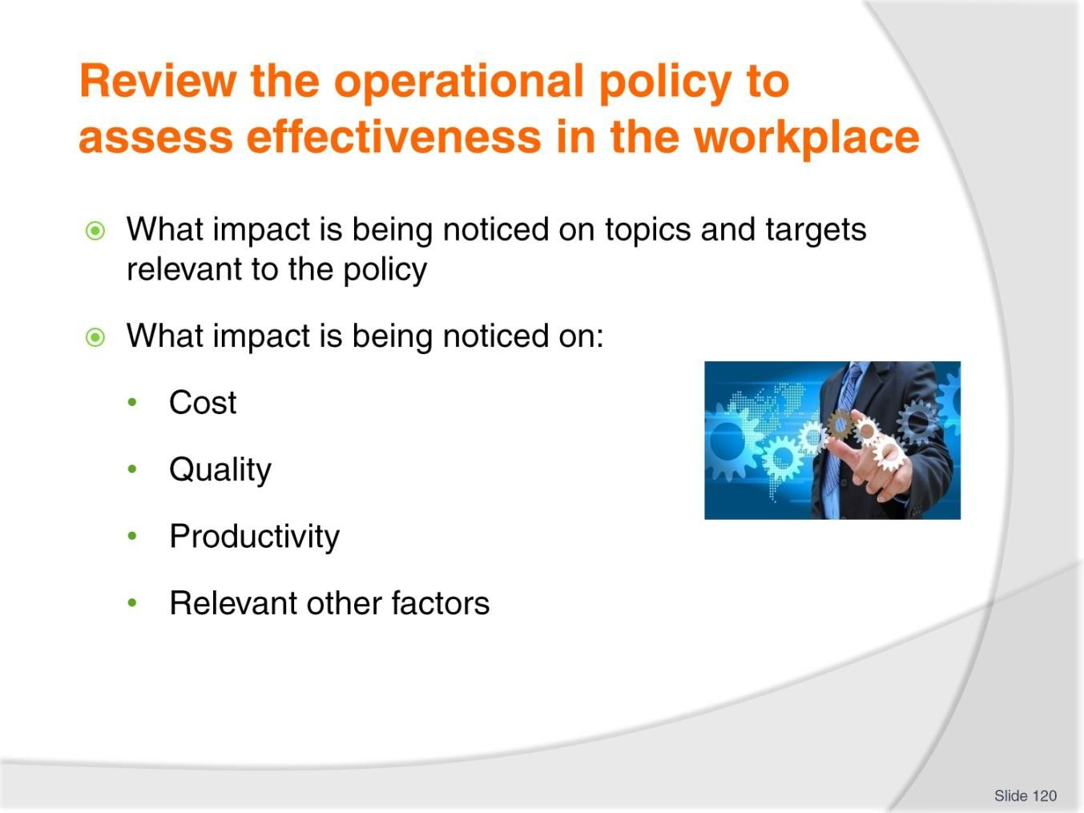
Slide No | Trainer Notes
120. | Trainer presents issues to address:  - What impact is being noticed on topics and targets relevant to the policy – for instance:  - Are services being delivered more efficiently and/or effectively  - Are sales and/or profits increasing?  - Is the policy introducing an unacceptable or annoying barrier to standard workplace operation? How? Why? What can be done about this?  - What impact is being noticed on expenditure? Is there a drop/rise in productivity or (for example) use of materials as a result of new/revised workplace procedures?

Slide
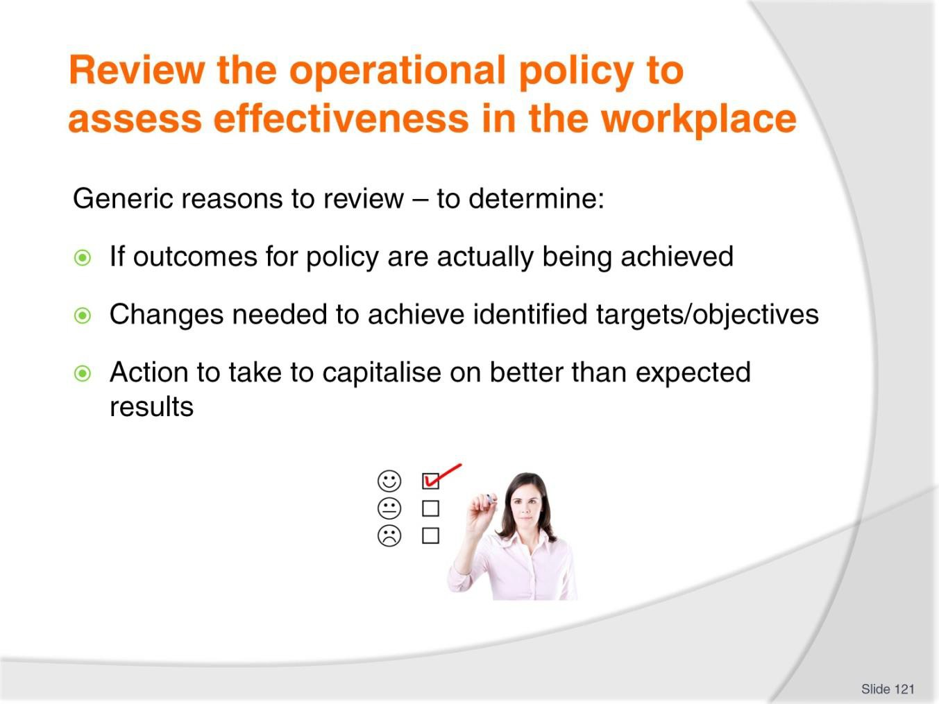
Slide No | Trainer Notes
121. | Trainer discusses objectives of the review observing:  - The review may have specific aims as stated in the policy ‘review’ section, or there will be generic needs to determine:  - If the outcomes for the policy are actually being achieved  - What changes need to be made to bring an under-performing policy back on track  - Whether alterations need to be made to certain aspects of the policy to capitalise on better than expected performance of the business.

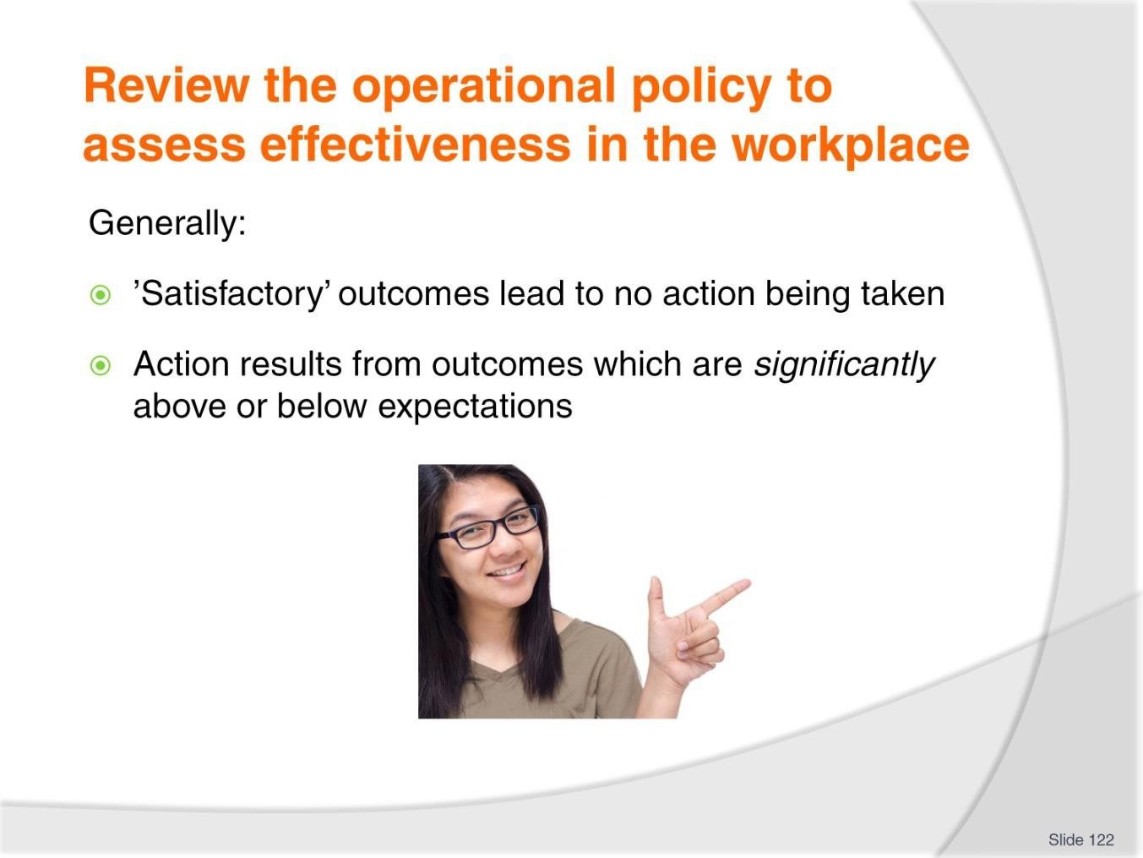
Slide
Slide No
Trainer Notes
122.
Trainer observes in general:
- Satisfactory outcomes lead to no action being taken
- Outcomes which are significantly above or below expectations lead to:
  - Revisions of policies
  - Modifications of other related polices
  - Changes to allied procedures.

Slide
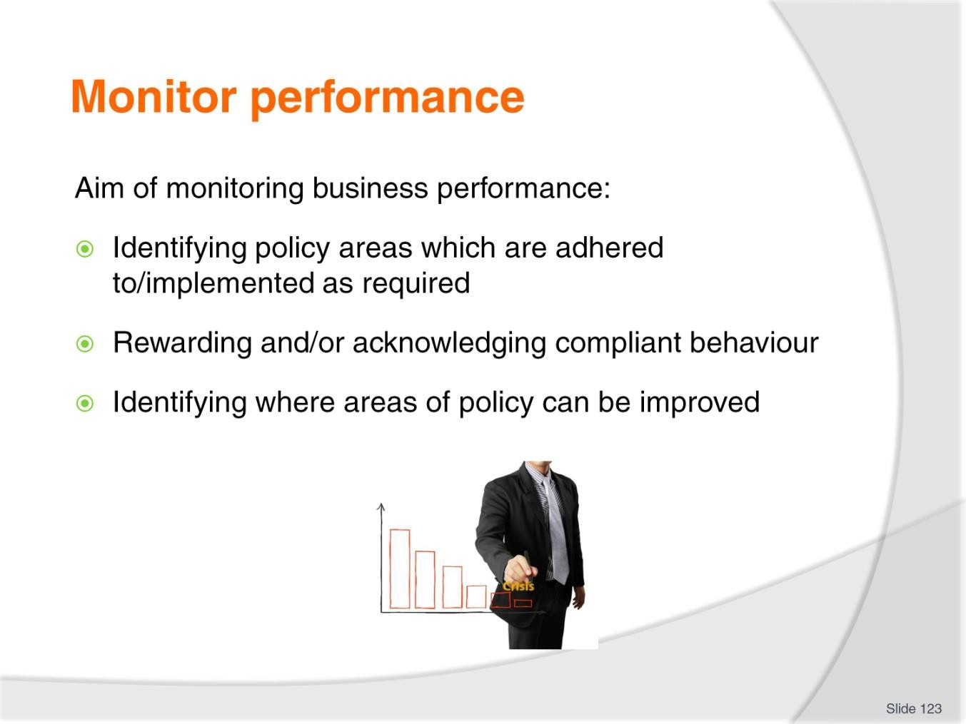
Slide No | Trainer Notes
123. | Trainer identifies the aim of monitoring business performance can be seen as to:  - Identifying policy areas which are adhered to/implemented as required or intended  - Rewarding and/or acknowledging compliant behaviour  - Identify where areas of policy can be improved through:  - Identification of problems  - Understanding cause/s of issues  - Finding suitable solutions to identified problems/issues  - Generating a viable solution.

Slide
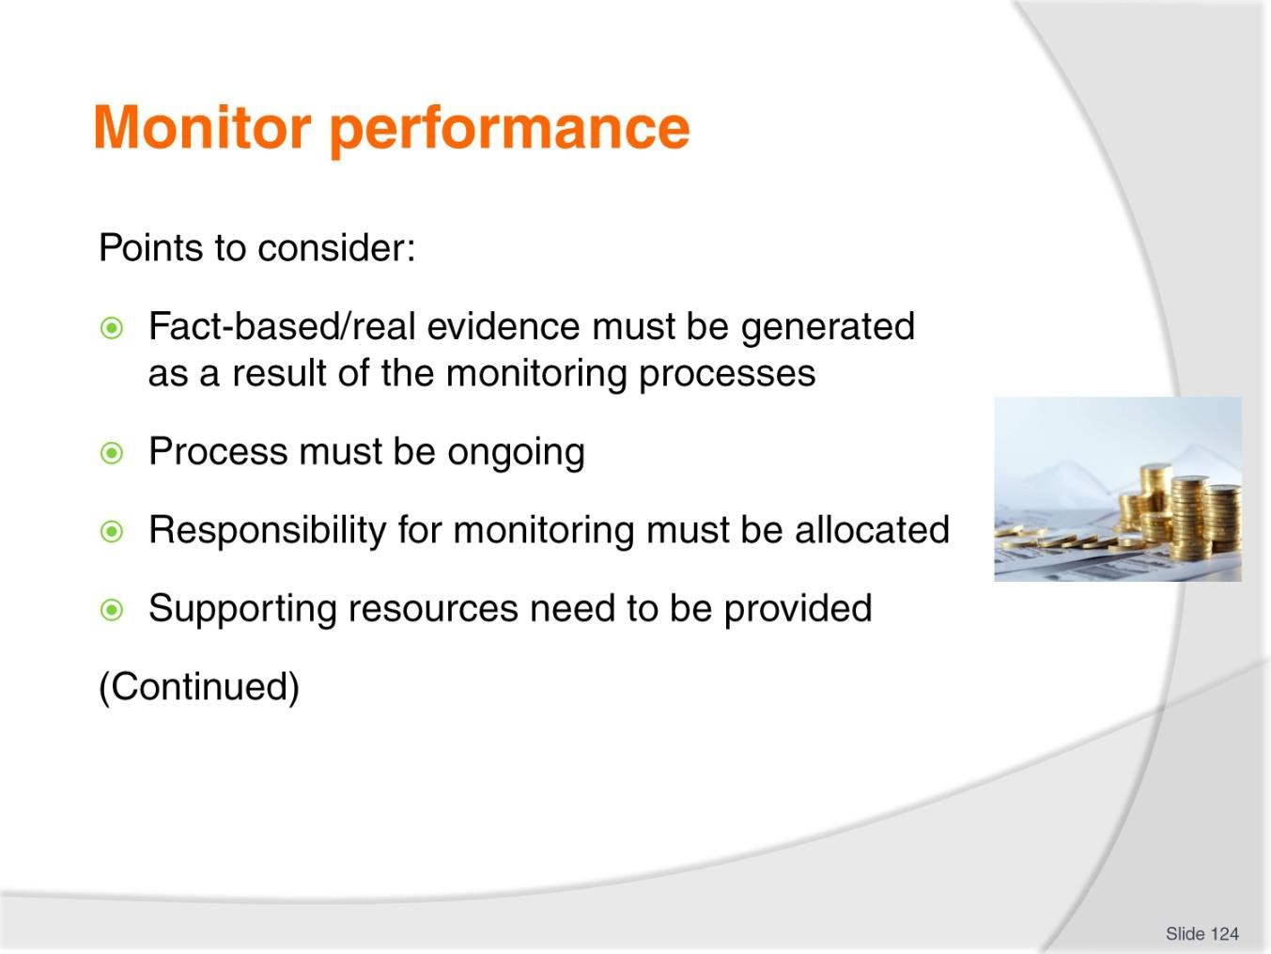
Slide No | Trainer Notes
124. | Trainer presents relevant points to consider:  - Fact-based/real evidence must be generated as a result of the monitoring processes – so:  - There is direct relevant of the data to the policy  - Objective ‘proof’ can be used for analysis and decision making  - The monitoring process should be an ongoing process – which means:  - Compiling cumulative data/evidence  - Not just gathering evidence on set dates or at ‘one point’ in time  - Definite responsibility must be allocated for monitoring activities – so:  - Nominated roles/persons have clear obligations  - Required actions are clearly identified  - Sufficient resources need to be provided – to:  - Enable sufficient and relevant monitoring to occur  - Ensure there is sufficient ‘time’ to do what is required.

Slide
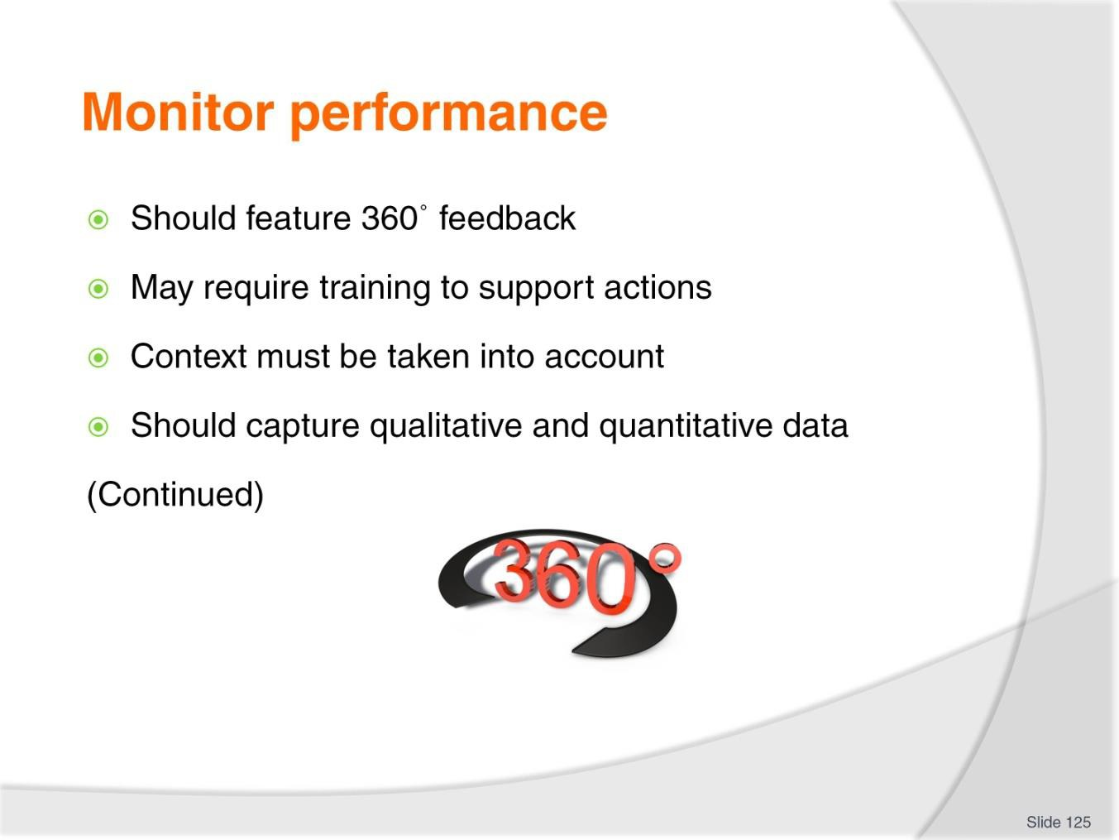
Slide No | Trainer Notes
125. | Trainer presents relevant points to consider:  - Attention must be paid to obtaining 360˚ feedback – that is, there should be data, evidence and/or input from:  - Those impacted by the policy  - Those expected to implement the policy  - Training may need to be provided to those who have responsibility for monitoring – it can never be assumed the responsible person automatically knows:  - What to do  - How to do it  - The context for the activity must be a foremost consideration – meaning:  - Times change  - It is critical the monitoring process factors in the reality ‘of the moment’ and the relevant internal and external factors which apply at the time  - The process should seek to produce two classifications of data – in particular:  - Quantitative data  - Qualitative information.

Slide
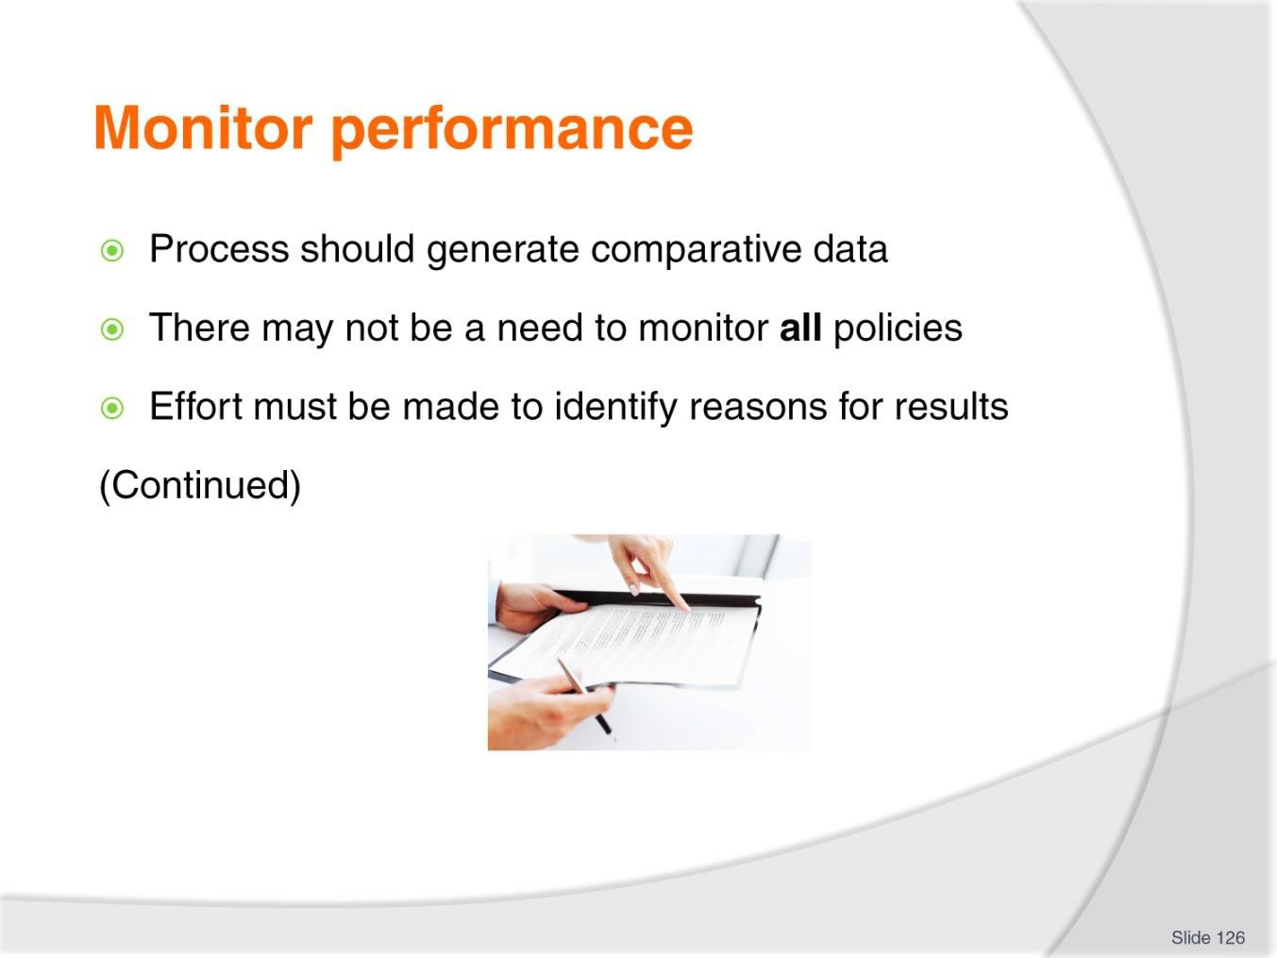
Slide No | Trainer Notes
126. | Trainer presents relevant points to consider:  - The process should generate comparative data – that will compare projected or anticipated targets against actual outcomes  - There may be a restriction on the number of policies which can be/have to be monitored – in some cases:  - Not all policies will have to be monitored  - There may be a priority list of policies which need to be monitored  - Effort must be made to identify reasons for results which are generated – so:  - The causes of outcomes can be determined  - Actual causes are used as the basis for further thinking and (where appropriate) decision making and action.

Slide
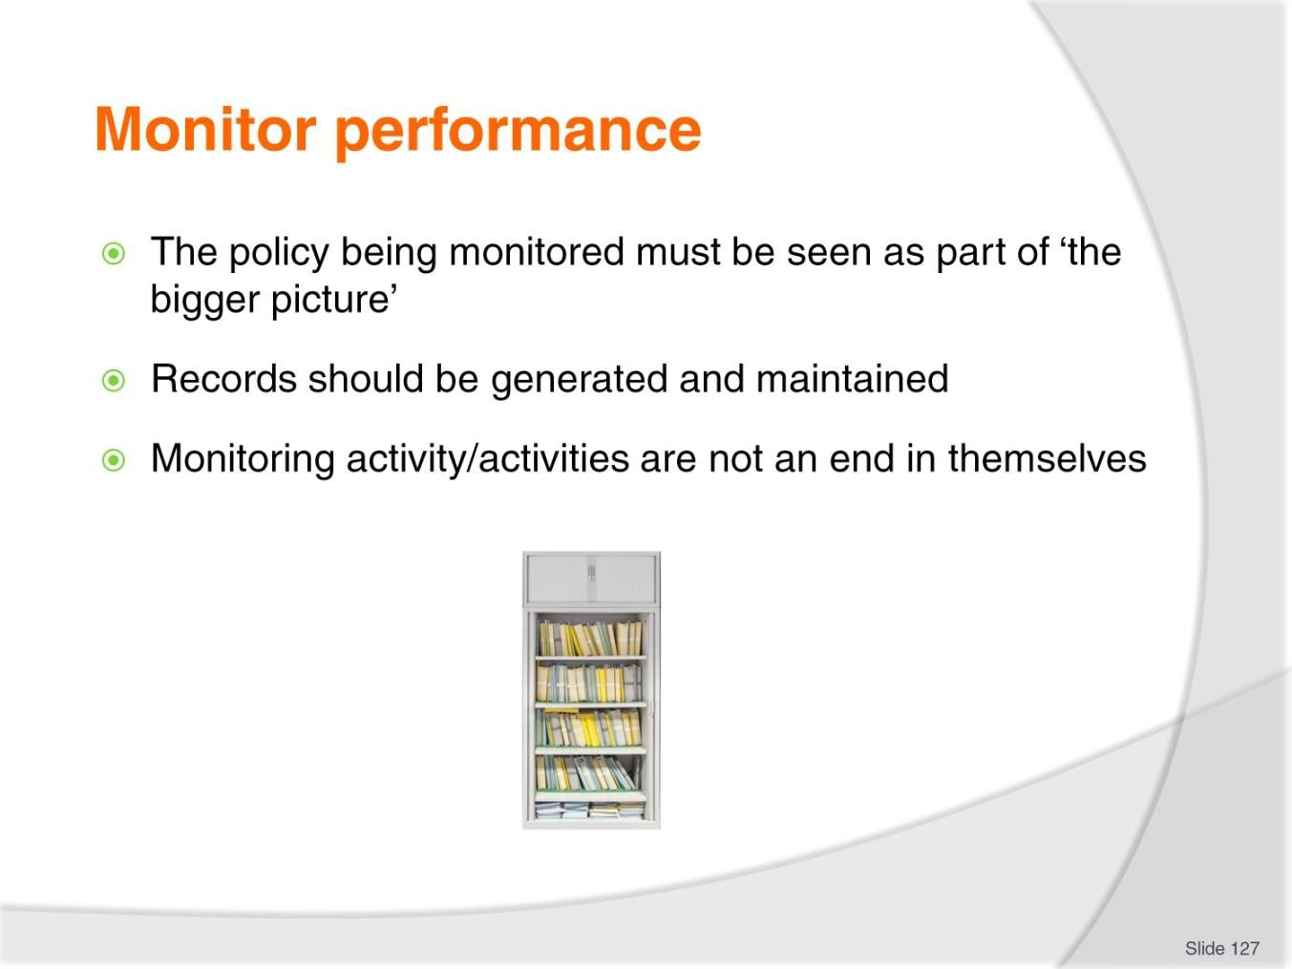
Slide No | Trainer Notes
127. | Trainer presents relevant points to consider:  - The policy being monitored must be seen as part of ‘the bigger picture’ – that is, the way other polices are performing, so that an overall picture of organisational performance is obtained  - Records should be generated and maintained regarding the monitoring process – so they:  - Can be shared with others  - Are available for future/further reference  - The monitoring activity/activities are not an end in themselves – it is to be expected the information generated from the process leads to some form of intentional action.

Slide
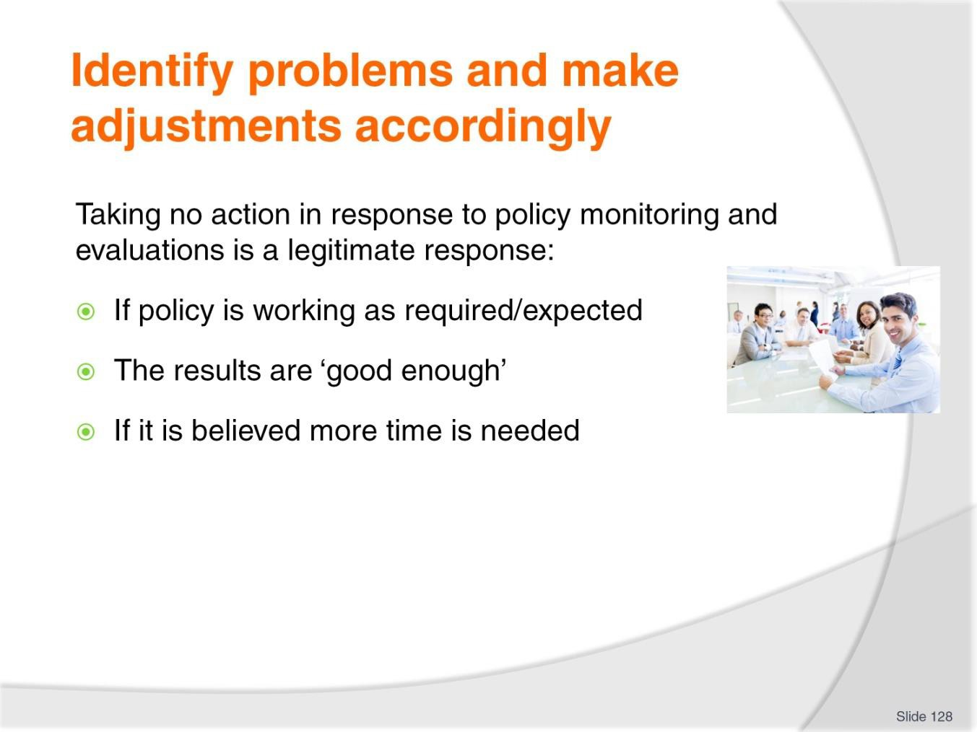
Slide No | Trainer Notes
128. | Trainer indicates making no changes at all to a policy can be a legitimate response in some cases where evaluations determine:  - The policy is working as required/expected – and everyone is satisfied with the outcomes being produced  - The results being generated are satisfactory enough – and do not warrant extra time, energy or resources being spent trying to improve them or their outcomes  - There needs to be more time given to the policy/initiative to see how things turn out in the longer run – in reality, perhaps the initiative has not had long enough to enable any valid conclusions to be drawn at this stage.  Note taking no action is an acceptable and responsible response where it is a reasoned one – this response is not acceptable where it is applied simply because people cannot be bothered doing anything else.

Slide
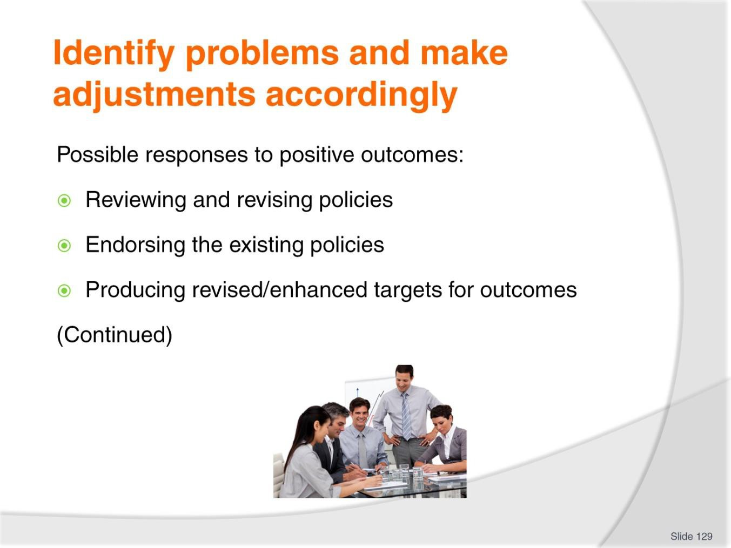
Slide No | Trainer Notes
129. | Trainer identifies possible responses to positive outcomes of evaluations:  - Reviewing and revising policies – to:  - Create enhanced objectives supported by what the data says  - Expand goals  - Increase participants  - Extend timelines and the timeframe for the policy  - Endorsing the existing policies – with a view to reproducing the previous results during the next monitoring/research cycle.  - This is acceptable where everyone is happy with things ‘as they are’ and do not want extra growth, revenue, productivity or other positive indicators  - Producing revised/enhanced targets for outcomes – seeking to increase results for the next/designated time period or milestone.

Slide
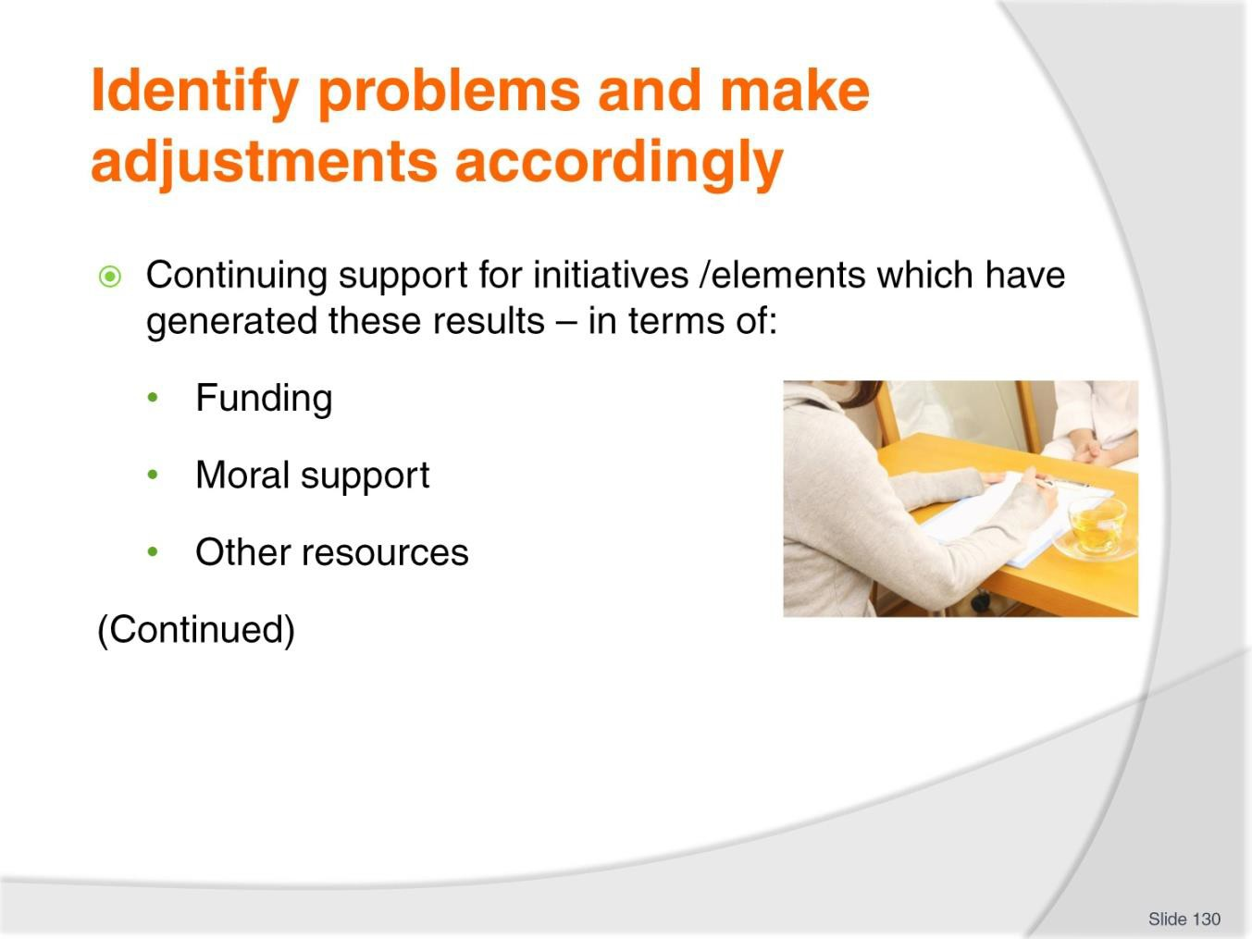
Slide No | Trainer Notes
130. | Trainer identifies possible responses to positive outcomes of evaluations:  - Continuing support for initiatives /elements which have generated these results – in terms of:  - Funding – which may be:  - Maintained at current level  - Increased to support expansion of the policy/initiative  - Changed with reference to source of the money, access to funds, timing of availability of cash  - Moral support – from management and stakeholders to:  - Encourage continued implementation/commitment  - Acknowledge the compliance already received from those impacted by the policy  - Other resources – which may mean:  - Providing extra staff and/or physical resources to support growth  - Supplying more hours for personnel to demonstrate required compliance  - Arranging for more or different physical resources  - Changing the mix of employees involved in implementation  - Altering supply protocols for physical resources.

Slide
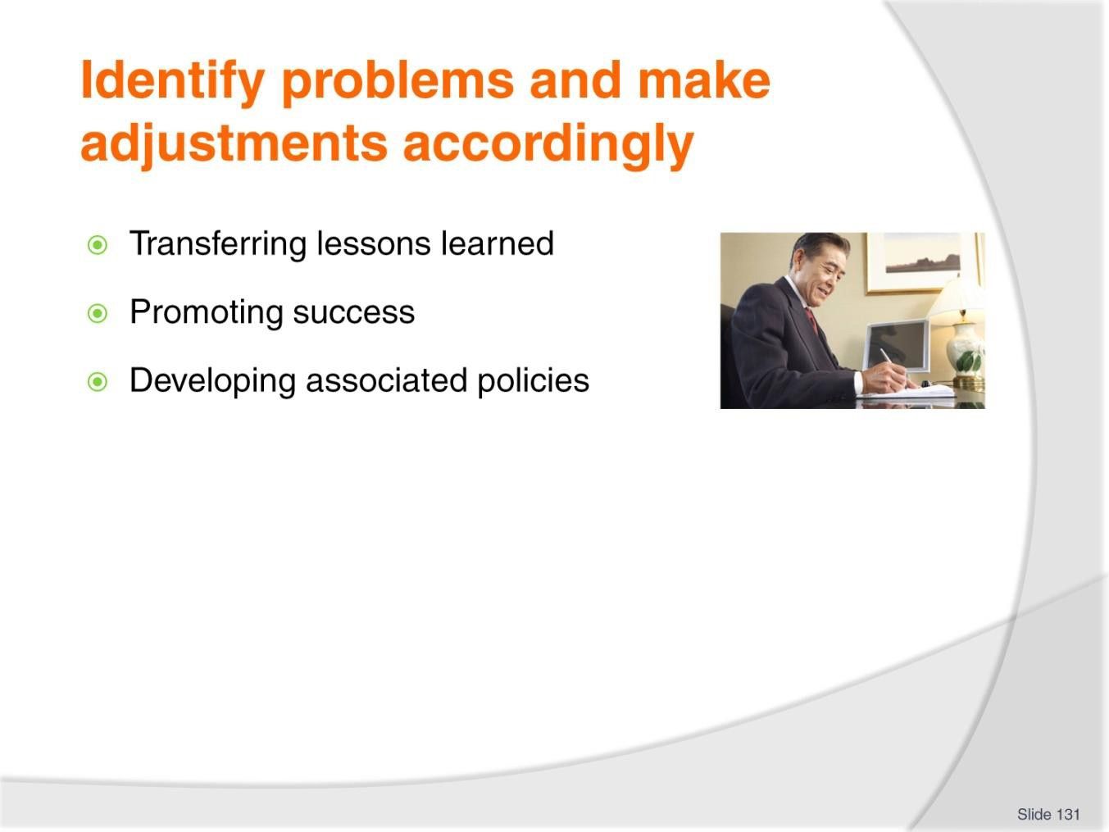
Slide No | Trainer Notes
131. | Trainer identifies possible responses to positive outcomes of evaluations:  - Transferring lessons learned – as a result of these policies/initiatives to:  - Other topics within the organisation  - Other programs, proposals or initiatives  - Promoting success – by:  - Celebrating with those who implement the policy and are responsible for its success  - Congratulating personnel  - Rewarding designated/key as/if deemed appropriate  - Developing associated policies – which:  - Expand the focus of the other policies on the basis of lessons learned from this policy  - Extend the scope of the initial policy – so its impacts and benefits are more widespread.

Slide
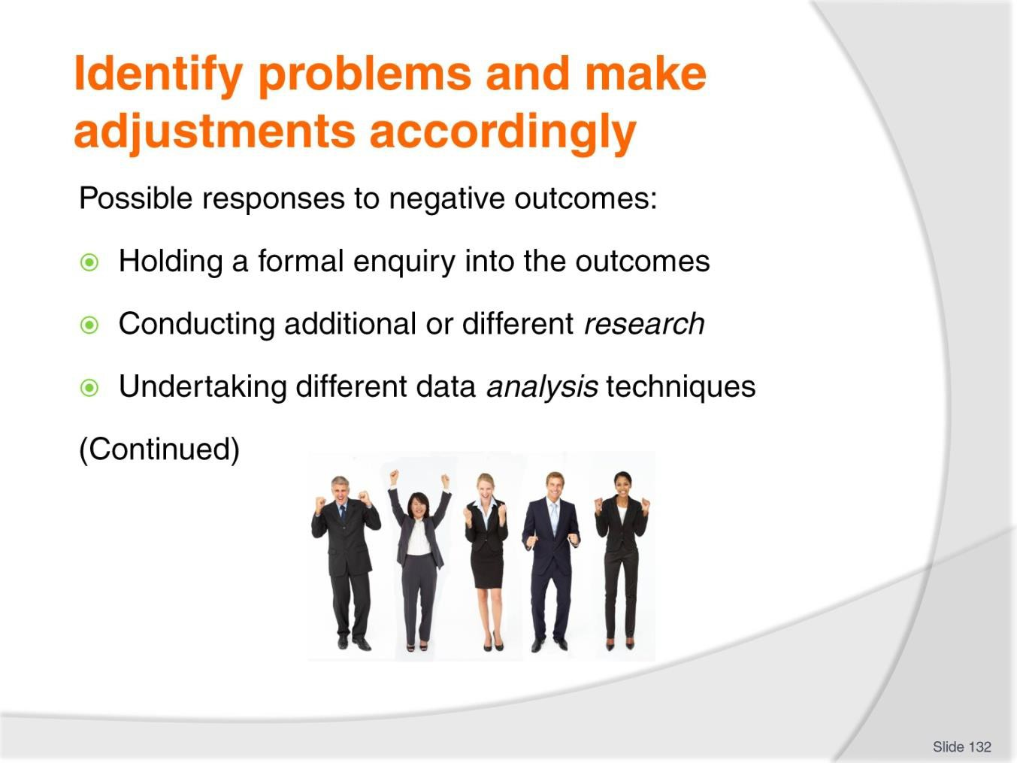
Slide No | Trainer Notes
132. | Trainer identifies possible responses to negative outcomes of evaluations:  - Holding a formal enquiry into the outcomes – which should:  - Involve those who implement the policy and are impacted by it  - Include all stakeholders  - Check/confirm/verify the conclusions  - Evaluate and interrogate the analysis which has produced the negative outcome  - Conducting additional or different research – to:  - Identify if results/outcomes are different  - Determine whether monitoring techniques and data collection is the reason for the outcomes  - Undertaking different data analysis techniques – to:  - See if the outcomes differ  - See if previous results are confirmed  - Confirm previous results or generate legitimate alternative data/outcomes.

Slide
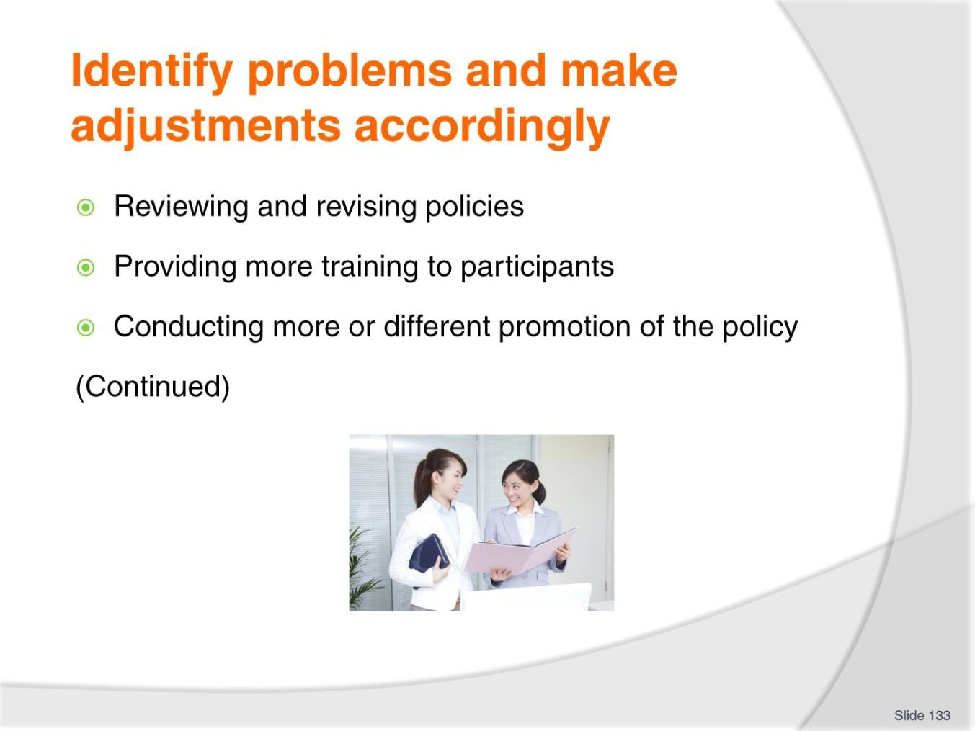
Slide No | Trainer Notes
133. | Trainer identifies possible responses to negative outcomes of evaluations:  - Reviewing and revising policies – to:  - Alter allocation of responsibilities of key persons where it is believed there is a demonstrable need to do so – that is, some people have not performed as expected/required and it is suspected this has caused the negative outcome  - Amend/reduce targets  - Increase funding/resources – to help achieve initial targets  - Reduce funding/resources – to reflect the reduced outcomes  - Provide more time for objectives to be achieved – if lack of time is assessed as being cause of negative outcome  - Include/upgrade risk management protocols relating to the policy  - Providing more training to participants – which may involve:  - Supplying formal training – addressing (as required/requested) training in knowledge related to the policy/initiative  - Using role plays and practical exercises to demonstrate required implementation/s of the policy  - Conducting more or different promotion of the policy – in terms of:  - Altering the way the policy is being promoted internally to those who have to abide by it – by (perhaps) assisting with re-wording the policy, changing entries in staff handbooks and/or amending intranet postings brochures

- Revising and reinforcing the way the new/revised policy is presented to users – in terms of explanations and rationales given to staff/users.

Slide
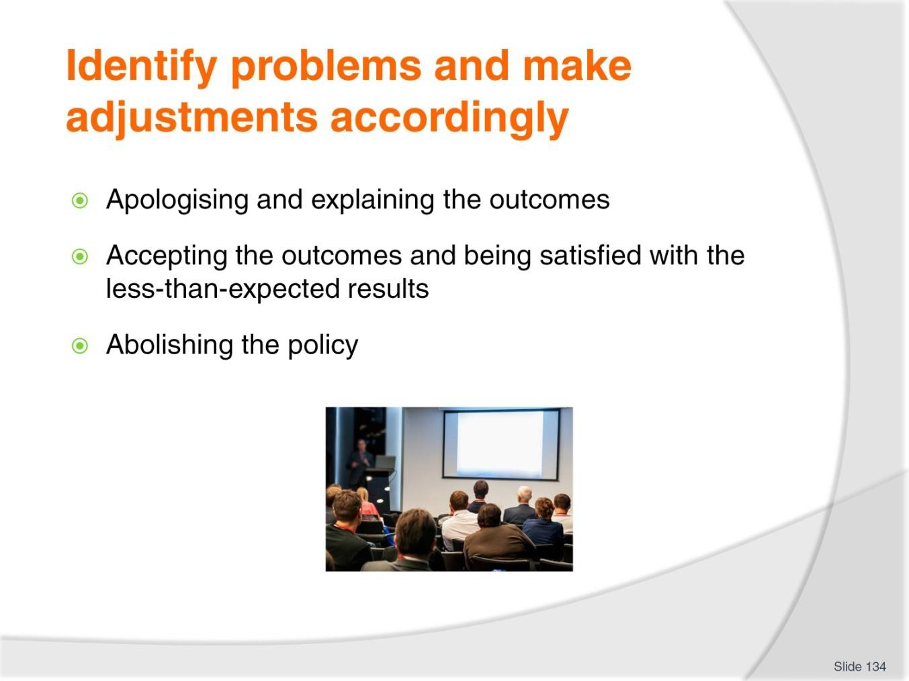
Slide No | Trainer Notes
134. | Trainer identifies possible responses to negative outcomes of evaluations:  - Apologising and explaining the outcomes – to:  - Users  - Stakeholders  - Accepting the outcomes and being satisfied with the less-than-expected results – in terms of:  - Acknowledging the results which have been achieved are nonetheless beneficial despite failing to achieve the targets set  - Understanding the impacts of the initiative were starting to become acceptable even though the positive expectations were not being achieved  - Abolishing the policy – and:  - Considering an alternative policy  - Waiting for a later/different time to re-introduce the original policy/initiative  - Deciding, on balance, the benefits of trying to persist with the policy are not justified in terms of the negative outcomes which are being realised.

Slide
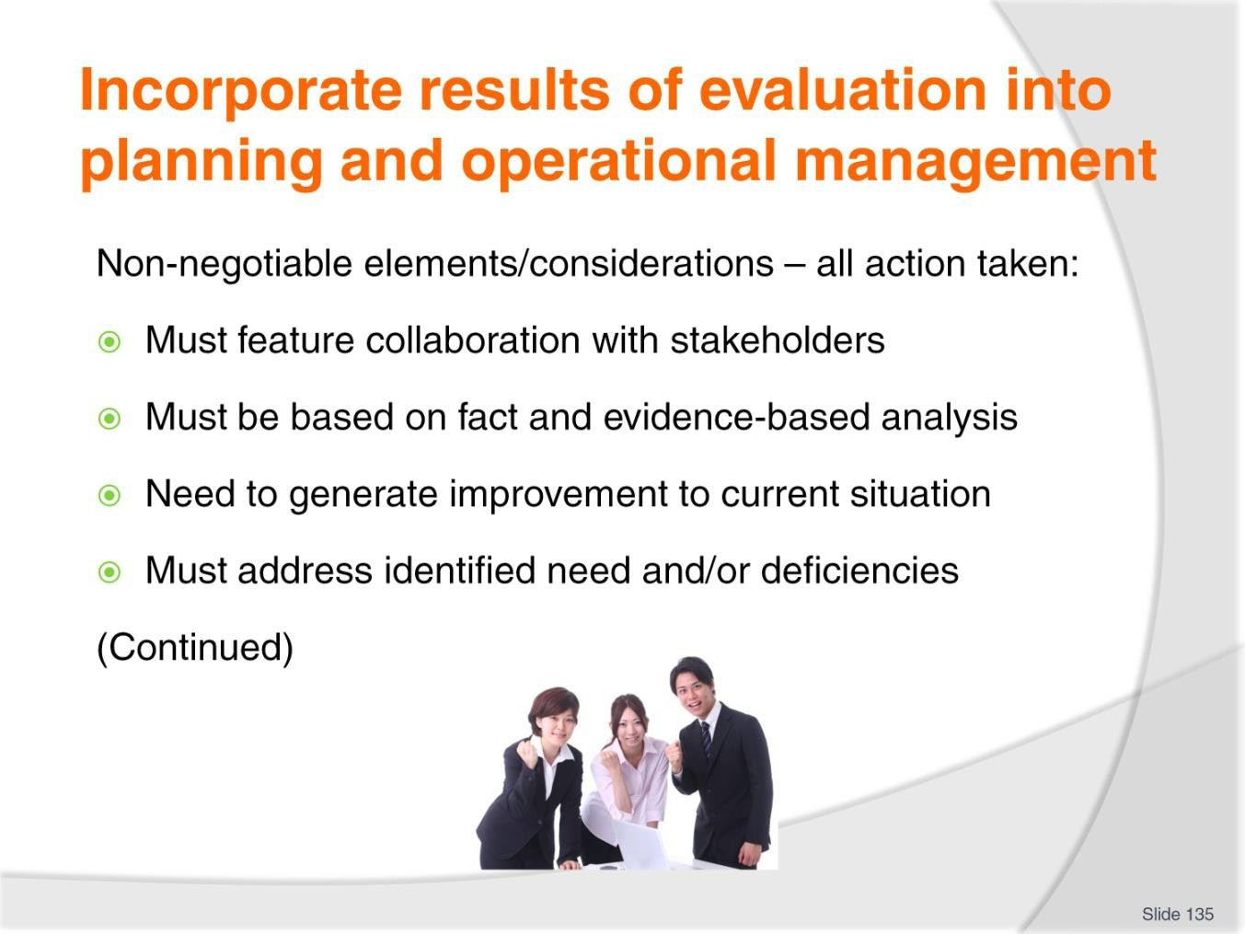
Slide No | Trainer Notes
135. | Trainer highlights the following are always non-negotiable elements/considerations – all action taken:  - Must feature collaboration with relevant stakeholders  - Must be based on fact and the results of evidence-based analysis  - Need to generate an improvement to the current situation  - Must address identified need and/or deficiencies.

Slide
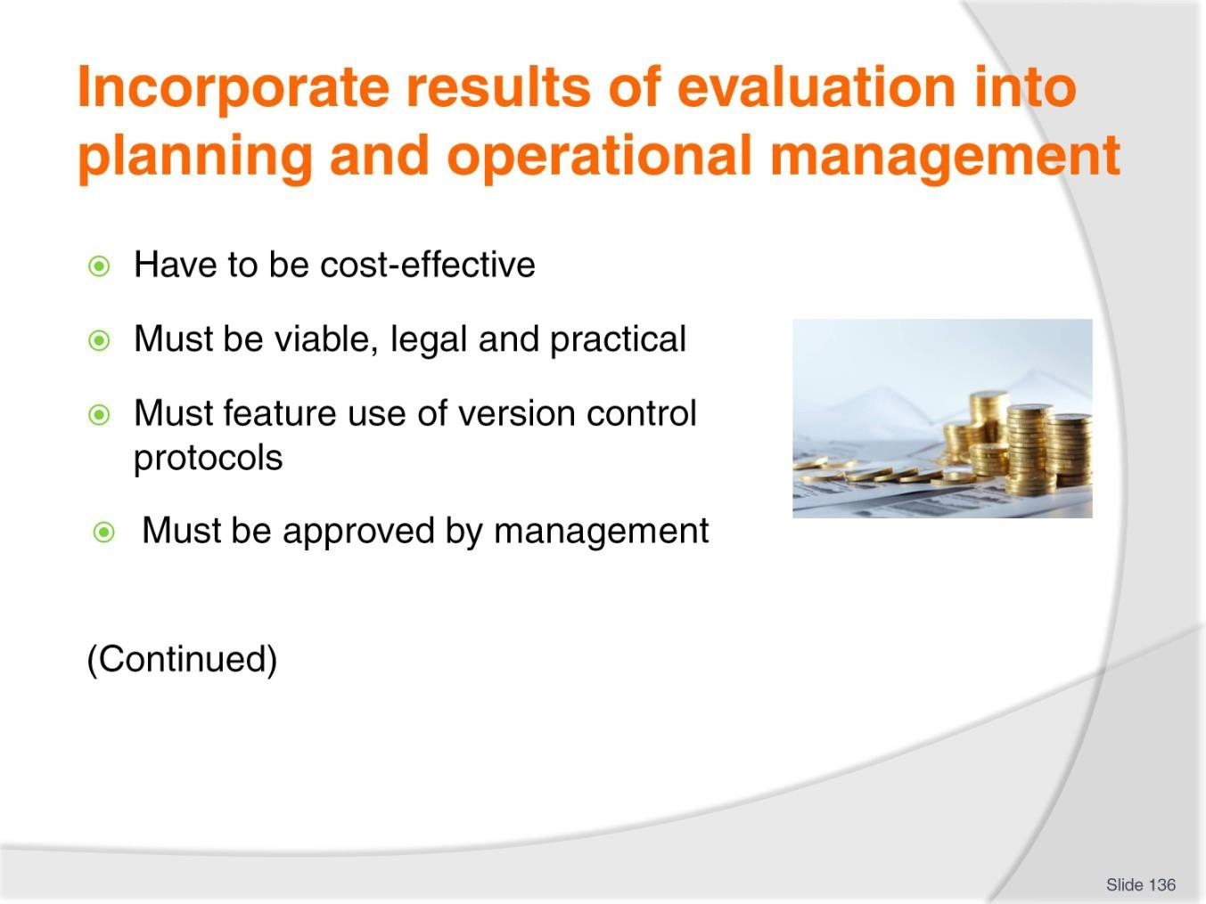
Slide No | Trainer Notes
136. | Trainer highlights the following are always non-negotiable elements/considerations – all action taken:  - Have to be cost-effective  - Must be viable, legal and practical  - Must feature use of version control protocols to ensure correct version is being used at any point in time  - Must be approved by management prior to implementation.

Slide
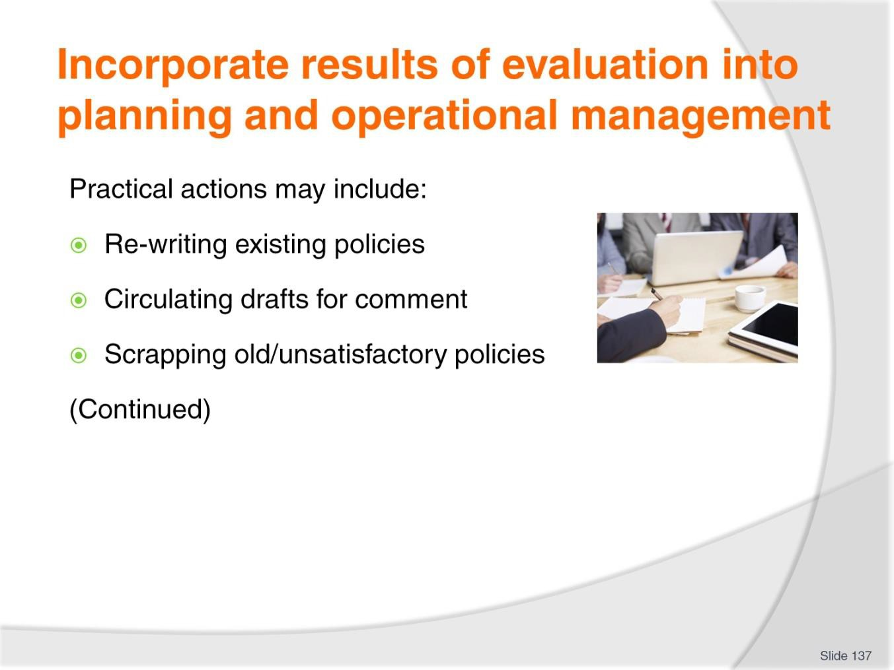
Slide No | Trainer Notes
137. | Trainer explains incorporating results of policy evaluations into ongoing planning and operational management may result in:  - Re-writing existing policies – to prepare ‘revised’ policies which address:  - Previous errors or omissions  - Identified policy gaps  - Circulating ‘draft’ for comment – prior to confirming them as endorsed  - Scrapping ‘old’ and/or unsatisfactory or un-workable polices - and writing new/replacement ones which may:  - Address new issues  - Feature benchmarking  - Update applicable criteria/standards.

Slide
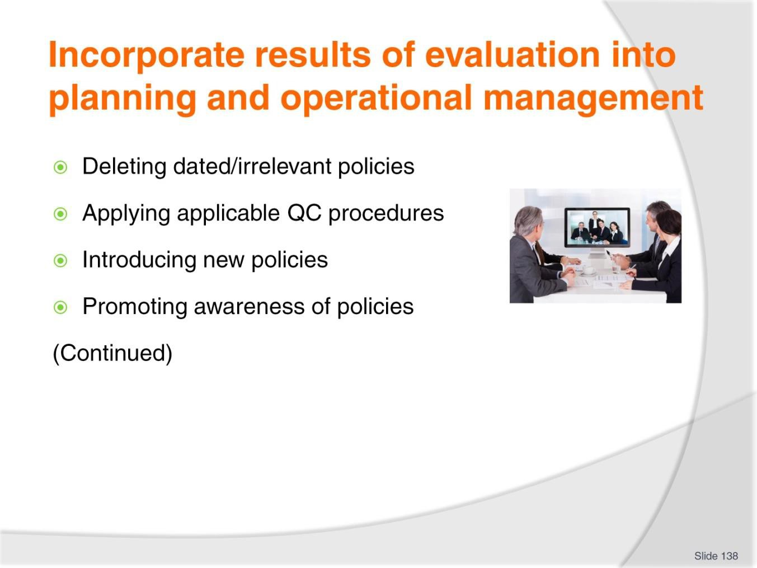
Slide No | Trainer Notes
138. | Trainer describes practical actions which may be required:  - Deleting dated/irrelevant policies – and not replacing them  - Applying applicable quality control procedures – which may involve:  - Compliance with organisational style guide  - Adherence to organisation-wide QA protocols  - Introducing new policies – to address identified and legitimate emerging requirements/need  - Promoting awareness of policies in the workplace in a better manner/differently – so there is greater understanding regarding what is required.

Slide
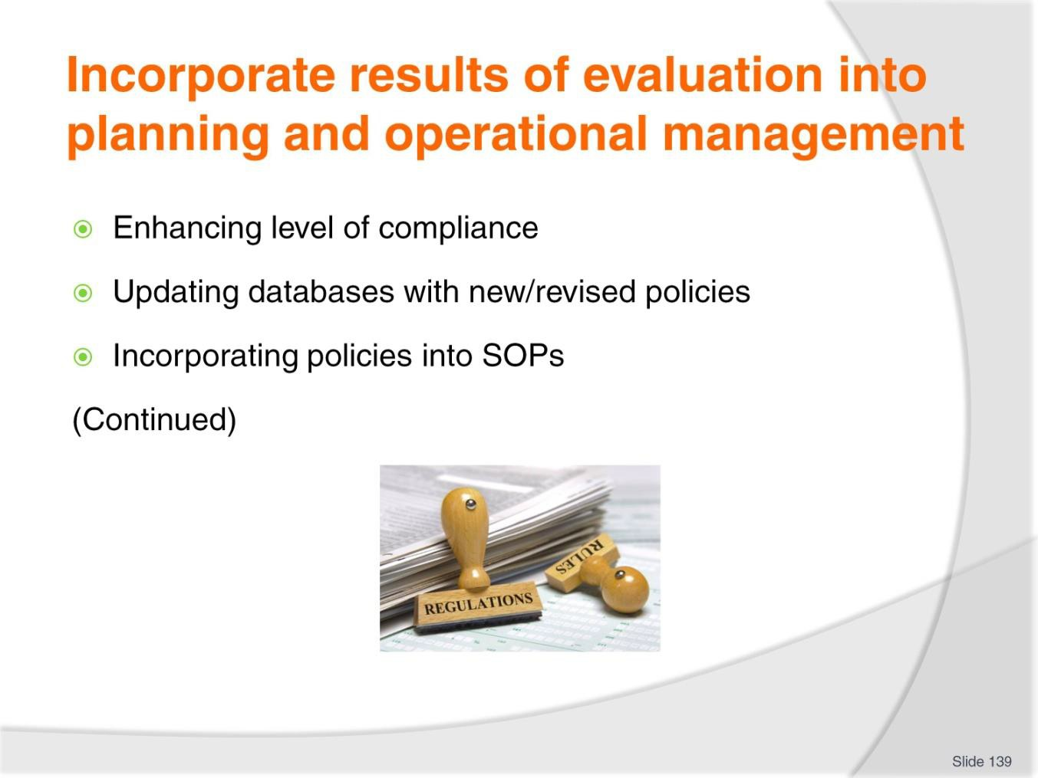
Slide No | Trainer Notes
139. | Trainer describes practical actions which may be required:  - Enhancing and/or altering monitoring of compliance with policies in the workplace – so users are more compelled to adhere to requirements of the policies  - Updating workplace databases and/or handbooks – so they contain the updated/current version of policies  - Incorporating new/revised policies into standard workplace protocols – in terms of, for example:  - Inclusion into internal workplace training courses  - Integrating into Induction and Orientation programs.

Slide
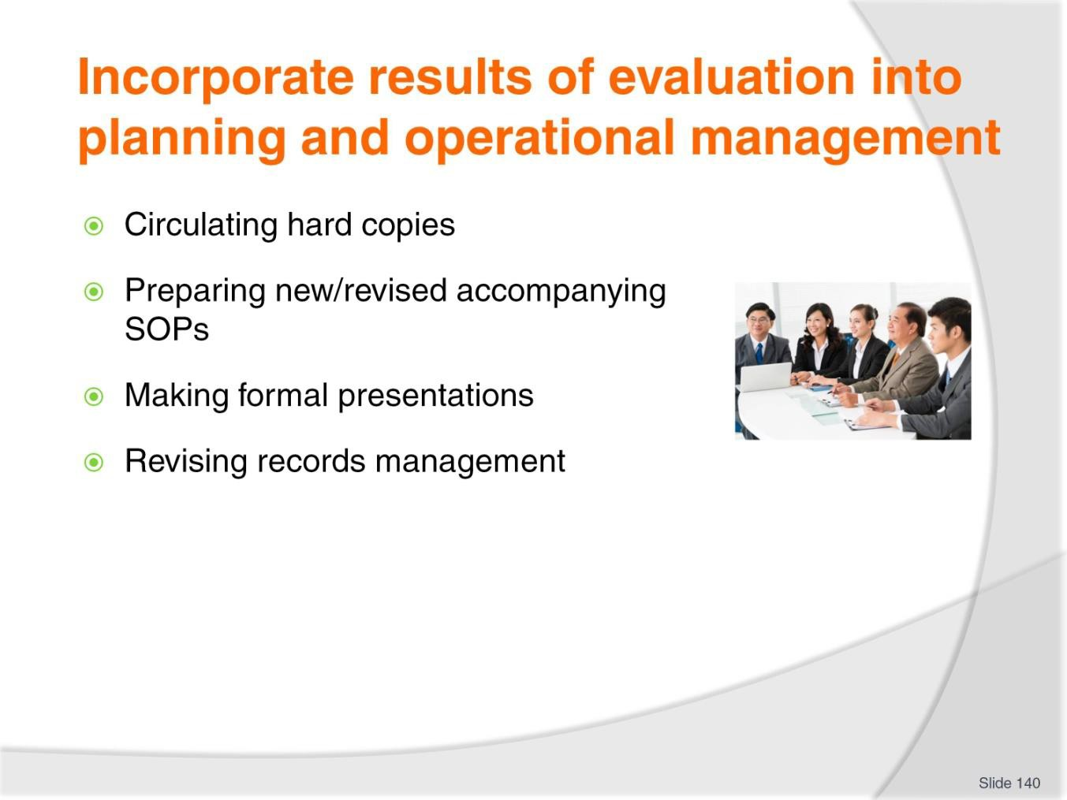
Slide No | Trainer Notes
140. | Trainer describes practical actions which may be required:  - Circulating copies of the new/revised policy – using hard copies and electronic options  - Preparing/developing new or revised SOPs – to reflect the changed policy requirements  - Organising and presenting relevant presentations – to all necessary levels/users within the organisation which may require/entail, as appropriate:  - Introducing, explaining and demonstrating implementation of the policy,  - Conducting supplementary information and training sessions  - Holding staff briefings  - Including articles in internal newsletters and posting on bulletin boards  - Revising records management – to ensure all necessary information is captured and maintained for reference/use as required.

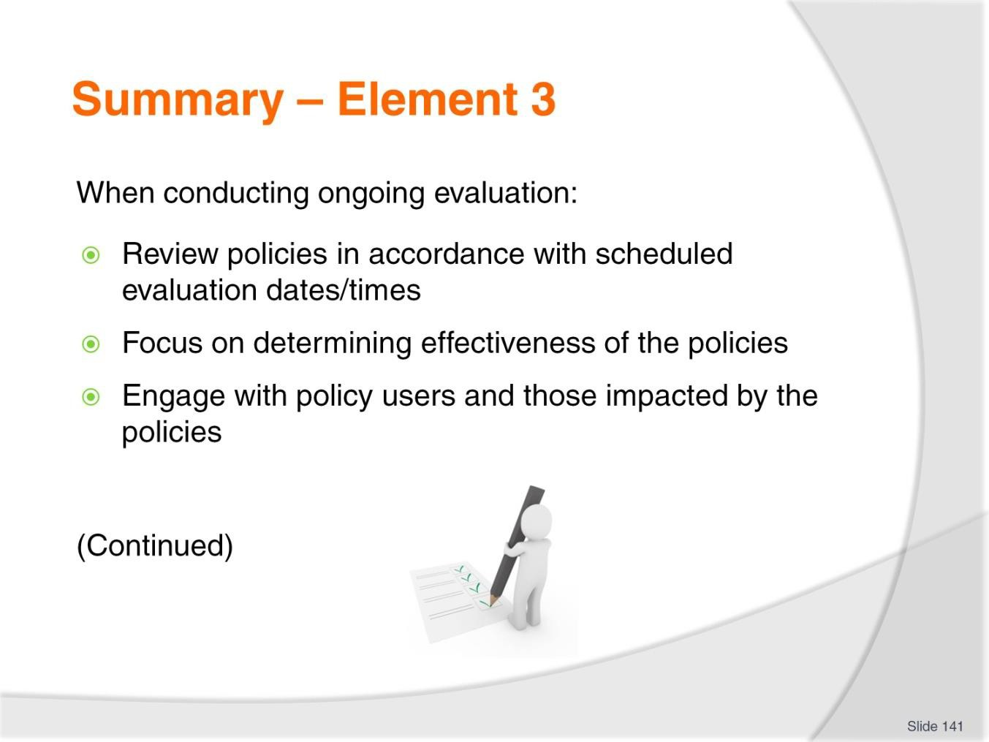
Slide
Slide No
Trainer Notes
141.
Trainer provides a recap of the Element asking questions to check trainee understanding and responding to questions from trainees, as required.

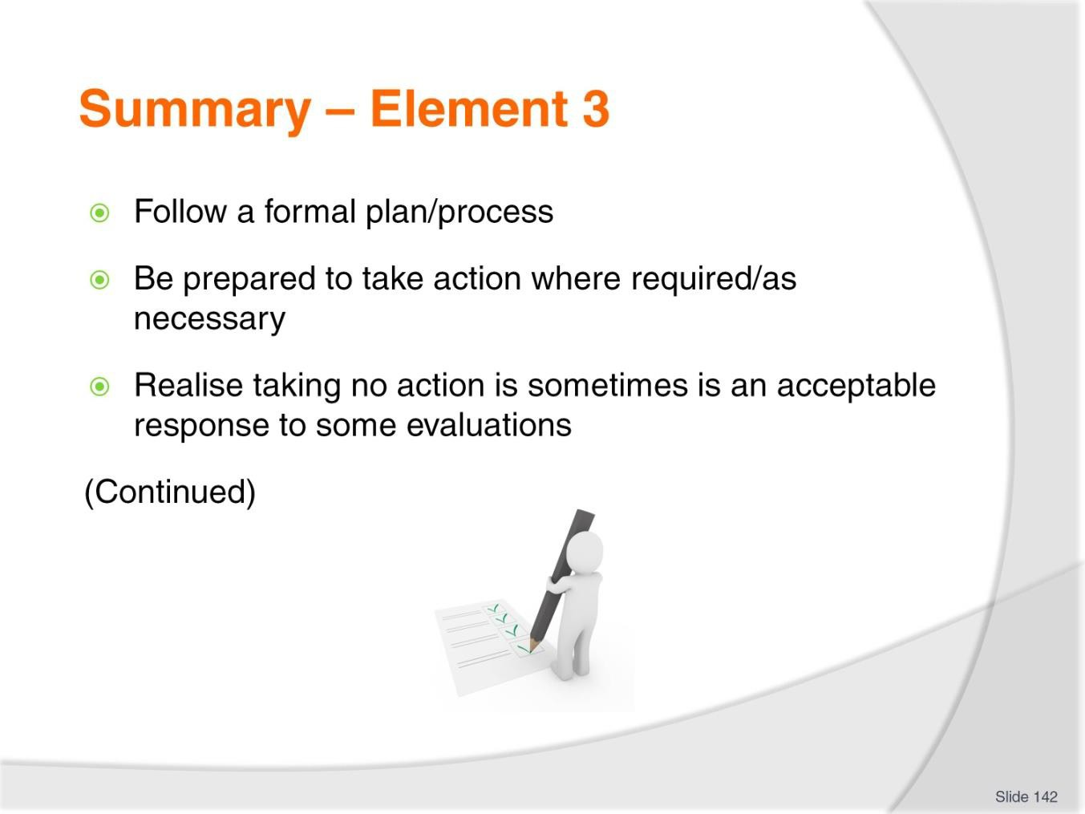
Slide
Slide No
Trainer Notes
142.
Trainer provides a recap of the Element asking questions to check trainee understanding and responding to questions from trainees, as required.

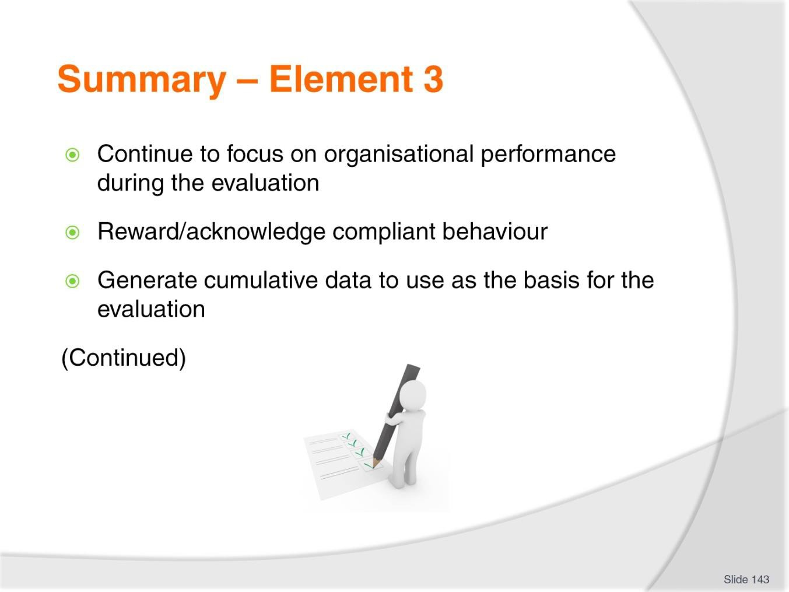
Slide
Slide No
Trainer Notes
143.
Trainer provides a recap of the Element asking questions to check trainee understanding and responding to questions from trainees, as required.

Slide
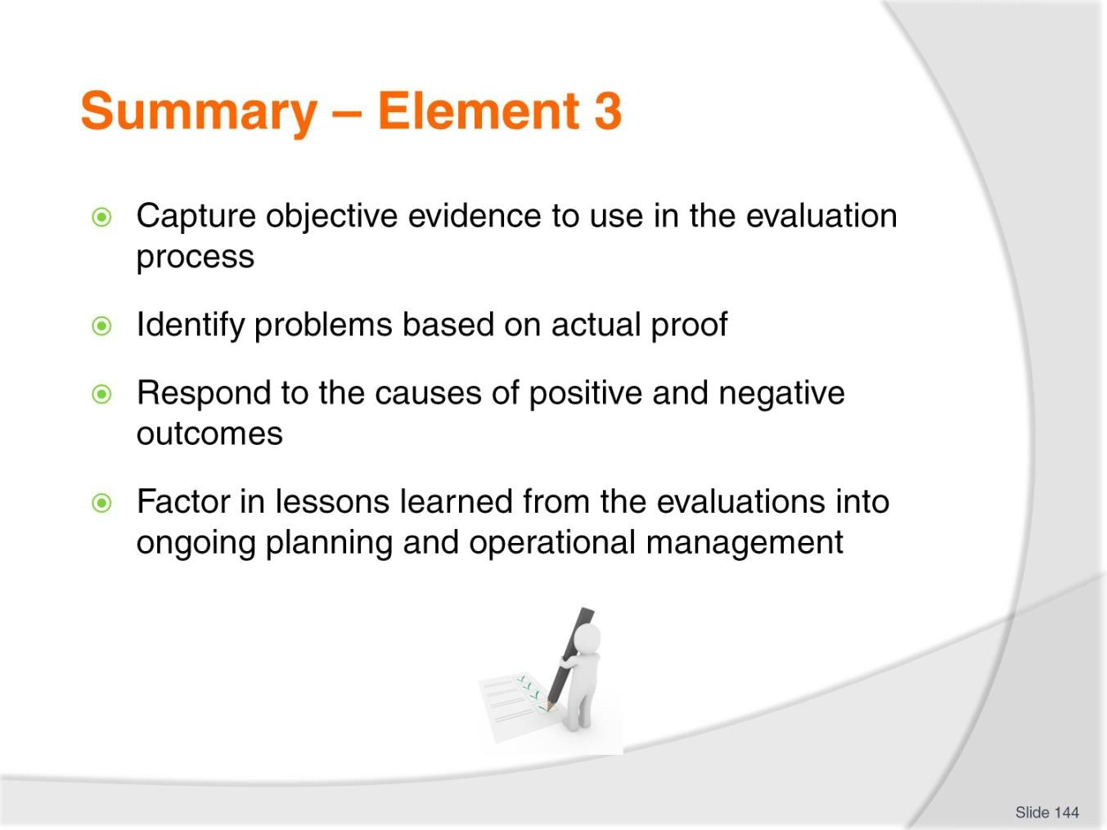
Slide No | Trainer Notes
144. | Trainer provides a recap of the Element asking questions to check trainee understanding and responding to questions from trainees, as required.  Trainer thanks trainees for their attention and encourages them to apply course content as required in their workplace activities.

Recommended training equipment
Sample plans including:
- Business plans
- Strategic plans
- Tactical plans
- Operational plans
- Contingency plans
Examples of organisational public statements in terms of (for example):
- Mission Statements
- Vision Statements
- Core Values statements
- Public advertisements
Sample operational polices for topics such as:
- The environment
- Products and services
- Training
- Workplace relations
- Finance
- Asset management
Sample policies and procedures manual/handbook for relevant industry sector/Labour Division
Sample operational strategies for topics such as:
- Client development
- Geographic expansion
- Organisational growth
- Service growth
- Debt reduction
- Income development Sample Style Guide Sample Distribution List Assets register

Instructions for Trainers for using PowerPoint – Presenter View
Connect your laptop or computer to your projector equipment as per manufacturers’ instructions.
In PowerPoint, on the Slide Show menu, click Setup Show.
Under Multiple monitors, select the Show Presenter View check box.
In the Display slide show on list, click the monitor you want the slide show presentation to appear on.
Source: http://office.microsoft.com

Note:

In Presenter View:
You see your notes and have full control of the presentation Your trainees only see the slide projected on to the screen

More Information

You can obtain more information on how to use PowerPoint from the Microsoft Online Help Centre, available at: http://office.microsoft.com/training/training.aspx?AssetID=RC011298761033

Note Regarding Currency of URLs

Please note that where references have been made to URLs in these training resources trainers will need to verify that the resource or document referred to is still current on the internet. Trainers should endeavour, where possible, to source similar alternative examples of material where it is found that either the website or the document in question is no longer available online.

Appendix – ASEAN acronyms

AADCP | ASEAN – Australia Development Cooperation Program
ACCSTP | ASEAN Common Competency Standards for Tourism Professionals
AEC | ASEAN Economic Community
AMS | ASEAN Member States
ASEAN | Association of Southeast Asian Nations
ASEC | ASEAN Secretariat
ATM | ASEAN Tourism Ministers
ATPMC | ASEAN Tourism Professionals Monitoring Committee
ATPRS | ASEAN Tourism Professional Registration System
ATFTMD | ASEAN Task Force on Tourism Manpower Development
CATC | Common ASEAN Tourism Curriculum
MRA | Mutual Recognition Arrangement
MTCO | Mekong Tourism Coordinating office
NTO | National Tourism Organisation
NTPB | National Tourism Professional Board
RQFSRS | Regional Qualifications Framework and Skills Recognition System
TPCB | Tourism Professional Certification Board



